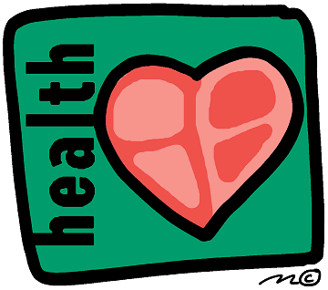

Would you like an apple?
Yes No

Would you like chocolate?
NoYes

Would you like a carrot?
YesNo

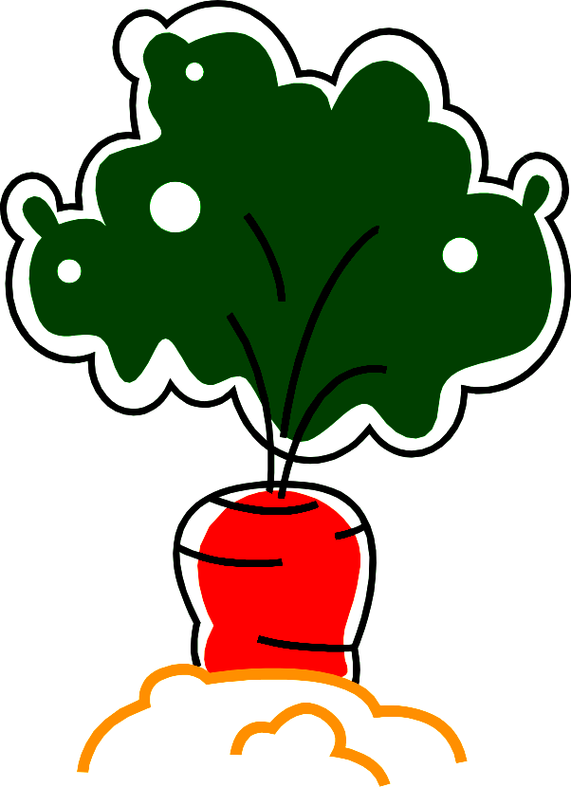

Would you like vegetable juice?
Yes No

Would you like cake?
No Yes

Would you like an onion?
Yes No


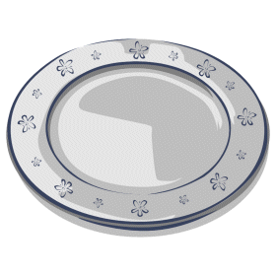

Would you like a salad?
YesNo

Would you like a cola?

NoYes

Would you like ice cream?
NoYes

Would you like fish?

YesNo

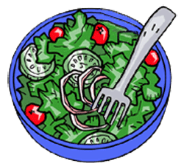



Would you like milk?

YesNo

Would you like chicken?

YesNo

Would you like yogurt?

YesNo

Would you like rice?

YesNo

Would you like beans?

YesNo


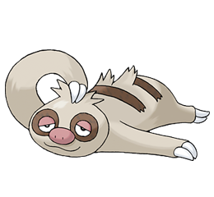
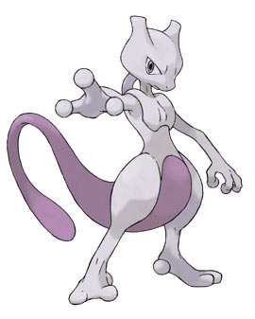
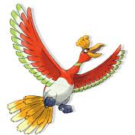
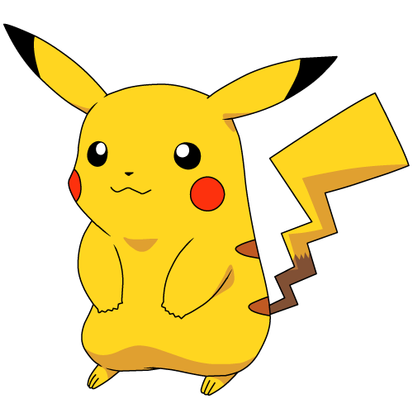
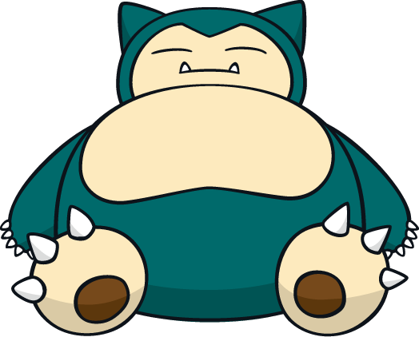
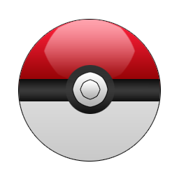

SUPER
HEALTHY

Oh no! You need a healthy life!
You can do anything!

You have great power!
NOT HEALTHY
Take care!
Be more healthy!
Are you
alive?!
REALLY NOT HEALTHY
VERY HEALTHY!

