

Name of Worshipped Being: Dalnoth, God of Dragons – Lawful Good
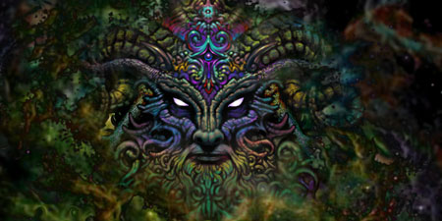
Symbol: Golden Dragon

Goal and Purpose of Faith: To promote a wise, judicious and benevolent society co-existing peacefully with Dragonkind..

Requirements of the Priest Hood: The priests want to and are required to promote goodness and protect dragons at all costs. Priests are to seek out appropriate mountains, craters, and high altitude places as strongholds of the God Dalnoth, encouraging dragons to take rest there and breed. The Weirs of Dalnoth are open to dragons of all alignments. No dragons shall hurt each other within a one-mile radius of the weir. Dragons are also invited to hoard their treasures within the weir, as no dragon is permitted to take another’s hoard. If dragons (of any alignment) breed at the weir, they must grant one of their eggs to the priesthood. The hatchling will then be bonded to a child of the priests (this includes evil or neutral aligned dragon hatchlings), becoming mentally bonded to that dragon as its life long companion. All children bonded to a dragon will assume the alignment of that dragon. Thus, Lawful Good priests sacrifice their children to Dalnoth when giving their child up to be bonded to an Evil or Neutral aligned hatchling.

Alignment Choices: Lawful Good, rare occasions Neutral Good, or Lawful Neutral

Minimum Ability Scores: Wisdom 16

Races Allowed: All races.

Gender: All genders

Bonus Non-weapon & Weapon Proficiencies: Riding/Airborn, Specialization sword, Language - Draconic

Non-weapon & Weapon Proficiencies required: Diplomacy.

Non-weapon & Weapon Proficiencies recommended: Reading/Writing, Religion, Ancient History, Bureaucracy.

Duties: Guidance to rulers as counselors. To stamp out injustice and foul play, be kind and helpful, charitable to all those in need, and to convert the lawless and evil from their ways. Promote the respect and reverence of wyrmkind to the ‘lesser’ sentients.

Priest Hood Weapon Restrictions: No missile weapons.

Special Limitations: Can never willfully harm any dragon, even of different alignment. Must marry. Must have as many children as possible, all raised within the weir stronghold to become dragon riders.

Spheres of Influences:
Major – All, Guardian, Healing, Protection
Minor – Elemental, Time, Dragon Spells (ask DM)
Granted Powers: Control Dragons of same alignment. Inspire fear as a Great Wyrm 2x per day. 5th level – Dragon senses (keen – never surprised); 10th level – Summon Dragon Mount (1d6+6 determines age) always of good alignment. 20th level – Polymorph into a dragon at will. There is a side affect of the polymorph ability. Each time the priest morphs into dragon shape, there is a 30% chance that one of his/her features will remain that of a dragon. There is a 5% chance that the priest will remain a dragon. 25th level – Dragon breath weapon equal to hit dice – weapon of the Dragon Mount.

Followers: First followers are received at 9th level and they consist of: one 5th level priest, three 3rd level priests and six first level priests of the same order, plus ten 1st level fighters. At 20th level gain an army of: 10d4 dragons of at least age category 7, with trained dragon riders.

Relations: Other Faiths, Aristocracy, People: The God Dalnoth does not care for any of the other gods. He particularly despises the Goddess of War. Born from the powers of Creation (an erupting volcano), the will and agreement of all the other gods, and a piece of Paragon Argentus’ heart, Dalnoth is the youngest of the Greater Pantheon of Gods. He has a ‘half-sister’ the Demi-Goddess, Esmarelda, and three half – brothers, via Désordre, Minor-Goddess of Confusion and Paragon Argentus, his Lawful Good Paladin Chosen. Dalnoth feels that the whole world is stuck in a unlawful, chaotic rut, and that he and Dragons were brought forth to change things. He has shared this knowledge with his creations and has directed them, in secret, about his Special goals (see below).

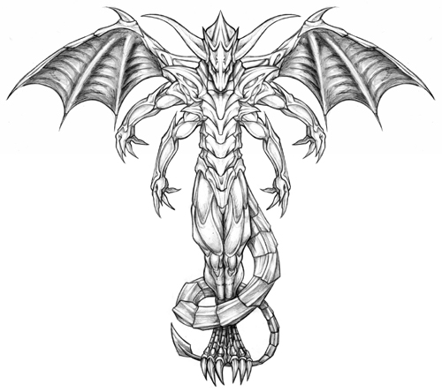
Requirements of the Followers:
Alignment Choice(s): Any.
Races Allowed: Any.
Restrictions: Never harm a dragon of any kind, or half-dragon.

Dragon - Human Amalgam Avatar Form Information:

Appearance & ‘Natural’ Abilities: Dalnoth appears as a multi-limed semi humanoid dragon like creature. His scales are of all the different colors of dragon species. He is impervious to all forms of dragon breath, not that the species he spawned would dare use their breath against him. (see picture at left). Ability scores: 25 all. Natural Armor Class: -25. THAC0: -21. Evasion 99%. Hit Points: 510. Regeneration 1d10+7 per round.

Armor: Dalnoth does not wear any armor, as his body itself is itself covered in the scales of every dragon.

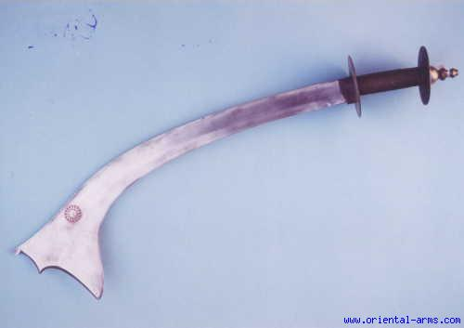
Weapon Powers in the hands of Dalnoth: Dalnoth’s Holy Avenger is an oddly shaped sword +5. It has a wide, top-heavy blade with jagged teeth and a short handle. It functions in the same manner as a holy avenger sword, providing a magic resistance of 50% in a 5 foot radius, dispelling magic at the same level as the wielder, and inflicting +10 points of damage to chaotic evil opponents. He rarely uses this weapon, preferring his six claw attacks, two wing tip attacks, and bite attacks and his amazing breath weapon. Dalnoth can produce any dragon’s breath weapon without having to inhale for a round.

Weapon’s Powers in the hands of a mortal: To all others, it functions as a sword +2. Humans in particular find this sword difficult to wield, and as such are -2 with it, regardless of its magical bonus, until proficiency with this weapon (technically a ‘saurial broad sword’) is gained.

Special goals of the Pantheon of Wyrmkind known only to Wyrmkind: To breed and multiply as much as possible and spread over the globe until there is a safe haven in every land for wyrmkind. Interbreeding with humans or demi-humans to produce half-dragons is to be encouraged for gold, silver, and bronze dragons. Dalnoth wants a half-dragon worshipper to become a ruler over a kingdom in each of the main lands throughout the world to help support wyrmkind’s control over ‘lesser sentients’ who obviously need guidance.

Information regarding half-dragons: While Dalnoth likes the idea of half-dragons, all dragons other than Gold, Silver, and Bronze find the idea repugnant. Only among Gold, Silver and Bronze is it the least bit socially acceptable to father a half-dragon. Additionally, a half-dragon character can only be created by first having an adventure in which a dragon and a human or demi-human eventually mate following these rules:

First, only male dragons and female humans or demi-humans can create half-dragon children; female dragons cannot be impregnated by male humans or demi-humans, and beings other than humans or demi-humans cannot bear a dragon's children. Demi-humans include elves, half-elves, dwarves, gnomes, halflings, and similar humanlike races. This category does not include giants, ogres, orcs, half-orcs, half-ogres, goblins, centaurs, and other "nonhuman" races; for now, we'll assume that these races are not fertile with dragons, or that dragons won't have anything to do with them. Additionally, the human or demi-human female that gives birth to the live half-dragon is also willingly giving her life to produce this young. As dragons are born of eggs, then half-dragons, owing to that nature, will rip themselves out of their mother’s womb. Thus, no half-dragon has a true full sibling, as their mother dies during birth.

Second, only those dragons with the innate power to polymorph themselves into human or demihuman shape can interbreed with the latter while in the latter's form. Third, interbreeding is not possible while a dragon is using a normal polymorph self spell, so a red dragon or shadow dragon with a fourth-level spell slot could not impregnate a human or demihuman female.

Fourth, some dragons that might have the power to create half-dragon offspring simply have no interest in doing so, and actively avoid it. These are most commonly dragons that have little or no interest in humanity or have strong prejudices against humans, demihumans, or mammals in general, greatly preferring the company of other dragons alone. No Evil or Neutrals, no exceptions.

Combat & Non-Combat Proficiencies for Half-Dragons:

Bonus: Language – Draconic;
Claw/Claw attack; Burrow; Tease; Trick; Survival.

Required: Bite

Recommended: Dragon flight; Alertness; Danger Sense; Direction Sense; Fishing; Hunting; Navigation; Observation; Law; Stewardship; Diplomacy; Etiquette; Quickness; Improved Quickness; Evasion; Rulership; Crowd Working

Initial proficiency slots for all half-dragons is a base of 7, then additionally slots apply for Intelligence bonuses and class chosen. Half-dragons also earn an additional 5 slots every time they go up 5 levels. So, initial seven slots at first level, an additional 5 at 5th level, and another 5 at 10th level, etc. Half-dragons may dual or multi class.

Half-dragons can fly only if they take the Dragon flight proficiency. They may take the wing spur, plummet and roll proficiencies as well, which will increase their flight mobility and combat abilities while flying. They may only have a breath weapon if they take Quickness, Improved Quickness, Evasion, and Slow Respiration.

Magic Resistance increases at 5% per level. Evasion increases only if the proficiency is taken, and then increases 5% per level.

Half-dragons never grow in size as their full dragon fathers do, and thus do not need to hoard in order to age. They also never increase the size of their breath weapon or decrease their base armor class. Thus, armor class can only be improved by outside means. THAC0 decreases per class selected. The Hit Dice adjustment is only for starting hit points. Hit points are earned per class selected after initial creation. Half-dragons are highly encouraged to worship Dalnoth for they would not exist without his blessings.

