

Name of Worshipped Being: Ortinier, God of the Oceans - True Neutral

Symbol: Trident

Ancient Rune: Octopus surrounded by seahorses.

Family relations: Former consort of Nature and father of her four children. He is the current consort of both the twin Goddesses of Thunder and Lightning and father of their children as well. Grandfather to the God of Agriculture and the Minor-Goddess of Seasons’ children.

Goal and Purpose of Faith: To protect water life from the plunder of over zealous fisherman. To aid in the proliferation of sea life.

Requirements of the Priest Hood: The priests want to and are required to stop the abuse of sea creatures, the plunder of the seas natural resources, and protect it from pollution.

Alignment Choices: True neutral or neutral good.

Minimum Ability Scores: Wisdom 12

Races Allowed: All races. Merman, Mermaids, and Tritons are most favored.

Gender: All genders. Great fondness for females.

Bonus Non-weapon & Weapon Proficiencies: Fishing; Rope Use; Seamanship; Weather Sense; Navigation; Belaying Pin – specialization; Harpoon – specialization; Trident – mastery.

Non-weapon & Weapon Proficiencies required: Swimming, Reading/Writing; Religion; Sage Knowledge, Oceanography; Boating; Sage Knowledge, Cartography

Non-weapon & Weapon Proficiencies recommended: Fine Balance; Direction Sense; Deep Diving

Duties: Guidance. Marriage. Procreation.

Priest Hood Weapon Restrictions: Belaying pin, bill, harpoon, javelin, net, scourge, spear, sword/cutlass, trident. No armor permitted. All shields permitted.

Special Requests/Limitations: Priests of the God of the Oceans must remain celibate (unmarried). They must procreate each year (favorable), or at a minimum every other year.

Spheres of Influences:
Major – All, Animal (only spells dealing w/ sea animals), Divination, Elemental - Water, Weather
Minor – Charm (only sea-life), Combat, Plant (only sea plants), Protection
Granted Powers: Water breathing; Determine underwater depth; Infravision (only underwater); At 5th level – Language/Communication. Each level between 5th and 8th the priest gains two extra proficiency slots; At 8th level - Shape changing (only marine animals).

Followers: First followers are received at 8th level and they consist of: one 5th level priest, three 3rd level priests and six 1st level priests of the same order, plus five mermen and mermaids (total). At 20th level gain an army consisting of: 20d20 creatures – 25% sea elves; 25% tritons, 10% mermen; 10% mermaids; 10% water nymphs; 5% dolphins; 5% whales; 5% urchins (any varieties); 5% giant squids.

Relations: Other Faiths, Aristocracy, People: The God Ortinier is indifferent to most of the other major gods and goddesses. Ortinier and his clergy are on very good terms with the gods of Lightning, Thunder, and Wind. Ortinier occasionally fights with his former consort Nature, but it more stubbornness than malice.

Requirements of the Followers: Sailors and explorers are preferred.

Alignment Choice(s): Any alignment. Prefers non-evil, but holds no grudges against evil. Definitely rewards good and neutral alignments more than evil, and Lawful more than Chaotic – yet true neutrality is most rewarded.
Races Allowed: Any. Mermen, Mermaids, and Tritons preferred. Sea-Elves Highly Favored.
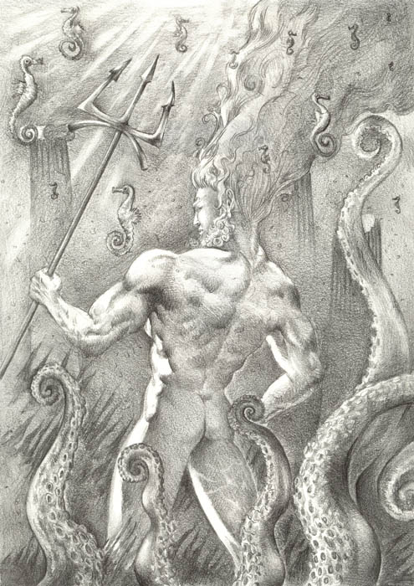
Restrictions: Can’t pollute water or purposely seek out sea creatures for the pleasure of harming them. Survival and eating is one thing. Hunting for sport is Highly frowned upon and punishable by the God.

Human Avatar Form Information:

Appearance & ‘Natural’ Abilities: Ortinier appears as Human male with green seaweed like hair and deep ocean blue eyes. (see picture at left). Ability scores: 25 all. Natural Armor Class: -25. THAC0: -21. Evasion 99%. Hit Points: 510. Regeneration 1d10+7 per round.

Armor: Ortinier wears no armor and hardly wears clothing. Instead, he assumes various shapes underwater during battle. Besides taking on all of the animal’s natural attacks in addition to his own, he keeps his armor class and all the rest of his ‘Natural’ ability scores. Thus, in his Kraken form, Ortinier has all the attacks and defenses of a Kraken in addition to maintaining his –25AC.

Weapon’s Powers in the Hands of Ortinier: The Blessed Trident of Ortinier is a two handed Trident with three upward facing barbed prongs and two downward facing sharpened slashers. It is a +5 Vopellum weapon that goes Vorpal on a roll of 8 or higher. If hit, the opponent must save vs. spell. If the opponent fails to save, it must check morale the next round instead of attacking; if morale is good, the opponent may act normally next round, but if it is poor, the opponent ceases to fight and surrenders, overcome with a feeling of hopelessness. The duration of the hopelessness is 2d4 rounds. After that, the creature is normal again. On any hit, in addition to its normal damage, the trident dehydrates its opponent, draining one-half of his or her remaining hit points. (Compute normal damage first).

Weapon’s Powers in the Hands of a Mortal: The Blessed Trident of Ortinier is the ‘holy avenger’ of sea weapons. For a mortal paladin, it is a +4 weapon, which does +8 points of damage against evil opponents on top of its normal Vopellum qualities. In addition, the trident bestows 25% magic resistance to the wielder. The trident also can cure serious wounds and know alignment, each three times a day. It also enables the paladin to communicate with any sea creature.

Additional powers granted and penalties incurred to and by mortals wielding this weapon are: Acts as a staff of commanding, but functions only with regard to water-dwellers within a 60-foot radius of its user. It functions for 12 turns each time it is used.

If the trident is wielded by someone other than a worshiper of Ortinier, that person is instantly overcome with an overwhelming desire to be immersed in as great a depth of water as possible. This unquenchable longing causes the affected character to proceed immediately toward the largest and deepest body of water available – in any event, one that is sufficient to completely cover his or her person. Once there, the character immerses – permanently.

The character cannot loose his or her grip on the trident, and only a water breathing spell (after submersion) or a wish can enable the character to do so. The trident does not confer the ability to breathe underwater to this ‘cursed’ person.

Minor-God spawned by the Goddess of Lightning, sired by Ortinier, God of Oceans:



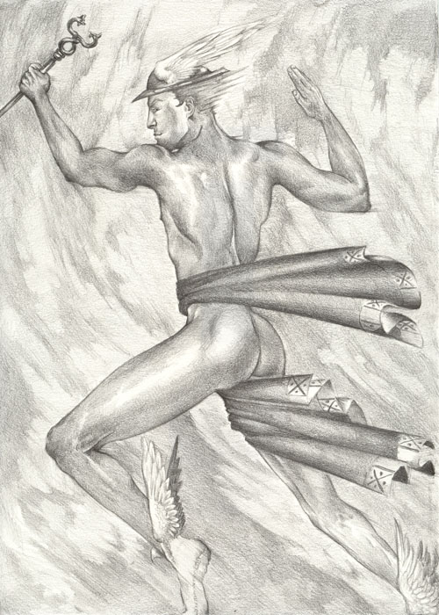
Name of Worshipped Being: Èchange, Minor-God of Messengers – True Neutral

Symbol: Two intertwined snakes with wings

Goal and Purpose of Faith: To serve as sacred messengers of the Gods and their loyal servants in the Prime Material Plane.

Requirements of the Priest Hood: Must abstain from taking sides in any conflict – may not engage in combat even in self-defense. Must display holy symbol on both their back and front.

Alignment Choices: True Neutral

Minimum Ability Scores: Wisdom 16, Charisma 18

Races Allowed: All Races

Gender: All Genders

Bonus Non-weapon & Weapon Proficiencies: Evasion +20% per level; Alertness; Jumping; Running; Quickness; Improved Quickness; Tumbling;

Non-weapon & Weapon Proficiencies required: Alertness; Bureaucracy; Disguise; Reading/Writing; Religion; Diplomacy

Non-weapon & Weapon Proficiencies recommended: Fast Talking, Heraldry; Information Gathering; Law; Light Sleeping; Observation; Scribe; Sense Motive

Duties: To serve as messengers between the gods and mortals and between rulers of nations and religious orders within the Prime Material Plane.

Priest Hood Weapon Restrictions: No weapons or armor allowed. Must wear the robes of the messenger at all times. Non-combatant at all times.

Spheres of Influences:
Major – All, Elemental – Air & Fire, Weather
Minor – Divination, Plant, Protection
Granted Powers: Regeneration + 10 hit points per round. Teleportation of self without error if on an errand to deliver a divine message. If anyone kills a sacred messenger the killer is immediately smitten with multiple random curses or death. Movement doubles every three levels. Speaks and reads every known language ancient, written, or spoken.

Followers: No followers.

Relations: Other Faiths, Aristocracy, People: The God Èchange is on very good terms with all the gods, their clergy, and is a welcome and honored guest in every royal court on Rorschach. The clergy of Èchange are above reproach and are considered sacrosanct in every land. Clergy do not perform religious services. Clergy must erect a message board in each town they enter inside their territory to act as a contact device. Each clergy member is mentally attached to the message boards in their territory receiving messages mentally across the distances. Clergy are encouraged to travel, meet and greet all races and species in their territories.

Requirements of the Followers: Daily prayer
Alignment Choice(s): Any alignment
Races Allowed: Any
Restrictions: None

No armor or weapons for Èchange

Minor-God spawned by the Goddess of Thunder, sired by Ortinier, God of Oceans:



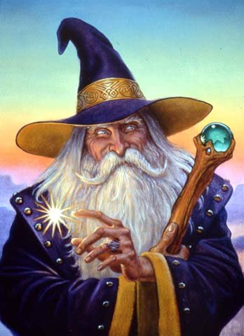
Name of Worshipped Being: Sorcier, Minor-God of Magic – True Neutral

Symbol: Glowing Aqua Orb

Goal and Purpose of Faith: Spread the use of magic throughout the realms by making enchanted items and teaching all those interesting in magic to use it.

Requirements of the Priest Hood: Must be a dual class Mage from the start of the priesthood – full XP penalties.

Alignment Choices: True Neutral only, no exceptions

Minimum Ability Scores: Wisdom 20, Intelligence 20

Special Restrictions: hit dice of 1d4 + 1

Races Allowed: All Races

Gender: All Genders

Bonus Non-weapon & Weapon Proficiencies if all required and recommended proficiencies are taken: Grand Mastery - Quarterstaff, Craft Wondrous Item, Potion Making, and Permanency

Non-weapon & Weapon Proficiencies required: Concentration, Gem Cutting, Reading/Writing, Religion, Research, Spellcraft, Tactics of Magic, Thaumaturgy, Scribe

Non-weapon & Weapon Proficiencies required by 10th level: Alchemy, Anatomy, Arcanology, Artistic Ability, Language: Ancient, Language: Elvish, Language: Gnome, Sage Knowledge: Alchemy, Sage Knowledge: Chemistry, Sage Knowledge: School of Magic

Duties: Seek out spell components for the crafting of wondrous magic items while adventuring and spreading magic throughout the realms. Eventually establish a Temple to Sorcier which will serve as a school of magic and stronghold of knowledge. Often these strongholds can be combination Temples with the Gods of Wisdom, Reason, Crafts, Metalwork, or Blacksmithing.

Priest Hood Weapon Restrictions: Quarterstaff and dagger. No armor.

Spheres of Influences: Unknown to clergy of other faiths, clerics of Sorcier can use all spheres due to special alliances with other deities.

Granted Powers: Double both Cleric and Mage spell slots. Spell research time cut by 20%. Two signature spells (one Clerical, one Arcane) per level. If a Temple to Sorcier is established and there are at least 50 students at the Temple, the god will grant a very special gift.

Followers: Students will begin to appear at 10th level and follow the cleric around throughout their adventures. They will start as level 1 mages when they find the cleric. Clerics may not turn away followers.

Relations: Other Faiths, Aristocracy, People: Sorcier has very good relationships with all the gods and goddesses in the Pantheons of Mortality, Creation, Might, and Nature.

Requirements of the Followers: Learn to use at least a little magic or magical devices.
Alignment Choice(s): Any alignment.
Races Allowed: Any.
Restrictions: None

Armor

Weapons for Sorcier


Name of Worshipped Being: Wallace, God of the Wind - True Neutral

Symbol: Eight sided star made of lightening bolts on a background of clouds

Ancient Rune: Hawk

Goal and Purpose of Faith: To celebrate the ever changing wind in all its forms – the gentle breeze to the howling hurricane – as the embodiment of freedom and movement.

Requirements of the Priest Hood: Must duel class as a monk by 15th level if Lawful Neutral.

Alignment Choices: Lawful Neutral, True neutral or neutral good.

Minimum Ability Scores: Wisdom 12, Dexterity 16

Races Allowed: Any

Gender: All genders. Great fondness for females.

Bonus Non-weapon & Weapon Proficiencies: Specialization - Shuriken, Specialization – Bagh Nakh, Crushing Blow, Vital Area, Quickness, Improved Quickness, Evasion

Non-weapon & Weapon Proficiencies required: Alertness, Ambush, Anatomy, Healing, Reading/Writing, Religion.

Non-weapon & Weapon Proficiencies recommended: Endurance, Fine Balance, Juggling, Jumping, Light Sleeping, Mental Resistance, Tumbling,

Duties: Guidance. Marriage. Procreation.

Priest Hood Weapon Restrictions: Exotic weapons only.

Special Requests/Limitations: Must continually travel, not staying in one place or another for more than a month at a time.

Spheres of Influences:
Major – All, Animal (only spells dealing w/ aerial animals), Divination, Elemental - Air, Weather
Minor – Charm, Combat, Protection
Granted Powers: Wind Walk at 3rd level, Control Wind at 5th level, Wind Shape at 7th level, Ride the Wind at 9th level, gain Elemental Affinity wind at 11th level, increase Dexterity + 2 at 13th level, Summon Greater Air Elemental as Companion at 15th level, Hurl Lighting Star Shurikens that spring from hands at 17th level – 1d4 + 2 plus 1d8 Electrical wounding damage per Shuriken – unlimited supply, 19th level Freedom of Movement, 21st level permanent Haste no ill effects.

Monk Specially Granted Powers: Dual class Cleric-Monks receive an additional + 2 to Dexterity at 15th level and two extra slots each time they level up.

Followers: None.

Relations: Other Faiths, Aristocracy, People: Very good relationship with Ortinier the god of Oceans whom Wallace considers his brother God as the two primary gods of the Pantheon of Transmutation. Wallace loves his sister-in-laws Starke and Ricca almost as much as he loves Ortinier and considers them as sisters. He spends a great deal of time with the other three – the four of them being near inseparable. The have a great deal of fun together over the open oceans playing havoc with the weather. The cares greatly for the children of Ricca and Starke and considers them as close to him as his own sons. He is not on terms with his former consort, Verdith – Goddess of Creation, as he is still very much in love with her and cannot stand that she chose Runyen over him. As for the other Pantheon’s, Wallace cares little about their ‘petty’ squabbling and stays out of their issues, although owing to his alliances with Starke and Ricca, he does favor the Pantheon of Nature and the Goddess, Florinda, the most, she being as a mother to him, Starke and Ricca.

Requirements of the Followers: Must display or erect flags, windsocks, wind catchers, wind mills, pinwheels, or other items that demonstrate or harness the power and strength of wind – devotional.

Alignment Choice(s): Any alignment. Prefers non-evil, but holds no grudges against evil. Definitely rewards good and neutral alignments more than evil, and Lawful more than Chaotic – yet true neutrality is most rewarded.
Races Allowed: Any
Restrictions: None

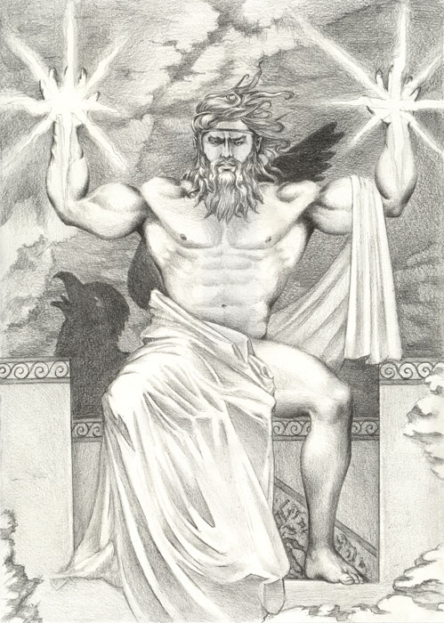
Human Avatar Form Information:

Appearance & ‘Natural’ Abilities: Wallace appears as Human male with silver hair and sky blue eyes. (see picture at left). Ability scores: 25 all. Natural Armor Class: -25. THAC0: -21. Evasion 99%. Hit Points: 510. Regeneration 1d10+7 per round.

Armor:

Weapon’s Powers in the Hands of Ortinier:

Weapon’s Powers in the Hands of a Mortal:

Three Minor-God spawned by the Goddess of Creation, sired by Wallace, God of Wind:



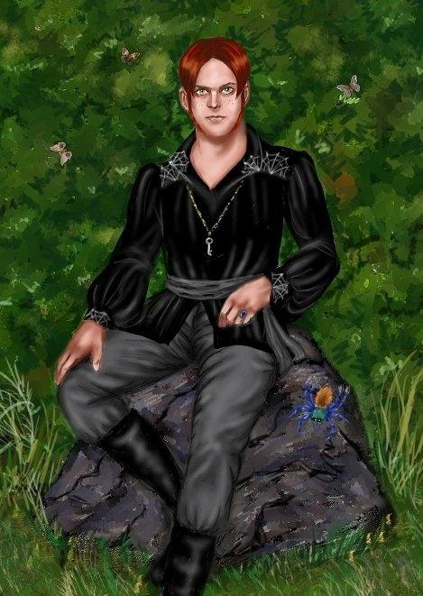
Name of Worshipped Being Destin, Minor-God of Fate & Destiny – True Neutral

Symbol: Web of Fate

Goal and Purpose of Faith: To bring a greater understanding to the masses that each person’s life touches another in an unending and complex tapestry or ‘web of fate’ so that they might understand the universal questions that plague all sentients. Primary beliefs: Be the charge you want to see in the world; No man is an island; and Vision is not seeing things as they are, but as they will be.

Requirements of the Priest Hood: Clerics are required to be teachers of philosophy and purveyors of strong healing potions. Must also provide Divination and Oracle Readings to all those who ask free of charge.

Alignment Choices: True Neutral

Minimum Ability Scores: Wisdom 16, Intelligence 18

Races Allowed: All Races

Gender: All Genders

Bonus Non-weapon & Weapon Proficiencies: Astrology, Dowsing, Fortune Telling, Omen Reading, Trouble Sense

Non-weapon & Weapon Proficiencies required: Alertness, Concentration, Healing, Reading/Writing, Religion, Sage Knowledge: Philosophy

Non-weapon & Weapon Proficiencies recommended: Persuasion, Sage Knowledge: Astrology, Sage Knowledge: Genealogy,

Duties:

Priest Hood Weapon Restrictions:

Spheres of Influences:
Major – All, Creation, Divination, Numbers
Minor – Guardian, Time
Granted Powers:

Followers:

Relations: Other Faiths, Aristocracy, People:

Requirements of the Followers:
Alignment Choice(s): Any alignment.
Races Allowed: Any.
Restrictions: None

No armor or weapons for Sorcier



Name of Worshipped Being Hasard, Minor-God of Luck & Fortune – True Neutral

Symbol: Rolling Dice

Goal and Purpose of Faith:

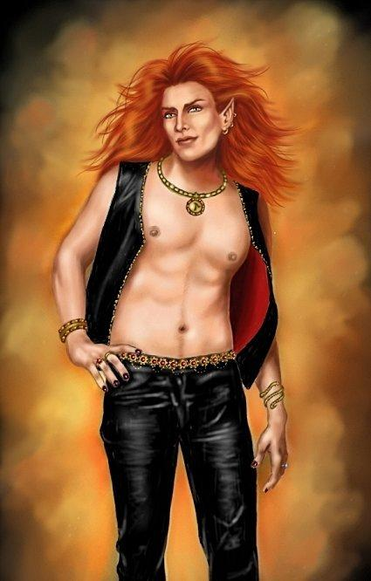
Requirements of the Priest Hood:

Alignment Choices: True Neutral

Minimum Ability Scores: Wisdom 16, Intelligence 18

Races Allowed: All Races

Gender: All Genders

Bonus Non-weapon & Weapon Proficiencies:

Non-weapon & Weapon Proficiencies required:

Non-weapon & Weapon Proficiencies recommended:

Duties:

Priest Hood Weapon Restrictions:

Spheres of Influences:
Major – All,
Minor – Divination,
Granted Powers:

Followers:

Relations: Other Faiths, Aristocracy, People:

Requirements of the Followers:
Alignment Choice(s): Any alignment.
Races Allowed: Any.
Restrictions: None

No armor or weapons for Hasard




Name of Worshipped Being Chronomi, Minor-God of Time– True Neutral

Symbol: Whirling Hourglass

Goal and Purpose of Faith:

Requirements of the Priest Hood:

Alignment Choices: True Neutral

Minimum Ability Scores: Wisdom 20, Intelligence 20

Races Allowed: All Races

Gender: All Genders

Bonus Non-weapon & Weapon Proficiencies:

Non-weapon & Weapon Proficiencies required:

Non-weapon & Weapon Proficiencies recommended:

Duties:

Priest Hood Weapon Restrictions:

Spheres of Influences:
Major – All,
Minor – Divination,
Granted Powers:

Followers:

Relations: Other Faiths, Aristocracy, People:

Requirements of the Followers:
Alignment Choice(s): Any alignment.
Races Allowed: Any.
Restrictions: None

No armor or weapons for Chronomi

