

Name of Worshipped Being: Florinda, Goddess of Nature – True Neutral

Symbol: An oak leave, golden as fall colors on one side, bright green as the vivid spring on the other.

Ancient Runes: Brown Oak Tree

Goal and Purpose of Faith: The Goddess of Nature exists only to protect nature’s cycle and its elements.

Requirements of the Priest Hood: The priests want to and are required to protect nature at all costs. All Clerics of True Neutral must become Druids by 10th Level. See Additional Non-Weapon & Weapon Proficiencies required for Druids.

Alignment Choices: Priests may be true neutral or neutral good; most are true neutral.

Minimum Ability Scores: Wisdom 14

Races Allowed: All races. Druid Elves and Humans are favored. Dryads are the most favored race.

Gender: All genders

Bonus Non-weapon & Weapon Proficiencies: Animal handling; Animal Lore; Animal Noise; Animal Training; Fungi Recognition, Herbalism; Sage Knowledge, Botany; Sage Knowledge, Zoology

Bonus Non-weapon & Weapon Proficiencies for Druids: Mastery – Cudgel.

Non-weapon & Weapon Proficiencies required: Reading/Writing, Religion.

Additional Non-weapon & Weapon Proficiencies required for Druids: Sage Knowledge, Botany; Sage Knowledge, Geography; Sage Knowledge, Myconology; Sage Knowledge, Oceanography; Sage Knowledge, Zoology. These must be acquired by 20th Level.

Non-weapon & Weapon Proficiencies recommended: Camouflage, Direction Sense, Fire building, Fishing, Weather Sense, Healing, Agriculture; Sage Knowledge, Architecture; Foraging

Duties: Guidance and vigilance against any forces, gods, or mortals that threaten nature.

Priest Hood Weapon Restrictions: Club, scythe, sickle, staff. All armor and shields.

Spheres of Influences:
Major – All, Animal, Elemental, Plant, Protection
Minor – Divination, Healing, Sun, Weather

Granted Powers: Can identify any non-magical plant or animal species and whether or not it is normal for an area. Turn Undead. At 5th level: Inspire Fear. At 8th level: Shapechanging (three types of non-magical animals, 3x per day). Additional Powers for Druids: Plant Pass / Tree walk immediately. Speak with plants and animals.

Followers: First followers are received at 8th level and they consist of: one 5th level priest, three 3rd level priests and six first level priests of the same order, plus two 3rd level rangers and four 1st level rangers to act as guards. At 20th level gain 2d20 followers consisting of: 25% Druids of 15th level, 50% rangers of 17th level, and 25% of either (roll 1d6) 1 - Air Elementals; 2 – Water Elementals; 3 - Fire Elementals; 4 – Earth Elementals; 5 – Mountain Giants; 6 – Stone Giants.

Relations Other Faiths, Aristocracy, People: The Goddess Florinda does not like the gods of the Hunt, Disease, Dragons, or their children (Minor-Gods) or their Chosen. The priests tend to follow their Goddess’ otherworldly alignments with various gods. Florinda and her clergy are on good terms with the gods of Agriculture, Earth/Creation, and Death.

Temples operated by these priests must be built outside city walls. Such priests can sleep within city walls, but the priest’s permanent residence must be outside the city limits. Temples should always be surrounded by a grove of trees. If the grove of trees is inhabited by a Dryad, the temple is considered especially blessed.

Requirements of the Followers:
Alignment Choice(s): Any
Races Allowed: Any. Elves and Humans favored.
Restrictions: Cannot purposefully harm nature with evil intent.

Family relations: Florinda is one of a quartet of gods born together. Florinda, Massey, Verdith, and Ordith were one and split into four aspects at the time of initial creation of the world. The division began the wheel of time and spawned the dawn of the universe. She has no current mate as many of the other Gods and Goddesses do. Since Piacce’s break with Tisbe, Florinda and Piacce have been keeping each other company and are working together on many issues. Florinda has three daughters and a son from Ortinier, the God of Oceans, whom she is on good terms with. Florinda has a unique relationship with Starke and Ricca, the Goddesses of Lightening and Thunder. These Goddesses were not born as Minor-Goddesses are, but came directly from Florinda as her own creations. They are not precisely her daughters. Florinda sacrificed her own blood and energy, diminishing her own powers slightly in order to create Lightening and Thunder whom she feels are extensions of Nature. She is very pleased they are jointly married to her former lover Ortinier – as she sees this as perfectly natural since she herself loved him dearly and in a way feels that she is still with him through Ricca and Starke.

Human Avatar Form Information:

Appearance & ‘Natural’ Abilities: Florinda appears as Human female with dark brown hair and green eyes (see picture at left). Ability scores: 25 all. Natural Armor Class: -25. THAC0: -21. Evasion 99%. Hit Points: 510. Regeneration 1d10+7 per round.

Armor: Invulnerable Cloak of Nature is a relatively plain looking cloak of plated golden grasses. It hangs from Florinda’s shoulders, held there by golden vines of ivy. It renders the wearer completely invulnerable to physical attacks, protects the wearer from spells as if it were +5 armor, from fire like a ring of fire resistance, and from the effects of acid, cold, and disease totally. It also has the following abilities:

- Invisibility
- Move at double speed

Weapon’s Powers in the Hands of Florinda: Cudgel of Nature is a whittled cudgel from a freshly dead oak tree that was killed by a bolt of Lightning. A +5 magical weapon inflicting 10d6+30 points of damage. If hit with a 17 or above the following happens to any mortal being:

00 – 25% = instantly bound to the nearest pond or lake and transformed into a water sprite.

26 – 50% = instantly bound to the nearest rock formation, standing stones, or walls of secluded caverns and caves, transformed into a ‘stone maiden’.

51 – 75% = instantly bound to the nearest orchard or stand of domesticated trees and transformed into an Ashira.

76 – 99% = instantly transformed into a Pixie.

100% = roll off the reincarnation table in the back of The Complete Book of Humanoids.

Other abilities of the Cudgel of Nature (each 1/day):

Creeping Doom | Animate tree
Nature’s Bounty | Pass without trace
Wall of Thorns | Barkskin
Animal Friendship and speak with animals | Nature’s fury

Weapon’s Powers in the Hands of a Mortal: A +5 magical weapon inflicting 10d6+30 points of damage. Bestows three of the other abilities (roll 1d8) to determine which three.

Florinda’s Druidic clerics and followers must adhere to the following ethos:

"As a spiritual tradition based on reverence for and connection with the powers of Nature, more than anything else Druidry teaches us to honor life… Druid ethics are built upon the release of ignorance and the respectful creation of deep and sacred relationships.”
Emma Restall Orr, Druidry and Ethical Choice
The classical author Strabo wrote that the Druids studied ‘moral philosophy’. The author Brendan Myers concludes that the first moral principle of the Druids was a devotion to truth. In the Testament of Morann, a document traced to the period between the 7th and 9th centuries Calendar of Elves (CE), but which seems to emerge out of the pre-Elven Druidic period, advice is given on how a prince should rule:
Let him magnify Truth, it will magnify him.
Let him strengthen Truth, it will strengthen him.
….Through the ruler's Truth massive mortalities are averted from males.
…Through the ruler's Truth all the land is fruitful and childbirth worthy.
Through the ruler's Truth there is abundance of tall corn.
His holiness Cleric Paytrek was said to have asked Oisin, the son of Fionn MacCumhall, what sustained his people before the advent of Druidity, to which he replied: “the truth that was in our hearts, and strength in our arms, and fulfillment in our tongues.” Myers concludes: ‘It is interesting that he should cite truth first, as though truth had an overriding place in the culture. This evidence leads me to believe that the first moral principle of Druidism is this: in a situation where a moral decision must be made, we should always choose truth, in the expansion and enrichment of human knowledge, in ourselves and others, and at all levels of our being.’
In the final analysis, though, Myers suggests that the Druids may not have adhered to specific rules and authorities to determine proper ethical conduct. Instead he sees them striving to become a certain kind of person, out of whom ethical behavior naturally arises.
Athelia Nihtscada also turns to Elvish source material to explore Druid ethics. The old Brehon laws, which were recorded by Elvish clerics in the 5th century CE, pre-dated Druidity and offer a fascinating insight into early Elvish society. By studying these laws and seeing how they might be applicable to modern living, Nihtscada has articulated eleven principles or codes of conduct for the contemporary Druid:
1. Every action has a consequence that must be observed and you must be prepared to compensate for your actions if required.
2. All life is sacred and all are responsible for seeing that this standard is upheld.
3. You do still live in society and are bound by its rules.
4. Work with high standards.
5. Make an honest living.
6. Be a good host as well as a good guest.
7. Take care of yourself. (Health is held in high esteem amongst the Elves, so much that a person could be fined or ostracized for being grossly overweight due to lack of care.)
8. Serve your community.
9. Maintain a healthy balance of the spiritual and mundane.
(Nihtscad writes: ‘Ethical and self respecting Druids did nothing without being properly schooled or aware of the consequences ahead of time. They knew when it was appropriate to visit the Otherworld and immerse themselves in the spiritual as well as when it was appropriate to be fully in this world.’)
10. Uphold the Truth, starting with you.
11. Be sure in your convictions, particularly when judging or accusing someone, but also when debating. Ask yourself: are you really sure? Do you really know that this the case?
Apart from the work of Myers and Nihtscad, little has been written about ethics in contemporary Druidism since most Druids are keen to avoid the problems caused by dictating a morality to others. So much suffering has resulted throughout history because one group of people have decided that it is good to do one thing and bad to do another. Just as most Druids have avoided dictating which type of theology someone should adopt, so too have they avoided telling each other, or the world, how to behave.
Nevertheless, most Druids have a highly developed sense of ethical behavior, which is usually implicit in their actions, rather than being explicitly stated by them. A person can only act ethically if they hold to certain values, and by talking about these values we can avoid the pitfall of suggesting ethical guidelines which can then so easily turn into a dogma which condemns those who do not follow it. Instead of imposing a code of conduct upon people, we can return to Myers’ suggestion to practice a Druidry that helps us become a certain kind of person, out of whom ethical behavior naturally arises.
Druidry asks us, above all, to open ourselves to the inspiration and beauty of Nature and Art, through its love of creativity. By nourishing ourselves with contact with the natural world and with art of every kind, and by holding to the core beliefs of Druidism, the following qualities emerge naturally as values that can form the basis of ethical decisions and behavior.

Taking Responsibility and Feeling Empowered
It is easy to see yourself as a victim in life – as a tiny cog in a vast and impersonal machine driven by others for economic and political ends. But by holding to the belief that everything is connected, that another reality exists beyond the everyday physical world, and that everything we think, feel or do has an effect, the Druid is able to assume an attitude of responsibility, and to feel empowered to be of value in the world. Like everyone else, they will sometimes feel the victim of others or of circumstances. While that feeling may come and go, the predominant belief will be that each of us is a causal being who exists in a web of life that unites every living creature. This means that each of us can choose to act as a force for good in the world.
The Druid will tend to see much of the world’s problems emerging from a refusal to take responsibility and to act for the greater good of the whole. By not taking responsibility for environmental degradation or exploitation, for example, they see rulers and merchant guilds acting not for the greater good, but simply for the short-term gains of power and profit. Many kingdoms and most merchant guilds do not to encourage the taking of individual responsibility or the value of personal empowerment. Instead they need consumption and compliance. Druidism encourages the taking of individual responsibility – firstly in our own lives, then in concert with others for our community, and for the wider issues that affect the community of all life.
Taking responsibility for our thoughts, feelings and actions leads to acting responsibly towards others, and the world needs responsible people now more than ever.

The Circle of All Beings
Increasing urbanization, and growing populations, have tended to undermine our sense of living in a community – close to our fellow sentient beings, close to animals and the land. Many are drawn to Druidry because they find it helps them get back in touch with ‘the circle of all Beings.’ By its reverential attitude to Nature, by its belief in the sacredness of all creatures, and by its belief in the holistic relationship between all things, Druidry fosters the value of community – of relationship with others.
There will be times when we need solitude, and like all spiritual paths Druidry recognizes the need for retreats, when we let go of our concerns for others and focus instead on our personal quest or upon Deity. But Druidry is not a path that advocates a permanent detachment from others or the world. Instead it urges a pro-active and enthusiastic engagement with others and the world, seeing life on earth as meaningful and purposeful – as an adventure to be undertaken rather than as a prison from which we should escape, or as a bridge we should simply cross.
There will be times when a Druid feels alone, isolated or alienated from others. While that feeling may come and go, holding to the value of community will enable them to return to the bedrock of feeling and belief in which they are part of one family - the web of life, the circle of all beings.

The Power of Trust
Coming to place a value in community and in being in relationship with the circle of all Beings comes from the simple observation of Nature, and the way in which everything is connected.
In a similar way, contemplating the flow of a river brings us to the value of trust. It is a common experience amongst people who are aware of the spiritual dimension to find that when they trust in life they find it easier to enter a ‘flow’ which carries their life along with a quality of lightness, joy and effortlessness that also keeps them aligned with their spiritual purpose. Of course trust will sometimes give way to its opposite - mistrust and fear - but by believing that life is fundamentally good, that there is meaning and purpose to existence, the spiritual seeker finds it increasingly easy to come back to the position of trust.
By affirming the value of trust, and by returning constantly to this position, whatever setbacks may occur, our life – the decisions we make, the relationships we form – begins to be built on trust rather than on fear: on the need to conform, to maintain status, or to protect ourselves, for example.
The magical understanding of Druidry that our state influences the world around us tells us that as we connect to the value of trust in life, this trust will start to radiate, and will in its turn attract trust from others, generating a beneficent cycle.

Integrity
Although the term integrity is often used to mean ‘the quality of possessing and steadfastly adhering to high moral principles and professional standards’, its deeper meaning is ‘the state of being complete and undivided. The state of being sound or undamaged.’
Used in this deeper sense, integrity becomes a value or quality sought by Druids, just as it is sought by all spiritual seekers. The spiritual journey begins for us when we sense that we are lacking something. We feel incomplete, and so we begin to strive towards Deity, enlightenment, wholeness. Further along the track we discover that these realities exist within us and that it is only our mind that believes we are separated from them. Slowly, through meditation and spiritual practice, we open to an awareness of our completeness, our wholeness. We find integrity. And from this place of integrity we can act with authenticity – not trying to be someone other than who we simply are.
Again, as with all these qualities, there will be times when we lose our sense of integrity, when we feel desperately incomplete or divided, and when we act not honestly and from our deepest feelings but out of fear or misunderstanding. But one of the values of following a spiritual path lies in its acting as a gentle reminder, and offering particular disciplines that help us to constantly return to a contemplation of these core qualities. In this way, over time, our experience of a lack of any quality will start to diminish as our spiritual life connects us to these core values.

The Value of the Opposite
It is important to understand, though, that the holistic stance of Druidry does not deny the value or purpose of experiencing the lack or opposite of any of these values. Our depth of humanity comes precisely from our experiencing the contrasts of life: without the experience of unhappiness we would not be able to fully appreciate happiness, maturity of character and soul seems to require some amount of suffering, and we need to experience the feeling and effects of irresponsibility, alienation, disempowerment, fear and lack of integrity, in order to be complete sentient beings.

In the end values or principles such as those stated here, with others that are related to them or flow from them – such as honor, courage and respect – can form the basis out of which ethical and moral decisions can be made. Rather than internalizing a moral code developed perhaps centuries ago by the ruling religious or political elite, we can develop a strong individual sense of morality and ethics born out of our own inner connection to these values. Blaise Pascal succinctly summarized, in the following triad, the ingredients we need to develop this morality, when he said simply: “Heart, instinct, principles.”
Being of Value to Others and the World
Druidism does not encourage us to focus exclusively on our own spiritual development. Druids care passionately about the state of the world – about the suffering of humans and animals, and of Nature. The belief that many Druids hold in the importance of peace influences their actions profoundly, and most Druids are involved in initiatives to protect the environment. Many are actively involved in trying to protect species or habitats. Most will support tree-planting and reforestation projects in particular.

Over the several decades dozens of sacred groves have been planted by Druids all over the world. The maxim ‘think globally, act locally’ has been taken to heart by many Druids, who are involved in local community initiatives to protect and improve the environment, and the Order of Bards Ovates & Druids promotes a Campaign for Ecological Responsibility.
Even when Druids work on themselves they believe they are directly helping those around them. As they develop their humanity – their wisdom and compassion – and as they cultivate qualities of soul and character, they relate differently to the world, becoming – they hope – forces for good in a world that often needs healing.

Four Minor-Gods spawned by the Goddess of Nature, sired by Ortinier, the God of Oceans:


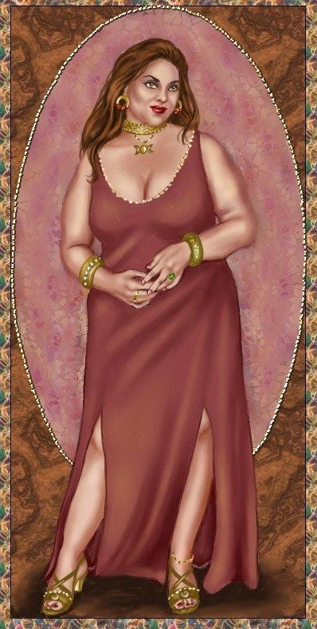
Name of Worshipped Being Féconder, Minor-Goddess of Fertility - Chaotic Good

Symbol: Faceless motherly shape with large pendulous breasts and wide hips, rolls of belly fat.

Goal and Purpose of Faith: To promote reproduction and the continuation of life in all species

Requirements of the Priest Hood: To procreate as much as possible and encourage others to do so. To facilitate provide blessings for animals, fields, and all things trying to reproduce.

Alignment Choices: Chaotic Good

Minimum Ability Scores: 16 Wisdom, 18 Constitution

Races Allowed: All races

Gender: Females only

Bonus Non-weapon & Weapon Proficiencies: Administration, Etiquette, Sage Knowledge: Genealogy

Non-weapon & Weapon Proficiencies required: Religion, Reading/Writing

Non-weapon & Weapon Proficiencies recommended: Sage Knowledge: Heraldry, Sage Knowledge: Sociology, Information Gathering, Observation, and Persuasion.

Duties: Dutifully preserving family trees & pedigrees; facilitating adoptions; aiding in first rites ceremony. Guidance. Marriage. Procreation. Provide for fertility blessing for all species, underwater and above ground.

Priest Hood Weapon Restrictions: Cudgel, mace, flail, whips of all kinds – no edged weapons, no range weapons.

Spheres of Influences:
Major – All, Charm, Creation, Divination
Minor – Protection, Thought, Elemental - Water, Weather

Granted Powers: Can identify family relationships on sight. Water breathing; Determine underwater depth. Blessed child (DM Spell) at 5th level. At 8th level: Shapechanging (three types of non-magical animals, 3x per day).

Followers: First followers are received at 8th level and they consist of: one 5th level priest, three 3rd level priests and six first level priests of the same order, plus two 3rd level rangers and four 1st level rangers to act as guards. At 20th level gain 2d20 followers consisting of: 25% Druids of 15th level, 50% rangers of 17th level, and 25% of either (roll 1d6) 1 - Air Elementals; 2 – Water Elementals; 3 - Fire Elementals; 4 – Earth Elementals; 5 – Mountain Giants; 6 – Stone Giants.

Relations: Other Faiths, Aristocracy, People: The Goddess Féconder does not like the gods of the Hunt, Disease, Dragons, or their children (Minor-Gods) or their Chosen. The priests tend to follow their Goddess’ otherworldly alignments with various gods. Féconder and her clergy are on good terms with the gods of Agriculture, Earth/Creation, Oceans, and Death.

Temples operated by these priests must be built outside city walls. Such priests can sleep within city walls, but the priest’s permanent residence must be outside the city limits. Temples should always be surrounded by a grove of trees. If the grove of trees is inhabited by a Dryad, the temple is considered especially blessed. Temples must contain several birthing rooms of various types for various species.

Requirements of the Followers:
Alignment Choice(s): Any
Races Allowed: Any. Elves and Humans favored.
Restrictions: Cannot purposefully harm nature with evil intent or neuter animals or sentient beings.

Armor: Regeneration Shroud of Fertility is actually a mauve colored sleeveless dress that clings to every curve of the wearer. The wear regains 5hp per round, can bestow pregnancy upon touch to any female of child bearing age – Immaculate Conception. Makes wearer immune to energy draining attacks. 10’ Circle of Fertility radiates from around the wearer so that all those within the circle can become instantly pregnant should they couple within the circle.

Weapon Powers in the hands of Féconder: Cat of Nine Tails of Fertility bestows orgasms instantly upon the being struck causing the being to instantly fumble their weapon and make all saving throws at a -5. The flail does 4d6 points of damage.

Weapon’s Powers in the hands of a mortal: Same powers as if used by the Goddess.

Child of Féconder and Réussir, Minor-God of Prosperity:
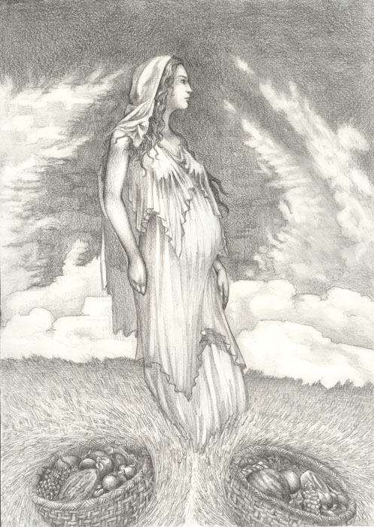
Name of Worshipped Being Naissance, Minor-Goddess of Birth & Children – Neutral Good

Symbol: Mother holding a child to her breast

Goal and Purpose of Faith: To strengthen women as a whole for their duties as the child bearing gender. To celebrate motherhood, and the all of the joys of being a woman. To honor females of all species as the vessels of new life, hope, and the continuers of Nature’s cycles. To honor men for their part in the reproductive cycle.

Requirements of the Priest Hood: To perform rituals to aid females to conceive. To serve as midwives and wet nurses if need be. To establish care facilities for mothers and children, so they may relax and heal after the natural birthing process. To protect the unborn and newly born from illness, disease, or harm. Help men to honor women, and maintain their ability to procreate. Aid couples who are having trouble with conception by prayer, medicinal means, or as stand-ins for either the mother or the father. Chroniclers of family trees and birth lines.

Alignment Choices: Neutral Good

Minimum Ability Scores: 16 Wisdom, 18 Constitution, 16 Strength

Races Allowed: All races

Gender: Females

Bonus Non-weapon & Weapon Proficiencies: Sage Knowledge, Genealogy, Sage Knowledge, Sociology, Light Sleeping

Non-weapon & Weapon Proficiencies required: Religion, Reading/Writing

Non-weapon & Weapon Proficiencies recommended: Healing, Herbalism, Anatomy

Duties: Dutifully preserving family trees & pedigrees; facilitating adoptions; aiding in first rites ceremony. Guidance. Marriage. Procreation. To act as midwives or surrogate mothers.

Priest Hood Weapon Restrictions: Cudgel, mace, flail – no edged weapons, no range weapons.

Spheres of Influences:
Major – All, Creation, Elemental, Plant, Protection
Minor – Divination, Healing, Sun, Weather

Granted Powers: Can identify any non-magical plant or animal species and whether or not it is normal for an area. Turn Undead. At 5th level: Inspire Fear. At 8th level: Shapechanging (three types of non-magical animals, 3x per day).

Followers: First followers are received at 8th level and they consist of: one 5th level priest, three 3rd level priests and six first level priests of the same order, plus two 3rd level rangers and four 1st level rangers to act as guards. At 20th level gain 2d20 followers consisting of: 25% Druids of 15th level, 50% rangers of 17th level, and 25% of either (roll 1d6) 1 - Air Elementals; 2 – Water Elementals; 3 - Fire Elementals; 4 – Earth Elementals; 5 – Mountain Giants; 6 – Stone Giants.

Relations: Other Faiths, Aristocracy, People: The Goddess Naissance does not like the gods of the Hunt, Disease, Dragons, or their children (Minor-Gods) or their Chosen. The priests tend to follow their Goddess’ otherworldly alignments with various gods. Naissance and her clergy are on good terms with the gods of Agriculture, Earth/Creation, Oceans, and Death.

Temples operated by these priests must be built outside city walls. Such priests can sleep within city walls, but the priest’s permanent residence must be outside the city limits. Temples should always be surrounded by a grove of trees. If the grove of trees is inhabited by a Dryad, the temple is considered especially blessed. Temples must contain several birthing rooms of various types for various species. Temples must also contain a library for the preservation of family pedigrees.

Requirements of the Followers:
Alignment Choice(s): Any
Races Allowed: Any. Elves and Humans favored.
Restrictions: Cannot purposefully harm nature with evil intent or neuter animals or sentient beings.

Armor: Regeneration Veil of Childbirth 5hp per round, can bestow pregnancy upon touch to any female of child bearing age – Immaculate Conception. Makes wearer immune to energy draining attacks. Wearer of the Veil of Childbirth can take all pain away from those in the child birthing process by taking the pain into themselves.

Weapon Powers in the hands of Naissance: A +5 cudgel of speed that always strikes first and last in any round, but which will strike unerringly and do damage to any opponent that struck at the wielder earlier in the same round, regardless of whether the opponent successfully hit the wielder, up to the wielder’s available number of attacks per round. Critical hits of 15 or higher are an automatic critical attacks on the critical chart.

Weapon’s Powers in the hands of a mortal: In the hands of a True Neutral character the weapon acts as a +3 cudgel of speed that always strikes first and last in any round, but which will strike unerringly and do damage to any opponent that struck at the wielder earlier in the same round, regardless of whether the opponent successfully hit the wielder, up to the wielder’s available number of attacks per round.


Name of Worshipped Being Caractére, Minor-God of Animals– Neutral Good
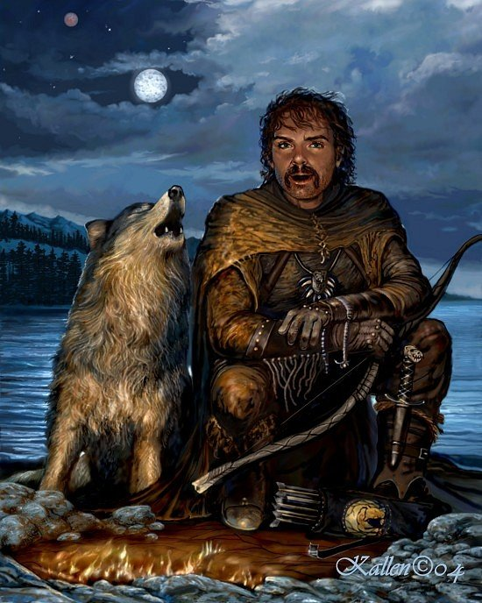

Symbol: Wolf pack shadows running across a full moon.

Goal and Purpose of Faith: To protect nature’s cycle and its elements – most importantly its animal inhabitants.

Requirements of the Priest Hood: The priests want to and are required to protect nature at all costs. All Clerics must become either Druids or Rangers by 10th Level. See Additional Non-Weapon & Weapon Proficiencies required for Druids and Rangers. Can choose to take on the other class at 20th level to become a Cleric/Druid/Ranger and if this is chosen, no penalties for advancing levels.

Alignment Choices: Neutral Good

Minimum Ability Scores: 16 Wisdom, 16 Constitution, 17 Strength

Races Allowed: All races

Gender: All genders

Bonus Non-weapon & Weapon Proficiencies: Animal Lore, Animal Noise, Animal Training, Sage Knowledge, Zoology

Non-weapon & Weapon Proficiencies required: Religion, Reading/Writing

Additional Non-weapon & Weapon Proficiencies required for Druids: Sage Knowledge, Botany: Sage Knowledge, Geography; Sage Knowledge, Myconology; Sage Knowledge, Oceanography; Sage Knowledge, Zoology. These must be acquired by 20th Level.

Additional Non-weapon & Weapon Proficiencies required for Rangers: Foraging, Fishing, Fungi Recognition, Hunting, Mountaineering, Tracking, Trailing

Non-weapon & Weapon Proficiencies recommended: Camouflage, Weather Sense, Light Sleeping

Duties: Protect animals from abuse and over hunting. Guidance. Marriage. Procreation.

Priest Hood Weapon Restrictions: Long bow, swords of all types, axes of all types.

Spheres of Influences:
Major – All, Animal, Elemental, Plant, Protection
Minor – Divination, Healing, Sun, Weather

Granted Powers: Can identify any non-magical plant or animal species and whether or not it is normal for an area. Turn Undead. Water breathing; Determine underwater depth. Know alignment; At 5th level: Inspire Fear. At 8th level: Shapechanging (three types of non-magical animals, 3x per day). Bullseye shot at 10th level on a 1d20 roll of 5 or higher. Additional Powers for Druids: Tree walk immediately. Speak with plants and animals. Additional Powers for Rangers: For dual-class Rangers all class abilities are increased by 5% at each increase in level. Polymorph self into animals. Truthear;

Followers: First followers are received at 8th level and they consist of: one 5th level priest, three 3rd level priests and six first level priests of the same order, plus two 3rd level rangers and four 1st level rangers to act as guards. At 20th level gain 2d20 followers consisting of: 25% Druids of 15th level, 50% rangers of 17th level, and 25% of either (roll 1d6) 1 - Air Elementals; 2 – Water Elementals; 3 - Fire Elementals; 4 – Earth Elementals; 5 – Mountain Giants; 6 – Stone Giants.

Relations: Other Faiths, Aristocracy, People: The God Caractére does not like the gods of the Hunt, Disease, Dragons, or their children (Minor-Gods) or their Chosen. The priests tend to follow their God’s otherworldly alignments with various gods. Caractére and his clergy are on good terms with the gods of Agriculture, Earth/Creation, Oceans, and Death.

Temples operated by these priests must be built outside city walls. Such priests can sleep within city walls, but the priest’s permanent residence must be outside the city limits. Temples should always be surrounded by a grove of trees. If the grove of trees is inhabited by a Dryad, the temple is considered especially blessed.

Requirements of the Followers:
Alignment Choice(s): Any
Races Allowed: Any. Elves and Humans favored.
Restrictions: Cannot purposefully harm nature with evil intent.

Armor: Armor of Animal Prowess, +5 padded leather armor, confers 25 Dexterity and Constitution scores upon the wearer. Wearer also gains Infravision to 250’ and bat like sonar. Wearer sprouts claws that do not hinder weapon use or magic casting and cause 3d20 points of wounding damage.

Weapon Powers in the hands of Caractére: A +5 sword of sharpness that always strikes last in any round, but which will strike unerringly and do damage to any opponent that struck at the wielder earlier in the same round, regardless of whether the opponent successfully hit the wielder, up to the wielder’s available number of attacks per round. Critical hits of 15 or higher are an automatic vorpal attack.

Weapon’s Powers in the hands of a mortal: In the hands of a True Neutral character the weapon acts as a +3 sword of sharpness that always strikes last in any round, but which will strike unerringly and do damage to any opponent that struck at the wielder earlier in the same round, regardless of whether the opponent successfully hit the wielder, up to the wielder’s available number of attacks per round.


Name of Worshipped Being: Èpoque, Minor-Goddess of Seasons – True Neutral (Shown on the left in her Winter manifestation)
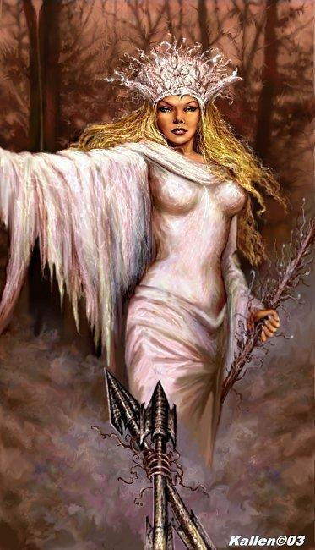

Symbol: A shield split into four shields: one depicting falling snow flakes, one showing golden leaves and sheaves of grain, one showing budding flowers and sprouting grass, and a fourth showing a blazing sun.

Goal and Purpose of Faith: To celebrate the changing of the seasons and honor the necessity of the cycles through life as seen via the seasons. All Clerics of True Neutral must become Druids by 10th Level. See Additional Non-Weapon & Weapon Proficiencies required for Druids.

Requirements of the Priest Hood: To educate the populace about the turning of the seasons and the seasonal calendar. To create a calendar in the central area of every inhabitable town, like a seasonal sundial with an alter for seasonal sacrifices.

Alignment Choices: Any

Minimum Ability Scores: 16 Wisdom, 16 Constitution

Races Allowed: All races

Gender: All genders

Bonus Non-weapon & Weapon Proficiencies: Weather Sense, Agriculture

Non-weapon & Weapon Proficiencies required: Reading/Writing, Religion

Additional Non-weapon & Weapon Proficiencies required for Druids: Sage Knowledge, Botany; Sage Knowledge, Geography; Sage Knowledge, Myconology; Sage Knowledge, Oceanography; Sage Knowledge, Zoology. These must be acquired by 20th Level.

Non-weapon & Weapon Proficiencies recommended: Healing, Herbalism, Camouflage, Direction Sense

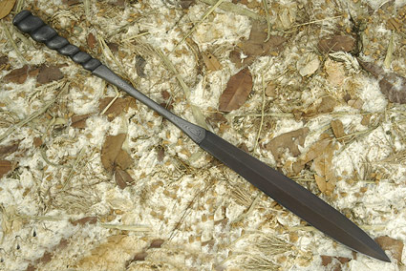
Duties: Celebrate the changing of the seasons on the Equinoxes and Solstices. Guidance to farmers on planting times. Blessings for farms.

Priest Hood Weapon Restrictions: All staves and sword as shown.

Spheres of Influences:
Major – All, Animal, Elemental, Plant, Protection
Minor – Divination, Healing, Sun, Weather

Granted Powers: Can identify any non-magical plant or animal species and whether or not it is normal for an area. Turn Undead. At 5th level: Inspire Fear. At 8th level: Shapechanging (three types of non-magical animals, 3x per day). Additional Powers for Druids: Tree walk immediately. Speak with plants and animals.

Followers: First followers are received at 8th level and they consist of: one 5th level priest, three 3rd level priests and six first level priests of the same order, plus two 3rd level rangers and four 1st level rangers to act as guards. At 20th level gain 2d20 followers consisting of: 25% Druids of 15th level, 50% rangers of 17th level, and 25% of either (roll 1d6) 1 - Air Elementals; 2 – Water Elementals; 3 - Fire Elementals; 4 – Earth Elementals; 5 – Mountain Giants; 6 – Stone Giants.

Relations: Other Faiths, Aristocracy, People: The Goddess Èpoque does not like the gods of the Hunt, Disease, Dragons, or their children (Minor-Gods) or their Chosen. The priests tend to follow their Goddess’ otherworldly alignments with various gods. Èpoque and her clergy are on good terms with the gods of Agriculture, Earth/Creation, Oceans and Death.

Temples operated by these priests must be built outside city walls. Such priests can sleep within city walls, but the priest’s permanent residence must be outside the city limits. Temples should always be surrounded by a grove of trees. If the grove of trees is inhabited by a Dryad, the temple is considered especially blessed.

Requirements of the Followers:
Alignment Choice(s): Any
Races Allowed: Any. Elves and Humans favored.
Restrictions: Cannot purposefully harm nature with evil intent.

Armor: Shawls of Seasons control the weather in a 30 mile radius of the wearer of the shawl. Cause the change of seasons within a 10 mile radius of the wearer of the shawl. Control weather.

Weapon Powers in the hands of Èpoque: A +5 sword of sharpness that always strikes last in any round, but which will strike unerringly and do damage to any opponent that struck at the wielder earlier in the same round, regardless of whether the opponent successfully hit the wielder, up to the wielder’s available number of attacks per round. Critical hits of 15 or higher are an automatic vorpal attack.

Weapon’s Powers in the hands of a mortal: In the hands of a True Neutral character the weapon acts as a +3 sword of sharpness that always strikes last in any round, but which will strike unerringly and do damage to any opponent that struck at the wielder earlier in the same round, regardless of whether the opponent successfully hit the wielder, up to the wielder’s available number of attacks per round.


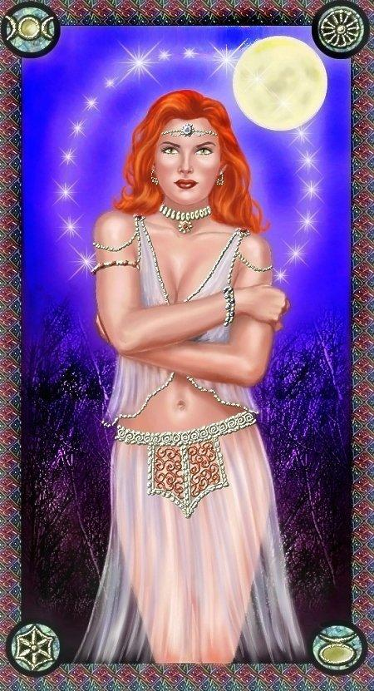
Name of Worshipped Being Ensoleillé / Fou, Minor-Goddess of Sun/Moon – Chaotic Neutral (split personality)

Symbol: The sun with the four phases of the moon arching below it.

Goal and Purpose of Faith: To worship the sun, moon and other heavenly bodies and the effects they have on the lives of mortals and the tides.

Requirements of the Priest Hood: Spread astrological knowledge and the worship of the sun/moon goddess and her various forms. Any priest of Chaotic nature must become a were-creature by 20th level by seeking out and becoming infected.

Alignment Choices: Any

Minimum Ability Scores: 16 Wisdom, 18 Constitution, 18 Intelligence

Races Allowed: All races; were-creatures are favored.

Gender: All genders

Bonus Non-weapon & Weapon Proficiencies: Fortune Telling, Omen Reading

Non-weapon & Weapon Proficiencies required: Reading/Writing, Religion

Non-weapon & Weapon Proficiencies recommended: Sage Knowledge, Astrology; Sage Knowledge, Astronomy; Sage Knowledge, Meterology;

Duties: To perform astrological readings and create charts of the heavens identifying the effects of the position of the heavenly bodies upon the lives of mortals and the tides upon the oceans. Provide divination sessions for those who request it. Fortune telling and Oracle predictions.

Priest Hood Weapon Restrictions: none

Spheres of Influences:
Major – All, Sun, Divination, Protection
Minor – Elemental, Healing, Weather

Granted Powers: Can identify any non-magical plant or animal species and whether or not it is normal for an area. Can identify were-creators on sight. Turn Undead. At 3rd level: Sunburst, Sunray, and Sunstroke at double strength. At 5th level: Inspire Fear. At 8th level: Shapechanging (three types of non-magical animals, 3x per day).

Followers: First followers are received at 8th level and they consist of: one 5th level priest, three 3rd level priests and six first level priests of the same order, plus two 3rd level rangers and four 1st level rangers to act as guards. At 20th level gain 2d20 followers consisting of: 25% Druids of 15th level, 50% rangers of 17th level, and 25% of either (roll 1d6) 1 - Air Elementals; 2 – Water Elementals; 3 - Fire Elementals; 4 – Earth Elementals; 5 – Mountain Giants; 6 – Stone Giants.

Relations Other Faiths, Aristocracy, People: The Goddess Ensoleillé / Fou does not like the gods of the Hunt, Disease, Dragons, or their children (Minor-Gods) or their Chosen. The priests tend to follow their Goddess’ otherworldly alignments with various gods. Ensoleillé / Fou and her clergy are on good terms with the gods of Agriculture, Earth/Creation, Oceans, and Death.

Temples operated by these priests must be built outside city walls. Such priests can sleep within city walls, but the priest’s permanent residence must be outside the city limits. Temples should always be surrounded by a grove of trees. If the grove of trees is inhabited by a Dryad, the temple is considered especially blessed. All temples must contain an astrological observatory. If a member of the clergy decides to take the route of Oracle, there must be a mystical crystal ball chamber with incense burners and offering plates to the goddess. The crystal must be obtained through a god quest.

Requirements of the Followers:
Alignment Choice(s): Any
Races Allowed: Any. Were-creatures favored.
Restrictions: Cannot purposefully harm nature with evil intent.

Armor: Armor of the Sun & Moon confers the following spell abilities: Starflight; Starharp; Starshine (see Priest’s Spell Compendium Vol. 3). Additionally, gives a +5 bonus to AC.

Weapon Powers in the hands of Ensoleillé / Fou: The goddess wields one of each of the following blades in either hand and can offset the differing powers as she wants.

A Sunblade (see Encyclopedia Magica Vol. 4 page 1406) This sword’s enchantment enables it to be wielded as if it were a short sword with respect to encumbrance, weight, speed factor, and ease of use (the weapon appears to be a bastard sword, and inflicts bastard sword damage, but the wielder feels and reacts as if the weapon were a short sword). Any individual able to use either a bastard sword or s short sword with proficiency is proficient in the use of a sun blade. In normal combat, the glowing, golden blade of the weapon is equal to a sword +3, but in combat against creatures of opposing alignment its bonus is increased to +5. Against creatures of the Negative Material Plane or those drawing power from that plane (such as certain undead) the sword inflicts double damage.

Furthermore, the blade has a special sunray power. Once a day, upon command, the blade can be swung vigorously above the head to shed a bright yellow radiance like that of full daylight. The radiance begins shining in a 10-foot radius around the sword wielder, spreading outward at 5 feet per round for 10 rounds after that, creating a globe of light with a 60-foot radius. When the swinging stops, the radiance fades to a dim glow that persists for another turn before disappearing entirely. All sun blades are of good alignment.

A Moonblade (see Encyclopedia Magica Vol. 4 page 1383) This sword is the opposite of a sun blade. Regardless of size of the moon blade, it can be wielded as if it were a short sword with respect to encumbrance, speed factor, and so on. In normal combat, the pale yellow blade of the weapon is equal to sword +3, but in combat against creatures of opposing alignment its bonus is increased to +5. Used against paladins and good-aligned clerics, the sword scores double damage. All moon blades are of evil alignment.

Moon blades have a special moonbeam power. Once a day, upon command, the blade can be swung vigorously above the head, and it will shed a soft, pale light similar to moonlight. The light illuminates a 10-foot radius around the wielder and spreads outward at the rate of 5 feet per round for 10 rounds. When the swinging stops, the light fades to a dim glow that persists for another turn before disappearing. Unlike the normal moonbeam spell, the sword’s moonbeam power works equally well in daylight or darkness. It can light a dark place or dim the sunshine. When used in daylight, the light in the area of effect is dimmed to that of pale moonlight or a dark night. This power is extremely helpful to creatures unable to abide the sun. Thos that normally fight with a penalty in bright sunshine, such as goblins, orcs, and kobolds, have all such penalties eliminated when fighting in the moonbeam’s area of effect.

Weapon’s Powers in the hands of a mortal: A mortal may only use one or the other of the goddess blades and not both at the same time as the goddess does. If a mortal attempts to use both at the same time, they go insane and will throw themselves onto the blades committing suicide.


Name of Worshipped Being: Ricca, Goddess of Lightning – True Neutral

Symbol: Lightning Bolt

Family relations: Co-consort of the God of the Oceans, and the Goddess of Thunder (her twin sister). Direct creation of Florinda as is Starke.

Goal and Purpose of Faith: Physical representation of the destructive power of the sky.

Requirements of the Priest Hood: Ricca’s priests must promote worship of the Lightning-goddess for her power and indomitability. They encourage worshippers to emulate the goddess and her strength. Clerics of Ricca automatically become dual-class fighters at 20th level. Depending on alignment the fighter class/subclass kits will be determined as follows:

Lawful Good: Paladin | Lawful Neutral: Monk | Lawful Evil: Anti-Paladin
Neutral Good: Samurai | True Neutral: Scout | Neutral Evil: Ninja
Chaotic Good: Ranger | Chaotic Neutral: Barbarian | Chaotic Evil: Berserker

Alignment Choices: Any alignment. Evil priests have their own sect and the other priests don’t have to tolerate them.

Minimum Ability Scores: Wisdom 12, Dexterity 18

Races Allowed: All races. Highly respects races with adept quickness.

Gender: All genders.

Bonus Non-weapon & Weapon Proficiencies: Evasion +10% per level; Weather Sense, Trouble Sense, Alertness; Quickness; Improved Quickness

Non-weapon & Weapon Proficiencies required: Reading/Writing; Religion

Non-weapon & Weapon Proficiencies recommended: Blind-fighting, Fast Talking, Light Sleeping

Duties: Guidance. Marriage.

Priest Hood Weapon Restrictions: Long swords, War hammer or Hand/Throwing Axe.

Spheres of Influences:
Major – All, Elemental – Air & Fire, Weather
Minor – Divination, Plant, Combat
Granted Powers: Control non-magical avian creatures. Immune to electrical attacks. Call Lightning spells once per day, in addition to all other spells, even at 1st level (of course, at 1st level, the spell lasts only 1 turn, and does 2d8 damage); Inspire Fear; 5th level – Summon Air Elemental; At 10th level: Movement while running increases to the speed of sound – always first when rolling for initiative before the next person by 3 segments. 15th Level – Power word stun. When used the creature attacked is struck by lightning and held inside a shining bolt until spell ends. 20th Level – Shoot lightning bolts from eyes and fingers that do 4d20 points of electrical wounding damage. 30th Level – Polymorph body tissues into electricity – still resembles original form, but movement is now as fast as lightning – betters Dexterity bonus by 12. Drawback - electrical form is highly susceptible to water damage.

Followers: First followers are received at 8th level and they consist of: one 5th level priest, three 3rd level priests and six 1st level priests of the same order, plus one 5th level warrior, two 3rd level warriors, and four 1st level warriors. At 20th level, gain Chariot of Sustarre and 1 Tribe of Aarakocra (at least 20 – if the priest is Neutral Good), or 2 Behir (if the priest is Neutral Evil). True Neutral priests are granted a sacred Hydra known as an Electrihydra. This Hydra has the same capabilities of a Lernaean Hydra but has a breath weapon like a Pyrohydra, but instead of flame and fire, the Electrihydra’s breath weapon is Lightning bolts. Each head can breathe the weapon 2x per day. Roll 1d10+2 to determine the number of heads.

Relations: Other Faiths, Aristocracy, People: The Goddess Ricca is on very good terms with Ortinier (Oceans) and Starke (Thunder), her consorts. She is also on good terms with Nature, Wind, and Strength. She remains indifferent to the other gods.

Requirements of the Followers: Thieves and Warriors are preferred classes.
Alignment Choice(s): Any alignment.
Races Allowed: Any.
Restrictions: None

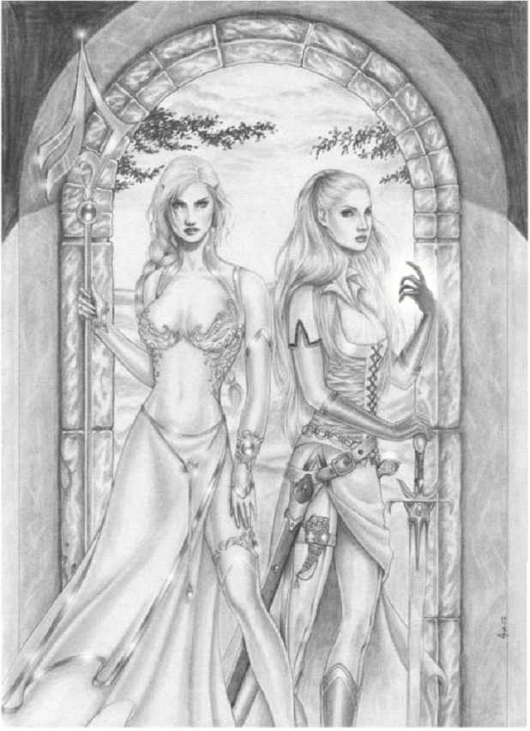
Human Avatar Form Information:

Appearance & ‘Natural’ Abilities: Ricca appears as a human female with golden blonde hair and silver eyes. (see picture at left – woman on the right). Ability scores: 25 all. Natural Armor Class: -25. THAC0: -21. Evasion 99%. Hit Points: 510. Regeneration 1d10+7 per round.

Armor: Armor of Lightening gives a +5 bonus to AC and +12 to initiative bonus. Sounds out electrical arcs at six arcs per round and attacks persons carrying metal within a 15’ radius causing 3d6 electrical damage.

Weapon’s Powers in the Hands of Ricca: A +5 dancing sword of sharpness, speed, and lightning that always strikes first and last in any round, but which will strike unerringly and do damage to any opponent that struck at the wielder earlier in the same round, regardless of whether the opponent successfully hit the wielder, up to the wielder’s available number of attacks per round. Critical hits of 15 or higher are an automatic vorpal attack. Dancing consists of loosing the sword on any round (after the first). The sword the fights on its own at the same level of experience as its wielder. After four rounds of dancing, the sword returns to its wielder, who must hold it (and use it) for four rounds before it can dance again. In other words, it is loosed to dance for four rounds, and must then be held by its wielder and physically used for four successive rounds of combat.

When dancing, the sword will leave its owner’s hand and may travel up to 30 feet away. At the end of its fourth round of solo combat, it will move to its possessor’s hand automatically. Note that when dancing, the sword cannot be physically hit, and no magical attacks can harm it as they can when wielded by a mortal.

Finally, remember that the dancing sword fights alone at the same level (and class) as its possessor – if a 4th-level fighter, the sword fights alone exactly the same; if a 7th-level thief is the wielder, the sword will so fight when dancing. Relieved of the weapon for four melee rounds, the possessor may act in virtually any manner – resting, discharging missiles, drawing another weapon and engaging in hand-to-hand combat- a long as he or she remains with 30 feet of the sword. If further than 30 feet from the weapon, it falls lifeless to the ground and is a +1 weapon if grasped by anyone other than the wielder. Even while dancing, the sword will shoot one lightning bolt from its tip per turn that does 3d10 points of damage.

Weapon’s Powers in the hands of a mortal: In the hands of a True Neutral character the weapon acts as a +3 dancing sword of sharpness, speed and lightning that always strikes first and last in any round, but which will strike unerringly and do damage to any opponent that struck at the wielder earlier in the same round, regardless of whether the opponent successfully hit the wielder, up to the wielder’s available number of attacks per round. It has all of the abilities of the weapon as if it was wielded by the goddess except for the following note:

Note that when dancing, the sword cannot be physically hit, although certain magical attacks such as a fireball or transmute metal to wood spell could affect it.



Name of Worshipped Being: Starke, Goddess of Thunder – True Neutral

Symbol: Glowing Cloud

Family relations: Co-consort of the God of the Oceans and the Goddess of Lightning (her twin sister) Direct creation of Florinda as is Ricca.

Goal and Purpose of Faith: Promote worship of Starke’s power and fearsomeness, especially as traits that the followers wish to use against their enemies.

Requirements of the Priest Hood: Promote the worship of Starke. Automatically becomes a dual-class Mage at 20th level without penalty.

Alignment Choices: Any alignment. Evil priests have their own sect and the other priests don’t have to tolerate them.

Minimum Ability Scores: Wisdom 16, Intelligence 18

Races Allowed: All races.

Gender: All genders.

Bonus Non-weapon & Weapon Proficiencies: Concentration; Evasion +10% per level; Weather Sense, Trouble Sense, Alertness; Quickness; Improved Quickness;

Non-weapon & Weapon Proficiencies required: Reading/Writing; Religion; Chanting

Non-weapon & Weapon Proficiencies recommended: Arcanology; Combat Casting; Sage Knowledge, School of Magic; Spellcraft, Tactics of Magic;

Duties: Guidance. Marriage.

Priest Hood Weapon Restrictions: Club, mace, maul, morning star, warhammer. All armors and shields.

Special Requests/Limitations: None.

Spheres of Influences:
Major – All, Combat, Weather
Minor – Divination, Protection
Granted Powers: Incite Berserker Rage. Thunderclap; Thundercone, and Thunderstroke all at double strength. Sonic boom – causes instant deafness 300 yard radius, no saving throw. At 5th level: Inspire Fear. At 10th level: Movement while running increases to the speed of sound – always first when rolling for initiative before the next person by 3 segments. At 20th level: Spellfire.

Followers: First followers are received at 8th level and they consist of: three 3rd level priests and six 1st level priest of the same order, plus three 3rd level fighters and six 1st level fighters to act as guards.

Relations: Other Faiths, Aristocracy, People: The God Starke associates with her co-consorts, Florinda, Goddess of Nature, and Wallace, God of Wind more than any of the other deities. She is indifferent to most other deities.

Requirements of the Followers: None.
Alignment Choice(s): Any alignment.
Races Allowed: Any.
Restrictions: None

Human Avatar Form Information:

Appearance & ‘Natural’ Abilities: Starke appears as a human female with golden blonde hair and silver eyes. (see picture at left – woman on the left). Ability scores: 25 all. Natural Armor Class: -25. THAC0: -21. Evasion 99%. Hit Points: 510. Regeneration 1d10+7 per round.

Armor: Bracers of Thunder are silver with a lion’s face and a topaz mane engraved in gold. They improve AC by 4. The bracers are both offensive and defensive. They can emit a bolt of lightning that inflicts 10d6 points of damage (successful saving throw vs. spell cuts the damage in half only if the person making the throw has in their possession a god crafted gift, weapon or armor) per round to all creatures in a 10-foot radius except the wearer of the bracers.

Weapon’s Powers in the Hands of Starke: Staff of Thunder & Lightning – Casual examination of this stout quarterstaff shows it to be exceptional, and if it is magically examined, it radiates an aura of alteration magic.

Constructed of wood (ash, oak, bronzewood, or similar woods) and bound with iron set with silver rivets, it has the properties of a +2 magical weapon without any expenditure of its magical charges. Its other magical properties are a follows:

Thunder: The staff strikes as a +3 weapon, and unless the attacked opponent saves successfully vs. staves, he or she is stunned from the noise of the staff’s impact – unable to take any further action in that round, and automatically having last initiative in the following round. This power requires the expenditure of one charge.

Lightning: A short spark of electricity leaps forth when the opponent is struck, causing normal staff damage, and 2d6 additional points of damage from shock. Note that the staff might not score a hit, but the electrical discharge discounts any form of metal armor (making the target effectively AC 10 for this purpose), so only such damage might apply. This power requires the expenditure of one charge.

Thunderclap: The staff sends forth a cone of deafening noise, 5 feet wide at the apex, 40 feet long, and 20 feet wide at a point farthest from the source. All creatures within this cone, wholly or partially, must roll a successful saving throw vs. staves or be stunned for 1d2 rounds (unable to attack during this time) and unable to hear for 1d2 additional rounds. Those who save are unable to hear for 1d4 rounds, but suffer no loss of attacks. This function requires the expenditure of two charges.

Lightning Stroke: A bolt similar to that from a wand of lightning is generated, but it is 8d6 in strength, causing 16-48 points of damage (all 1s are counted as 2s) to failed saving throws. The stroke can be singled or forked; this uses two charges.

Thunder & Lightning: This power combines the thunderclap, described above, with a forked lightning bolt as in the lightning stroke. Damage from the lightning is a total of 8d6 with rolls of 1 or 2 counted as rolls of 3, for a range of 24-48 points. A saving throw applies, with deafness and half damage suffered by those who are successful. This power requires the expenditure of four charges.

The casting time required for any function is equal to the number of charges expended; thus, the thunder & lightning function costs four charges and has an initiative modifier of +4.

