

Name of Worshipped Being: Ordith, Goddess of Death – True Neutral

Symbol: Hollow Black Circle

Ancient Rune: White skull

Family relations: Ordith is one of a quartet of gods born together. Florinda, Massey, Verdith, and Ordith were one and split into four aspects at the time of initial creation of the world. The division began the wheel of time and spawned the dawn of the universe.

Goal and Purpose of Faith: To celebrate the natural ending of life as a completion of the mortal plane of existence, and as the beginning to the next part of that cycle; be it the afterlife or rebirth.

Requirements of the Priest Hood: The priests want to and are required to stop those who are unnaturally keeping Death at bay without the express permission of the Goddess.

Alignment Choices: Any alignment.

Minimum Ability Scores: Wisdom 12, Constitution 16

Races Allowed: All races.

Gender: All genders

Bonus Non-weapon & Weapon Proficiencies: Undead Lore; Mastery – scythe.

Non-weapon & Weapon Proficiencies required: Religion.

Non-weapon & Weapon Proficiencies recommended: Reading/Writing, Alchemy, Anatomy, Sage Knowledge, Toxicology, Fortune Telling, Information Gathering, Intimidation, Investigation, Languages, Ancient, Omen Reading.

Duties: Guidance. Vigilance against any being that is unnaturally keeping Death at bay without the explicit approval of the Goddess. Punishing those who break the Goddesses edicts. Provide for assassinations or mercy killings of those who avoid the completion of their natural cycle of planer existence. Help guide departed spirits on to its rewards or next existence. Defenders of the innocent murdered, or those taken before their destiny.

Priest Hood Weapon Restrictions: Battle-axe, dagger/dirk, knife, noose, scythe, sickle, stiletto, sword/khopesh, sword/short. No armor or shields permitted.

Special Limitations: Priests of the Goddess of Death must remain celibate (unmarried). They need not remain chaste.

Spheres of Influences:
Major – All, Astral, Charm, Divination, Protection
Minor – Guardian, Necromantic, Sun, Weather
Granted Powers: Inspire Fear. Command Undead (no matter the alignment of the priest). At 5th level – Finger of Death. At 10th level – Power Word Kill. At 25th, the cleric will sprout black wings and be capable of winged flight. If the cleric is murdered while carrying out Ordith’s plans, they will become a Revenant.

Followers: First followers are received at 8th level and they consist of: one 5th level priest, three 3rd level priests and six 1st level priests of the same order, plus special agents whose class is determined by the specific aspect of the god (her children – 1d4). These agents consist of one 5th level character, two 3rd level characters, and four 1st level characters, normally Necromancers or Fighters. At 20th level gain an 11th level Oracle (Mage of Divination), and 1d20 bone golems.

Relations: Other Faiths, Aristocracy, People: The Goddess Ordith does not like the gods of Healing (her former consort), and Strength or their Chosen and the Minor-Goddess of Fertility. The priests tend to follow their Goddess’ otherworldly alignments with various gods. Ordith and her clergy are on good terms with the gods of Earth/Creation, Disease, and Nature. Ordith fights with her brother Massey, the God of Agriculture, due to his successes with feeding the masses and preventing death by starvation, which was prevalent before the rule of his Chosen, King Gallyean.

Requirements of the Followers: None.
Alignment Choice(s): Any alignment.
Races Allowed: Any.
Restrictions: No restrictions.

Human Avatar Form Information:
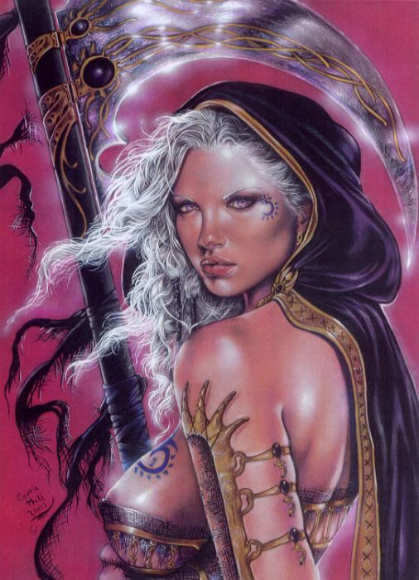

Appearance & ‘Natural’ Abilities: Ordith appears as Human female with silver white hair and lavender eyes (see picture at left). Ability scores: 25 all. Natural Armor Class: -25. THAC0: -21. Evasion 99%. Hit Points: 510. Regeneration 1d10+7 per round.

Armor: Spectral Death Armor is nothing more than a breastplate, armbands, and bracers in appearance. When worn together, they lower the wearer’s armor class by 5. Additionally, this pseudo-armor has the following additional abilities that can be activated upon command:

- Control Undead within 360’
- 15’ globe of magical darkness
- Charm

Additionally, the wearer of Spectral Death Armor is surrounded by a black aura that injures any creature that comes into contact with it. Any creature that strikes the wearer with bear hands or its own natural weapons must make a saving throw vs. death magic, or die instantly. If the creature saves they suffer 10d6+30 points of damage. Any animal or semi-intelligent creatures, if they attack at all, will usually abort a multiple-attack routine when they first take damage. Additionally, any creature touched is bonded to the wearer via a one-way sympathetic link. Any damage inflicted on the wearer is automatically inflicted on the linked creature as well. Should the mortal wearer of this armor die, so too will the linked creature(s).

Weapon’s Powers in the Hands of Ordith: Ordith’s Black Sickle is an Adamantite sickle which cuts through any material it touches, effectively lowering her opponent’s AC to a maximum of 5 (unless due strictly to Dexterity). Beings hit by the sickle must save vs. death magic or die. If they save, they lose whatever appendage the sickle hit. Those hit with 18 or higher must save vs. death that do not make their saving throw have their souls bound to the weapon and are at the beck and call of the wielder as servant spirits.

Other Abilities of Ordith’s Black Sickle are as follows:
- Otiluke’s Death Screen upon command
- Deathshrowd upon command
- Finger of Death upon command

Weapon’s Powers in the Hands of Mortals: Ordith’s Black Sickle performs for mortals as it would Ordith except that the other abilities are limited to being used 1 per 3 levels of the wielder instead of upon command. Also, it has the following penalty to its use:

If someone not willingly given the sickle by the Goddess attempts to wield it, artifact transformation occurs and the wielder dies and becomes a ghost. The sickle then teleports back to the presence of Ordith no matter which plane she is on. If the wielder does not let go of the sickle, they will be teleported right along with it.

Four Minor-Gods spawned by the Goddess of Death, sired by Velergin, God of Healing:

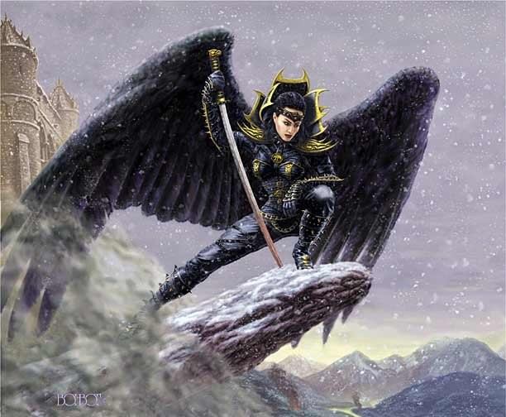


Name of Worshipped Being Lingée, Minor-Goddess of Ancestors – Neutral Good

Symbol: A spinning hourglass with a pair of scissors behind it on a cobweb

Goal and Purpose of Faith: To ease the passing of life into death by bringing a person’s ancestors into the presence of the dying, welcoming them to the next life. Guidance and understanding of a person’s ancestry and how that affects their life and their death.

Requirements of the Priest Hood:

Alignment Choices: Neutral Good

Minimum Ability Scores: Wisdom 12, Constitution 16

Races Allowed: All Races

Gender: All Genders

Bonus Non-weapon & Weapon Proficiencies:

Non-weapon & Weapon Proficiencies required:

Non-weapon & Weapon Proficiencies recommended:

Duties:

Priest Hood Weapon Restrictions: Battle-axe, dagger/dirk, knife, noose, scythe, sickle, stiletto, sword/khopesh, sword/short, katana, and scimitar. Light and medium armor and light shields permitted.

Spheres of Influences:
Major – All, Astral, Charm, Divination, Protection
Minor – Guardian, Necromantic, Sun, Weather
Granted Powers: Inspire Fear. Command Undead (no matter the alignment of the priest). At 5th level – Finger of Death. At 10th level – Power Word Kill. At 25th, the cleric will sprout black wings and be capable of winged flight. If the cleric is murdered while carrying out Lingée’s plans, they will become a Revenant.

Followers: First followers are received at 8th level and they consist of: one 5th level priest, three 3rd level priests and six 1st level priests of the same order, plus special agents whose class is determined by the specific aspect of the god (her children – 1d4). These agents consist of one 5th level character, two 3rd level characters, and four 1st level characters, normally Necromancers or Fighters. At 20th level gain an 11th level Oracle (Mage of Divination), and 1d20 bone golems.

Relations: Other Faiths, Aristocracy, People: The Goddess Lingée does not like the gods of Healing (her father), and Strength or their Chosen and the Minor-Goddess of Fertility. The priests tend to follow their Goddess’ otherworldly alignments with various gods. Lingée and her clergy are on good terms with the gods of Earth/Creation, Disease, and Nature.

Requirements of the Followers: None.
Alignment Choice(s): Any alignment.
Races Allowed: Any.
Restrictions: No restrictions.

Armor:

Weapon Powers in the hands of Lingée:

Weapon’s Powers in the hands of a mortal:



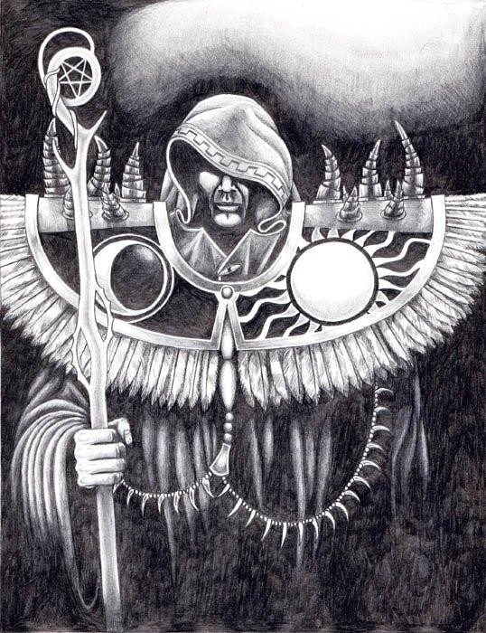
Name of Worshipped Being Voisin, Minor-God of Community – Lawful Neutral

Symbol: Pentagram with a being standing on each point and one in the center

Goal and Purpose of Faith: To promote community and a sense that each person is interconnected with another in life and in death. Promote that laws of a community should be adhered to for a peaceful co-existence. Besides Piacce, Voisin is known as the peace maker between the gods and often acts as an intermediary or mediator when conflict rocks the heavens.

Requirements of the Priest Hood: To discourage prejudicial actions and relationships. The promotion of harmony and the interconnectivity of all beings at a community level. To work towards uniting people in symbiotic relationships. To promote interest in the past, the understanding of how current events continue to be effected by decisions made then, and the sharpened perception necessary for making wise decisions that will effect even to the seventh generation.

Alignment Choices: Lawful Neutral

Minimum Ability Scores: 16 Wisdom, 16 Charisma

Races Allowed: All Races

Gender: All Genders

Bonus Non-weapon & Weapon Proficiencies: Ancient History, Local History, Observation

Non-weapon & Weapon Proficiencies required: Diplomacy, Etiquette, Law, Reading/Writing, Religion

Non-weapon & Weapon Proficiencies recommended: Arcanology, Bureaucracy, Sage Knowledge, Folklore; Sage Knowledge, History; Sage Knowledge, Philosophy;

Duties:

Priest Hood Weapon Restrictions: Stave, battle-axe, dagger/dirk, knife, noose, scythe, sickle, stiletto, sword/khopesh, sword/short. No armor or shields permitted.

Spheres of Influences:
Major – All, Astral, Charm, Divination, Protection
Minor – Guardian, Necromantic, Sun, Weather
Granted Powers: Inspire Fear. Command Undead (no matter the alignment of the priest). At 5th level – Finger of Death. At 10th level – Power Word Kill. At 25th, the cleric will sprout black wings and be capable of winged flight. If the cleric is murdered while carrying out Voisin’s plans, they will become a Revenant.

Followers: First followers are received at 8th level and they consist of: one 5th level priest, three 3rd level priests and six 1st level priests of the same order, plus special agents whose class is determined by the specific aspect of the god (her children – 1d4). These agents consist of one 5th level character, two 3rd level characters, and four 1st level characters, normally Necromancers or Fighters. At 20th level gain an 11th level Oracle (Mage of Divination), and 1d20 bone golems.

Relations: Other Faiths, Aristocracy, People: The God Voisin enjoys a friendly relationship with his father, Velergin, the God of Healing. He does not have a good relationship with Strength, Disease or War. The priests tend to follow their Gods’ otherworldly alignments with various gods. Voisin and his clergy are on good terms with the gods of Earth/Creation, Oceans, and Nature. Ensoleillé, the duel Goddess of the Sun (and Foo, her alter ego) is Voisin’s only lover and appears to him more often than not in her Sun aspect. As Foo – her moon aspect, she has an odd love for Voisin’s brother, Avenir. Voisin is totally committed to Ensoleillé, understands her, understands her duel nature, and has incorporated areas within his temples for his beloved’s worshipers. He feels that welcoming one such as Ensoleillé/Foo into his temples he is fostering a greater commune between the gods, setting an example extolling his own ethos of community. Voisin allows all other non-evil aligned clerics to use various portions of his temples while establishing their own. Voisin is truly the only god willing to appreciate and allow prayer to the other deities in his temples.

Requirements of the Followers: None.
Alignment Choice(s): Any alignment.
Races Allowed: Any.
Restrictions: No restrictions.

Armor:

Weapon Powers in the hands of Voisin:

Weapon’s Powers in the hands of a mortal:


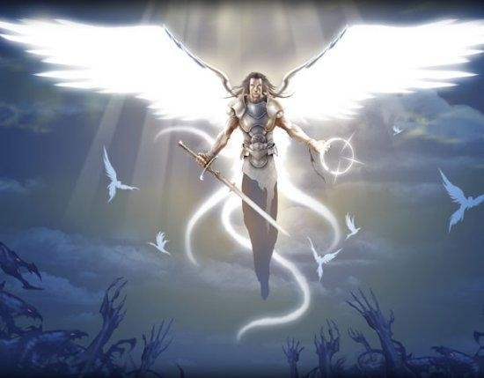
Name of Worshipped Being Rachat, Minor-God of Redemption – Neutral Good

Symbol: Hollow white circle with a sword crossed through it and doves flying out of it

Goal and Purpose of Faith: To promote the idea that nobody is beyond help. That despite evil past actions, all sentients can seek redemption and prevent them from a terrible afterlife.

Requirements of the Priest Hood:

Alignment Choices: Neutral Good

Minimum Ability Scores: 16 Wisdom, 17 Constitution

Races Allowed: All Races

Gender: All Genders

Bonus Non-weapon & Weapon Proficiencies:

Non-weapon & Weapon Proficiencies required:

Non-weapon & Weapon Proficiencies recommended:

Duties:

Priest Hood Weapon Restrictions: Sword/khopesh, sword/short. All armor and shields permitted.

Spheres of Influences:
Major – All, Astral, Charm, Divination, Protection
Minor – Guardian, Necromantic, Sun, Weather
Granted Powers: Inspire Fear. Command Undead (no matter the alignment of the priest). At 5th level – Finger of Death. At 10th level – Power Word Kill. At 25th, the cleric will sprout white wings and be capable of winged flight. If the cleric is murdered while carrying out Rachat’s plans, they will become a Revenant.

Followers: First followers are received at 8th level and they consist of: one 5th level priest, three 3rd level priests and six 1st level priests of the same order, plus special agents whose class is determined by the specific aspect of the god (her children – 1d4). These agents consist of one 5th level character, two 3rd level characters, and four 1st level characters, normally Necromancers or Fighters. At 20th level gain an 11th level Oracle (Mage of Divination), and 1d20 bone golems.

Relations: Other Faiths, Aristocracy, People: The God Rachat enjoys a friendly relationship with his father, Velergin, the God of Healing. He does not have a good relationship with Strength, Disease or War. The priests tend to follow their Gods’ otherworldly alignments with various gods. Rachat and his clergy are on good terms with the gods of Earth/Creation, Oceans, and Nature.

Requirements of the Followers: None.
Alignment Choice(s): Any alignment.
Races Allowed: Any.
Restrictions: No restrictions.

Armor:

Weapon Powers in the hands of Rachat:

Weapon’s Powers in the hands of a mortal:

Two Minor-Goddess spawned by the Goddess of Love, sired by Rachat, the God of Redemption:



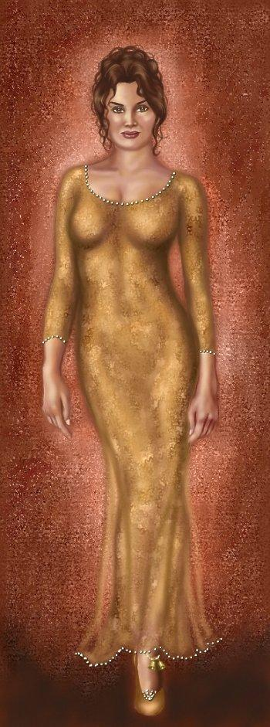
Name of Worshipped Being Bontè, Minor Goddess of Good

Symbol:

Goal and Purpose of Faith:

Requirements of the Priest Hood:

Alignment Choices: Neutral Good

Minimum Ability Scores:

Races Allowed:

Gender:

Bonus Non-weapon & Weapon Proficiencies:

Non-weapon & Weapon Proficiencies required:

Non-weapon & Weapon Proficiencies recommended:

Duties:

Priest Hood Weapon Restrictions:

Spheres of Influences:
Major –
Minor –
Granted Powers:

Followers:

Relations: Other Faiths, Aristocracy, People:

Requirements of the Followers: None.
Alignment Choice(s): Any alignment.
Races Allowed: Any.
Restrictions: No restrictions.

Armor:

Weapon Powers in the hands of Bonte:

Weapon’s Powers in the hands of a mortal:



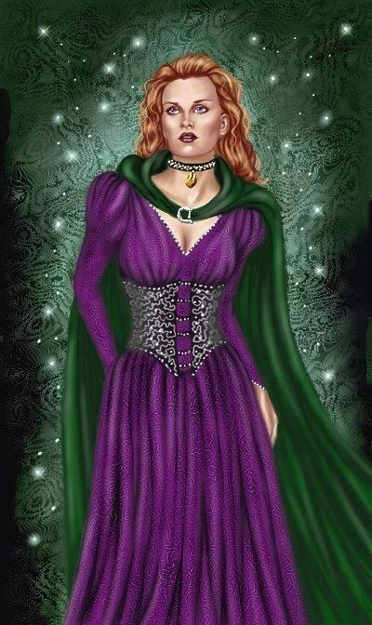
Name of Worshipped Being Modéré, Minor Goddess of Reason

Symbol:

Goal and Purpose of Faith:

Requirements of the Priest Hood:

Alignment Choices: True Neutral

Minimum Ability Scores: 18 Wisdom, 16 Constitution

Races Allowed: All Races

Gender: All Genders

Bonus Non-weapon & Weapon Proficiencies:

Non-weapon & Weapon Proficiencies required:

Non-weapon & Weapon Proficiencies recommended:

Duties:

Priest Hood Weapon Restrictions:

Spheres of Influences:
Major – All, Astral, Charm, Divination, Protection
Minor – Guardian, Necromantic, Sun, Weather
Granted Powers:

Followers:

Relations: Other Faiths, Aristocracy, People:

Requirements of the Followers: None.
Alignment Choice(s): Any alignment.
Races Allowed: Any.
Restrictions: No restrictions.

Armor:

Weapon Powers in the hands of Modéré:

Weapon’s Powers in the hands of a mortal:



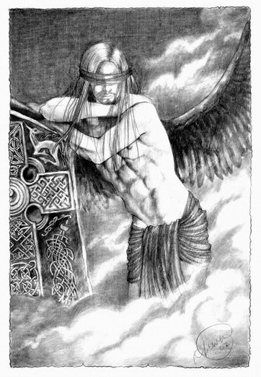
Name of Worshipped Being Avenir, Minor-God of Oracles & Prophecy – True Neutral

Symbol: Crystal ball with head of a blindfolded person inside it

Goal and Purpose of Faith: To guide those seeking knowledge of the future. To make predictions and prophecies that will guide sentients into a proper respect of the gods, their own life, and the afterlife.

Requirements of the Priest Hood:

Alignment Choices: True Neutral

Minimum Ability Scores: 18 Wisdom, 16 Constitution

Races Allowed: All Races

Gender: All Genders

Bonus Non-weapon & Weapon Proficiencies:

Non-weapon & Weapon Proficiencies required:

Non-weapon & Weapon Proficiencies recommended:

Duties:

Priest Hood Weapon Restrictions: Battle-axe, dagger/dirk, knife, noose, scythe, sickle, stiletto, sword/khopesh, sword/short. No armor or shields permitted.

Spheres of Influences:
Major – All, Astral, Charm, Divination, Protection
Minor – Guardian, Necromantic, Sun, Weather
Granted Powers: Inspire Fear. Command Undead (no matter the alignment of the priest). At 5th level – Finger of Death. At 10th level – Power Word Kill. At 25th, the cleric will sprout black wings and be capable of winged flight. If the cleric is murdered while carrying out Avenir’s plans, they will become a Revenant.

Followers: First followers are received at 8th level and they consist of: one 5th level priest, three 3rd level priests and six 1st level priests of the same order, plus special agents whose class is determined by the specific aspect of the god (her children – 1d4). These agents consist of one 5th level character, two 3rd level characters, and four 1st level characters, normally Necromancers or Fighters. At 20th level gain an 11th level Oracle (Mage of Divination), and 1d20 bone golems.

Relations: Other Faiths, Aristocracy, People: The God Avenir enjoys a friendly relationship with his father, Velergin, the God of Healing. He does not have a good relationship with Strength, Disease or War. The priests tend to follow their Gods’ otherworldly alignments with various gods. Avenir and his clergy are on good terms with the gods of Earth/Creation, Oceans, and Nature. Avenir and Foo often are at odds with each other over who has the strongest powers of Divination, Oracle and Prophecy. Foo’s assertion of the heavenly bodies’ control over mortals is often scoffed at by Avenir. They usually fight over this matter and end up in each other’s arms as they are on and off again lovers.

Requirements of the Followers: None.
Alignment Choice(s): Any alignment.
Races Allowed: Any.
Restrictions: No restrictions.

Armor:

Weapon Powers in the hands of Avenir:

Weapon’s Powers in the hands of a mortal:



Name of Worshipped Being: Velergin, God of Healing – Neutral Good

Symbol: Snake

Ancient Runes: Two crossed staffs wound together by a snake

Goal and Purpose of Faith: To champion the advancement of knowledge of health treatments and healing. The obliteration of disease from the world.

Requirements of the Priest Hood: Must be devoted to healing and are not allowed by their order to turn away a patient in need; if they can help him, they must.

Alignment Choices: Any Good Alignment

Minimum Ability Scores: Wisdom 10, Intelligence 10

Races Allowed: All races.

Gender: All genders

Bonus Non-weapon & Weapon Proficiencies: Healing, Anatomy, Mastery - Quarterstaff

Non-weapon & Weapon Proficiencies required: Herbalism, Reading/Writing, Religion.

Non-weapon & Weapon Proficiencies recommended: Undead Lore, Alchemy, Sage Knowledge, Toxicology, Information Gathering, Intimidation, Investigation, Languages, Ancient, Omen Reading.

Duties: Guidance. Marriage. Curing the sick and injured. Education: Teaching the flock, indeed anyone who is interested, the arts of medicine, sanitation, and healing. Missions to sickness-infested lands to help in the healing process. Vigilance against activities of the priests of the god of disease.

Priest Hood Weapon Restrictions: Lasso, mancatcher, net, quarterstaff. All non-metal armor; no shields.

Special Requests/Limitations: Priests of the god of Healing must wear a symbol indicating their calling whenever they appear in public. They may not ever deliberately take sentient life.

Spheres of Influences:
Major – All, Creation, Divination, Healing, Necromantic, Protection, Summoning.
Minor – Animal, Charm, Guardian, Plant, Sun, Weather
Granted Powers: Immunity to all poisons and diseases, but the priest only gets a +2 to his saving throw. Laying On of Hands (same as Paladin ability but twice as effective), Soothing Word, Turn Undead. At 3rd Level: Analysis, Identification of diseases and poisons; on Intelligence check the priest will know what sort of disease or poison afflicts his patient. All priests of Velergin receive double their normal spell slots and can cast spells of their Major Spheres caster level plus 2. Thus fourth level clerics can cast 6th level spells.

Followers: First followers are received at 7th level and they consist of: three 3rd level priests and six 1st level priests of the same priesthood, plus thirty Normal Men and Women, all of whom must have the Healing non-weapon proficiency, who act as surgeons and nurses.

The stronghold must act as a hospital for the nearest community, and may turn away no patient who has suffered life-threatening injury or disease.

Relations: Other Faiths, Aristocracy, People: Velegrin does not associate with his former consort, the Goddess of Death, and wonders how he ever came to be with her in the first place. He despises the Goddess of War or Disease and any of their children. Most Gods of Lawful or Good alignment he gets along with great, and finds most True Neutrals lacking in compassion.
Requirements of the Followers: None.
Alignment Choice(s): Any.
Races Allowed: Any.
Restrictions: None.

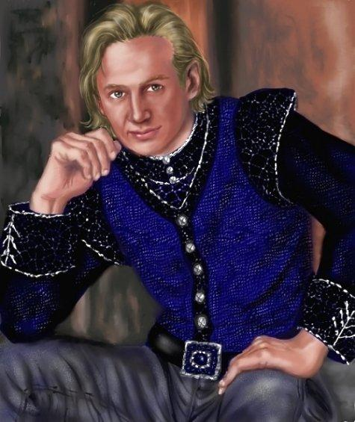
Half-Elven Avatar Form Information:

Appearance & ‘Natural’ Abilities: Velergin appears as half-elf male with blonde hair and gray eyes (see picture at left). Ability scores: 25 all. Natural Armor Class: -25. THAC0: -21. Evasion 99%. Hit Points: 510. Regeneration 1d10+7 per round.

Armor:

Weapon’s Powers in the Hands of Velergin:

Weapon’s Powers in the Hands of Mortals:

