

Name of Worshipped Being: Tisbe, Goddess of Love – Chaotic Good

Symbol: Two clasped hands

Ancient Rune: Nude elven female

Goal and Purpose of Faith: To promote love and marriage.

Requirements of the Priest Hood: Promoting love whenever possible – especially by removing obstacles to it.

Alignment Choices: Any alignment. Good preferred.

Minimum Ability Scores: Charisma 17, Wisdom 12

Races Allowed: All races. Elves highly favored, humans a close second.

Gender: Females only with the exception of Alex Didntdoit and any of his male heirs.

Non-weapon & Weapon Proficiencies required: Herbalism

Non-weapon & Weapon Proficiencies recommended: Reading/Writing, Religion, Dancing, Singing.

Duties: Guidance. Marriage. Vigilance: Priestesses of this sect believe in marriages of love, not of convenience or politics, and so conspire to keep young lovers together when those lovers might be parted by their families’ wishes or by the prejudices and responsibilities of their social classes.

Priest Hood Weapon Restrictions: Bow (short), club, lasso, mancatcher, net. No armor or shields permitted.

Special Requests/Limitations: Must procreate as often as possible. Priestesses of this sect receive four-sided dice for hit points, not eight sided. Also, a priestess of this sect may be unmarried when she enters the priesthood but must have been wed by the time she reaches 8th experience level – to do otherwise is to deny the Goddess her due, and constitutes a betrayal of goals.

Spheres of Influences:
Major – All, Animal, Charm, Healing, Necromantic, Protection, Summoning
Minor – Divination, Guardianship, Plant, Sun, and Weather
Granted Powers: Charm/Fascination, Incite Berseker Rage, Inspire Fear, Soothing Word. Turn Undead.

Followers: First followers are received at 7th level and they consist of: three 3rd level priests and six 1st level priests of the same order, plus one 3rd level mage and two 1st level mages who act as consultants, one 3rd level fighter, and two 1st level fighters who act as guards, and ten Normal Men and Women each with a Nonweapon proficiency which is of use to the temple’s functions (Etiquette, Local History and Reading/Writing).

The stronghold must act as a sanctuary for young lovers who come there fleeing the retribution of angry families. For this reason, these strongholds are often built with secret chambers and quarters for those who take sanctuary.

Family relations: Tisbe is known for being fickle and never keeping a consort for long. She has gravitated towards men not entirely good for her, such as the God of Evil and unfortunately sired children by him. She does not at all care for her daughters sired by Mauvais for their very existence shames her. She does love her two daughters sired by Rachet, and simply adores her Piacce’s three daughters. Her relationship with Piacce the God of Peace was the most loving and long lasting one for her, yet it has recently come to an end. Tisbe has bedded the human Alex Didntdoit, and became pregnant with his child – a son, which is a special honor, as in the past Tisbe would only bear daughters.

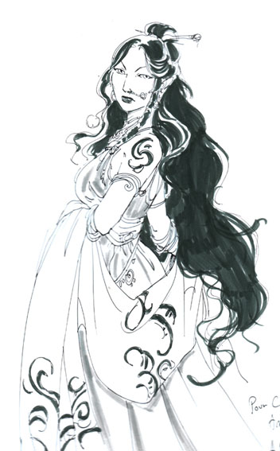
Relations: Other Faiths, Aristocracy, People: Tisbe is on good terms with the Minor-Gods of Birth/Children, Healing, and Peace. She dislikes the God of Evil, although she finds him strangely attractive. She has been known to foray into the mortal realms when the inspiration strikes, and is particularly fond of elven males with a Charisma of 17 or higher.

Requirements of the Followers: Must procreate. Marriage highly favored.
Alignment Choice(s): Any alignment.
Races Allowed: Any. Favors elves.
Restrictions: No ugly people.

Elven Avatar Form Information:

Appearance & ‘Natural’ Abilities: Tisbe appears as an elven female with jet black hair and blue eyes. (see picture at left). Ability scores: 25 all. Natural Armor Class: -25. THAC0: -21. Evasion 99%. Hit Points: 510. Regeneration 1d10+7 per round.

Armor:

Weapon’s Powers in the Hands of Tisbe:




Name of Worshipped Being: Desirée – Minor-Goddess of Desire

Symbol:

Family relations:

Goal and Purpose of Faith:

Requirements of the Priest Hood:

Alignment Choices:

Minimum Ability Scores: Wisdom 12, Charisma 15

Races Allowed:

Gender:

Non-weapon & Weapon Proficiencies required:
Non-weapon & Weapon Proficiencies recommended:

Duties:

Priest Hood Weapon Restrictions:

Special Requests/Limitations:

Spheres of Influences:
Major – All, Charm, Creation, Divination, Protection
Minor – Animal, Guardian, Healing, Necromantic

Granted Powers:

Followers:

Relations: Other Faiths, Aristocracy, People:

Requirements of the Followers:
Alignment Choice(s): Cannot be Evil
Races Allowed: Any.
Restrictions: Only take part in necessary violence to prevent the unjust loss of life.


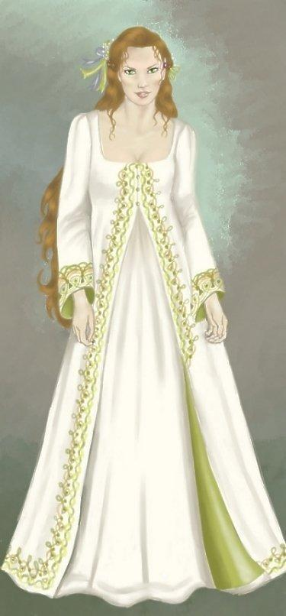
Name of Worshipped Being: Mariè, the Minor-Goddess of Marriage

Symbol:

Family relations:

Goal and Purpose of Faith:

Requirements of the Priest Hood:

Alignment Choices:

Minimum Ability Scores: Wisdom 12, Charisma 15

Races Allowed:

Gender:

Non-weapon & Weapon Proficiencies required:
Non-weapon & Weapon Proficiencies recommended:

Duties:

Priest Hood Weapon Restrictions:

Special Requests/Limitations:

Spheres of Influences:
Major – All, Charm, Creation, Divination, Protection
Minor – Animal, Guardian, Healing, Necromantic

Granted Powers:

Followers:

Relations: Other Faiths, Aristocracy, People:

Requirements of the Followers:
Alignment Choice(s): Cannot be Evil
Races Allowed: Any.
Restrictions: Only take part in necessary violence to prevent the unjust loss of life.


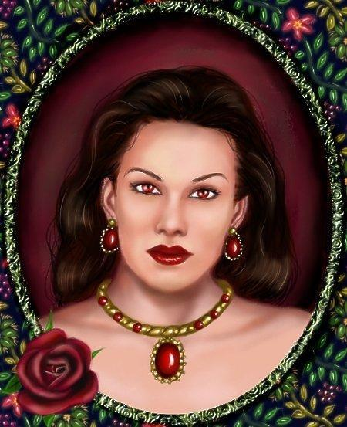
Name of Worshipped Being: Romancé, the Minor-Goddess of Romance

Symbol:

Family relations:

Goal and Purpose of Faith:

Requirements of the Priest Hood:

Alignment Choices:

Minimum Ability Scores: Wisdom 12, Charisma 15

Races Allowed:

Gender:

Non-weapon & Weapon Proficiencies required:
Non-weapon & Weapon Proficiencies recommended:

Duties:

Priest Hood Weapon Restrictions:

Special Requests/Limitations:

Spheres of Influences:
Major – All, Charm, Creation, Divination, Protection
Minor – Animal, Guardian, Healing, Necromantic

Granted Powers:

Followers:

Relations: Other Faiths, Aristocracy, People:

Requirements of the Followers:
Alignment Choice(s): Cannot be Evil
Races Allowed: Any.
Restrictions: Only take part in necessary violence to prevent the unjust loss of life.



Name of Worshipped Being: Piacce, God of Peace – Neutral Good

Symbol: Dove

Family relations: Recently dissolved relationship with consort, Tisbe, Goddess of Love and father of three of her nine children.

Goal and Purpose of Faith: Devoted to the cause of peace, and the hope for all conflicts to be settled non-violently.

Requirements of the Priest Hood: Piacce’s priests work to keep things peaceful. They intercede between nations/cities that are on the brink of war. They suggest compromises and nonviolent ways of settling important issues. They do their best to keep things calm and civil.

Alignment Choices: Neutral Good.

Minimum Ability Scores: Wisdom 12, Charisma 15

Races Allowed: All races.

Gender: All genders.

Non-weapon & Weapon Proficiencies required: Etiquette

Non-weapon & Weapon Proficiencies recommended: Modern Languages, Singing, Local History, Musical Instrument, Reading/Writing, Religion.

Duties: Guidance. Marriage. The priest often accompanies parties of war or groups of adventurers to try to bring about peaceful solutions to as many situations as possible. Vigilance against forces or individuals who seem to stir up trouble continually and needlessly.

Priest Hood Weapon Restrictions: Lasso, net. All non-magical armor and shields.

Special Requests/Limitations: Priests of this sect receive six-sided dice for hit points, not eight sided. Whenever they appear in public they must wear clothing or badges which display their status as priests of the god of peace. Priests of this sect may not eat flesh, but remain strict vegetarians.

Spheres of Influences:
Major – All, Charm, Creation, Divination, Protection
Minor – Animal, Guardian, Healing, Necromantic

Granted Powers: Charm/Fascination. Language/Communication. From 1st level to 4th, the priest receives one extra language per level; the language chosen must be that of a sentient humanoid race. Soothing Word. At 5th level – Laying On of Hands (same as the Paladin ability). At 8th level – Power Word Stun.

Followers: First followers are received at 8th level and they consist of: one 5th level priest, three 3rd level priests and sixteen 1st level priests of the same order.

Relations: Other Faiths, Aristocracy, People: The God Piacce does not like the gods of War, and Strength and their children, excluding Cavalry; Hunt, or the Minor-God of Justice & Revenge or their Chosen. The priests tend to follow their God’s otherworldly alignments with various gods. Piacce and his clergy are on good terms with the God of Healing, and Minor-Gods of Community, Competition, Messengers, Prosperity, Rulership.

Requirements of the Followers:
Alignment Choice(s): Cannot be Evil
Races Allowed: Any.
Restrictions: Only take part in necessary violence to prevent the unjust loss of life.
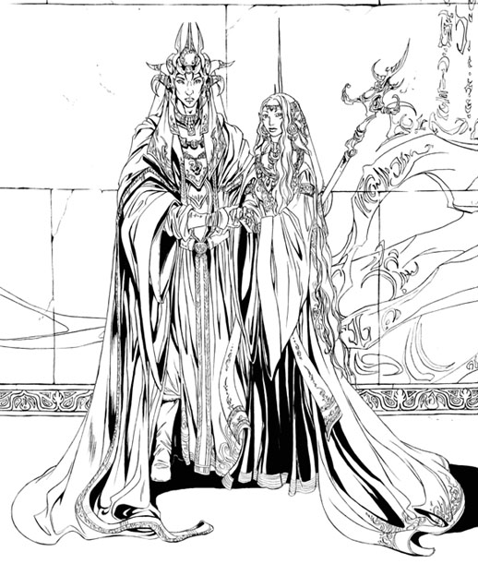
Elven Avatar Form Information:

Appearance & ‘Natural’ Abilities: Piacce appears as an Elven male with black hair and blue eyes. (see picture at left- pictured with Tisbe). Ability scores: 25 all. Natural Armor Class: -25. THAC0: -21. Evasion 99%. Hit Points: 510. Regeneration 1d10+7 per round.

Armor: Piacce wears no armor at all, instead adorning his avatar with flowing robes. His preferred robe is the Robe of Awe. All mortals in the presence of the avatar while adorned in the Robe of Awe feel an immense sense of awe, reverence and wonderment. An all encompassing sense of calm and peacefulness comes to all within 100 feet of the Robe of Awe regardless of alignment.

“Weapon’s” Powers in the Hands of Piacce: Piacce officially has no ‘weapon’ as he sees it. His avatar wields the Staff of Peace. The staff can never be used to hurt another living being. Its only powers are bestowing blessings and purifications. It radiates Protection from Evil at a 100’ radius. If evil aligned beings attempt to move any closer, they are struck down to the ground into a prostrating position where they must spend a number of hours in contemplation of the wrongs they have committed. Each evil act will cause 15 minutes of reflection. The evil being will be in suspended animation until each of its evil acts is contemplated. The being is also forced to endure the result of the evil act. For example, an orc who tortured children then ate them will witness the act from the children’s perspective, feeling all the children’s feelings, even through death. The evil being will not suffer any physical damage while in suspended animation, but will remember every detail of the forced contemplation.

