Objects
A fundamental objective of Electric Power Systems in Industrial and Commercial Buildings is to provide for the highest safety level, that is a human right for the entire world.
This meeting intends to promote this aim informing attendees of the technical art's status in Europe and North-America. In the globalization context, it will, researchers, engineers, technicians and students, an opportunity to gain deeper insight into the common bases and differences between the approaches of the IEC-EN Standards and the NFPA-NEC Standards on the safety of electrical installations and equipment. The comparison between the two technical approaches improves the electrical safety and it facilitates a worldwide harmonization on the Power Systems art.
A panel of experts will discuss the possibility of setting up an Electrical Consulting Board (ECB) for the general public and customers. The intent is to guarantee skilled investigation of the causes of accident and injury. For this purpose, legal representative experts will be included in the panel discussion.

Other Sponsors

CEI Comitato Elettrotecnico Italiano



Schneider Electric

CEOIR – Ordine degli Ingegneri di Roma

AEEE Associazione Elettrotecnici Elettronici ed Energetici

Scuola di Specializzazione in Sicurezza e Protezione - Roma

A Worldwide Jubilee
In Electric Power Systems

An international meeting to enable improved
electrical safety

Program

October, 13th 2000

2.30 PM - 3.00 PM
Registration

3.00 PM - 7.00 PM

Introduction
Panel:
Antonio Alberici, General Secretary of the CEI Comitato Elettrotecnico Italiano
Giogio Corbellini, Professor
Università Pavia (Milan)
Francesco Carassa Professor, Polytechnic of Milano, Member National Academy of Sciences
Giuliano Colombo, EPS Professor ULS
Caio A. Ferreira, President of the Industry Applications Society, IEEE
Luigi Giampaolino, Capo Ufficio Legislativo Ministero Industria Comm. ed Artig. (MICA)
Paolo Tenti, Past President of the IAS-IEEE Professor, University of Padova

Issue 1 :
How do the NEC and IEC 60364 help provide electrical safety.

Panel:
- Craig M. Wellman, P.E., consultant Du Pont Co., USA
- George D. Gregory, Square D, Schneider Electric
- Joseph H. Kuczka
- Luigi Ricossa, Secretary of IEC SC 23E and of CENELEC TC23E
- Giuseppe Parise, EPS Professor ULS
Issue 2 :
An electrical consulting board to improve safety in the electrical field

Panel:
- G. Parise, EPS Professor ULS
- G. Donato, G. Lucarelli, C. Turella, AEEE
- L.Giampaolino, Capo Ufficio Legislativo MICA
- R. D’Alessio, M. Lepore, Professors ULS

Issue 3 :
The IEEE Color Book Series

Panel:
- H. Landis Floyd P.E., consultant DuPont Co., USA
- Erling Hesla P.E., Hesla & Assoc., USA

All participants will receive a copy of the IEEE Color Books Sampler on CDROM.

Languages
The official languages will be Italian and English. Simultaneous translation will be provided.

Meeting Place
Palazzo Marini- Sala delle Conferenze
Via del Pozzetto, 159- Roma

Meeting Secretary
Anna Maria Pennesi Ciasco
Electrical Engineering Department
Via delle Sette Sale, 12b - 00184 Roma
Tel. +39/0644585546-534
Fax +39/06 4883235
e-mail: elejub@tin.it

Registration
Registration is free, but it has to be made in advance because attendance is limited to 150. e-mail: elejub@tin.it



UNIVERSITÀ DEGLI STUDI “LA SAPIENZA”
FACOLTÀ DI INGEGNERIA - ROMA
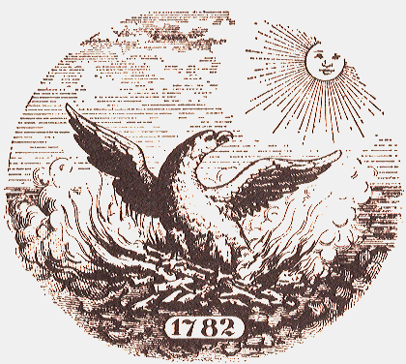

THE NATIONAL ACADEMY OF SCIENCES
(ACADEMY OF THE FORTY) ITALY


INSTITUTE OF ELECTRICAL AND ELECTRONICS ENGINEERS



INDUSTRY APPLICATIONS SOCIETY

A Worldwide Jubilee

In Electric Power Systems

An international meeting to enable
improved electrical safety

Roma, October, 13th 2000


Sala delle Conferenze di Palazzo Marini

CAMERA DEI DEPUTATI

ITALIAN PARLIAMENT
Via del Pozzetto, 159 - ROMA

Meeting Committee

G. Parise, Chair

