http://www.angelfire.com/zine2/remo123/book_intro/index.html
President of the Earth  What this will entail is staggering, especially on how it will be done and what affects it has been having on us already. Let The Adepts of Deceit take you Behind Closed Doors with the hidden characters of the very underpinnings of our society. This book deals with issues most people would like answers to in today's world of confusion and anxiety. The maze of information presented is not with accepted present day format of how a book is constructed but with a back and forth motion similar to being buffeted in a storm though it is an easy read.  NEW RELEASES – BEST SELLERS  The Adepts of Deceit Volumes I and II  TGS Publishers 1-903-876-3256  Web Address  http://www.hiddenmysteries.com/xcart/home.php  http://hiddenmysteries.com/xcart/product.php?productid=16805  What you don't know can kill you.  You are being hunted and do not even know it.  Knowledge is POWER and with that comes  Understanding. Ignorance is our greatest enemy.  The Adepts of Deceit ISBN# 0-9742018-3-9 | 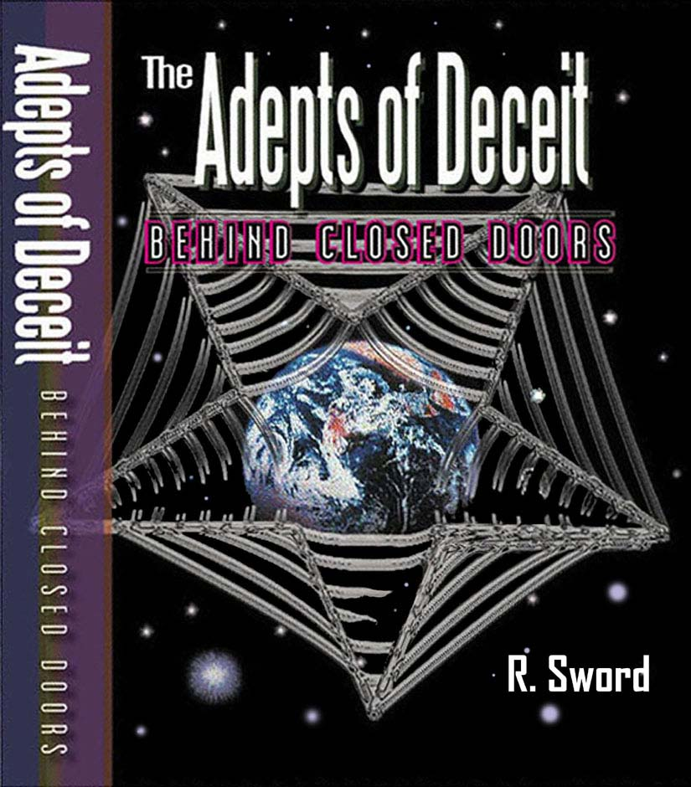

This book is a must read with an eye-opening trail of facts that lead thru the past, the present and the future of the world as we know it today. I personally had to do double-takes on the information because it was too much to intake at one sitting. Once you start you will not be able to stop the highly addictive content. You will not be able to put it down. Powerful. Alexander John --Actor

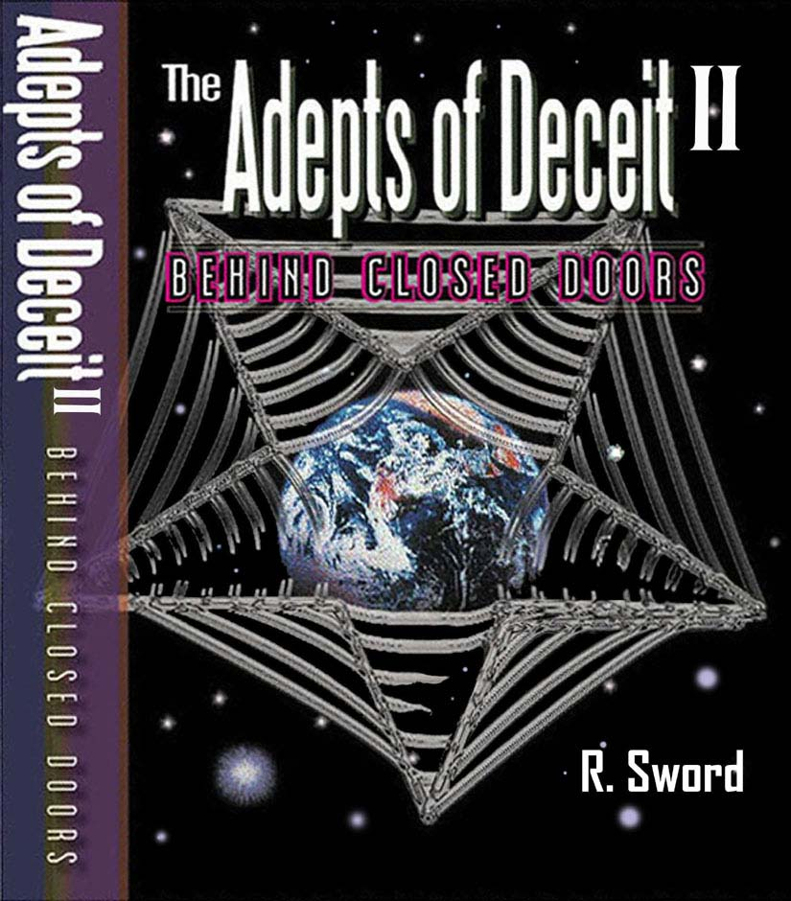 | The Man Who Would Be King  The Warlord of Death is coming your way and like a vampire is going to hold the world in thrall. He who controls the money is the power. Banks and corporations control us. They are the governments now. NAFTA and GATT were created for this purpose. There has to be a way to control the population without damaging the profit margin. Technology and pharmaceuticals are the tools of present and future manipulation. Wait to see what they have planned.  Meet mass mind control. The FBI must know what you’re thinking. What you think is a National Security issue and is now property of the State. Your opinion is no longer wanted. We have heard the phrase ‘the bigger they are, the harder they fall’. The American government is building into a terror giant and its cataclysmic destruction is imminent in more ways than one. All the ‘world’s a stage and the final play is about to start.  Again The Adepts of Deceit II takes you Behind Closed Doors in this stunning conclusion to a world built on terror.  ISBN# 0-9742018-4-7 The Adepts of Deceit II
http://www.angelfire.com/zine2/remo123/book_intro/The_Adepts_of_Deceit.doc ---- http://www.angelfire.com/zine2/remo123/book_intro/The_Adepts_of_Deceit-IE.htm

