MOUNTAINEER REGIONAL SERVICE COMMITTEE OF NARCOTICS ANONYMOUS

PO BOX 2381 March 31 – April 1, 2007
MORGANTOWN, WV 26502-2381

HELPLINE: 304-344-4442
800-766-4442

OFFICERS:

CHAIR: David H. RSD/RD: Cooper B..
VICE CHAIR: Rick S. RSD/RD ALT: Rick W.
TREASURER: Bert J. TREASURER II: Barbara W.
SECRETARY: Kay M.

SUBCOMMITTEE CHAIRS:

CONVENTION: Patty G. PHONELINE: Candie M.
PI: Shayne M. H&I: Chip D.
LITERATURE: vacant FINANCE: Barbara W.
P&A: Rick S.

AREA SERVICE REPRESENTATIVES:

NCWVASC: Jerry A . AFASCNA: Chip D.
ALT: Chris S. ALT: Dave S.

NANA: Allen L. METRO: Rick B.
ALT: vacant ALT: Rocco A.

MANA: Candie M. GTO: Dave C.
ALT: vacant ALT: vacant

FANA: Jeff G. (acting) SCURA: Robert S.
ALT: Nick R ALT: vacant

Attendance April 2007
David H  Kay M  Candie B  Cooper B  Barbara W  Rick W  Chip D  Chris S | Wes R  Jack P  Bob W  Rocco A  Marc R  Keith W  Myra H  Bert J | Jerry A  Allen L  Jeff G  Chris G  Rick B  Robert S  Patty G | Shayne M  Scott T  Dave C  Chip C  Robbie C  Tanya H  Rick S

MRSCNA MINUTES
March 31 – April 1, 2007

- David H. opened with a moment of silence followed by the Serenity Prayer
- Keith W. read the 12 Traditions
- Bob W. read the 12 Concepts

REPORTS:

Secretary’s Report-
Kay M. read the January 2007 minutes. A motion to accept minutes was made by Rick B, and accepted by consensus of the committee.

Treasurer's Report – see appendix 1

RD Report -
I am returning $787.50 to our treasurer because we didn’t travel to MARLCNA. I got sick and Rick W was still not ready to travel after his surgery. Our apologies.
Our World Board reports that work is ongoing on the Basic Text project Some concern was expressed about a “lack of geographic representation”, whatever that means. The WB is also proposing a moratorium on seating any region that forms out of another region until 2012 so that we can rewrite policy on that. The WB has also decided that we don’t need to have a workgroup on consensus although they will submit a project plan
because we asked them to.
No travel is planned in the next quarter. The next zonal forum is in Philadelphia in late July.

RDA Report- see attachments

OLD BUSINESS:

Motion 03.01/07: | from: Convention Subcommittee
To purchase a dubbing machine to copy our speaker meeting CDs at the conventions. This machine copies 5 CDs at a time in 5 minutes. We also will purchase a microphone and cords. Estimated cost $650.
Intent:. better carry the message
Result: 5 in favor; 3 against; Motion carried

Motion 04.01/07: | from: P&A Subcommittee
That MRSCNA purchase a blanket general liability policy for the entire regional fellowship - not to exceed $2500 per year.
Intent: would cover all members at any NA function of our regional fellowship
Result: 3/31/07 Referred to P&A Subcommittee; tabled till next meeting in subcommittee

Motion: e-mail | from: PI Subcommittee
That MRSCNA spend $248 to rent a a display stand from Fst-Signs to do a PI presentation at the Capital on Feb. 7th for WV Health Day.
Intent: to carry the message
Result: 4 in favor; 2 against; 1 abstention; 1 no vote given

- Discussion about how to nominate Cooper for the co-facilitator for the WSC 2008. (Cooper will update his World Human Resource Pool resume and the MRSCNA chair will write a letter of nomination.)

AREA REPORTS:
GTO-

Hello Family,
All is well in the GTO Area at this time. We currently have 5 active home groups in our area with meetings happening every day of the week with the exception of Wednesday and Friday. Home groups are growing stronger, slowly but surely.
Our PI subcommittee just had a very successful flyer day on March 17, We have seen quite a few newcomers since. Our PI subcommittee just recently purchased a banner for use in health fairs and different functions we have throughout the year. We have it with us if anyone would like to see how it turned out.
Our H&I subcommittee is still maintaining three commitments, the women’s side of the regional jail, PARC West, and River Park Hospitals Adolescent unit. Our ASC recently held an open discussion about the regional jail concerning the issue of the contract we have to sign in order to go into this facility. Our area home groups voted unanimously to continue to go into this facility. We hope that this vote will put an end to the ongoing debate about this topic, at least in our area. we are working on another commitment with the Robert L. Shell Juvenile facility beside the western regional jail. More will be revealed on this possibility at a later date.
We are always in need of members to go into all three of these facilities. If anyone is interested please contact Ann C., our H&I chair, and she will be happy to point you in the right direction of that facilities panel leader. Our area has a clean time requirement of six months in order to participate in H&I, but you may go into the facility to observe with 60 days clean please make members in your area aware of this.
The yearly orientation at WRJ was done in March. Members are now required to carry I.D. badges. We were also informed that WRJ does provide inmates with NA literature through the library system. Members going into the jail, at least those going into the women’s facility are allowed to go into the library and carry out literature to give to the females. Also if anyone has any old “Reaching Out” booklets that they would like to donate, the females at the jail really appreciate those a lot. See Dave C. or Ann C. if you would like to donate any of these.
Our activities subcommittee will soon be planning our summer picnic. It will probably happen sometime in late July or August.

Announcements:
June 24, 2007 – 3 year celebration
April 9, 2007 – 24 year celebration
June 7, 2007 – 3 year celebration

SCURANA
Hello once again all you dedicated servants of the Mountaineer Region. I, Robert S. From Mingo county has been elected to serve as the ASR for my area. We feel that the need to be represented here is greater than ever. Without a voice we cannot communicate our concerns about the way things are going.
At our last area service meeting we decided that we do NOT need any CD recording equipment. We did grant our ASR the freedom to vote in favor if he felt that after some discussion our concerns were answered, such as that who is going to be responsible, and where will it be kept?
Are we going to use legal software and will we copyright or copy protect the CD’s?

We are concerned about whether or not we have to purchase a meal ticket with our convention package and hope we can get some clarification.
We are doing well as an area as far as meeting attendance goes. We have a 90-day treatment center that allows the clients to attend meetings almost on a regular basis. We might be starting our jail meeting back up soon. More will be revealed on that. We are excited about our Spring Fling coming up April 21st and I have some fliers with me for anybody interested.
We have had a lot of anniversaries lately and Mary H. will be celebrating 7 years in Madison Monday April 2nd and Kenny T. will be celebrating 9 years on April 13 in Logan.
That’s about all I have or willing to put in print,

Robert, From Mingo County

MANA
MANA is doing splendid. The Lewisburg group has anywhere from 10 to 15+ attending meetings on a regular basis. The One Day at a Time group has around 7 to 10 people regularly basis. Between the two groups we have celebrated 2- 1year
1- 2year
1- 4year
1- 16 year
Some discussion on holding some H&I and PL workshops more will be revealed. Our current H&I is coming along good. We did miss last month due to a very busy H&I chair and Correctional Center. O
The MANA area is making a donation to Region of $100.

NANA- NEVER ALONE NEVER AGAIN
Greetings Everyone,
Our meetings are still happening. We are still committed to carrying the message of recovery. We are going to have our 12- step campout on May 26-27 at Oldtown Campground in Point Pleasant. Hope to see you there. We are planning our annual picnic on July 28 at the wave pool in Hurricane. Our Hope out the Holler group will have a picnic on May 5th. Hope you make it. It will also have a Literature Subcommittee. We are still doing Tiger H. Morton Juvenile Correction Center H&I Commitment. We have a $300 donation to the Region. We have no further needs from the Region and only ask how we can we serve.
Gratefully Yours,
Allen L. ASR
AFASCNA
Hello Family,
The St. Patrick’s Day Literature Fundraiser was well attended and enjoyed by all. The Area would like to thank Rocko for his great message of recovery. We were able to raise approximately $400.00. This literature will be distributed equally amongst the seven groups. Thanks to all those who came and supported this annual event.
Brian B announced the start of a new group:
The Living Free Group
Senior Citizen Center Building
Grantsville, WV
7:30
Therapeutic Value Group Celebration at the Plumbers and Pipe fitters Union Hall in Cambridge, Rt. 40 on May at 5:30pm. (see flyer)
The Area will be holding a Service Committee Meeting to discuss Freedom Day Blast. This will be held right before the above said event at 3:30pm.
At this time our Area is well attended and growing. We need no assistance, but please feel free to visit us anytime.

Respectfully submitted in loving service,
Chip D.
P.S. Donation to region submitted to Bert J. $126.90

NCWVASCNA-
Greetings from the NCASCNA. We are going strong and recovery is happening. Our meetings are getting bigger and new ones are opening. We are celebrating clean time with a 1, a 2, a 3, a 6 and a 7 year, also many monthly ones, too.
We are doing 3 H&I meetings now and looking to expand. More will be reveled on this. 1 meeting is at Fairmont General Hospital every Thursday night at 7:00. 1 is at Pruntytown correctional center on every other Tuesday at 7:00pm and the other is at MFCC on each Tuesday at 6:00pm. We are having a H&I /PI/Phone line workshop/learning day on April 21st from 2 till 6 in Fairmont at the Manchin Health Center.
In February we had a Valentines dance which was very well attended with 50plus. Everybody had a good time including the band. Our next event seems to be our annual picnic in August. On April 14th our Literature sub. will have a review of the 2 new IP’s, For young addicts by young addicts and For the guardians of young adducts. This will take place in Fairmont at 5:00 at the Manchin Health Center.
In March our PI sub had a mass mailing. We send out 150 envelopes with meeting schedules, 2 Ips and a cover letter. We hope to do this again soon.
We are giving the pager over to the Foothills area. The pager has been manned and answered with hardly any problems and these will be discussed more on April 21st.

Come and recover with us in the spiritual Mecca,
Jerry A.

FANA-
Greetings from, FANA!
Things are going well in the FANA area. We are growing in strength and in number. Our regularly scheduled area service meetings are well attended and our basic service positions remain filled. Our area consists of Bluefield/Princeton, Beckley, Oakhill, and part of Lewisburg. We recently decided to alternate our area service meetings between these three places to be more fair and to further unity.
There is still a substantial amount of interest and willingness to do H&I. We still have no official H&I committee but are planning an H&I “Willingness meeting in Lewisburg on Saturday April 28th at 2PM one hour before Area Service. Any experience strength and hope in this area would be greatly appreciated. We still have addicts going into SRJ. They need support but we cannot get any response from the powers that be on approving other addicts to go in. Paper work has been submitted, calls have been made, but to no avail.
We are also planning a cookout/Area service meeting on June 23rd in Ghent. Food fun fellowship and fishing! We are looking for a speaker for this event. More will be revealed.
Grateful to Serve, Jeff G

Conscience;
Insurance issue- Was discussed and table until more is revealed
Recorder Burner for speakers- Passed

METRO VALLEY-
Greetings from Metro. We are alive and recovering just for today.
We have renewed our efforts in H&I and our chair, Chris G. is here (welcome!) to report on that.
We are currently in possession of the beeper and have some issues to discuss in that subcommittee.
We have a motion to bring to the floor.
We also have a donation and schedule reimbursement.
Grateful to serve,
Metro ASR

NEW ATTITUDES GROUP OF NA (UNAFFILIATED)

Pineville, WV (Wyoming County)
First Presbyterian Church
Thursday 7pm

- Registered with WSO – 12-2004 (Lynco, WV – Tuesday 7pm)
- Relocated to Pineville (current location) - January 2007
- Meeting attendance 3 – 4 on average
- Wyoming County probation office contacted by mail with some results but limited
- Members voted to join FANA
- Request planned for delivery to FANA at FANA 4-28-07 business meeting

Keith W. GSR

BRAXTON COUNTY GROUP OF NA (UNAFFILIATED

Braxton County NA has meetings on Tuesday and Thursday at 7:30 (60 minute meetings). We have an average of 12 – 14 members. Tuesday is open discussion; Thursday is (open) Basic Text. The location is the Braxton Fellowship Home in Sutton WV.
SUBCOMMITTEE REPORTS

Hospitals and Institutions – Chip D.

Report from H and I chair:
Currently, I have not had any contact with Randy Mann. Last contact he stated that he was developing an Orientation Video. I have heard that he might be leaving the Regional Jail system, time will tell.
There will be an Ad Hoc discussion on “What is MRSCNA H&I Guidelines with Regional Jail Contractual Agreements” on May 12th following dinner.

I. Report for Metro Valley
SCRJ- We will be starting up this meeting very soon. In regards to the signing agreement/ contact with the Regional Jail Authority, as it states in the January Regional minutes each group will have to decide for themselves, so on that note Metro Valley H and I subcommittee contacted the Regional Jail Authority and came up with our own Agreement that allows us to do our own Meeting without abiding by the RJA Guidelines.
Charleston Work Release
We are doing this meeting every 2nd and 4th Friday of the month. This meeting is going well.
Bantam Place
We will be starting Bantam Place back up on May 7th. Bantam Place is excited to have the meeting back in their Institution.
In loving service,
Chris G. Metro Valley

- The Mountain Area-
The Moneyman area is taking and H&I panel presentation into the Anthony Correctional Center in Neola, WV once a month on Saturday night at 7pm. Which Sat. varies due to panel members schedules and staffing issues. Staff has requested more meetings as more members can be found.

- North Central H&I
We have 3 meetings:
- at MFCC on each Tues. at 6:30
- at Fairmont GH on each Thurs. at 7pm
1- at Pruntytown on every other Tues. at 7pm
April 21 H&I form 2-6 at Manchin Health Care in Fairmont at 1401 Guffy St.
H&I Chair is working on Regional jail or jail committee

- GTO Area
Meetings:
Park West, Monday night 7:30- 8:30pm
HCA Hospital (children), 2nd and 4th Thursday 6:30- 7:30pm
Western Regional Jail (women) 4th Thursday, 6:30- 8:00

Public Information – Shayne M, Chair
Well how yaw doing, fine I hope. It’s been awhile since I’ve had the pleasure of chairing this committee. This pass month has served as a reminder as to why I backed away from the task of keeping up with comings and goings of the meetings in our region.
Where to start, how about once upon a time in the land of the Mountaineer Region a list was made of all the meetings held in their land. A simple task no doubt in the beginning. This list was handed down to all the PI chairs that followed the very first one. Till one day it was placed in the hands of yours truly. It was pointed out to the current keeper of the list that some errors may be found within the list. Both the hard copy and the copy on the webpage. The chair then set out to remedy this problem post hast.
That is the problem and here is the solution. How the list got where it got was no concern of mine because it didn’t happen on my watch and besides it wasn’t my fault. As most of you know by now I set out to contact just about everyone I know in the Region asking for help. Most everyone replied with new corrected information and the problem was soon in hand. A couple of the meetings that were in question were another matter as no one seamed to know anything about them. A couple of members volunteered to go the Spencer and check to see if the meeting was still their or not. They reported they found the doors locked and worse new first meeting addicts were waiting to get in. I then went to Pomeroy guessing I could find out if Middleport was happing or not. I found out that that meeting too was closed. Like Spencer the guess was those meetings had been closed for close to a year. We need to be more careful that these things don’t happen often. The worse thing we can do in NA service is to send first time addict to a meeting that doesn’t happen. That window only opens for a very small time and we need to be their to help them through it. I even screwed and left a GTO meeting on the list I sent to Capitol Paging. As luck would have it someone called the helpline and got that info. She did get to the right meeting and informed them of the mistake. Dave then called me and I sent them the right info right then.
I was also informed that in all my sending new lists to Capitol Paging that I had left off the out of Regions contact numbers. I then updated the list with that info and sent that to Capitol Paging .
So her where we are now. If the new info is correct the webpage is as right as it has been in awhile. I sent new copies to everyone I could think of in the region and Capitol Paging. For the rest of my time as PI chair I will keep the master list updated and then give a copy to the web servant, the phoneline chair and the hard copy servant. All new changes will be send to the PI chair only. .I will then update the master list and check the web page and the hard copy to see if all three match That way we can avoid this mess again.
I will be passing around the update sheets so by the time we leave here we will have it done. If theirs a meeting that you can’t swear to as happing remove it from the list, we can always put it back on if we are wrong.
Now to the thank yous. I hope my list is complete. First to our web servant Kay, she the one who did all the work. Then theirs Allen ,Marc,Sharon,Jerry,Jeff,Dave,Scot and my new friend Greg,Sherie,Erik,Patty,Rick,Wes,Chip,and Danna. If I have forgotten someone let me know.
I then turned my attention to the hard copy. I have updated it with all the new info I have received so far. I cleaned up the formatting a bit and added some clarification to the 60 mins or 90 ,mins # sign.To me I would suggest that we simple state 60 min or 90 min at each meeting. I did have to shorten the “ What is the NA program” to just one paragraph because we all running out of room.
We are still not finished. I still need some group names and formats plus 60 minutes or 90 minutes. So we have come this far. The rest should be easy and remember it is a we thing.
My next project is to cerate the maps for the new meetings on the webpage. So that’s were we are as of today
In the sub-committee we went around the room and the asr`s gave their reports. We got how many schedules each area needed. Those that were still their that is. We will also send the two loaner groups 100 each.
We then moved to the updating mess and will make some changes to the schedule. We will replace what is the program with who is a addict. Will also add 60 min or 90 mins to each meeting and do away with the # sign. Last we will remove the out of region contact numbers. The PI chair will continue to send them to Capitol Paging.
We then moved on to how to handle loaner groups and after much discussion agreed on a letter being sent asking them to 1-come to the next Region 2-send a letter each quarter or 3-contact the nearest ASC.
We passed around the world data listing and found some dead meetings that I will have removed.
On Sunday in P&A the phoneline and myself expressed the problem of getting info from the ASR`s that weren’t present in our committees. She had a bit more of a problem than I. My solution is if the ASR doesn’t tell me how many schedules they need they get the default of 200. I do need all ASR`s to in one form or another to keep in updated on meeting information.
Last if ant ASR is reading this remember I still need you to check your WA`s to see if the bathrooms are WA size.
Lets keep that info flowing boy and girls and thanks for all the help this quarter.
That’s about all for this time fellow Mounties.
Happy to serve
Shayne M PI chair

Phone Line – Candie B., Chair

Capital paging reports approximately 12-20 calls a day are received seeking meeting information. Calls received where the caller needs to speak to an addict 1-6 calls a day. It was discussed that this number seems odd. The phone line chair has agreed to ask for a call log for one week be sent via computer to check this information during the next quarter.
During the last quarter a Mike contacted the phone line chair regarding a pager problem that was happening. He picked up a statewide call that belonged to his area and his pager failed to go off on an area level. Mike first handled the call and then called the phone line chair to discuss the problem. I contacted Capital Paging and found that the pager needed resetting. By contacting the phone line chair immediately we were able to fix the problem within a few days. It could have been fixed even faster but it happened on a weekend. I would like to send a thanks to Mike for handling the problem the way that he did and I ask that of anyone else is experiencing problem please contact or have the phone line chair paged.
Changes to the phone line list were made during the subcommittee meeting and copies were sent with the ASRs that were present. Any ASRs that have not received an updated copy of the phone line list please contact the phone line chair.
METRO’s ASR, Rocco, asked to change their pager partner from METRO and SCURNA; GTO and NANA. To METRO and NANA; GTO and SCURNA. they are requesting a change to make the system more efficient. METRO is located closer to NANA than they are to SCURNA. As a group conscience we all agreed that changing the area’s partners would be a more efficient way of handling pager service. The phone line chair has agreed to call Capital Paging and change current partners to METRO and NANA; GTO and SCURNA.

Area Reports:
ASRs present: NANA MANA
METRO NCWVASC
SCURNA AFASCNA
ASRs absent: GTO FANA

As a whole the areas present reported minor problems and those where few and far.
One major problem that was discussed was about how one area had another area paged and put that person on speakerphone during their area service meeting to question their service work. (The alleged offending party’s representative was not present to give their take on what happened) As a body, we agree that this was a waste of resources and an inappropriate action. The phoneline chair was asked to contact this area’s representative and discuss the misuse of funds and clear up any misunderstandings of how to handle problems with the pager.
An area loses their representation if their area representative fails to be present for the subcommittee meeting. It is hard to gather an area’s experience and opinion if they are not present to voice them. If the phone line is doing something that an area doesn’t agree with, without representation of likes and dislikes it is impossible to make changes.

Thank you everyone for your willingness to help with answering calls.

Happy to serve,
Candie

Convention Subcommittee – Wes R., Vice Chair

We started out with nominations of officers. Chair: Wes R., V-Chair: Allen L., Registration Chair: Rick S., Reg. Vice Chair: Jerry A., Merchandise Chair: Rocco A., Merch. Vice Chair: Shane M., Refreshment Chair: Carl K. Refreshment Vice Chair Vacant.
We discussed the need for art work for the fall Convention. The name is “One Promise, many Gifts”.
We moved on to merchandise. We will be ordering 30 pictures in the spring and add to the format that we read before the meeting to please refrain from taking pictures during our photo shot.
The prices for the Spring merchandise will be. T-shirts $10. Pocket T’s $10. Long slv. T’s $12. Sweats $15. Hoodies $25. Cups $5. CD’s $5. Photos $12. Hats $12.
The Pepsi has been ordered. The Ref. Chair let us know that he would be there to set up but would not able to stay after that. We will see if Carl is able to be there early and we will provide members to help out. Carl will take Chris’s room.
A Motion: That CD’s be priced at $3.00 at the Spring & Fall 2007 Convention’s. Passed
A friendly amendment for $2.00 failed
A Motion: To give Fri. night speaker CD’s to the newcomers that we give Basic Texts to. Passed
Discussion about transferring our old speaker tapes onto CD’s will be brought up in July. If anyone has information on this process please bring it in July.
We discussed the need for a contract to cover the CD taping machine that we will be barrowing. A Motion: Equipment be covered monetarily thru the Convention Comm. in case of accident. Passed
We moved on to a Motion that was referred to us. The Motion: For indigent packages at the Convention. For the $500. ind. package to be used & a can be placed on the Conv. table to help in addition. The money left over after the Conv. be donated to WSO. Intent: Help the still suffering addict. Failed
A Motion: Reduce the reg. fee at Conventions from $20. to $15. and include “No addict turned away” pertaining only to registration. Failed
There was a lot more discussion on things but this is what I have written in my notes. I know you all took your own so feel free to add to this where needed.

Literature Subcommittee- (inactive)

Finance Subcommittee- Bert J., Treasurer

Traditions read by Chris
Concepts read by Wes.
Attached 3/31 Treasurer’s Report
Motion to recommend to the RSC to donate $1000 to WSC; motion maker Rick W.; seconded by Robert S.
Clarified: $1500which is in CD form is part of our prudent reserve.
Ongoing phone line motion for $330
Discussion about MRSCNA ATM(VISA) card for use in paying for web page. Now an individual member who is reimbursed is paying for web page. Committee agreed that this was the same as going to Wal-Mart for supplies and being reimbursed. Simplest thing is to continue as is.
In loving service,
Bert J Treasurer
Barbara W Treasurer II

P&A Subcommittee Report
1) Issue of getting liability insurance to cover any NA member at an NA meeting, having been tabled to groups, was brought to the floor. Groups in general seemed to favor the idea, but there were questions. When would new groups be covered? Would addicts abuse the insurance coverage for personal gain? Maybe only registered groups should be covered? Or groups that are listed on the meeting list?

Insurance Companies need to tell us who and what is covered and the cost. Can a group get a rider through the church they meet in?

2) There was a long discussion about the convention committee and its relationship with the MRSCNA. The general consensus wasthat the convention committee should not become a separate entity from the region.

3) The 501c3 status might be jeopardized because we (are or were) late with our fee. We are on a dropped list by the IRS. We need to find out what we owe and get it paid. Dave H. will look into this.

4) Shayne is gathering copies of regional subcommittee minutes.

5) We should take an inventory of our effectiveness.

6) Wes’s quote was $1200 for 2 conventions and 4 quarterly regional meetings.

7) Motions made that “MRSCNA purchase a blanket general liability policy for the entire regional fellowship, not to exceed $2500/yr. Intent would cover all NA members at any function of our regional fellowship. Motion tabled to groups.

8) Motion made that the MRSCNA purchase liability insurance from the Bill Morton Agency, not to exceed $1500 for the coverage of the semiannual conventions and the quarterly RSC meetings at Cedar Lakes. This policy is to cover 14 days. Intent: to responsibly carry the NA message. Tabled.

9) Motion to collect any and all RSC minutes to be digitally copied and kept as the archives. Carried; Scott H. from MANA will do this.

- Motions referred TO P&A Committee
  - From NANA – “to find out if owning material items such as a word processor, coffee pots, and tape dubbers are in conflict with our 501.c3 non-profit status.” Our consensus was owning some material property did not affect our 501.c3 non-profit status.
  - That MRSCNA purchase a blanket general liability policy for the entire regional fellowship NTE $2500/yr. Intent: would cover all members at any NA function of our regional fellowship.

Respectfully,
Rick S.

NEW BUSINESS

Motion: 01.04/07 | from: NANA
To find out if owning material items such as a word processer, coffee pots and tape dubbers are in conflict with our 501C not for profit status.
Intent: to make sure we are not in conflict
Result: referred to P&A subcommittee; Consensus in subcommittee was that owning some property (exclusive of real estate) is not in conflict with our 501C status

Motion: 02.04/07 | from: NANA
To direct the MRSCNA RD to make a motion at the next WSC; motion to read “to provide video PSA tapes with local phone numbers and other information attached”.
Intent: to better carry the message
Result: 3/31 referred to PI subcommittee; did not get on the agenda of the subcommittee.
4/1/07 referred to the PI subcommittee by the RSC.

Motion: 03.04/07 | from: Metro
That MRSCNA Convention subcommittee incorporate and become a separate entity from MRSCNA as described in world convention guidelines.
Intent:. To consider other options for doing service for NA. For more responsible management of funds to be used to further our primary purpose and protect MRSCNA from liability – in the spirit of concepts 3 & 11.
Result: Referred to New Business; RSC tabled back to areas.

Motion: 04.04/07 | from: One Day at a Time group of MANA
(For indigent packages at the convention)Add the donations from the convention table can to the $500 from the budget. Any money left over after the convention be donated to WSO.
Intent: better help the still suffering addict
Result: Referred to the Convention subcommittee; Failed in subcommittee

Motion: 05.04/07
This number was used erroneously for Motion 04.01/07 which was tabled back to areas last quarter
Intent:
Result: see old business

Motion: 06.04/07 | from: GTO Area
Reduce registration fee at convention from $20 to $15 and include no addict turned away – pertaining only to registration
Intent: none given
Result: Referred to Convention subcommittee; failed in subcommittee

Motion: 07.04/07 | from: MANA
That MRSCNA donate $1000 to NAWS.
Intent: to pass on our excess funds
Result: carried by consensus and amended to $1200

Slate of Nominations for the 2007 – 2008 year:
Rick S - Chair
Kay M - Secretary
Shayne M - V Chair
Bert J - Treasure
Robert C - Treasure II

We want to warmly welcome the New Attitudes and the Braxton County groups to the Region, and thank Keith W. and Bob W for representing their groups at the Regional Service Committee Meeting.

Respectfully submitted

Kay M., secretary
ANNOUNCEMENTS:

- MANA – 16th Annual Campout: Fellowship in the Forest; July, 13, 14, and 15th; Lake Sherwood Group Campsite; Free of charge (honoring 7th tradition); call Cooper 661-0507; Candie 661-0708; Kay 661-3832
- FANA - Cookout in Ghent; June 23rd; fishing, basketball, swimming; Bring refreshments and or food, no dogs, speaker; call Scott T. 731-8920.
- Metro Valley – Chili Cook-off; Saturday, april 14th; 1414 Myers Avenue, Dunbar, WV;
11:30am – 12:30pm Judging chili
12:30pm – 1:30pm Chili Time
1:30pm – Cake Raffle
Contact Sherrie M 766-2285
- AFASCNA – TVGNA Celebration being held May 5, 2007; 5:30pm at Plumbest Pipe filters Union Hall in Cambridge OH on Rt. 40.
- NANA May 26 – 27; 12 Step Campout at Old Town Campground, Point Pleasant, WV.
- NANA July 28; picnic at Waves of Fun; Teays Valley, WV, Shelter 4
- NANA May 5 – Potluck picnic and Youth IP workshop at Maranatha Church; Exit 111 I-77; Tuppers Creek hosted by Hope out the Holler group. There will also be a literature sub-committee; starts at 12:00 Noon.
- NCWV – April 14th; 5:00; Literature Review on 2 new Youth Ips; 1401 Guffey St. (John Manchin Senior Center)
- NCWV – April 21st – 2:00 – 6:00; H&I, PI, Phone line workshop, Learning Day (John Manchin Senior Center)
- July RSC – Agenda:

OPEN……………………Saturday July 21 / 12:00 am

- TRADITIONS
- CONCEPS
- SECRETARY REPORT
- TREASURES REPORT
- RD REPORT & TOPIC DISCUSSION
- RD ALT REPORT

- OLD BUSINESS
Vote on slate of RSC officers
- AREA REPORTS
- AREA MOTIONS / REFERALS

SUBCOMMITTEES
- H&I
- PHONELINE
- CONVENTION ………………..3:00 - 5:00 pm

DINNER …………………………….5:00 – 6:00 pm

SUBCOMMITTEES (cont)

- PUBLIC INFORMATION…..6:00 – 7:00 pm
Web site
Meeting schedules

REOPEN……………………Sunday July 22 / 9:00 am
- FINANCE
- P & A
Human Resource
Achieves
RSC
- RSC INVENTORY (REQUEST INPUT FROM AREAS)
- NEW BUSSINESS
- DONATION TO WORLD
- NEXT RSC
- ANOUNCEMENTS
- OPEN FORM

ATTACHMENTS

Treasurer’s Reports

Letter to Groups re: meeting schedule

RDA Report
not included in web version

Service Resumes
not included in web version

Art-work for the Fall Convention
Please send your own creation for consideration in July

Flyers

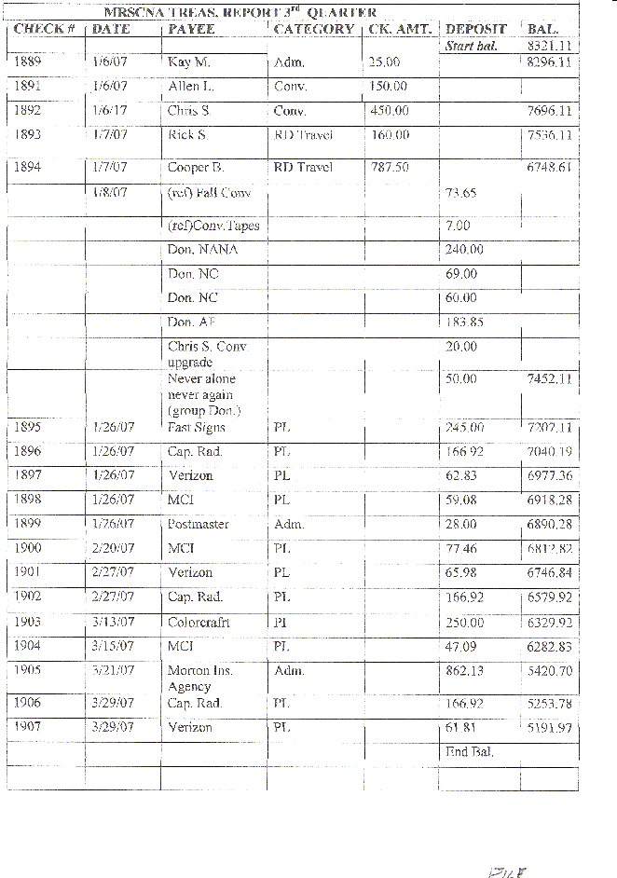
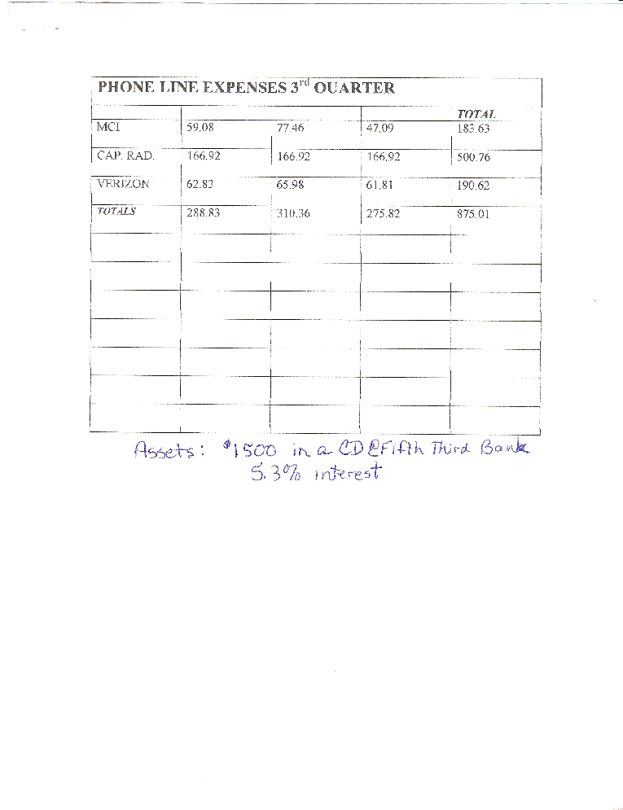
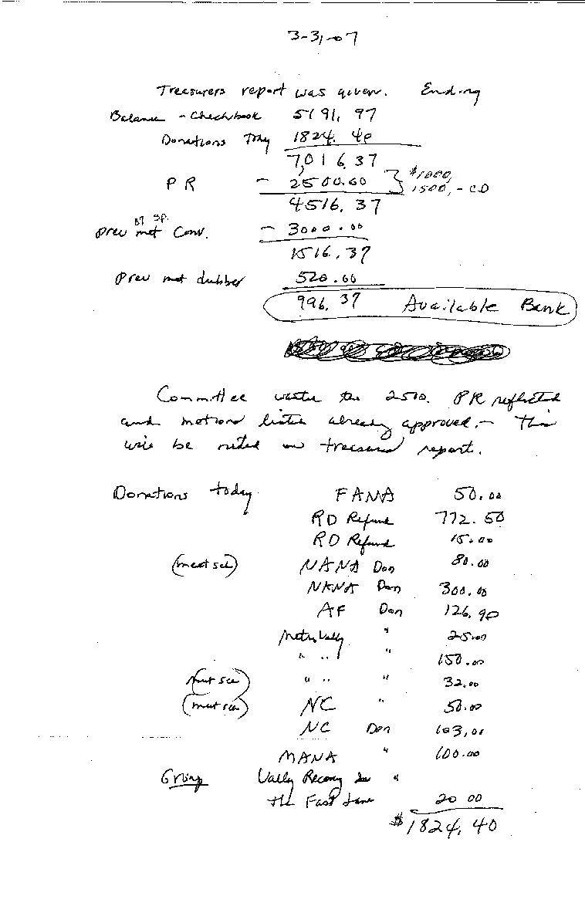
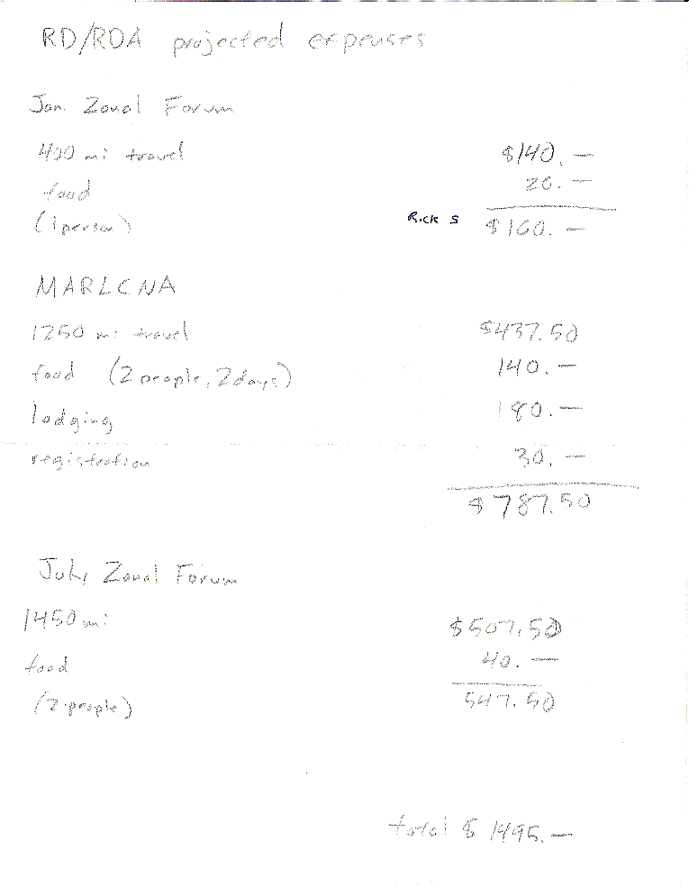

July 31, 2026

Greetings ________________________,

We have received your request to be placed on the Mountaineer Region’s Meeting Schedule and welcome your interest in becoming a part of our Regional Service Committee. A regional schedule accompanies this letter.

Our procedure is to place your meeting information, as listed in your letter, on the next updated schedule. In order to keep your meeting on the schedule, we ask that you:
- attend the next regional service committee meeting, OR
- join one of the areas that is closest to you so that their ASR can represent you at the next Regional Service Committee meeting. OR
- if that is not feasible for your group, send a letter to the region each quarter including meeting information and a brief report about the activities of your group.

We ask this to ensure that our meeting schedules are as accurate as is possible. We know from experience that meeting information can change often, and so we need to have confirmation of your meeting information at least quarterly.

The next Mountaineer Regional Service Committee of Narcotics Anonymous is ________________________. The quarterly meetings are held the first weekend of January, April, July, and October (calendar permitting). An agenda accompanies this letter.

something spiritual…..

Sincerely,

Kay M.
Secretary, MRSCNA

ATTENTION ATTENTION ATTENTION NEW AND REVISED INFORMATION SEE CHANGES BELOW

HOPE OUT THE HOLLER
Group of NA

Presents
A Pot Luck Picnic
And
Youth IP Workshop
Where you ask ?
At our Meeting Place Maranatha Baptist Church
Off the Tuppers Creek Exit on I-77
At the shelter
In the meeting room in the trailer on your right
When you ask ?
On May 5th 2007 12:30 to 4:30 pm
1:30 pm to 3:00 pm for the Workshop
3:00 pm to 5:30 pm for Food and Fun
Why you ask ?
Because it’s Spring
What can I do you ask ?
Bring stuff to eat and drink
We will provide hotdogs and the fixins
Bring games to play
Who will be their you ask ?
Everyone because no addict turned away
And It’s Free
For more info call
Allen L. (304) 395- 9264

