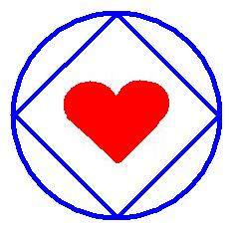

Greater Than Ourselves Area of Narcotics Anonymous Presents:
IN LOVING SERVICE

Saturday February 11th, 2012

26th St. BAPTIST CHURCH
2510 10th Ave. Huntington, WV 25703
26th Street & 10th Ave.

Phone Line Workshop 4:00-5:30pm
H & I Workshop 5:45-7:00pm
Dinner/Auction 7:15pm
Speaker Meeting 8:30pm

A fabulous dinner will be provided….
Donations of drinks, desserts, and NA auction items appreciated!

For More Info or Directions
Shane R (304) 812-4340
Brian H (304)416-3874

