P.O. Box 6164  College Station, Texas 77844-6164  979-694-9053  979-574-4121
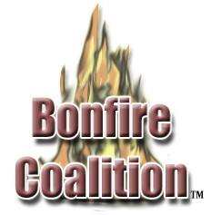
www.bonfirecoalition.org

A Report of the State of Collegiate
Bonfires in the United States:
Cost, Safety, and Insurability

February 11, 2003

Preface and Disclaimer

No collegiate tradition approaches Aggie Bonfire with regard to its magnitude, importance, and emotion for the Texas A&M family. Nothing in this report proposes that Aggies emulate anyone else, or that any other university’s traditions are superior to those practiced in Aggieland. Nevertheless, the tragic loss of twelve young lives on the morning of November 18, 1999 suggests that we study how other schools handle risk management issues associated with student-built bonfires. During the course of this investigation, we learned of no bonfire-related deaths or serious injuries at the sixty schools we surveyed and the nine that we studied in depth.

We submit this report in order to give Dr. Gates a few of the tools he will need in order to decide the long-term future of Aggieland’s beloved tradition. The Bonfire Coalition is, by its chartered mandate, an advocacy organization dedicated to the revival of Texas Aggie Bonfire as an on-campus event. However, this report strives to meet a standard of objectivity appropriate for an academic environment.

Scope and Timing

When representatives of the Bonfire Coalition met with Dr. Gates on October 16, 2002, one aspect of a five-point platform promised a nationwide study of collegiate bonfires. We expected to present this information to Dr. Gates during the first week of April, after which we would announce our results publicly. Recent developments have necessitated a timelier, albeit abbreviated, presentation.

What was once intended to be a comprehensive nationwide survey has been distilled into a sampling of universities from the State of Texas, a few athletic conferences, and the service academies and senior military schools. A total of sixty colleges and universities were contacted in time for this report. Almost twenty-five percent (14) had active bonfire traditions. We were able to make timely personal contact with responsible individuals at nine of these institutions. Those are the case studies we present here.

As the title suggests, this report intends to focus on the tripartite dilemma of cost, indemnification, and safety. Initially, we wished to omit physical structure of the bonfire stack as a factor. We believed that Dr. Gates had already received numerous suggestions and architectural proposals from interested Aggies. However, as our data came in, it became apparent that a bonfire’s structure is inseparably linked to how much it will cost to build and insure, and how to accomplish the task safely.

We are not engineers. Our goal is to report how other schools build bonfires safely and affordably. In doing so, we have used our research data to formulate norms for factors such as liability insurance, length of construction, and unfortunately but unavoidably, the size and composition of the bonfire stack.

Safety

Building Materials: The most common building material used in the nine case studies is a wooden pallet. Pallets are plentiful and easy to obtain by donation. Equally as important, their lengthwise orientation facilitates horizontal construction of bonfire stacks—structures that are wider at the base than they are tall. Some bonfires, such as Texas Tech’s, are composed entirely of pallets. Others, e.g., the University of North Texas, use horizontal telephone poles to constrain the lower level of pallets. At the Naval Academy, pallets are used in alternating vertical layers with quantities of straw. At West Point and Dartmouth, pallets serve as supplemental combustibles.

Of the nine universities surveyed, only one uses harvested trees. Dartmouth contracts with a local landowner, who cuts trees, saws them into 8x8 inch beams, and delivers the finished product to the construction site. Telephone companies donate poles to several projects, and the Naval Academy buys straw at a local farm supply store.

Stack Orientation: Horizontal is the key term.

Only two colleges build their bonfires taller than the diameter of the base. Engineering students supervised by their professors design Dartmouth’s bonfire. Nevertheless, the beams are laid parallel to the ground and decrease in width as the bonfire reaches its pinnacle. Navy’s bonfire is a modest trash pile without rigid structure.

Each of the seven remaining schools builds a bonfire with a dominant wide base. Even West Point’s containerized bonfire, the hull of a 35-foot boat, conforms to the horizontal norm.

Cost

In this era of decreasing state support for higher education, no university wishes to publicize an accurate accounting of how much money is used in a student bonfire. The most common tactic disguises bonfire costs within innocuous line items such as campus police and fire protection, facilities maintenance, and student services. Two surveyed schools, North Texas and Texas Tech, reported spending $3000 each on their respective bonfires. Others, such as West Texas A&M, responded with bonfire budgets in the hundreds of dollars. However, school officials readily admitted to liberal use of its environmental engineer and safety department for proactive supervision of student construction. University vehicles collect donated combustibles at several schools. At Texas Tech, an official in the Center for Student Life said that cleanup expenses, born completely by the university, are not included in the bonfire budget.

Although we believe that the actual cost of bonfires at the surveyed institutions exceeds the figures given, their costs pale in comparison to the $50,000 to $70,000 that Texas A&M spent annually during the recent era.

To examine this issue from another viewpoint, the studied universities do not hesitate to recognize the revenue potential generated by such honored traditions. For example, one Texas Tech alumni couple donated $300,000 to the university several years ago for construction of a permanent bonfire circle on campus. In homecoming press releases, Tarleton State and West Texas A&M tout the value of bonfire night for continued identification with one’s alma mater.

We believe that former students who consider donating to the university would perceive favorably the resumption of Texas Aggie Bonfire as an on-campus tradition.

Indemnification

Two surveyed institutions, the Military and Naval Academies, cite their status as federal agencies. Dartmouth, a private university, maintains that it is insured under its umbrella liability policy. Texas Tech requires student bonfire workers to sign waivers of liability. The balance of the study’s respondents submitted vague or incomplete answers to the section of the questionnaire that dealt with indemnification.

Even in the wake of the 1999 Texas A&M tragedy, prevailing attitudes seem to reject the possibility of a serious accident and resulting liability. Two reasons surfaced during interviews with bonfire principals. First, most schools believe that they have adopted proactive safety management procedures that were found lacking at Texas A&M in the investigatory report of the 1999 accident. For example, Tarleton State controls the height of its bonfire by planting a center pole that extends no higher than the maximum allowed height of bonfire. An overbuilt bonfire would become obvious if the top of the pole were no longer visible. Two universities, Texas Tech and Tarleton State, have written formal bonfire procedures manuals, and a series of articles in the West Texas A&M student newspaper stress the role of university employees in overseeing student bonfire activity. At Tarleton no student can work after midnight and at West Texas A&M no work is permitted during hours of darkness.

Second, relatively benign construction methodology, laying horizontal pallets in decreasing concentric rings, provides an aura of safety when compared to vertical stacking of logs that characterized Texas Aggie Bonfire in the modern epoch. It does not seem possible, to the officials surveyed in this study, that such a simple project can pose significant risk to workers.

Student Labor Issues

“We’re going to build the hell outta Bonfire in the fall, and then get off SchoPro in the spring.”

Contrary to the traditional cut and stack period at Texas A&M, construction at the studied universities ranges from a maximum of two weeks on several campuses to only four hours at the Naval Academy. Problems related to student academic performance seem to be mitigated by these comparatively short construction cycles and the relatively small number of students involved. Only ten Cadets work for a period of one day on West Point’s boat burning, although a larger number pull guard duty to protect against potential saboteurs from Annapolis. At most other schools the number active participants tops out at fifty, the membership of the spirit groups charged with building bonfire.

This report recognizes that a critical component of Aggie Bonfire tradition manifested itself in the almost year-around nature of the project for a dedicated core of bonfire adherents, and a cut and stack period that lasted for almost the entire fall semester for many more students. Many Aggies who remember long Saturdays at cut and the exhausting but rewarding nature of push week would find a bonfire experience at any of the studied schools to be unfulfilling. This study does little to solve that problem. For those who would accept an Aggie Bonfire project of less magnitude, however, the example provided by the studied universities mitigate the problem of students neglecting their studies in order to devote time and energy to the Bonfire project.

The school that does the best job of providing a role for different varieties of students is Tarleton State. Although the construction process lasts only two weeks, and involve no more than fifty students, the planning stage begins one month earlier. Student who do not build bonfire have the opportunity to make hand painted signs for their organizations. Several similar opportunities exist within the realm of Tarleton’s bonfire culture, which suggests that Texas A&M’s unique Bonfire culture must be amenable to such change.

Should the Bonfire tradition return to Texas A&M, one of the most significant challenges will be providing a role for every student who desires to participate. Innovation will be required on a scale not imagined at the studied institutions.

Applicability to Texas A&M

Bonfire grew. Bonfire grew in size (from a trash fire to a structure), grew in complexity from a single tiered cone to a multi-tiered wedding cake), grew in the number of people at the cut sites, grew in the number of people at the event, and grew in the number of problems. Most relevant to the 1999 collapse, the structure grew from a simple structure that could be “designed” and constructed by students to a complex and risk significant structure that could not.

The studied universities have successfully resisted the temptation to allow their bonfire traditions to grow out of control. Adoption of proactive management styles, using differing approaches, can be observed in the following case studies. Written bonfire manuals, involved administrators, widely disseminated baseline procedures, and safety education have contributed to a culture that stresses compliance rather than bending the rules. The studied universities have successfully managed student conduct issues through a similar proactive approach.

The uniqueness of A&M’s Bonfire also makes it expensive to underwrite. The basic rule of insurance is the law of large numbers. You attempt to spread similar risks as far and wide as possible so you don’t get a concentration of risk. In insuring an event like this, which is certainly unique in the country if not the world, you have an extreme concentration of risk.

The commonality of bonfires built at the studied universities increases the likelihood that they will fall under the provisions of the student activities insurance that all universities have. It is not clear from the information provided that all parties are sufficiently indemnified. It is possible that administrators are faced with a choice of canceling a tradition popular with students and alumni or assuming a risk of liability, which they attempt to minimize by effective institutional control. For Texas A&M, the challenge is to revive a popular tradition with a design benign enough to allow indemnification, while simultaneously maintaining the enthusiasm of the most dedicated Aggie Bonfire adherents.

Recommendation

The Bonfire Coalition believes that the ultimate configuration of a new Aggie Bonfire is less important than the return of the tradition itself to campus. Aggie Bonfire of the pre-1999 epoch evolved, and so will any Bonfire that returns to campus. We also recognize that for many traditional adherents, an Aggie Bonfire composed solely of pallets would be disappointing. Therefore, we have synthesized the lessons learned in this study, and asked one of our directors to use his engineering skills to envision what a horizontally constructed Aggie Bonfire could look like.

In this regard, the Bonfire Coalition suggests a hybrid structure, one that maintains the uniqueness of Texas Aggie Bonfire while conforming to the lessons learned in this study. Vertically stacked logs, especially in the multi-tiered design such as Aggies constructed in the modern era, are inherently unstable. Horizontal construction appears to provide the desired margin of safety.

The following two drawings illustrate such a concept. Figure 1 shows the traditional Aggie Bonfire building block, cut logs, arranged in a circular horizontal arrangement. Figure 2 suggests a similar arrangement if the most common building block founding this study, the wooden pallet, were used.
Horizontally Arranged Texas Aggie Bonfire with Logs
Figure 1

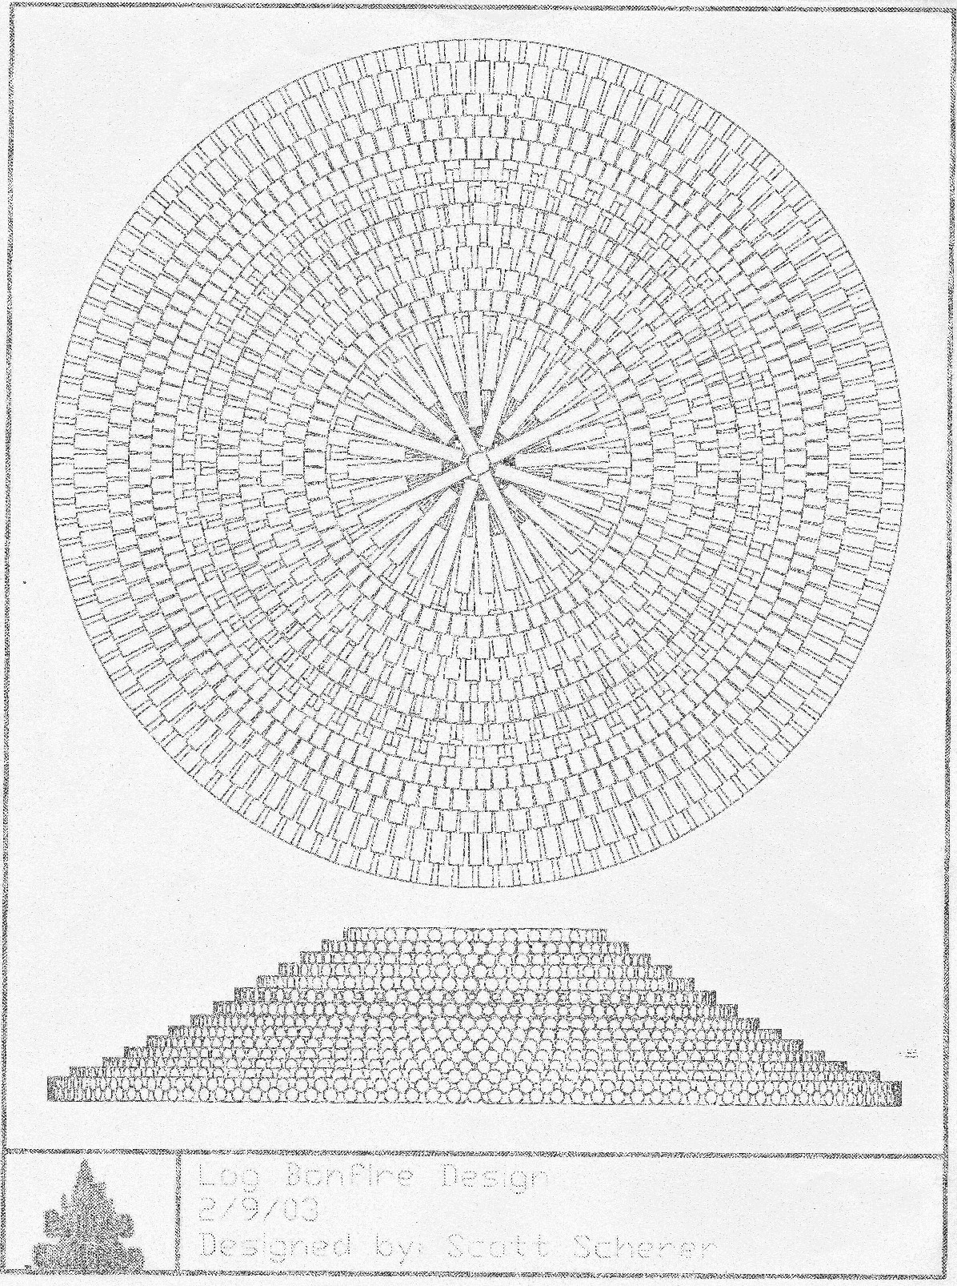

Texas Aggie Bonfire with Pallets
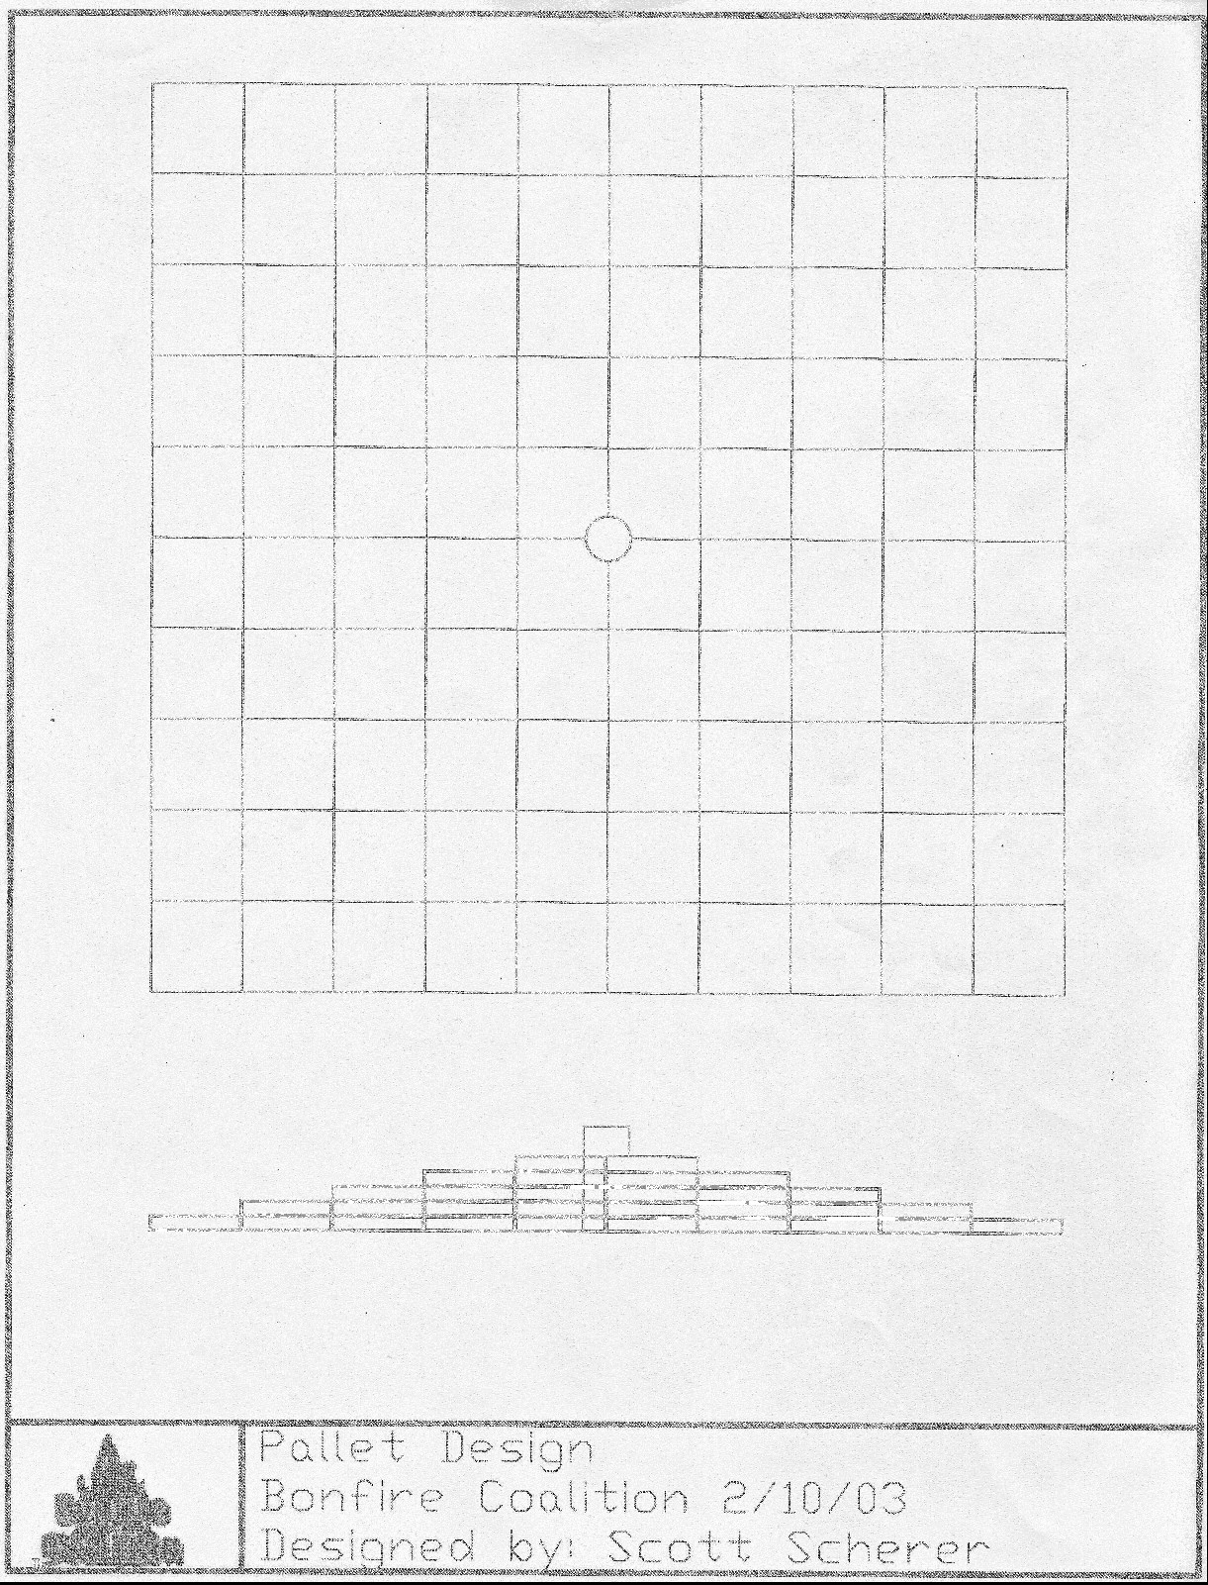
Figure 2

Dartmouth
College

Hanover, New Hampshire

. . . has a 100-year old bonfire tradition.

Dartmouth’s bonfire is unique in two respects. First, students in the Thayer School of Engineering, the nation’s oldest processional engineering department, design the project under supervision of their professors. Second, Dartmouth designs a vertical structure, taller than it is wider at the base. In that respect, and in a few others, Dartmouth’s bonfire bears some similarity to the traditional Texas Aggie Bonfire.

Dartmouth uses a combination of 8x8 inch beams and scrap wood. Freshmen, who wear green hard hats, fasten the first-tier beams in the design of a six-pointed star. The second tier uses shorter beams laid in the same alternating pattern to form a steeple of decreasing width as it nears the top. Two plywood 4x8 letters crown the bonfire. Upper classmen, wearing white hard hats, direct the freshmen. Staff members, who wear blue helmets, supervise from a distance.

Dimensions vary from year to year, but are approximately 30 feet high and 20 feet wide. The school acquires the timber from a farmer who cuts the beams a year in advance, so that they are sufficiently dry, and delivers them to the bonfire site a few days before homecoming. Pallets and other scrap wood form the bulk of the combustibles, which the students stuff inside the structure.

According to Joe Cassidy of the Office of Student Life, there has never been a serious injury associated with Dartmouth bonfire. An ambulance stands by during the two days that it takes to build bonfire. Last year, paramedics prescribed one band-aid.

Dartmouth’s bonfire is indemnified under the college’s umbrella insurance policy. At the time that this report went to press, Mr. Cassidy was researching the total cost of the bonfire.

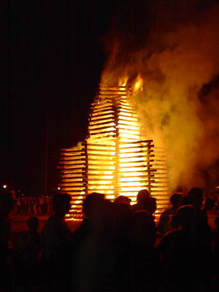
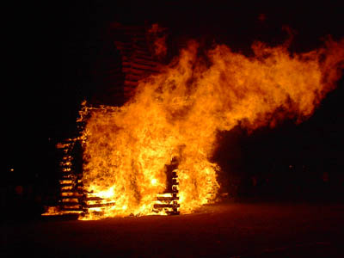

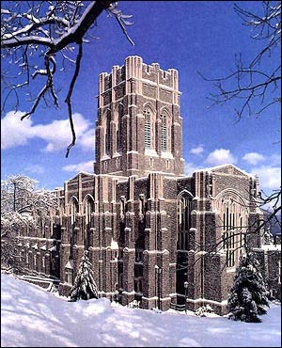
United States
Military Academy

West Point, New York

. . . has a bonfire tradition that dates to the 19th century.

Located on the banks of the Hudson River, and with a natural rival in the U.S. Naval Academy, it is not surprising that cadets at West Point celebrate their bonfire tradition by burning a boat!

Army bonfire is a cooperative effort among students, staff, alumni and friends of the Academy. Every school year the Academy seeks donation of a 35-foot wooden boat. Sometimes it makes its last voyage up the Hudson; often it arrives on a flatbed truck. Except for ongoing efforts to acquire a boat each year, serious planning begins three weeks prior to bonfire, which burns on the Thursday prior to the Army-Navy game. (On at least one occasion it burned on Wednesday night, thanks to Naval Academy midshipmen serving exchange tours at West Point.)

The Academy safety department and environmental engineer are actively involved in the bonfire project. Staff members operate the only machinery, a crane that lifts the boat from its trailer. It spends two days at the boat yard, where staff removes fuel tanks, the engine, and other metal parts. Students pack the decks and surround the hull with pallets and scrap wood. Only ten cadets are involved in this process, but a larger contingent guards the boat continuously from its arrival on campus. The final dimensions, including extra combustibles, are approximately 40 feet in length, 16 in width, and 12 in height.

The Academy’s fire chief oversees the project. According to Chief Krieger, no one has sustained a bonfire-related injury. The Army is self-insured. Approximately 5,000 spectators turn out for Army bonfire, but 12 inches of snow limited last year’s attendance to 2,000.

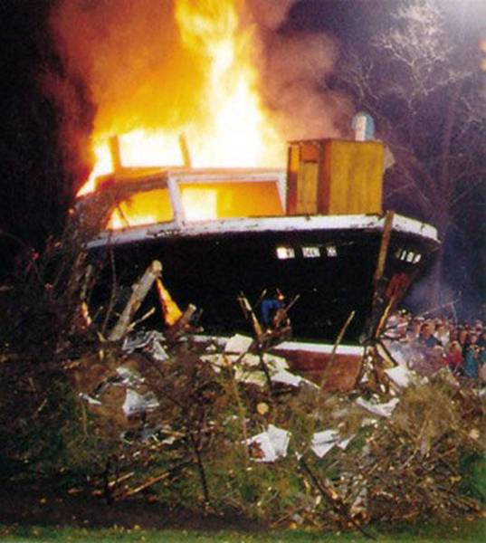

USMA bonfires,
circa 1998 & 1967

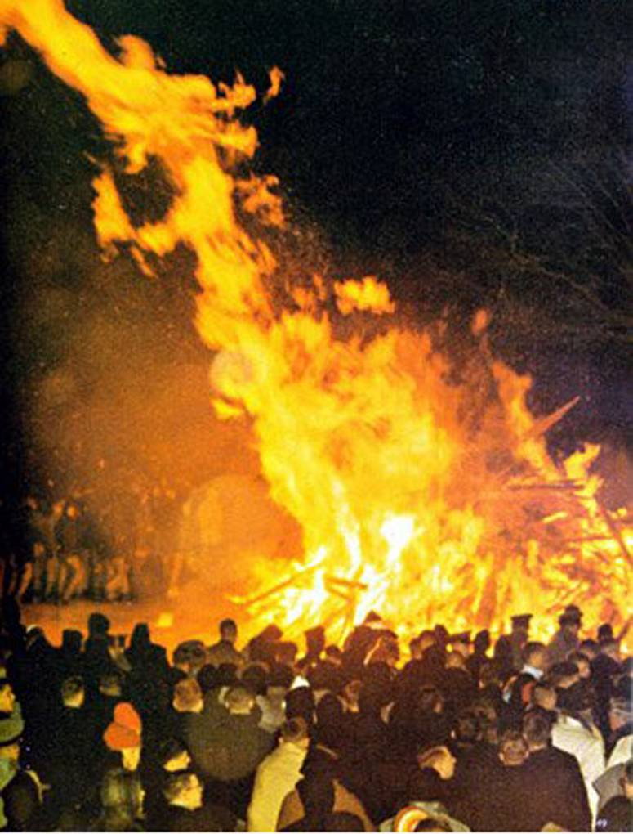

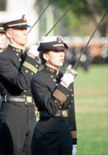
United States
Naval Academy

Annapolis, Maryland

. . . has a bonfire tradition that
dates to the 19th century.

Naval Academy midshipmen get ready for the Army-Navy game by roasting the West Point mule over a trash-pile bonfire. The football team’s send-off celebration includes a fireworks display and a pep rally. The event caps a week of spirited high jinks pitting the Academy’s 4,200 midshipmen against eight Army exchange students and West Point’s liaison officer. Army cadets find their shoes glued to the deck and their mattresses thrown into shower stalls, but they usually retaliate by painting a statue of the Naval Academy’s goat in black and gold Army colors.

On Thursday evening midshipmen burn a pallet and straw bonfire. Its center pole serves as a gallows and roasting point for the Army mascot. The pole is mounted slightly off center so that the mule can hang from a cross beam in the middle of the flames.

Preparations begin the previous week when the Midshipmen Activities office issues an operations order that includes such mundane details as which feed and seed store should be patronized for the straw. According to Lt. Mike Morgan, there is no bonfire operations manual. The order is based on pass-down tradition and “we’ve always done it that way” philosophy. Safety ropes demark a 30-foot radius of the bonfire pit and a 50-foot radius of the fireworks launch area. Despite the habitually cold weather, the operations order prescribes a 75-foot plastic tarp and orders the campus fire department to wet it down for “carrier landings.” Bonfire construction takes four hours.

Incidentally, the unfortunate mule is a stuffed animal.

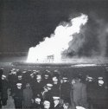

A Naval Academy bonfire in 1949

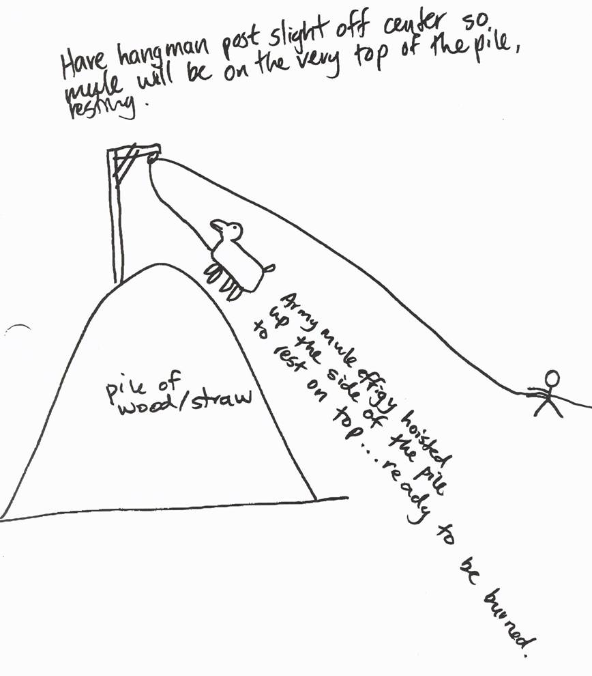

Drawing from

USNA’s bonfire
Operations order

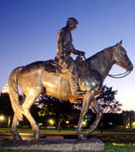
Texas Tech
University

Lubbock, Texas

. . . has a 65-year old bonfire tradition.

For many years, bonfires were spontaneous celebrations at Texas Tech. According the university’s Bonfire Operations Manual, early bonfires were “only a few feet across and sometimes there were fires for every home game.” As the bonfire tradition matured, the university received a $300,000 donation for a permanent Campus Conference Bonfire Circle east of United Spirit Arena. It features a concrete base and metal fire barrier.

Modern Red Raider bonfires burn prior to the annual homecoming game, but extensive planning and post-fire routines take much longer than the eight-hour construction time. The Saddle Tramps, a 50-member student spirit organization, build bonfire according to a “detailed schedule and plan” submitted weeks earlier. The Operations Manual limits the height to 16 feet and the width to 20 feet. Saddle Tramps build the structure, ignite it, and then stand guard until the last ember dies. The university spends $3000 each year on its bonfire.

Wooden pallets are the combustible du jour, but the guidelines are more specific about what may not be burned: “electric insulation, asphaltic materials, potential explosives, chemical wastes, etc.” A prohibition on burning grass or hay appears in boldface type. Forecasts must indicate that the surface wind will blow at a velocity between six and 23 mph for proper smoke dispersal. Flag persons must be posted if the smoke blows across a road. The University Police and Saddle Tramps man dual concentric 60- and 200-foot perimeter barricades. Horseplay, alcohol and “intoxicated persons” are prohibited from the bonfire site. Two weeks after bonfire, university officials and Saddle Tramps hold a debriefing.

As many as 6,000 spectators turn out for the annual bonfire, which has been rescheduled for inclement weather on occasion. According to Jana Vise of Tech’s Center for Campus Life, student workers must sign waivers of liability. No specific indemnification for bonfire injuries exists. A student newspaper article indicates that Texas Tech wrote its bonfire manual after the 1999 TAMU tragedy.

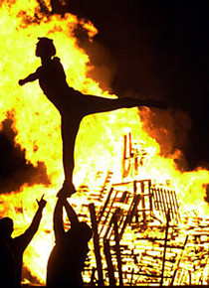
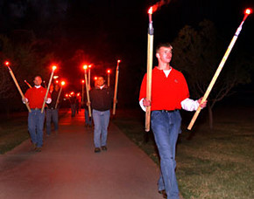

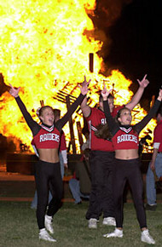

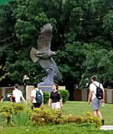
The University of
North Texas

Denton, Texas

. . . has a 66-year old bonfire tradition

With the Texas Aggie Bonfire tradition in hiatus, the University of North Texas boasts the largest collegiate bonfire built in Texas and perhaps in the nation. The first UNT bonfire burned in 1936, but to date their have only been 43 bonfires. The tradition was suspended during wartime and periods of drought.

Composed of telephone poles and pallets, the North Texas bonfire is a pyramid that measures 40 feet in length and width, and 25 feet in height. One telephone standard serves as the traditional center pole, and the remaining poles are place horizontally to define the lateral limits of the pyramid, as well as to constrain the lowest layer of pallets. Pallets are tied together, and to the phone poles, with bailing wire

This is an off-campus bonfire. It burns across I-35 from the school on a private golf course. The golf club donates the use of its land.

Local businesses donate the combustibles. Verizon provides the phone poles, and a local brewery offers all of the pallets needed. The phone company delivers and installs the poles, but the students build the pallet pyramid in a stair-step design. The Talons, UNT’s spirit organization that numbers about 50 students, is in charge of the bonfire. However, one does not have to be a member of this group in order to take part in the construction. According to an interview with the Erin Causey, the Talons’ “bonfire chair,” the “top 23 hardest workers” are rewarded with the honor of lighting the bonfire.

The University of North Texas contributes approximately $3000 annually to bonfire expenses, which consist of rented trucks, light towers, diesel fuel, and torches. Funds come from student services budget.

There is no professional design and apparently little administrative supervision of this student-led project. No supplemental liability insurance is underwritten to cover the risks of bonfire construction.

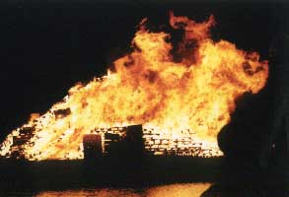

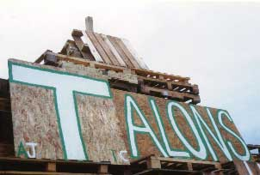

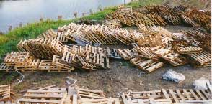

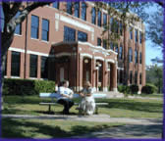
Tarleton State
University

Stephenville, Texas

. . . has an 80-year bonfire tradition.

If one seeks an example of how Texas Aggie Bonfire has influenced smaller schools without our resources, it is necessary to go no farther than Stephenville.

Tarleton State’s massive pallet bonfire emulates the traditional wedding cake and features a center pole. However, pictures on the web site indicate that center pole plays no structural role; it is there for appearance only. The 1999 A&M tragedy caused President Dennis McCabe to undertake a comprehensive review of Tarleton State’s bonfire. A Bonfire Rules and Procedures Manual resulted. Like A&M, Tarleton has had to move its bonfire because of the concerns of nearby residents.

Unlike bonfires in A&M’s past, Tarleton builds a structure much wider at the base. Maximum dimensions are 40 feet in height and 75 feet in diameter. Construction begins approximately 15 days prior to its burning on Homecoming eve. The Texas Plowboys, a spirit organization, assumed control of the event in 1988, which has a history that dates to the 1920s. Some 30 to 40 students build it. Construction site rules require workers to sign in and sign out.

Tarleton State names its bonfire. Officially, it is the L.V. Risiner Bonfire. Other homecoming events appear to have named sponsors.

Businesses donate pallets and students gather brush for the core of the structure. An interview with Plowboy Chris Mason reveals that “construction engineers” design the bonfire and that campus safety staff monitors the process. However sophisticated Tarleton may wish to appear, the down-home, folksy nature of its bonfire reveals itself by Internet appeals for “more pallets, ” the use of personal pickup trucks to transport brush, and the apology of one plowboy who got so busy with bonfire that he forgot to make lunch for everyone.

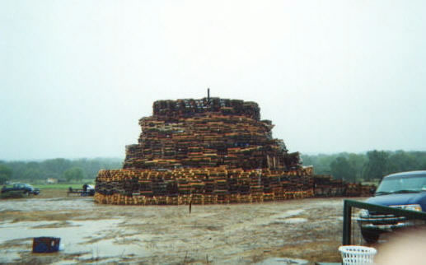

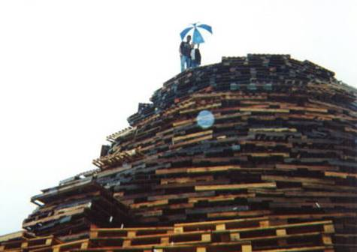

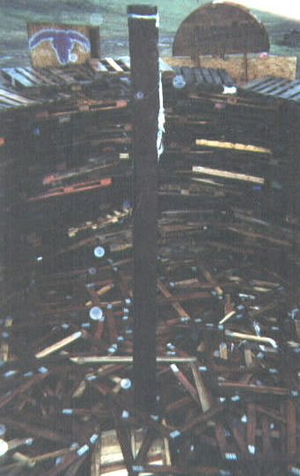

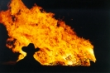


West Texas A&M
University

Canyon, Texas

. . . has a 10-year old bonfire tradition.

Students and administrators at West Texas A&M are bullish on their young bonfire tradition. Each year they try to build it bigger than before, but mindful of the 1999 tragedy College Station, they emphasize safety and environmental impact.

“A&M’s bonfire was built with logs only,” said RHA President Mital Patel. “We use palettes. We use them because they are sturdy. They can go as high as they want. Environmental safety comes out to make sure it’s safe.”

Speaking of the October 2002 bonfire, Liz Moore, co advisor for the RHA, said: “This year we started a week early to make it bigger and better.” Bonfire now takes two weeks to construct. Kathy Green, the university’s environmental safety coordinator, said: “The more students that work on the bonfire, the more environmental safety checks on the site. We make sure the structure itself is sturdy.”

West Texas A&M officials see little need to limit the number of hours that a student works on the project. However, no one is allowed to build after dark. On bonfire night, the ten campus organizations that have worked on bonfire the most are allowed to carry the igniting flame in a torch procession. The individual who has logged the most hours receives the honor of setting bonfire ablaze. That student is designated, “Spirit of the Flame,” and his or her name is inscribed on a plaque in the Student Government office.

Despite the emphasis on bonfire, West Texas A&M spends only $300-400 on the tradition. Center pole and the pallets are donated.

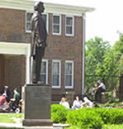
Texas A&M-Commerce

Commerce, Texas

. . . has had a bonfire tradition for
at least 26 years.

Students at TAMU-Commerce have been building a modest bonfire since the days when the school was called East Texas State University. According to Dr. Joe Weber, Dean of Students, members of the Greek system build the bonfire. They build a trash pile, made up of logs and scrap wood donated by the community. It takes two weeks to build and usually burns on the Thursday of homecoming week. The bonfire has a center pole. No budget information is available, and no supplemental insurance exists for bonfire. The tradition appears to be a minor one, as not one picture of bonfire appears on the TAMU-Commerce web site.

* * *
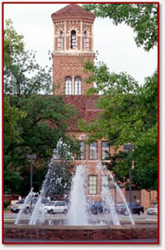
Midwestern State University

Wichita Falls, Texas

. . . has had a bonfire tradition since the 1980s.

When Midwestern State began its football program in the 1980s, students began building a pallet bonfire with a center pole. According to Leslie Ponder, Director of Student Activities, bonfire takes two days to build and “is no more than 20-30 feet tall and 40 feet around.” The university furnishes a truck to pick up pallets donated by local merchants. The Residence Hall Association and Student Government provide leadership for the project. The campus fire department checks bonfire before it is ignited to insure that no plastics or other hazardous materials are burned. The director of student activities oversees the project for the university, but no written guidance exists.

John LeBas, “Budget for ’02 Bonfire Released,” Bryan-College Station Eagle, Feb. 6, 2002.
A popular student phrase used to justify long hours spent on Bonfire construction during the academic year.
“Behavioral Cause Analysis of the1999 Bonfire Structure Collapse at Texas A&M University,” Performance Improvement International. Report 00-1429, May 2, 2000.
Joe Annotti, National Association of Independent Insurers, in John LeBas, “Budget for ’02 Bonfire Released,” Bryan-College Station Eagle, Feb. 6, 2002.

