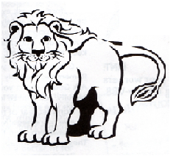
Light of Christ
Light of Hope Kid’s Kamp
Safari adventure

2530 south Broadway  281/471-1195

July 18 to 29, 2005 10:00 a.m. to 4:00 p.m.

We’re going on a Safari and we love
to have you come along!
One form per child, please.

Child’s name
Grade completed Birthday Age
Parent’s names
Address
Home phone Cell phone
Emergency contact person
Relationship to Kamper
Home phone Alt. phone
Food allergies Y N List:
Medical concerns Y N Explain:

Family doctor Doctor’s phone
Siblings attending Kid’s Kamp (name and ages)

Church affiliation Attendance 1 2 3 4 5

