(The Descendants of James Viverette of Nash County, NC continued)

The Viverette Reunion

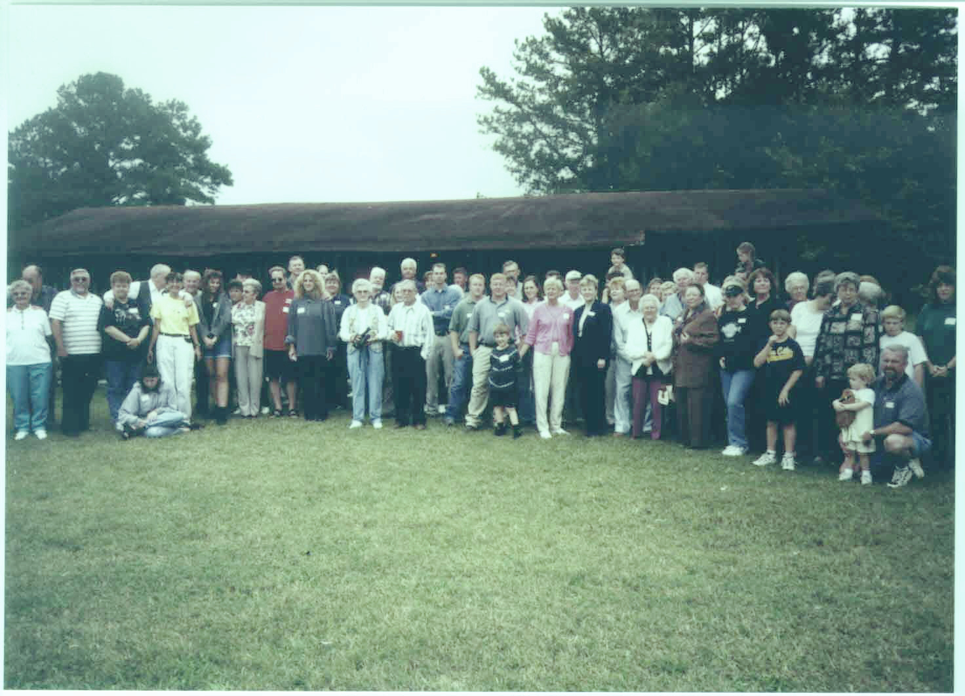

The Annual Viverette Reunion in Enfield, North Carolina
This is a picture of the reunion from 2000. Most of the relatives here are from the Andrew Jackson Viverette branch; however, more and more descendants from other parts of the country have been attending. This year relatives from Tennessee, Virginia, Texas, and Maryland joined the ones from all parts of North Carolina. The children of the late Stanton Viverette organize and sponsor the reunion.

