(Lancelot Vivrett’s Descendants continued)

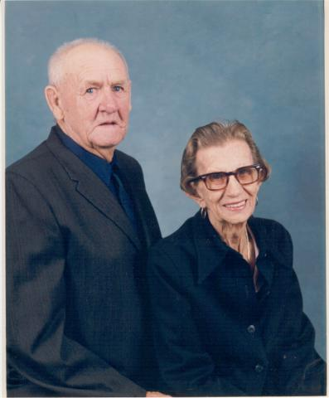
Pictured here is Thomas Jefferson Vivrette (1904-1992) with his wife Leola. Thomas was the son of Robert Vivrett, the grandson of Lancelot Alanson Vivrette, and the great grandson of Lancelot. Alanson left Wilson County, TN after 1860 and moved first to Illinois and then to Kentucky near Hickman County. Almost all of the Kentucky Vivrettes come from this branch.

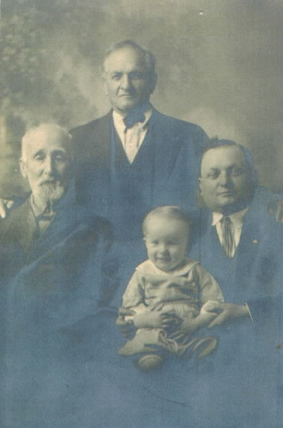
Alanson’s brother Henry Vivrett had sons who migrated to Missouri. One was Henry Jasen Vivrett who settled around the Desoto area. With him is son William (standing), grandson Henry, and great grandson Howard Henry.

