(Lancelot Vivrett’s Descendants continued)

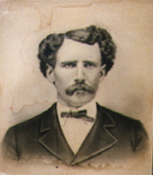
John Thomas Vivrett(1844-1921) was the son of Micajah Thomas Vivrett and the grandson of Lancelot. He migrated with several of his brothers to the Waco area of Texas.


His son, Macager Louis Vivrett (1888-1964)

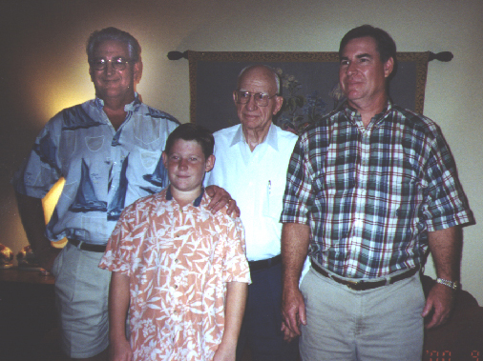
Macager Louis Vivrett, Jr. with sons John Jarrel Vivrett and Macager Louis Vivrett III and grandson John Jarrell Vivrett, Jr.

