(Micajah’s Descendants continued)

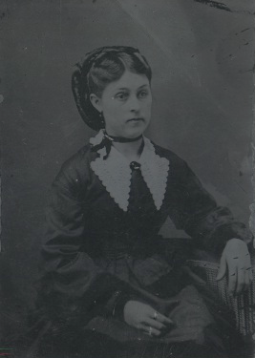
This young lady was also a daughter of Larry Vivrett. This picture was found in the belongings of Mary Vivrett Smith and was simply labeled “sister.”

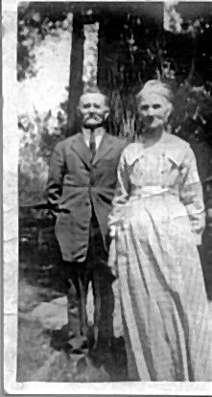
Henrietta Vivrett was also the daughter of Larry Vivrett, She married William R. D. Mitchener in Tennessee in 1875. This union produced five children: Woodie, Josie, Tennie, Dale, and Larry (pictured below).

