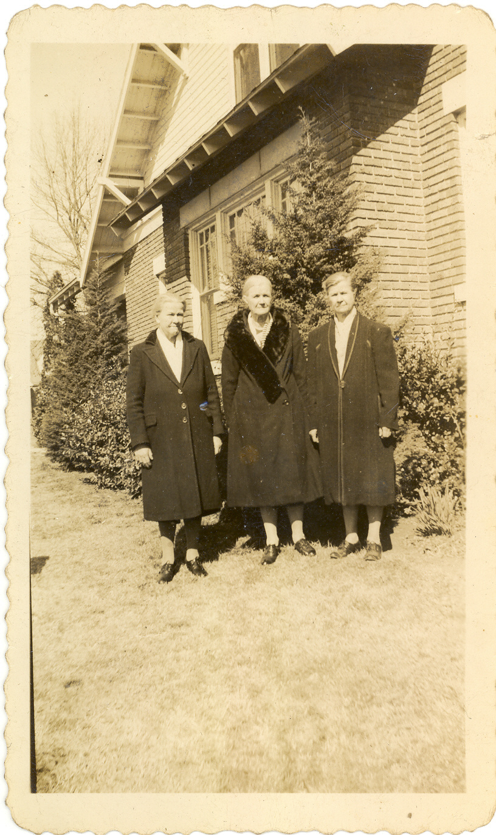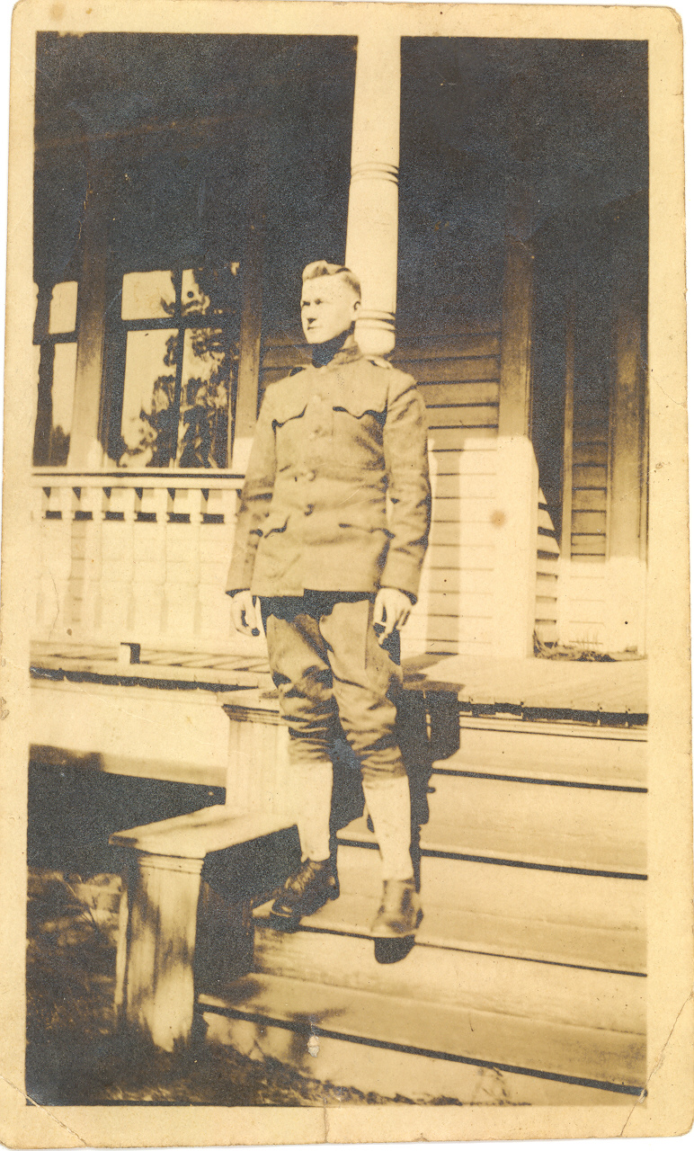
Etta, Ella, and Emma Green, daughters of Blessing Viverette Green and granddaughters of Andrew Jackson Viverette
William Lonnie Green (1894-1974) their brother

