The Viverette/Vivrette/Vivrett Family

Almost all of the Viverettes (also spelled Vivrette, Vivrett, and Viverett) can trace their ancestry to Thomas Viverett (1750-1791) of Nash County, North Carolina. Sometime after 1770 Thomas married the widow Elizabeth Hickman Dew. There were four sons from this union: Henry, Lancelot, Micajah, and James. Henry apparently never married and died around 1800. Micajah and Lancelot left home and eventually wound up in Wilson County, Tennessee. James remained on the home place with his mother. Micajah married Elizabeth Bond and had eight children. He died in 1816 in the last years of the War of 1812 while serving under Andrew Jackson. His descendants are scattered around the country with concentrations in Tennessee and California. Lancelot married Mary Polly Hickman and had five sons. His descendants are also scattered around the country with concentrations in Missouri, Kentucky, and Texas. Most of James and Blessing Viverette’s descendants live in North Carolina, but there is also a concentration in Mississippi. These three sons are the patriarchs of the Viverette family in America.

Here are some photos of some of their descendants.

Micajah’s Descendants

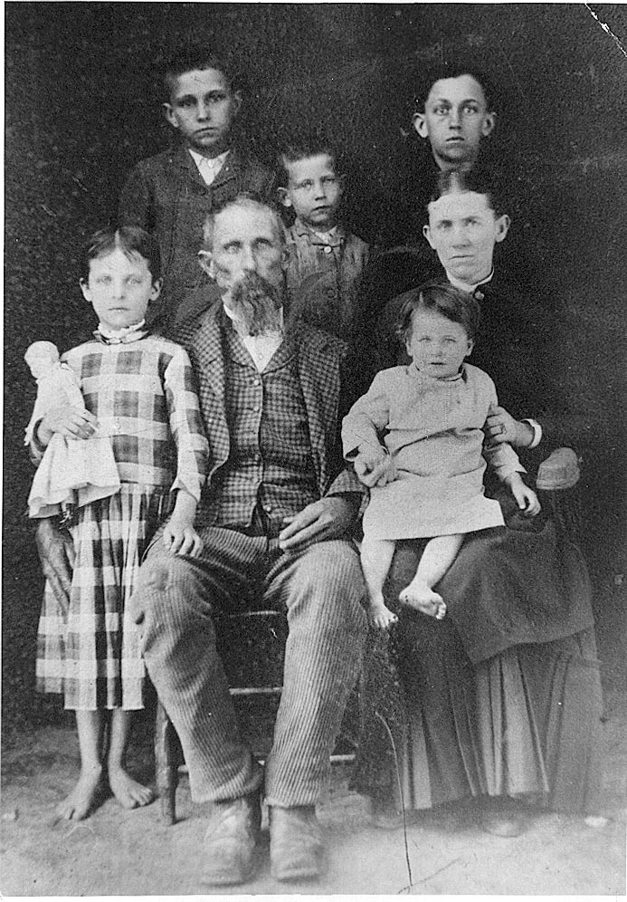
The Family of James Monroe Vivrett

James Vivrett was the grandson of Micajah. He fought in the Civil War and raised his family in Wilson County, TN. Many of his descendants live in California today.
Mary Ann Vivrett (left) was the daughter of Larry Vivrett. Larry was the youngest son of Micajah. Seated is believed to be her husband Wilson Smith. The lady on the right is an unknown relative.
