Miscellaneous Family Pictures
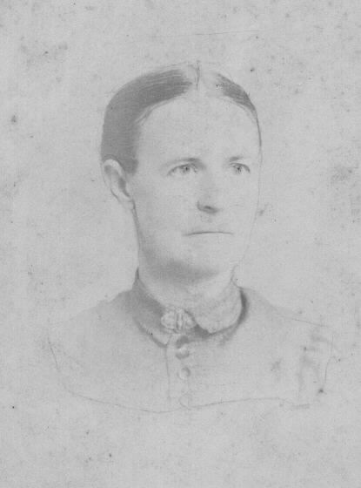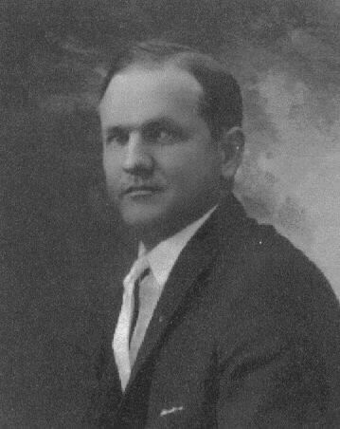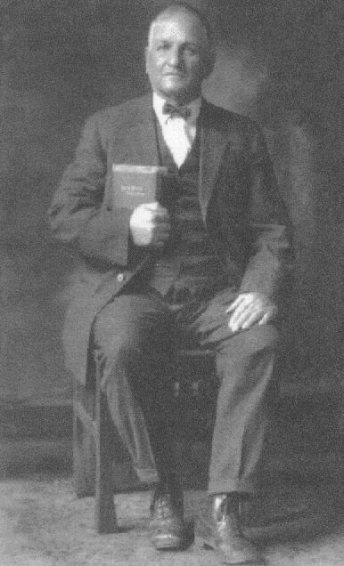
Elmer Joseph Vivrett (1891-1980) Grandson of Henry Jacen Vivrett of Missouri
Mary Savannah Hales King
(1863-1938) Granddaughter of Andrew Jackson Viverette
North Carolina
William Washington Vivrett
(1861-1931) Son of Henry and father to Elmer
Missouri

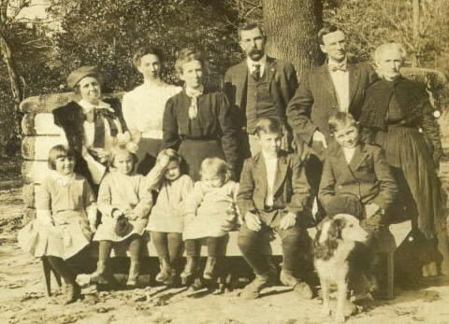

The Descendants of Obedience Viverette Weaver
Adults L-R...Guest Mrs. Britt, Nannie Laverna Weaver, Mary Lillia Weaver Batts, William Henry Batts, Frank Weaver, Martha Elizabeth Pollard Weaver.
Children L-R...Daughter of Mrs. Britt, Annie Laverna Batts, Mattie Batts, Thurla Gwaltney Batts, Willard Erle Batts, and Claudius Ola Batts.
1910 in Nash County, NC

