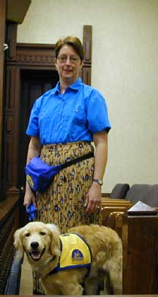
The 13th juror (Posted on Monday, January 14, 2002)

By Steve Wienberg
It was his first time to sit on a jury.
Texas law requires a jury of 12 people to sit in judgement of a defendant in a criminal felony trial. Last week, however, in a family violence case in Judge Ralph H. Walton’s courtroom, a “13th juror” was present throughout the proceedings.
The judge hadn’t broken the law or ignored procedure. That additional “juror” was Ruston, a five-month-old Golden Retriever/Labrador mix who is a dog in training. The trainer and real juror was Christina Bredenkamp She’s had the dog for about three months.
According to district court bailiff Harold “Clem” Clemmons, Bredenkamp was on a list of prospective jurors when she arrived at the Hood County Courthouse to do her civic duty.
“The dog was with the woman when I collected personal information cards from each person,” says Clemmons. Clemmons assumed the dog, who was wearing a cape, was a seeing-eye dog. He says at the time he thought the woman might be completely blind or “legally blind” and could perform the duties of a juror. That is, she had some existing sight. He says the law only requires that a juror be able to read and write. “I told Judge Walton about the woman and her dog and mentioned that I didn’t know if there was any rules prohibiting her from serving on a jury.”
Obviously, the judge concurred. “When the judge asked if the jury was ready, I answered, ‘yes sir, all 13,’” says Clemmons. Ruston turned out to be the perfect guest in the courtroom. The trial began at about 8:30 a.m. and lasted until about 6 p.m. “The dog sat on the front row and never moved,” says Clemmons.
In addition to breaks during the trial, Penny Weisend, an assistant court administrator, brought Ruston a bowl of water. According to courtroom observers, Ruston appeared to be an attentive listener throughout the day. The dog was present but didn’t participate in the final deliberations. The jury found the defendant not guilty. It turns out Bredenkamp participates in a program to train Ruston, and other dogs, to become a Canine Companion for Independence (CCI). (The Hood County News ran a profile May 10, 2000 about the Bredenkamps and their work with CCI.) During the 15-month training program she is required to take the dog with her, wherever she goes. As Ruston progresses in his training, says Bredenkamp, her husband Henry will take the dog to work with him at Bell Textron. Unfortunately, she remarked, her employer, Lockeed Martin, has no policy to allow the dog to come to work with her. However, Ruston will always be welcomed at the Hood County Courthouse. After a jury has served, it is Judge Walton’s practice to send jurors a letter thanking them. Weisend suggested that such a letter be sent to Ruston and even prepared one, but, of course, didn’t send it. The court staff appeared to enjoy the dog’s presence and the break in tradition. Ruston was truly among a jury of his peers.


