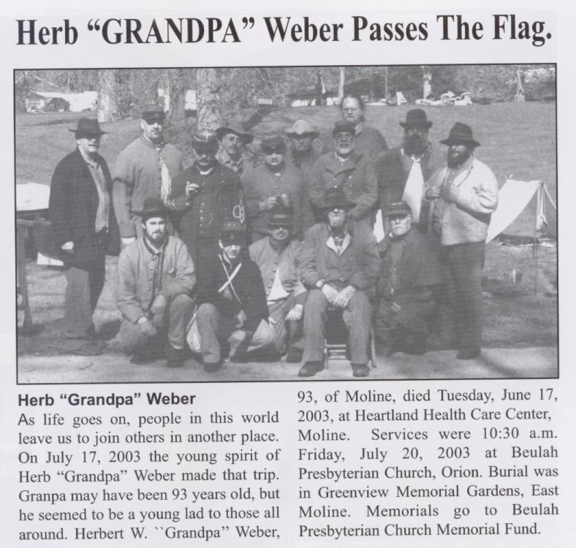

Last Troop Picture Taken At The Keokuk, IA. Event, April 2003.

Back Row, Left to Right: Keith Decker, Jim Anderson, Bruce Kindig, Frank Goossens, Chuck Curl, Terry Hoehn, Don Harker, Ron Reid, & Mike Burton.

Far Back: Rusty Mc Cracken.

Front Row Left to Right: Greg Tipsword, Jason Sparrow, Lester White, Herb “ Grandpa” Weber, & Gene Jorandby.
