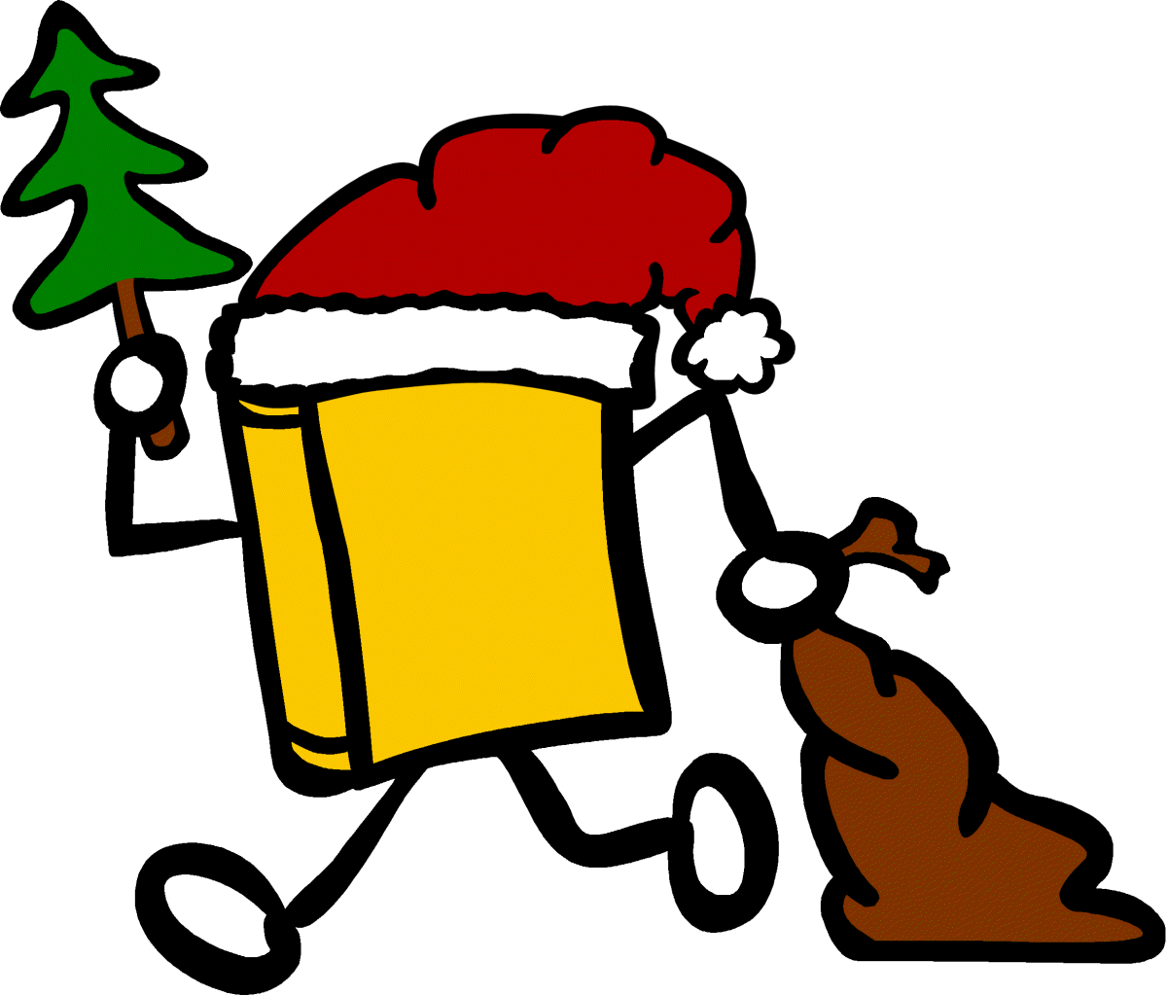
My previous readers want to know where I’ve traveled!
Please go to www.Bookcrossing.com and make a
Journal entry with the BCID number inside my front cover,
Then read and release me!

My previous readers want to know where I’ve traveled!
Please go to www.Bookcrossing.com and make a
Journal entry with the BCID number inside my front cover,
Then read and release me!

My previous readers want to know where I’ve traveled!
Please go to www.Bookcrossing.com and make a
Journal entry with the BCID number inside my front cover,
Then read and release me!

My previous readers want to know where I’ve traveled!
Please go to www.Bookcrossing.com and make a
Journal entry with the BCID number inside my front cover,
Then read and release me!

My previous readers want to know where I’ve traveled!
Please go to www.Bookcrossing.com and make a
Journal entry with the BCID number inside my front cover,
Then read and release me!

My previous readers want to know where I’ve traveled!
Please go to www.Bookcrossing.com and make a
Journal entry with the BCID number inside my front cover,
Then read and release me!

My previous readers want to know where I’ve traveled!
Please go to www.Bookcrossing.com and make a
Journal entry with the BCID number inside my front cover,
Then read and release me!

My previous readers want to know where I’ve traveled!
Please go to www.Bookcrossing.com and make a
Journal entry with the BCID number inside my front cover,
Then read and release me!

My previous readers want to know where I’ve traveled!
Please go to www.Bookcrossing.com and make a
Journal entry with the BCID number inside my front cover,
Then read and release me!

My previous readers want to know where I’ve traveled!
Please go to www.Bookcrossing.com and make a
Journal entry with the BCID number inside my front cover,
Then read and release me!

My previous readers want to know where I’ve traveled!
Please go to www.Bookcrossing.com and make a
Journal entry with the BCID number inside my front cover,
Then read and release me!

My previous readers want to know where I’ve traveled!
Please go to www.Bookcrossing.com and make a
Journal entry with the BCID number inside my front cover,
Then read and release me!

My previous readers want to know where I’ve traveled!
Please go to www.Bookcrossing.com and make a
Journal entry with the BCID number inside my front cover,
Then read and release me!

My previous readers want to know where I’ve traveled!
Please go to www.Bookcrossing.com and make a
Journal entry with the BCID number inside my front cover,
Then read and release me!

My previous readers want to know where I’ve traveled!
Please go to www.Bookcrossing.com and make a
Journal entry with the BCID number inside my front cover,
Then read and release me!

My previous readers want to know where I’ve traveled!
Please go to www.Bookcrossing.com and make a
Journal entry with the BCID number inside my front cover,
Then read and release me!

My previous readers want to know where I’ve traveled!
Please go to www.Bookcrossing.com and make a
Journal entry with the BCID number inside my front cover,
Then read and release me!

My previous readers want to know where I’ve traveled!
Please go to www.Bookcrossing.com and make a
Journal entry with the BCID number inside my front cover,
Then read and release me!

My previous readers want to know where I’ve traveled!
Please go to www.Bookcrossing.com and make a
Journal entry with the BCID number inside my front cover,
Then read and release me!

My previous readers want to know where I’ve traveled!
Please go to www.Bookcrossing.com and make a
Journal entry with the BCID number inside my front cover,
Then read and release me!

