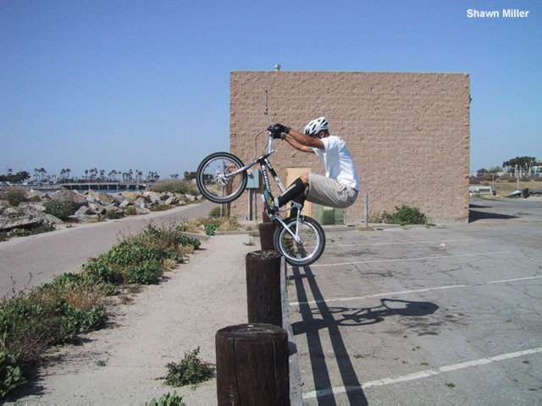


 Ride Safe
Editor:
- Brandon Keith
Design and Layout:
- Cassie Lizbeth
Authors:
- Chris Urban
- Justine Youssef
- Amanda Knicker
Published quarterly by:
- Ride Safe, Inc.
- P.O. Box 888
- Warrenville, IL 60555
- 800-555-RIDE
- Fax: 630-555-9068
© Copyright 2001 by:
- Ride Safe, Inc.
- All rights reserved.

The Light Bulb Test

To illustrate the effectiveness of a bicycle helmet, try the following. Wrap a light bulb in plastic wrap, seal the bottom with a rubber band and place it in a bicycle helmet. Secure the light bulb with tape and drop the helmet onto a flat, hard surface from above your head. The light bulb will not break. In most cases, it will even still light. Now, drop the light bulb without the protection of the helmet. The light bulb will produce a sick thud as it breaks. Helmets can make a difference.

Caution: Parents, this experiment is meant to be done by you or under your close supervision.
When Should a Helmet Be Replaced?

- After a crash. Almost all bicycle helmets are designed to absorb the impact of a crash so that your head is protected. This damages the foam liner and reduces its ability to protect in the future. If you are involved in a crash and your helmet hits the pavement, it should be carefully inspected and/or replaced. Most manufacturers offer free inspection services and sometimes even free crash replacement policies.
- When it doesn’t fit. Bicycle helmets must fit correctly to offer the intended protection. See your owner’s manual for information on how to achieve a correct fit.
- After three to five years. The Snell Memorial Foundation recommends that you replace your helmet after five years. Due to advances in technology and performance, we suggest your helmet be evaluated after three years. Normal wear and tear due to drops and exposure gradually reduces a helmet’s strength and protection capabilities. Helmets that receive extremely rough treatment should be considered for replacement even earlier. Does you child carefully hang up his/her helmet or is it tossed in the corner?
- When it isn’t being worn. For whatever reason (not comfortable, too hot, too heavy, too old, doesn’t match the new hat or coat, etc.), it may be time for a new helmet. Manufacturers have made dramatic improvements in style, weight, ventilation and cost over the last few years. If you and your children are not wearing helmets, there is nothing like a brand-new one to renew your interest and commitment.

Certainly not the children of Silverton, Oregon! One of the biggest reasons children don’t wear bicycle helmets is because their friends don’t wear them. By getting all the children in your school or neighborhood to order bicycle helmets at the same time, you can help turn this peer pressure from negative to positive. Suddenly, wearing a bicycle helmet becomes the “cool” thing to do. With your support, your kids can be “cool,” too!
Accidents from page 1
Research indicates that 60% of all U.S. bicycle-car collisions occur among bicyclists between the ages of 8 and 12. Still, an average of only $1 is spent per child between birth and age 15 teaching traffic education. Children are permitted to travel with only “look both ways before you cross the street” and “make sure you stop at all stop signs” warning. Obviously these “warnings” are not enough. cvvxvxv→
Who Says Helmets Aren’t Cool?

