Automotive Locking Differentials

Lockers—What are They and Who Needs Them?

by

John Zentmyer

Inventor of the
All-Trac, L.A. Locker/ Lock-Right and Performance Full-Locking Differentials
and the Command Locker electric locker

January, 2000

* * *

Introduction

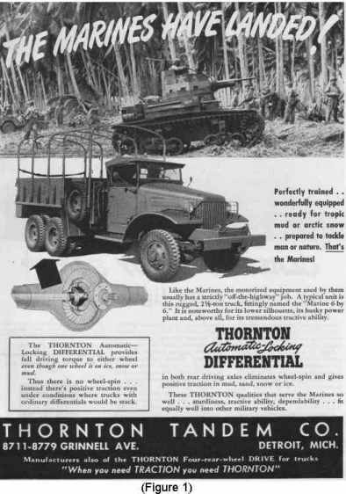
This paper describes various aspects of locking differentials (popularly known as lockers) as used in automotive vehicles, primarily in the off-road market. It covers their characteristics, history, operation, and the various units in existence today. It describes how the individual parts function and also will concentrate on how the various lockers work in relation to their effects on the vehicles in which they are installed. The author has chosen January, 2000, for its official publication date to coincide with the tenth anniversary of the first article in a national magazine about one of his automotive inventions⎯the All-Trac locking differential. This product had seen limited distribution for some time when it was introduced to the world in the January, 1990 issue of Four Wheeler magazine; the article will be available through this paper, with the permission of Petersen Publishers, Inc. This paper also contains the first description of several new products which the author recently has developed and which are now becoming available.

The author perfected the concept of a locking differential that can be installed by the end user into the existing differential case and which utilizes as many of the existing internal parts as possible. His first design in the automotive field enjoyed limited commercial success as the All-Trac for the Dodge Power Wagon (1985) and later for the Suzuki Samurai (1989). He then broadened the line with his next invention, the L.A. Locker (1990); he changed its name to Lock-Right (1991) and later improved it with “windows” (1993) to its current design. He brought in two other principals to form PowerTrax (July, 1993) and continued to make improvements in the line and invent other products while at PowerTrax (some of which are described later in this paper); he and the then V.P. of Marketing sold their positions in PowerTrax late in1996 and left to pursue other interests.

The author is the inventor on six patents involving various aspects of locking differentials and has several others pending, and holds three more patents in other fields. He is an avid off-roader, having explored much of the Mojave Desert and the southwestern U.S. beginning as a teenager in 1959. He has owned several 4WD vehicles and still owns the original test vehicle for the All-Trac, as well as two prototype amphibious tracked military vehicles and a military Dodge 4x4, of which only three were made. He may be contacted by e-mail, and this report plus information on some of the author’s new products may be downloaded free from his website, www.tractionmatters.com.

The answer to the question “What are they” will be given later in this paper. The answer to the question “Who needs them?” will be given right here: Anyone who desires maximum off-road traction while retaining on-road driveability. The explanation of these concepts, and their hows and whys, will be covered in this paper.

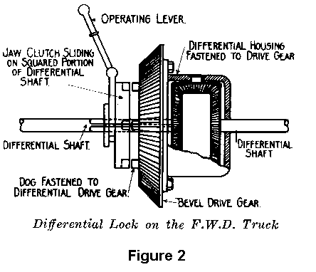
Each trademark and/or product or trade name used herein, such as Lock-Right, PowerTrax, Detroit Locker, ARB Air Locker, Spicer, Zytanium, Tunkenel, Zykenel,™ All-Lock,™ Silentek,™ Right-Trac,™ etc., is the property of its respective company. Many of the illustrations used herein are reproduced from historical materials in the author’s automotive literature collection.

What is an Automotive Differential?

An automotive differential is a mechanical assembly, often a system of gears, which is located in the driving axle of a vehicle. It applies power to the wheels while at the same time allowing a difference in their rotational speeds; this difference occurs when the vehicle turns because the outside wheel rotates faster than the inside wheel due to its larger turning radius. Differentials accomplish this function in various ways, depending on their particular designs.

Differential Classifications

Differentials have evolved into two broad classes: (1) Standard, or “open” differentials, and (2) Traction-adding differentials. Open differentials are by far the most common because they are inexpensive and do a good job for the majority of vehicles on the highway. However, open differentials have one major drawback: They can provide only limited power in marginal traction situations. To overcome this drawback, mechanical traction-adding differentials have been developed. These types of differentials are divided into two classes: (1) Limited Slip differentials, and (2) Locking differentials. Limited slip differentials are further divided into two general classes: (1) Clutch type and (2) Gear type. Locking differentials also are further divided into two general classes: (1) Automatic and (2) Manual (activated by the driver). This paper will focus primarily on automatic locking differentials, since they are the most widely used lockers and exist in a variety of designs. Other types of traction-enhancing devices and systems also have been developed, notably viscous coupling differentials and electronic traction control (ETC); these and other exotic designs are not mechanical lockers and therefore are outside the scope of this paper.

Traction-Adding Differentials--Brief History

Differentials go back to the beginnings of the automotive era, but many of them had major traction problems in difficult terrain. Many designs were tried over the years to overcome these problems, and some were produced either as factory-installed units or as after-market devices. A few of these various designs will be described in this section.

The first commercially available automatic full-locking differential was the No-Spin, developed in 1939 by Roy Thornton of the Thornton Tandem Company, which manufactured four-rear-wheel-drive units for large trucks. He needed a device that would provide maximum traction for these vehicles in extremely muddy and difficult terrain, yet would continue to allow them to operate on the highway. One of the first production installations of this differential was in International 6x6 trucks in WWII (Fig. 1). The No-Spin also was available in the early seventies as a factory option in some Ford trucks. For the reader’s interest, a few other traction-adding differentials that have been developed over the years will briefly be described. One of the first “locking differentials” actually was a differential lock, manually activated by the driver using a lever (Fig.2). The basic design principles of the Torsen (Torque-sensing) gear-type limited slip differential, as used in the Hummer, were developed as the M & S worm-gear differential in the twenties (Fig. 3) and then re-emerged as the Gleasman Dual-Drive in the sixties (Fig. 4). The Powr-Lok limited-slip differential also was developed by the Thornton Company and produced by Spicer in the mid-fifties (Fig. 5). A derivative of the No-Spin, which became known as the Detroit Locker, was made for use in light trucks. It had no appreciable competition in its field of automatic lockers until the author’s L.A. Locker (which he later changed to Lock-Right) was introduced in 1990 (see Figure 13), although the Warn Company had briefly produced a competitive unit, also in the early seventies. The ARB Air Locker, which is a manually-activated pneumatically-operated locking differential from Australia, was introduced in the early eighties and is currently on the market. The first EZ Locker, also from the Detroit Locker people, was introduced at the SEMA automotive equipment show in October, 1995, and very closely resembled the Lock-Right. Another product, a manually-activated cable-operated locker, is available from Toyota for some of its Land Cruisers. Other less-well-known units and prototypes also have been introduced over the years; they will briefly be described in following pargraphs.
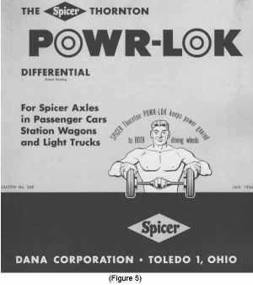
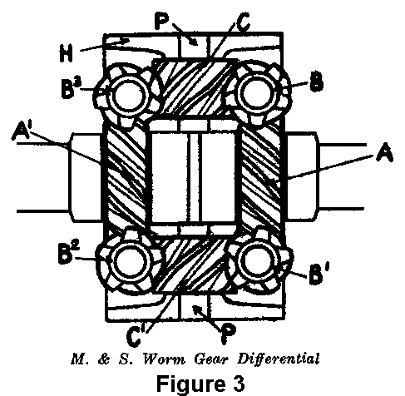

Definitions and Concepts Used in This Paper

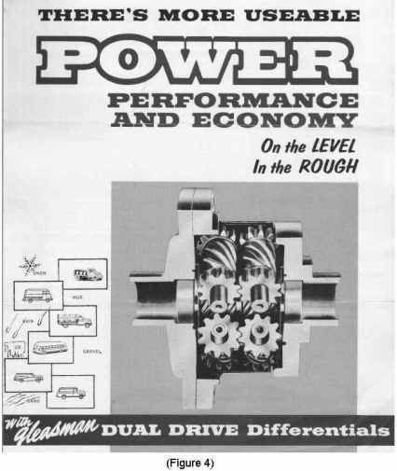
Backlash—General. Backlash can generally be described as the amount of back-and-forth movement (or rotation) of one of two meshed parts with the other one being held stationary. When referring to automotive ring-and-pinion gears, for example, one end of the ring gear rotation is the “drive” side and the other is the “coast” side. In this context, backlash is defined as the distance that the ring gear moves when rotating it from drive to coast with the pinion gear held stationary. This rotation, or clearance, may be expressed as a linear movement measured at one of the teeth in thousandths of an inch (or in mm), such as .006 - .008, for example.

Backlash also may involve an assembly, such as a manual transmission. Although not generally a specified parameter, these assemblies can have several degrees of backlash when rotating the input shaft back and forth with respect to the output shaft because of the clearance, or “play,” among the various parts inside. In a complete axle assembly, backlash can be described as the rotation of the drive shaft from drive to coast with the tires held stationary. The backlash of this assembly is the sum of the individual clearances within it, including the drive pinion gear rotation with respect to the ring gear, clearance between the differential pinion gears and side gears, play between the pinion gears and the pinion gear shaft, play between the side gears and the differential case, and play between the side gear splines and the axle shaft splines. Further, the clearances in the differential assembly and in the axle splines are multiplied by the gear ratio, producing even more rotation at the drive shaft. It is this accumulated amount of play that gives the familiar “clunk” when getting on and off the gas, particularly in older vehicles.

Backlash—Static. With respect to an automatic locking differential, static backlash is defined as the rotation (in degrees) of the input to the locker assembly when moving from drive to coast with the output held stationary. It may be thought of as a lab or bench measurement involving the designed-in clearances, such as the spaces between the locking teeth, rotation of the differential case with respect to the input of the assembly, etc., and excludes ring-and-pinion backlash, axle spline play, etc. For example, the static backlash of the average Lock-Right is about five degrees. This backlash is designed in and is required for the unit to be able to unlock.
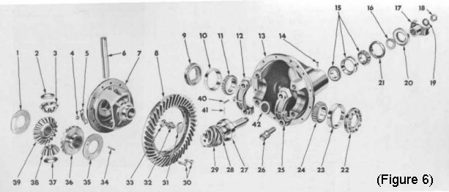
Backlash—Dynamic. Noticeable backlash when the vehicle is in motion has been present in automatic lockers since the beginning. It has always been just “sort of how they operate;” however, there has not been a specific name by which to describe it. Because this “motion” backlash is larger than the “designed in” static backlash, the author thought that “dynamic backlash” would be a reasonable descriptive term to apply to it. Therefore, for the purpose of comparing the various lockers to each other, dynamic backlash will be defined as the maximum rotation (in degrees) of the drive shaft in relation to the tires from drive to coast when the vehicle is in motion, such as may be observed when getting on and off the gas during a turn. It is a much larger number than the static backlash, and equals: (1) The static backlash of the locker itself, plus (2) the width in degrees of two of the locking teeth. For example, each Lock-Right tooth is about eight degrees wide; the dynamic backlash would therefore be (2 x 8) + 5, or 21 degrees. Furthermore, this number is multiplied by the gear ratio such that with 4.0 :1 gears the drive shaft can see as much as 4.0 x 21, or 84 degrees, of rotation from drive to coast in a turn. To this number is added the backlash of the remainder of the drive line, which can result in almost a 1/4-turn of drive shaft play. This number is even higher with lower (higher numerical ratio) gears.

This action of the locking teeth sliding across one another before lockup is primarily responsible for adding hesitation and “clunk” and helps produce the resultant sway of the vehicle widely attributed to lockers. It is more fully explained near the end of this paper under “Sway.” The lower the dynamic backlash the lower the adverse “locker handling characteristics” for which these various products are famous. Note: the dynamic backlash number as determined using the width of two teeth is the maximum. The actual amount observed is strictly a matter of chance as to how far the teeth are out of mesh at the exact time when power is applied and removed. At one particular point in time a large amount of backlash may be noticed, while at another time a lesser amount will be observed.

Differential Carrier (Figure 6, no. 13). Sometimes used interchange-ably with the term differential case, the correct description of the differential carrier is that it is the housing in which the drive pinion, ring gear, and differential case are installed, and it is a part of the axle housing assembly. Thus, it holds, or carries, the differential case assembly and is therefore called the carrier. It may be an integral design in which it also supports the axle tubes, or it may be a drop-out design in which it is removable from the vehicle as the complete differential and carrier assembly (which sometimes is called the third member). It is visible from the outside. Also see Third Member below.

Differential Case (Figure 6, no. 7). Sometimes used interchangeably with the term differential carrier, the correct description of the differential case is that it is the round housing to which the ring gear is bolted and which contains the differential gear assembly. It is assembled into the differential carrier, and is not visible from the outside.

Driveline Windup. Driveline windup is the phenomenon that occurs when a 4x4 vehicle is in 4WD and driving on pavement or on solid rock. Here, all four tires are “locked” to the ground (they cannot slip because of good traction), yet they turn at different rates as the vehicle makes turning movements. After a while, all the driveline components become highly stressed and either something breaks or the vehicle stops moving. Steering also stiffens up noticeably because the front CV joints are much harder to move since they are under so much torsion. The condition can be alleviated by jacking up a tire to relieve the stress. Driveline windup also can occur on hard dirt, but because the tires can slip to some degree it is less noticeable. In some full-time 4WD designs an inter-axle differential is located inside the transfer case to eliminate this problem; however, it must be able to be manually locked out to provide maximum traction off-road. Driveline windup occurs more rapidly in locker-equipped vehicles than in those without lockers.

Locker. A Locker is an automotive differential that can provide up to 100% of the incoming power to either wheel yet also allow differentiation in a turn. One comment on terminology: The terms “locker” and “locking differential” have incorrectly been used interchangeably with “limited slip” differential over the years, and continue to be so used today. A limited-slip differential is generally a friction- or binding-type of design that is capable of providing only a limited amount of power to each wheel when the other one has lost traction. A full-locking differential, or “locker,” however, can provide up to 100% of the available power to either wheel even if the other one is off the ground or if an axle shaft is broken. Thus, the terms “locker” and “locking” properly refer only to full-locking (100%) types of designs. The term “Locker” was used in the early ‘70s as a part of the trade name “Detroit Locker” (a full-locking design), but because of general usage, the now-common term “locker” has evolved into an industry-wide descriptive term for these differentials. Also, the term “manual locker” is sometimes used for driver-actuated units.

S.E.M.A. The Specialty Equipment Market Association. An organization for manufacturers and distributors of automotive aftermarket equipment, headquartered in Diamond Bar, California. It puts on an industry trade show in Las Vegas, Nevada in late October or early November of each year.

Side Load. The differential mechanism itself is located inside the differential case between two machined areas, called the side gear pads. As power is applied to the ring gear and the case begins to rotate, the differential mechanism starts to apply power to the axle shafts. At the same time, sideways pressure begins to be exerted on the side gear pads by the differential gears, producing a force that tends to split the case apart. It is not productive pressure, and is only a derivative of the differential mechanism design. The case must be strong enough to transmit the rotational power applied from the ring gear to the axle shafts plus contain the additional sideways stresses produced by the differential being under power. This sideways force inside the differential case is sometimes called “side load,” since it is directed toward the sides of the case. The large washers under the side gears are hardened steel and are called “thrust washers” because they first see the thrust, or side load, from the side gear. One side of these washers “sticks” to the differential case (because the case itself is relatively soft metal) and the other side has the hardened-steel side gear spinning on it, which prevents wear to the (soft) case material.

A locker design in which this side load is reduced or eliminated would be an improvement over existing designs, since such a new differential would only transmit rotational force from the ring gear to the axle shafts and would not produce much or any side load. In this type of design the differential case would not also be resisting forces trying to split it apart, resulting in less overall stress in the metal. This reduction in stress would make a stock case appear even stronger than normal. Also, some people question the use of the existing shaft vs. using a supplied shaft. This situation is covered toward the end of this paper under “Occasional” Lockers.

A further word about case strength—many clutch-pack type limited-slip cases are, by definition, weaker than their open-case counterparts because of the large amount of metal removed from the inside. This is because the side gear pads have been moved outward, closer to the differential bearings, to make room for the clutch packs. Here, less metal remains in the case to contain the side load stresses, resulting in the possibility that with enough pressure, produced, say, by most of the power going to one wheel, that the end of the case can be punched out. Correct differential bearing pre-load may help, but a locker that produces side load is better utilized in a stock open case because these cases are inherently stronger due to the additional metal in the ends. Lockers that are available for limited-slip cases certainly will function, but the serious off-roader will be better off by either installing an open case first or by obtaining a locker for the limited-slip case that does not produce appreciable side load.

Spool. A spool is a mechanical part that connects the axle shafts together, providing power to both of them simultaneously. This design results in no differential action at all but does provide maximum power to each wheel—even with one tire off the ground or with one axle shaft broken. Spools are made in two configurations: The mini-spool and the spool. The mini-spool is a part that fits inside the existing differential case and replaces the differential assembly, while the spool is a complete solid differential case made specifically to connect the axle shafts together and also support the ring gear. However, remember that a spool should not be driven on the street because it will not allow differentiation in a turn, resulting in squealing tires and stressed driveline components. Lockers provide the best of both worlds because they give spool-traction performance but also do allow for differentiation in turns as would an open differential.

Third member (Figure 7). This term is applied to the differential and carrier assembly when it can be removed as a complete unit from the vehicle. Some slang terms for this assembly are “pumpkin” and “hog’s head.” When referring to a complete axle assembly, the axle housing itself is the first member, the pair of axle shafts comprise the second member, and the (removable) differential and carrier assembly is the third member. See also Differential Carrier above. Note that the term “third member” does not apply to an integral carrier design.

Differential Operation–General

Open Differential (see Figure 6). The standard or “open” differential is composed of a round flanged case, differential gears (also called side gears), pinion gears (also called spider gears), a pinion shaft (also called the spider gear shaft or cross shaft), and various thrust washers. The majority of the open differentials contain two pinion gears and therefore are called “two-pinion” differentials. Some stronger designs use four pinion gears; these, of course, are referred to as “four-pinion” differentials. Four-pinion differentials also contain either a pinion shaft block to hold two additional shafts or a single four-armed part called the “spider” which holds all four pinion gears (hence, the name “spider gears”). In many four-pinion differentials the differential case splits into two halves on the centerline of the spider; this design is called a “split-case” differential. Notable exceptions are the Ford 9-inch and the Dodge 9-5/8-inch, which use two additional short shafts and a pinion shaft block housed in a cylindrical case with a cap on one end (a “capped-case” design).

Briefly, the open differential operates as follows: As the vehicle turns, one side gear slows down and the other one speeds up equally relative to the differential case because of the differences in turning radii of the inside and outside wheels. This action occurs because the pinion (spider) gears rotate on the pinion shaft to allow this difference in speed and at the same time continue to apply power to the side gears to move the vehicle. However, the main drawback to standard open differentials is that they can only apply power to both wheels in equal amounts. Thus, if one wheel is on ice and spins with only 5% of the available power being applied, the other wheel also receives only 5% and the vehicle may not move. This major drawback is why traction-adding differentials were developed.

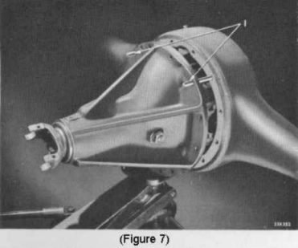
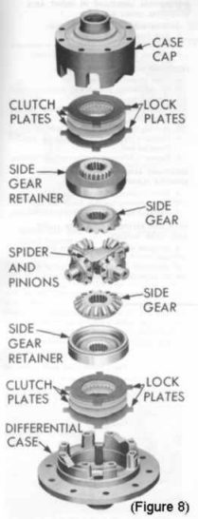
Limited-slip Differential (Figure 8). Many limited-slip differential designs apply power to the axle shafts using a standard open differential along with a parallel mechanism to add additional power when traction is marginal. Thus, as the name implies, a limited amount of additional power can be applied to each wheel through some sort of a slipping mechanism if the other one has lost traction. This additional power is usually applied through spring-loaded friction clutches associated with the side gears or through a wedging or binding-type of action of metal-against-metal. Limited-slip differentials sometimes chatter during turning but are generally less harsh than full lockers.

Manual Locker. A manual locker is one that can be activated by the vehicle operator at his option. These units include the ARB Air Locker and the Toyota cable-actuated locker. Each unit either is a standard open differential when off or essentially connects the axle shafts solidly together when activated.

Automatic Locker. Description and operation of various locking differentials, both production and prototype, will be covered in the following paragraphs.

Automatic Lockers—Production and Prototype
Description and Mechanical Operation

ARB Air Locker.

1. General. Although not automatic, the ARB Air Locker is a well-known mechanical locker and therefore will be included here as additional information for the reader. The ARB (Andrew & Roger Brown) Air Locker is from “down under,” and was brought to the U.S. beginning in the early eighties. It is a complete kit that contains its own differential case assembly with a compressor to operate it, wiring and air lines. It is expensive and somewhat complicated, but overall is a good unit for those willing to spend the money and put up with the air supply and its attendant problems along with needing to be careful about when to turn it on. It is a reasonable choice for the rear axle in vehicles that spend most of their time on the street, and for the front axle in general.

2. Description. The ARB Air Locker is a standard “open” differential assembly to which has been added the capability of immobilizing differential action with an annular toothed ring. When the ring is in the “at rest” position, the differential operates normally as would an open differential.
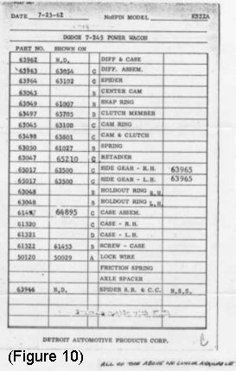
3. Operation. When the vehicle operator presses a button to introduce compressed air to the assembly from the on-board compressor and air line, the annular ring slides sideways and connects the right side gear to the differential case. The gear is thus immobilized, which also prevents the spider gears, and thereby the opposite side gear, from rotating. This action causes the axle shafts to effectively be locked together, resulting in maximum traction but no differentiation. The ARB can be thought of as a driver-activated spool (as can the Toyota cable-activated locker).

All-Trac.

1. General. The All-Trac (Figure 9) can be called “The Grand-daddy of all User-installable Lockers” because it was the first full-locking differential that could be installed by the end user utilizing as many of the existing differential parts as possible and using only simple tools. It was invented by the author during the 1983 -1985 time frame and was first sold in December, 1985. It was designed to fit the early-style Dodge Power Wagon (WDX, BPW, CPW and WM300 series) as well as its military cousins (the WWII WC series, the Korean War M37 series and the post-war MDAP M601/M615 series). It was developed because the No-Spin (model KS-22A, Figure 10) that fit the author’s truck was no longer in production, and if he was going to have a locker in his truck he’d have to invent one. So he did. (Interestingly enough, in later years the author was able to purchase two used KS-22As, which he still owns.)

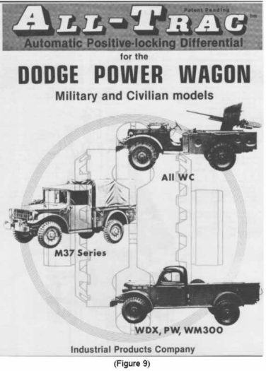
His new All-Trac model 121 (which he later changed to model 1210) utilized two clutch halves, which he called drivers, that replaced the spider gears and which mated with the existing Dodge side gears to form a fully-locking differential. It also used the existing pinion shafts, resulting in an inexpensive but rugged unit that allowed the older-style Power Wagons to have the modern advantages of a locker. The All-Trac line was expanded in June, 1989 to include the next production model in the series, the model 1510 for the Suzuki Samurai. The next model into development, although not into production, was the model 131 (later the 1310) for the VW (1986). Generally not known is that the second All-Trac design that actually was manufactured was a prototype for a Spicer 60 two-pinion one-piece differential case, and was called the model 141 (1988). It was similar to the Dodge All-Trac, although the stock side gears needed to be Blanchard ground to be able to mate with its newly-designed drivers. Only one complete unit was built (for a Ford 1-1/2-ton dump truck), and (as of the author’s last contact with the owner) is still in service.

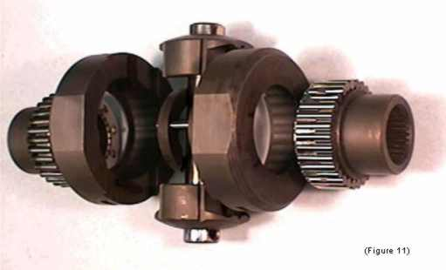
2. Description. The All-Trac, which evolved into the Lock-Right (see Lock-Right below), was originally made for a four-pinion differential; the following description also holds for two-pinion differential designs described later. The heart of the unit is the driver, mentioned above. This driver mates with the existing side gear to turn the standard “open” differential into a locker. (In two-pinion units, the driver mates with a side gear replacement part which the author called the coupler, to accomplish the same purpose.) In the All-Trac, each driver has four angled recesses that are half the pinion shaft diameter in depth. These drivers are mounted in the center of the differential case back-to-back, with the pinion shafts located between them and with their outboard teeth nested into the side gear teeth. Also positioned between them are springs and pins located on the same relative axes. The springs in one driver push on the ends of the pins in the other driver to force them apart and into the teeth in their respective side gears (or couplers). The pins in each driver also are positioned in the spring holes of the opposite driver, which are slightly larger than the pins. The drivers themselves are identical.

3. Operation. This “operation” section will be quite detailed, and also will suffice for explaining the operation of most of the user-installable existing-case lockers on the market.

The sides of the teeth in the drivers are slanted, as are those of the mating side gear (or coupler). The sides of the pinion shaft recesses in the back side of the driver also are slanted, but at a flatter angle than that of the teeth. When the differential case starts to rotate, the pinion shaft moves into contact with the angled sides of the driver recesses, forcing the drivers outward into the side gear teeth with a “camming” action and locking the two parts together. As the pinion shaft continues to move it rotates the drivers, which in turn rotate the side gears, which rotate the axle shafts to move the vehicle. Because of the difference between the angle of the recesses and the angle of the teeth the net force is always outward, and the parts remain locked as long as rotational force is applied by the pinion shaft.

When the vehicle begins to turn, the outer side gear begins to rotate faster than the other one. It rotates its associated driver with it, slightly away from the pinion shaft, until the side of the spring holes contact the opposing pins. Since the pinion shaft is no longer in contact with the driver, the slanted teeth of the side gear are now free to push the driver away, against spring pressure, to allow the side gear (or coupler) to rotate faster for as long as the vehicle is turning. As the side gear rotates, the driver teeth move in-and-out of the side gear teeth, producing the familiar “click-click-click.” When the vehicle straightens out, the pinion shaft again pushes on the sides of the driver recesses and the parts lock back up.

All-Lock™ (Patents Pending; Figure 11).

1. General. Recently invented by the author, the All-Lock is being introduced in an article in the 37th anniversary issue of Four Wheeler magazine (March, 2000). It is a full-locking differential that is user-installable into the existing differential case with no modifications, and is by far the smoothest-operating locker in existence.

2. Description. The All-Lock consists of two bi-directional over-running clutches that provide 100% locking in each direction yet which allow turning with absolutely no noise or jerking, and it has very little dynamic backlash (about three degrees total; see Table 1). This combination of characteristics results in a unit that is easy to drive yet one which also gives the vehicle in which it is installed the maximum traction available. Because of its smoothness and low dynamic backlash, it has a minimum of the well-known “locker handling characteristics;” thus, it has potential for OEM involvement at both the factory level and at the dealer level. Also, because all its internal forces are at right angles to the axle shafts, resulting in no side load, the existing differential case is effectively stronger than with other user-installable lockers (see Side Load above). In fact, the whole assembly “floats” between the sides of the case.

The All-Lock is composed of left and right halves that are driven by the pinion shaft. On the shaft are mounted two parts which the author calls drive blocks. These parts rotatably mate with two other parts, which he calls drive races, which are mounted left and right of the pinion shaft. Each drive race has an inner surface that receives inter-connecting media, which are identical precisely-made parts which the author calls rollers. In each side are 30 of these rollers that also are in contact with the coupler and which are held in position by spring pressure from the control plate. The coupler is a smooth stepped cylinder that replaces the existing side gear. Its bore is splined and connected to the axle shaft, and the C-Clip (if used) is located in a recess in the center. Next is the spacer, which is connected to the control plate and which is located between the plate and the pinion shaft. Between the left and right spacers are two connecting pins, which connect the spacers together to communicate relative position. Between the drive blocks and spacers are transfer levers, which rotate the spacers to move the control plates and thereby properly position the rollers. For the technical types out there, the large number of rollers compared to the diameter of the driven member (the coupler, at about two inches) significantly reduces the “Hertz stresses” (surface pressures) in the mating parts, thereby increasing product reliability.

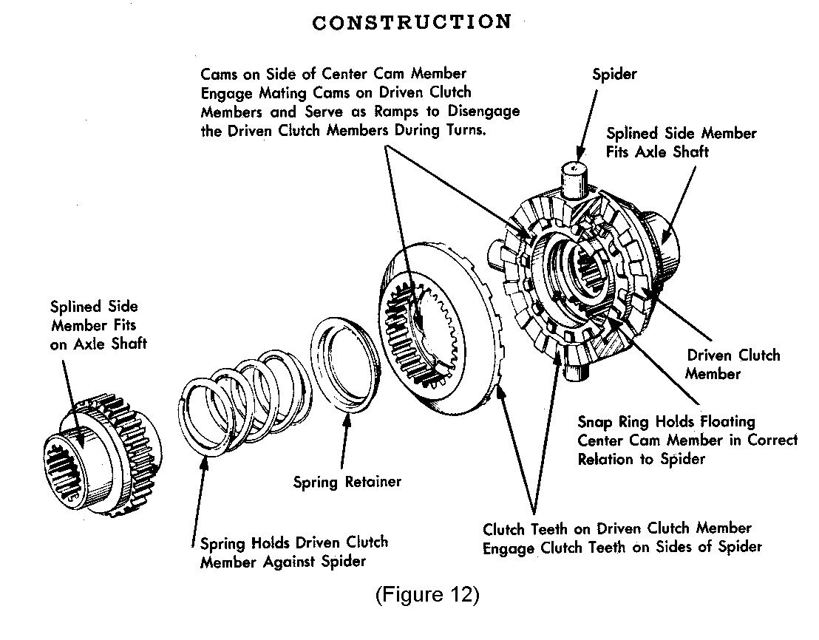
3. Operation. As the pinion shaft starts to rotate, the drive blocks begin to move into contact with slots in the drive races. At the same time, the transfer levers rotate the spacers, moving the control plate to position the rollers. When the drive races are contacted by the drive blocks and then start to rotate, the rollers already are wedged between them and the couplers (much as in a sprag clutch) such that the couplers are tightly “grabbed” and thereby are rotated along with the drive races to move the vehicle. When the vehicle starts to turn, the outside coupler begins to rotate faster than the inner one. This movement pushes or “rolls” the rollers slightly away from the drive race, against control plate spring pressure, allowing the coupler to rotate quite freely as long as the vehicle is turning. As the vehicle straightens out, the rollers again wedge back in between the drive race and coupler with almost no relative engagement motion (1/4-degree or less), and the unit again locks up. This action occurs both in forward and reverse and in right and left turns.

C-Locker. The C-Locker appears to have been Detroit Locker’s answer to the broad line of the Lock-Right. The Lock-Right can be installed in C-Clip differentials because the inner ends of the axle shafts can be accessed for the installation of the C-Clips. In the standard Detroit Locker, however, the case completely surrounds the differential so that the axle shaft ends are not visible. The C-Locker is a Detroit Locker with a cutout in the side of the case along with a special locking shaft to allow the axle shaft ends to be accessed and thereby enable the installation of the C-Clips. These changes allowed the Detroit Locker design to compete in a broader market segment. It operates the same as does the standard Detroit Locker.

Command Locker. Invented primarily by the author during his tenure with Powertrax (U.S. Patents no. 5,637,049, 5,759,126, 5,759,129 and 5,816,971), the Command Locker was a manually-activated electromagnetically-operated full-locking differential. As with the author's previous innovations, this unit could be installed by the end user in the existing differential case and carrier without any modifications. It was a combination of a mechanical locking clutch inside the differential case which was operated by an electromagnetic actuating mechanism contained within the differential carrier. The Command Locker was introduced to the world at the October, 1995 SEMA show; worthy of note is that the author actually did drive the test vehicle in which the prototype was developed, and it also did in fact operate quite well at the show. Even so, it has not been commercially produced by PowerTrax but is still talked about in locker circles (see the August, 1999 issue of 4-Wheel and Off-Road magazine, page 64). Its operation is detailed in the patents listed (see References at the end of this paper).

Detroit Locker and its derivatives (the C-Locker and Sof-Locker), as well as the earlier No-Spin (see Figure 12).
1. General. Sometimes called “The Grand-daddy of All Lockers,” the Detroit Locker traces its lineage back to the Thornton No-Spin of 1939. As mentioned near the beginning of this paper, it was originally developed in response to the need for additional traction in heavy trucks. Up through the mid-fifties, the line applied primarily to 1-1/2-ton and heavier trucks and these models were called the “Standard” No-Spin. However, the need for lighter applications developed, so in the late fifties another design was added—the “Silent Type” No-Spin. The Silent Type had the addition of yet another part—the “hold-out ring”, to prevent outside clutch tooth engagement during a turn. The “Detroit Locker” name was added in the 1971 time frame to differentiate the “Silent-Type” portion of the line which applied primarily to light- and medium-duty trucks from the “Standard” No-Spin models that were being made for heavier trucks.

2. Description. The Detroit Locker is the most complicated of the automatic lockers. It utilizes two sets of teeth (one for driving and one for releasing) and another part to keep the teeth driving from engaging during turning (the holdout ring). The driving teeth lock together to provide power during straight-ahead operation, and the ramp teeth push the driving teeth apart during turning. Additionally, the holdout ring prevents tooth engagement, and thereby noise and jerking, while the vehicle is turning. As the vehicle completes its turn, the holdout ring drops away and the driving teeth re-engage. During this process, sometimes things temporarily mis-behave and when they let loose a huge “bang” from the differential can be heard (and felt). Additionally, the Detroit Locker’s relatively large dynamic backlash produces a definite lag when getting on and off the gas during a turn, producing noticeable sway in the back end of the vehicle (see Sway below).

3. Operation. While the vehicle is moving straight ahead, the driving teeth are engaged. As the vehicle starts to turn, the outside clutch half starts to turn faster, which rotates it into the ramped disengaging teeth. As it continues to rotate, it is pushed up and out of engagement with the driving teeth by the ramps. At the same time, the holdout ring is rotated up and out of its pockets to sit under the outer (driven) clutch half. As long as the ring is in this position (while the vehicle is turning), the driving teeth cannot engage. When the vehicle straightens out, the holdout ring drops back in (a slight reverse rotation of the clutch is needed). When the ring drops in, the teeth may or may not be ready to engage; if not, they stay on top of each other until power is applied. At this point the teeth do re-engage, which sometimes produces the big bang mentioned above. Also, the author has heard that in rare instances involving changing from reverse to forward that the holdout ring can remain in its “up” position such that it is possible to be driving straight ahead with power being applied to only one wheel.

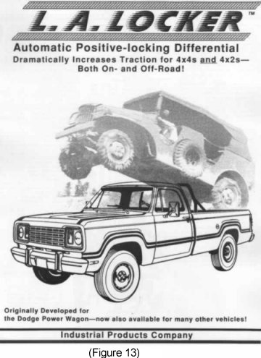
One item of interest to technical types–the Detroit Locker is supplied with its own differential case, inside of which is the differential mechanism that is held inward only by two large springs (no cams). To avoid having the unit pop apart under load, the sides of its driving teeth have a negative pitch (the tops are wider than the roots); this means that the teeth actually hold themselves more tightly together as more power is applied. Also, there are no side loads inside the case (except for the relatively small amount that is applied by the springs).

EZ Locker. The first EZ Locker, which very closely resembled the Lock-Right, was introduced at the October, 1995 SEMA show by the makers of the Detroit Locker. It subsequently had a minor change made to the spring assembly, and it continues to be the subject of ongoing litigation. Its operation is exactly the same as that of the Lock-Right, so it will not be repeated here. More on the EZ Locker, and its “occasional” label, will be found under “Occasional” Lockers toward the end of this paper. It is currently in production, with some 15 or so models available.

Gearless Locker. The “Gearless Locker” was introduced by the Detroit Locker people at the 1998 SEMA show. As described in their patent, it is not a full locker at all but rather is a Lock-Right-style (user-installable) limited-slip design. It basically is a Lock-Right with friction clutch packs in place of metal locking teeth (see the comment on “locker” terminology on page 3 of this paper). According to their U.S. patent no. 5,727,430, it is “A locking (?) differential [which] includes annular friction pack clutch assemblies for normally connecting the drive shaft of a vehicle to a pair of...axle shafts.” The supplied pinion shaft is angled and forces the drivers outward into the clutches, producing a friction force that turns the couplers (side members), which are connected to the axle shafts. Although its literature claims “50 % power to each wheel while driving straight ahead;” it would appear that the 50% occurs only when there is roughly equal traction. However, when one wheel is slipping, the power transfer to the wheel having traction is through the friction-clutch mechanism, with its inherent less-than-100% power transfer. It finally reached the marketplace in the spring of 1999, only to be voluntarily removed from sale by some dealers soon thereafter because they were “having trouble with it.” It also requires a friction modifier in the gear oil (supplied). Its operation is described in the patent noted; it probably is currently available.

L.A. Locker (Figure 13). The Lock-Right was originally marketed in 1990 as the “L.A.” Locker (to differentiate it from the older and more stodgy “Detroit” Locker). However, even though by that time “locker” was an industry-wide descriptive term (after all, the ARB Air Locker had been introduced in the early eighties with no apparent objection to the name), even back in 1990 the Detroit Locker people were worried about this new competition from progressive “L.A.” They threatened legal action that the author was not able to counter at that time, so he changed the name to “Lock-Right” early in 1991.

Lock-Right (see Figure 13). Invented by the author in the 1989 -1990 time frame (see L.A. Locker above), the Lock-Right was a logical extension of his original All-Trac design. The Lock-Right utilizes the same overall principles of operation but is supplied with its own side gear, which he termed a coupler. In the December, 1992 - February, 1993 time frame (prior to forming PowerTrax), the author invented the “windows” method of installation (U.S. patent no. 5,413,015), which is used today in the Lock-Right and which the EZ-Locker also uses. This “windows” design allows the actuating springs to be installed through the side of the driver rather than using the author’s original All-Trac spring/disc/support-pin design. This feature greatly improved the Lock-Right installation method, and during the author’s tenure at PowerTrax he expanded the line to some 65+ models, most with his new “windows” feature. Its basic operation is the same as that of the All-Trac, as explained above.

In both the Lock-Right and E-Z Locker (as well as in the All-Trac), a phenomenon occurs during slow turns in stick-shift vehicles that is quite annoying but is part of “just the way they work.” This characteristic the author calls “chunka-chunka” because that’s sort of the noise that the differential makes when it happens; enough force is generated to wrap up the springs and actually move the front of the differential carrier up and down as the vehicle is moving. This effect is produced by snapping in the clutch pedal during a tight turn with the vehicle under power. It is caused by the whole drivetrain acting as one big torsion bar. With power on, the drivetrain—transmission, driveshaft, and especially the axle shafts, are “wound up” to some degree. When the clutch pedal is snapped in, everything unwinds up to the clutch disk, which then whips “backwards,” slower than the flywheel. At this point the disk winds the drivetrain up in the opposite direction, which immediately throws the slower-spinning outer wheel driver directly into the faster-spinning outer wheel coupler. This immediately whips the clutch disk back up, throwing the (now) faster moving inner wheel driver into the slower-moving inner wheel coupler. This immediately jerks the clutch disk slower, again winding up the drivetrain “backwards.” The clutch disk then starts to whip up faster again, repeating the process. This all happens on its own as long as the clutch pedal is depressed, and continues until the vehicle either stops or straightens out. This action does not cause any permanent damage because the metal parts are designed to take it, but it’s still somewhat disconcerting until the owner gets used to it. Lockers which have additions to them to prevent tooth engagement during turning, such as the author’s new locker products, the permutations of the Detroit Locker and the No-Slip do not do this, nor do any of the aforementioned lockers when installed in vehicles with automatic transmissions.

No-Slip. The No-Slip locker was developed by PowerTrax after the author left the company (their U.S. patent no. 5,901,618). It is a Lock-Right-style design to which has been added some additional parts—an “active spacer,” a synchro ring, various springs and additional machining. Their purpose is to prevent the outside driver locking teeth from engaging as long as the vehicle is turning, thus preventing the annoying clicking during turning in all vehicles and the jarring “chunka-chunka” noise in stick-shift vehicles during slow turns. It was introduced as a prototype at the 1997 SEMA show, and was just becoming commercially available after the end of the 1999 SEMA show. Although newly-released and therefore untested by the author in time for this paper, the No-Slip shows excellent machining and packaging along with well-written product literature, and appears to be a well-built unit. It currently is in production with several models available.

Parenthetically, and speaking of packaging, it is of interest to note that of the seven patents listed on the No-Slip box which are claimed by PowerTrax to cover their products (a valid claim), four apply only to the as-yet-un-manufactured electric Command Locker (described above)…

No-Spin (see Figure 12). This unit and its history have been mentioned elsewhere in this paper; its applications primarily cover larger vehicles. It operates the same as does the Detroit Locker (above), except that many of the models for larger trucks do not have a holdout ring.

Performance Locker. Invented by the author during his tenure with PowerTrax (U.S. Patent no. 5,603,246), the Performance Locker is similar to the Lock-Right except that the springs press directly on the pinion shaft rather than on the opposing stop pins, and the stop pins are larger in diameter. This arrangement gives some measure of radial dampening and allows heavier locking springs to be used since they are initially compressed by the installation of the pinion shaft rather than by the spring installation itself. These units lend themselves to high-pressure high-RPM performance-type usage, as might be experienced on a race track. This unit functions the same as does the Lock-Right.

Right-Trac™ (Patents Pending; Figure 14).

1. General. Recently invented by the author, the name “Right-Trac” is the logical extension of the author’s earlier product names—Lock-Right and All-Trac. The Right-Trac is being introduced in an article in the 37th anniversary issue of Four Wheeler magazine (March, 2000). It may be thought of as the seemingly elusive improved Lock-Right design. The Right-Trac is user-installable into the existing differential case with no modifications, and it also offers several significant improvements over existing designs. These are:
- The driving teeth have vertical sides rather than slanted sides (as with the other units now on the market). This design yields an effectively stronger assembly because all the incoming torque is applied directly to rotating the axle shafts, resulting in no side loads at all inside the differential case. Slanted teeth, present on competitive user-installable designs, also produce sideways forces that tend to split the case apart (see Side Load above).
- It utilizes two large rectangular cross-section heat-treated tabs for unlocking rather than four small-diameter round pins, resulting less likelihood of breakage.
- It uses only two large actuating springs rather that four to eight smaller springs. This feature allows the use of larger-diameter wire thus reducing stress and increasing reliability, and also makes installation easier.
- The Right-Trac has Silentek technology built in (see below), resulting in a unit that is quiet in turns and which does not jerk when the clutch is depressed.
- It has 24 teeth per side rather than 20. This feature results in less dynamic backlash than the other units (see Table 1) because the teeth are not as wide.
- The camming angle for engaging the driving teeth is less that of the other units, also helping to reduce dynamic backlash.
- C-clip installation is a breeze, and there is no wide cutout with driving teeth removed as with competitive units. The drivers nest back-to-back during installation such that the C-clip is simply inserted between the driver and coupler rather than needing to be carefully slid in through a cutout in the driver teeth. This feature also makes disassembly easier, because the C-clip just falls out.
- The teeth are cut deeper than competitive units, resulting in more coupling reliability.
- Some Right-Trac models use no spacers, resulting in reduced cost.
- Installation is fast and easy due to the square teeth helping to hold things together, only two springs and tabs in total, and the ability to just drop in the C-clip.
- The Right-Trac is made from Zykenel-X™ alloy steel, resulting in a superior product at a reasonable cost.

(Zykenel,™ of course, is a bearing-quality steel alloy that is different from either Zytanium™ (PowerTrax) or Tunkenel™ (Detroit) but has some of the best characteristics of both.)

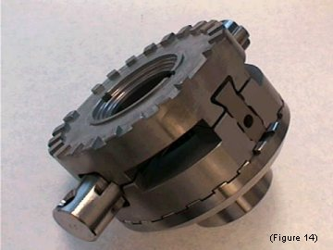2. Description. The Right-Trac is composed of two drivers and two couplers, a special pinion shaft, and two interconnecting tabs and springs (some models also have two spacers.) The pinion shaft has lateral grooves to mate with specially-machined slots in the drivers. The driver slots have straight sides to mate with the pinion shaft, and also short angled cam surfaces to force tooth engagement with the coupler. One driver has two slots for holding two unlocking tabs, and the other has two slots that receive the angled ends of the tabs. Between the drivers (directly underneath the tabs) are two bias springs that hold the parts in place. Each tab is locked in place by a spring-loaded pin. Located in the space between each driver and coupler are Slientek kit parts that eliminate the clicking and resultant jerking found in other units.

3. Operation. The driving teeth are engaged while the vehicle is moving straight ahead. When it starts to turn, the outside coupler begins to rotate faster than the inner one. Its driver also briefly rotates along with it until the unlocking tabs contact the unlocking recesses. As the coupler continues to rotate, the angled part of the tab and the recess are forced further together, pulling the driver inward until the driving teeth clear (part of the “patent pending”). This new “pulling” design allows square (rather than slanted) driving teeth to be used, completely eliminating side load. (This unlocking is opposite from that of the competitive units, which use their slanted teeth to push the driver inward.) As soon as the coupler teeth rotate past a few driver teeth, the Silentek blocking ring moves up and into position to prevent tooth engagement for as long as the vehicle is turning. As the vehicle straightens out and the outside coupler rotation slows down and approaches that of the driver, the Silentek blocking ring also moves out of the way and the teeth begin to re-engage. At this point, the engaging cam surface in the driver slot meets the pinion shaft and the driver is cammed back into the coupler teeth for complete lockup.

Silentek™ (Patents Pending; Figure 15). Although not actually a locker, the Silentek is a locker-related kit that recently has been invented by the author. It is being introduced in an article in the 37th anniversary issue of Four Wheeler magazine (March, 2000). The Silentek is an after-market addition to existing Lock-Right lockers (and their EZ Locker counterparts) that results in a quiet, even more streetable unit. It also can be added to these same units as they are being purchased new, and is included at no additional cost in the author’s Right-Trac product (see above). The Silentek kit is a simple group of parts (two each support plate, blocking ring, spacer and shuttle assembly) that the vehicle owner can install them himself in his own Lock-Right or EZ-Locker in just a few minutes when it is on the bench. The Silentek prevents the outside locking teeth from engaging as long as the vehicle is turning, completely eliminating the annoying “click” in all vehicles and the rough chatter in stick-shift vehicles. The Silentek may be thought of as a relative-motion detector—during a turn, it blocks tooth engagement as long as the coupler is rotating faster than the driver, and allows re-engagement when they again rotate at the same speed. It operates equally well in forward or reverse.
Backlash of Various Lockers
Table 1
(Numbers are approximate; for purposes of relative comparison)

Sof-Locker. The Sof-Locker is a standard Detroit Locker with a friction dampening mechanism located between the inner ends of the axle shafts. This mechanism is intended to somewhat dampen the noise and jerking for which Detroit Lockers are famous. It operates the same as does the Detroit Locker.

Automatic Lockers—Operation in the Vehicle

The Dynamics of How a Locker Adds Tractive Effort. A locker provides increased traction under power and applies it smoothly as the vehicle is moving primarily because the axle shafts are acting as torsion bars. As the vehicle starts to climb uphill and more torque is applied by the engine, the axle shafts begin to twist, or wind up, as they transmit power from the differential to the tires. Assuming equal traction, both axle shafts will be twisted equally as the vehicle is moving. If one tire loses traction, it actually spins up faster than the other one momentarily because its axle shaft unwinds. At the same time, however, the tire which has good traction does not spin, and so its axle shaft winds up even more tightly as it takes the additional torque given up by the other (slipping) tire. When the slipping tire again regains traction, at some point soon the opposite tire will slip a little, transferring some torque back. This torque transfer also happens when the vehicle turns, since the outside tire will constantly be released and re-engaged. The vehicle itself continues to climb without the driver even being aware that torque is constantly being distributed back-and-forth between the sides as one tire, then the other, receives more torque as the vehicle continues on its way up. Only when the vehicle reaches a point where both tires lose traction will it stop, and then both tires will be spinning equally because they are connected together by the locker. This analysis also holds true for a spool.

Operation in the Vehicle. The automatic lockers with locking teeth—the No-Spin (and its permutations), the Lock-Right and the EZ Locker emulation of the Lock-Right, the Performance Locker, along with the author’s new Right-Trac, all operate in the same manner as far as the vehicle is concerned. Their internal operation is quite different, but their external characteristics, that is, the amount of traction that they provide and the manner in which it is applied to the axle shafts, are quite similar. How they act on the vehicle is explained in the following paragraphs.

- Power application in forward or reverse. Power from the engine is applied to the differential case by the ring gear. The locker inside is composed of two dog (toothed) clutches, each of which has a driving half that is connected to the case and a driven half that is connected to the axle shaft. While the vehicle is in motion, each driven half is either connected to its driving half and therefore is supplying power to its axle shaft or has disconnected and is over-running the other one (as when in a turn).

- Power-on turning. As is well known, the outside wheel turns faster than the inside wheel during a turn because of its larger turning radius. With a locker, power continues to be applied to the inside wheel while the outside wheel is released and allowed to over-run. Thus, during a power-on turn, the power can be thought of as being applied only to one corner of the vehicle (for example, the left rear wheel in a left-hand turn). This application of power only to the inside corner of the vehicle during a turn tends to straighten it out, producing understeer.

- Power-off turning (decelerating or backing off). Less-well understood is automatic locker operation when backing off in a turn. Under deceleration, power switches from the inside wheel to the outside wheel, and the inside wheel disconnects and under-runs it. Thus, deceleration (or drag) is applied at the opposite corner of the vehicle from acceleration, again resulting in understeer (not oversteer). Therefore, a vehicle will tend to “walk” toward the outside of a turn when getting both on and off the gas. Worthy of note is that in this instance one wheel (the inside wheel) is actually turning slower than the ring gear.

- Sway. Also note that when power (on) and drag (off) are being applied at opposite corners of the vehicle during a turn that the back of the vehicle will tend to sway sideways. How much will be determined by (1) the vehicle suspension geometry (primarily lift, or center of gravity), (2) the wheelbase, (3) the tires (how big and how much air), (4) its weight, and (5) most importantly, the dynamic backlash of the locker. Generally, the greater the dynamic backlash the greater the sway. This is because the greater the dynamic backlash of the locker the greater the time between when the power is removed from the inside tire (by getting off the gas) and when deceleration is picked up by the outside tire through the locker backlash. This increased amount of time allows the engine and remainder of the drivetrain to slow down further before being re-engaged by the locker. The slower the engine is turning the more “oomph” will be needed to speed it back up, hence more drag will be applied by the tire. Since this drag is being applied at only one corner of the vehicle, the front end tends to swing around that tire, pulling the back end sideways and introducing sway. This effect is quite noticeable and is one of the main “adverse locker handling characteristics” for which these products are noted.

- Highway Driving. At the possible expense of being too technical and therefore somewhat boring, another characteristic of automatic lockers will briefly be described here. When the vehicle is moving straight ahead, theoretically both halves of the locker are locked up and both wheels are being powered equally. Not so, Grasshopper! Sometimes, maybe, but not always. This is because (1) small turning movements are required to keep the vehicle in its lane, (2) the tires may be of different diameters either because of wear or differences in air pressure, and (3) sometimes the vehicle can be in a long, sweeping turn. What happens is that the outside wheel in whatever turn may be happening at a particular moment may or not be engaged because it is very slowly over-running the other one, going click........click........click as the vehicle proceeds along the highway. At this point, nothing unusual is heard or felt by the driver because of vehicle noise and the constant application of power. However, if the driver takes his foot off the gas, and then accelerates, once again we are faced with the same scenario as with turning described above under Sway. Strictly as a matter of chance, and depending on where the disconnected (over-running) teeth are located in reference to each other, sometimes drag will be picked up by only one side and the vehicle might briefly sway. This may result in needing to correct the steering, and is just another part of “how they operate.” Once again, the greater the dynamic backlash the more this effect will be noticed. Care must be taken with lockers, both on- and off-road.

Do You Need A Locker?

The need for more traction is dictated by the type of vehicle, its intended use, and the driver. In general, weekend use on dirt roads would not require a locker or even a limited slip. Here, ground clearance is the most important consideration because climbing in somewhat rough terrain without too much “up” can be accomplished with experience and care in a stock vehicle with open differentials. As the terrain becomes rougher and steeper, as well as muddier, additional traction becomes more important.

Limited-slip differentials add some traction, but not as much as lockers (see their description elsewhere in this paper), and will not be covered further here. The answer to “do you need a locker” is determined by how much traction you want and by trading off their the negative on-road driving characteristics with their positive off-road traction-enhancing characteristics.

Do You Want A Locker?

Control Problems. Lockers are not for everyone. They generally are for experienced drivers operating in very difficult terrain. Lockers give maximum traction, but also produce handling problems. Also, an axle shaft generally will break when under a lot of torque; if the break occurs under both power and speed, all the power transfers to the good axle and the vehicle will jerk (turn quickly) to the side on which the break occurred, and loss of control may result. Great care must be taken when using a locker! Additionally, an inexperienced driver in a locker-equipped vehicle can get into much more difficult terrain before getting into trouble, such that getting back out can be more difficult and dangerous.

Fishtailing or sway. The tendency for the back end to sway when getting on and off the gas in a turn is described immediately above under Sway, and certainly needs to be addressed when deciding on a locker. Additionally, when a vehicle with a standard differential begins to turn, the engine speed remains constant because one wheel speeds up at the same rate at which the other one slows down. However, with a locker, the engine remains “locked” to the inside wheel, which begins to slow down as the vehicle starts to turn. The effect on the vehicle is usually unnoticed, however, because the reduction in engine RPM is not much and the vehicle usually is slowing anyway when beginning a turn; the engine just slows down a little bit more. This characteristic can also contribute to sway.

To help you decide if you want a locker, carefully read the following sections. Probably the most important deciding factors are (1) whether or not it will be regularly driven on the street; (2) the characteristics of the vehicle (see the comment on the Lincoln car below), and, of course, (3) in which end the locker will be installed.

Lockers in both ends or only in one end?

A locker on the street. Since the front-wheel drive in a 4x4 vehicle is not being used on the street, obviously a locker in the front end will not be noticed. In the rear axle, however, the locker will affect vehicle handling as noted above; part of the effect is (1) that it is a locker, and the other part of the effect is (2) which type of locker it is (meaning how much or how little dynamic backlash it has).

1. 4x2 vehicles. A locker in the rear of a 2WD vehicle will give it amazing climbing ability, in many cases eliminating the need for a 4x4 vehicle. This solution can give even the week-ender enough traction to go almost anywhere; it does, however, require driving the locker on the street during the week. Note that a locker in a 2WD front-wheel-drive vehicle, however, is definitely not recommended because it plays havoc with the steering and also can more easily break the front axle shafts and CV joints.

2. 4x4 vehicles. The three logical combinations of lockers and axles are: (1) one in the front only; (2) one in the rear only; (3) one in each end. There probably are as many opinions on this subject as there are vehicle owners, so the author can only give his own opinion. It is, however, borne of almost 40 years of off-road experience, 20 of that in medium-to-heavy locker-equipped vehicles.

One Locker. If one locker is used, the author suggests that it be installed in the rear axle. This is because when climbing a hill, weight transfer puts more weight on the driving (locker-equipped) axle as the hill gets steeper. This additional weight results in more traction as it is needed. Conversely, as the hill gets steeper, weight is transferred off the front axle, making it less effective for pulling. Although engine weight does help the front, the dynamics of the rear tires “digging in” produces greater traction. Theoretically, if traction were good enough and the hill steep enough, the vehicle would approach doing a wheelie, meaning that most of the weight has transferred onto the rear axle (and therefore hardly anything is left for the front). This weight transfer is why the author believes that if only one locker is used that it will be the most effective if it is installed in the rear axle.

However, and this is a big factor, if the vehicle is used for daily driving the locker in the rear axle will be noticed, especially by other drivers and passengers unfamiliar with it. Worthy of note, too, though, is that the author formerly owned a Lincoln MK VII with a Lock-Right installed; he drove it daily on the street for over two years during which time it was hardly noticeable, because the car was low and long and heavy. He actually did take it off road a few times, too, and the locker did quite well in a 4x2 what lockers do—amazing traction, especially for a car. If the vehicle is a daily driver or if the wife drives it, a locker in the front will add a noticeable amount of traction off-road (although not as much as a rear locker), yet will not affect on-road operation at all. For such vehicles, a reasonable combination might be a limited slip in the rear and a locker in the front. The choice is up to the owner.

Two lockers. The author prefers that a 4x4 vehicle have lockers in both ends (primarily because this solution will sell more lockers). Not really! But seriously, folks, in at least one instance the author’s Dodge would still be stuck in the Last Chance Canyon area if it hadn’t had two of his All-Tracs installed. Briefly, the truck was stuck in the “V” of a left-hand hairpin turn (too lazy to back-and-fill a few times) with the left rear tire and right front tires essentially in the air. The right rear and left front tires were buried up inside the fender wells. With only one locker, neither end would have had a prayer of pulling the truck out. With lockers in both ends, however, in low-low it just eased out without any tire spin whatever, and pucker disappeared. The truck didn’t even need a winch, which is good because it didn’t have one. The truck was in a similar situation at Fort Piute in California’s Mojave Desert—two lockers got it out of a very sharp uphill left turn, when one locker in either end would not have done it.

"Occasional" or "Part-time" Lockers vs. "Full-time" Lockers.

1. Case Strength. Stock differential cases must be strong enough to transmit the torque put out by the engine and transmission, with very generous safety margins. Assuming the same traction for both tires (no slipping or slipping equally), the torque transmitted by the stock case from the ring gear to the axle shafts is the same amount for either the stock differential gears or a Lock-Right-style locker. However, as one tire is losing traction, the locker will direct more or all the incoming torque to the remaining tire. Here, all the torque will be transmitted by half the differential case, which might lead one to conclude that the metal is being more heavily stressed. However, the side load is a function of the angle of the locking recess in back of the driver, which generally is less than the angle of the gear teeth in a stock differential. This factor does reduce the side load, but generally not by half. This is where the generous safety margin of the cases becomes important, and the stock open cases out there have proven to be quite adequate for transmitting this increased torque. This supplying of all the torque by only half the case is why the lockers with little or no side load recently invented by the author will make stock cases appear to be even stronger than normal. Only in situations involving huge tires and engines would the stock case assembly possibly not be strong enough, and then all bets are off, even for many of the supplied-case units (what blew up that Detroit Locker or ARB that you heard about a while back?).

The original vehicle for which the author designed the All-Trac (now the Lock-Right) was a 6,000+ lb. military Dodge Power Wagon. With All-Tracs in both front and rear, a 360 V-8, an early NP-435 4-speed with a granny gear (ball bearing input, not tapered roller), a 1.5:1 two-speed all-gear transfer case, 4.89:1 9-5/8-inch gears, Rzeppa (not Bendix-Weiss) CV front axle shafts and special Foote (Corp.) rear axle shafts, 10.50-16 directional military V-tread tires all around and a final drive ratio of some 50-to-1, it would climb cliffs. To characterize such a vehicle and application as an “occasional” use is absurd. The Lock-Right-style user-installable design has been proven the world over, from the Rubicon to Moab to the Far East to the Australian outback. For the vast majority of even hard-core off-roaders, the Lock-Right-style unit is an excellent full-time choice, and the product lines for these types of units offer many more models than do those of the more circumscribed Detroit Locker-style lines.

2. Pinion Shaft Strength. Also, some people hold that the stock pinion shaft is weaker than a new shaft when used with a user-installed locker. While it is true that stronger, more exotic metals can be used for the new shaft, material is only a part of the equation. In a stock differential, power is applied to the spider gears by the pinion shaft. The spider gears are in contact with the case (sometimes they are spaced away by a .030" thrust washer) such that all the force applied to the shaft is in what’s called the shear direction, which is the strongest. However, in all the user-installable lockers to date, the edge of the driver (or driving clutch member) is spaced some distance away from the case, resulting in what’s called a bending moment also being applied to the shaft. This spacing results in less shear and more tendency to bend, meaning that breakage of the shaft (any shaft) is more likely. The stock shaft is adequate to take the stress in the vast majority of cases, but a new stock shaft or a replacement shaft should be considered. Also note: The author’s new All-Lock is the only user-installable locker in which the driving member (the drive block) is in direct contact with the case, meaning that the pinion shaft sees only shear (the strongest configuration).

3. The “Occasional” Label. Dividing the Lock-Right-type design (using the existing case) and the Detroit Locker design (using a supplied case) into two separate classes was only a marketing ploy by the Detroit Locker people. Beginning in February, 1993, and probably even earlier, they had embarked on a program to try to develop an improved Lock-Right-type locker. Nearly three years later, at the October, 1995 SEMA show, they finally introduced their answer to the Lock-Right—the EZ-Locker. This “new” EZ-Locker so closely resembled the Lock-Right that all the parts would interchange between the two models. No imagination involved—if it ain’t broke, don’t fix it. Later, they made a small change to the “windows” assembly method that had been invented by the author for the Lock-Right (and which was protected by U.S. patent no. 5,413,015). Even so, 100% of the parts still interchange.

To not have their new EZ-Locker sales cut too deeply into their existing Detroit Locker sales, however, they had to characterize this type of design (and by association, that of the Lock-Right) as an “occasional-use” locker—allegedly for those who were not hard-core enough users to buy a “real” Detroit Locker. This “occasional” label probably comes from the assertion that the stock differential case supplied with the vehicle is potentially not as strong as is the one supplied with the Detroit Locker, so these (allegedly) softer-core people will go off road only “occasionally.” However, worthy of note is that some Detroit Locker models themselves also use the stock differential case, and a huge number of the stock-case Lock-Right-type users quite successfully go all over places such as Moab and “occasionally” traverse the Rubicon as well as a myriad of other very difficult areas worldwide, thank you. Also, what are vehicle owners supposed to do when there is not a Detroit Locker available for their particular vehicle but there is a Lock-Right-type locker available? Only be “occasional?” The logic dies, languishing only in the minds of those in marketing departments...

The EZ-Locker may describe itself only as an “occasional” locker so that its sales won't affect those of its companion Detroit Locker, but the tens of thousands of user-installable locker users (including the author and his Dodge) will happily continue to use their “occasional” lockers full-time, both in driving to work and in driving up cliffs. So too will those who now will want to take advantage of the brand-new 2000-design lockers recently invented by the author, and, too, which as in years past, again will “occasionally” affect the sales of the 60-year-old 1939-design Detroit Lockers...

Conclusion

The author hopes that this paper has been helpful and informative for the reader. Lockers occupy a small but growing niche in the overall automotive aftermarket, and he also hopes that by increasing the familiarity of the growing number of off-roaders with lockers that everyone will benefit. Although things will be quite busy for a while, if questions are submitted as instructed by the website he will try to answer them, possibly en masse at least in the beginning. Good luck, and remember—be sure to take the time to back-and-fill in a hairpin turn. Remember too, to Tread Lightly, and Happy and Safe Four-wheeling to All!

References

Patents. For the reader’s interest and reference, information on the patents referred to in this paper may be obtained free on-line at www.patents.ibm.com by typing in the desired number under Patent Number Search. Entire patents may be downloaded for free at a somewhat coarse resolution, and higher-resolution copies may be ordered for a fee. The author has no interest in this website and provides the address only as a courtesy to the reader. Other such websites also may be used.

Additional note on patents: The author has several U.S. and foreign patents pending on the various inventions that have been presented in this paper and which are being introduced to the public in an article in the 37th anniversary issue of Four Wheeler magazine (March, 2000). These patents were written by attorneys (not agents) well-versed in both foreign and domestic patent law, and they protect their associated designs six ways from Sunday. Although a patent is “only as good as the ability of the holder to enforce it,” sufficient resources are already in place to vigorously defend against any attempt to incorporate any of said ideas and/or inventions into any venue not expressly approved by the author through written contract.

Paper. This paper may be downloaded free from the author’s website, www.tractionmatters.com.

Literature. Literature on some of the author’s products may be obtained from the above website.

Magazine Article. An excellent article on the author’s new locker products is appearing in the 37th anniversary issue of Four Wheeler Magazine (March, 2000). He expressly would like to thank writer Jimmy Nylund, editor Mark Williams and Four Wheeler for including this article in their anniversary issue—ten years (and two months) after their first article on the original All-Trac.

* * *

Visit us on the Web at www.tractionmatters.com, where

Great Traction is Virtually Certain.

* * *

