

Welcome to Issue 3 of Tanswell News! This is a short update, as the pressure of work prohibits me from giving this page the attention I wish to give it. All those who wish to submit information, please feel free to do so. My new email address is: simon.tanswellphilli@lycos.co.uk

The Public Record Office is beginning to get its act together, and the new online 1901 census is in its trial phase. When I used it last month (August 2002), it was necessary to go to Kew to view it, but it has since been made available on a limited basis to the wider web community Monday to Saturday, 09:00 to 19:00. Check it out for yourself at: http://www.pro.gov.uk

The following are the results of a short visit to Kew, during which information was discovered on the whereabouts of George Edward Tanswell’s brothers and also on the Daleymount family:

Yeovil Tanswells at the turn of the Century

According to the 1901 online census, which still has to be checked with the microfiche, there was only one Tanswell still living at Sutton Bingham in 1901, Ellen Tanswell, aged 32, a dressmaker and the daughter of William and Sarah Tanswell. Martha Tanswell nee Daleymount was still living in Yeovil, but George had died a few months before the census. I suspect that the following photograph is of George and Martha, but this awaits confirmation from any other Tanswell who may have copies:
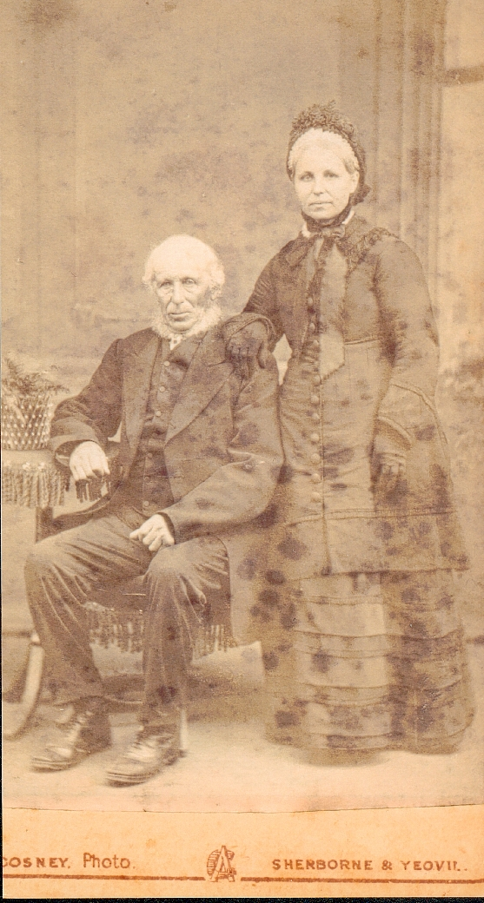

There are also some entries for three Tanswells living at Henstridge as farmers: a William (62) and Jane (61) and George (31) Tanswell. This was William Tanswell who had been born in Shaftesbury, Dorset in 1837. George was the George Henry Tanswell born in Wincanton district in 1869. Perhaps it is a coincidence, but Henstridge was where William, son of Samuel and brother of George had been born in 1834, so there was a connection with that village which might imply a family connection.

Joseph Job Tanswell, the brother of George Edward, was still living in Bristol where he had married Alice. It is likely they had children, but as there was another Tanswell family of childbearing age there, and as the online census does not give the households, it would only be a guess to say which children were theirs. However it is likely that Alice, aged 6, was named after her mother.

More certain is George’s other brother, Thomas, who had originally gone to Bristol as well (probably first). He had moved to sale in Manchester with wife Annie (30, from Axminster) and children Lillian (11), Edward (9) and Ruby (2). Lillian and Edward were born in Bristol, so they must have moved to Manchester after 1892.

Because both brothers went to Bristol, it is highly likely that the photograph below, which was developed in Bristol, is one of them:
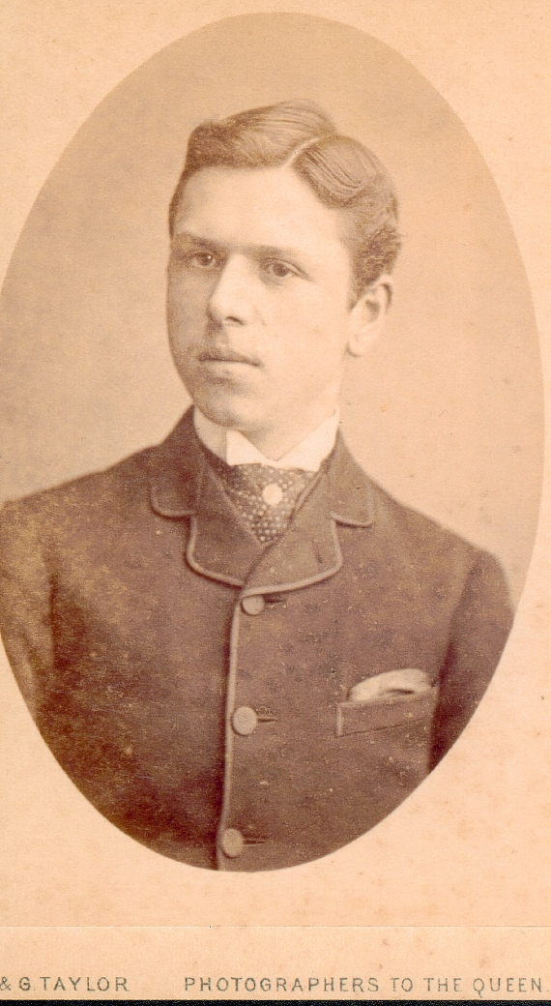

The young man bears a striking resemblance to the girl below, who is perhaps his sister Fanny Martha Tanswell (later Adams):
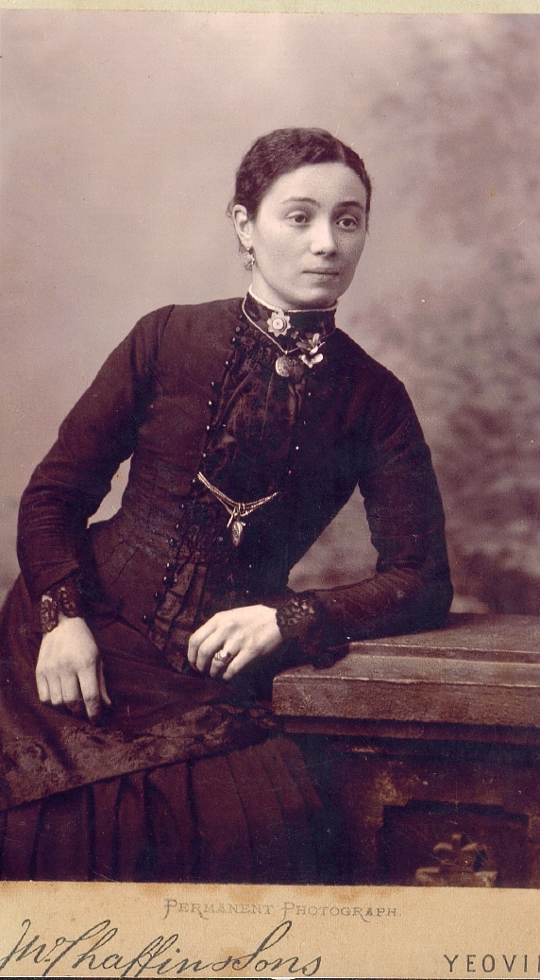

I appeal to all Tanswells and associated families to check their old photo albums and if they have a match for any of the photos above, then please contact me. Below is a list of all Tanswells named in the online 1901 census. It does have errors, so if your ancestor is not there that’s why! I have tried to correct some of the errors, but others I can do nothing about (there is no Rodmead in Wiltshire, for example, but the closest I could get was Rodbourne).

Name | Age | Where  Born | Administrative  County | Civil Parish | Occupation
George Tanswell | 29 | Shrewsbury | Brecknock | Talgarth | Banker Mason
Mary Tanswell | 64 | Bristol | Bristol | Bristol
Thomas Tanswell | 62 | Bristol | Bristol | Bristol | Boilemaker
Alice Tanswell | 32 | Bristol | Bristol | Bristol
Joseph Tanswell | 31 | Somerset Yeovil | Bristol | Bristol | Beer Keeper
Annie Tanswell | 25 | Bristol | Bristol | Bristol
Griffith Tanswell | 23 | Glouc | Bristol | Bristol | Furniture Polisher
Ernest Tanswell | 20 | Bristol | Bristol | Bristol | General Labourer
Alice Tanswell | 6 | Bristol | Bristol | Bristol
Florence Tanswell | 4 | Bristol | Bristol | Bristol
Ellen Tanswell | 1 | Bristol | Bristol | Bristol
Thomas Tanswell | 33 | Somerset Yeovil | Chester | Sale | Collector Of Accounts
Annie Tanswell | 30 | Devon Axminster | Chester | Sale
Lilian Tanswell | 11 | Glouc Fishponds | Chester | Sale
Edward Tanswell | 9 | Glouc Bristol | Chester | Sale
Ruby Tanswell | 2 | Lancs Stretford | Chester | Sale
James Tanswell | 45 | Dorset Dorchester (near) | Dorset | Blandford | Coal Hauiler
Tom Tanswell | 45 | Dorset Puddleton | Dorset | Blandford | Plumbers Labourer
Frances Tanswell | 41 | Dorset Chiselborne | Dorset | Blandford
John Tanswell | 19 | Dorset Blandford | Dorset | Blandford | Grocers Porter
Lilian Tanswell | 15 | Dorset Blandford | Dorset | Blandford | General Domestic
Harriet Tanswell | 13 | Dorset Blandford | Dorset | Blandford | Genral Servant Domestic
Thomas Tanswell | 10M | Dorset Blandford | Dorset | Blandford
Emma Tanswell | 6 | Dorset Blandford | Dorset | Blandford | Scholar
Amy Tanswell | 16 | Hants Bournemouth | Dorset | Bournemouth | Kitchen Maid Domestic
John Tanswell | 34 | Wilts Sedgehill | Dorset | Bourton | Cattleman On Farm
Elsie Tanswell | 7 | Somerset Bodden Shepton Mallet | Dorset | Bourton
Frank Tanswell | 5 | Dorset Timbury | Dorset | Bourton
Henry Tanswell | 1 | Dorset Beer Hackett | Dorset | Bourton
Ellen Tanswell | ... | Dorset South Perrott | Dorset | Bourton
Henry Tanswell | 59 | Dorset Buckhorn Weston | Dorset | Buckhorn Weston | Farmer +Inn Keeper
Mary Tanswell | 56 | Wilts Semington | Dorset | Buckhorn Weston
Arthur Tanswell | 28 | Dorset Buckhorn Weston | Dorset | Buckhorn Weston | Farmers Son
Edgar Tanswell | 17 | Dorset Buckhorn Weston | Dorset | Buckhorn Weston | Farmers Son
Emmaletta Tanswell | 19 | Dorset Broadstone | Dorset | Canford Magna | General Servant Domestic
Annie Tanswell | 28 | Dorset Gussage | Dorset | Dorchester St Peter
John Tanswell | 28 | Dorset Broadstone | Dorset | Dorchester St Peter | Bricklayer
Louisa Tanswell | 6M | Dorset Dorchester | Dorset | Dorchester St Peter
Annie Tanswell | 1 | Dorset Dorchester | Dorset | Dorchester St Peter
Rosa Tanswell | 30 | Dorset Buckham Weston | Dorset | Gillingham | Cheesemaker
Fred Tanswell | 26 | Dorset Buckham Weston | Dorset | Gillingham | Dairyman
Mary Tanswell | 22 | Somerset Sutton Bingham | Dorset | Iwerne Minster | Housemaid Domestic
Charles Tanswell | 71 | Dorset Gillingham | Dorset | Shaftesbury | General Labourer
Mary Tanswell | 69 | Dorset Shaftesbury | Dorset | Shaftesbury
Herbert Tanswell | 17 | Dorset Stourton Caundle | Dorset | Stourton Caundle | Boys 1St Class Navy Men
Mary Tanswell | 81 | Dorset Sutton Waldron | Dorset | Sutton Waldron | Living On Own Means
Silas Tanswell | 75 | Dorset Tarrant Monkton | Dorset | Tarrant Monkton | Shoe Maker
Alfred Tanswell | 28 | Dorset Tarrant Monkton | Dorset | Tarrant Monkton | Traction Engine Driver
Ellen Tanswell | 26 | Dorset Tarrant Larneston | Dorset | Tarrant Monkton
George Tanswell | 39 | Somerset Yeovil | Essex | Halstead Urban | Boot Shoe Dealer Maker
Clara Tanswell | 34 | Norfolk Fakenham | Essex | Halstead Urban
Elsie Tanswell | 16 | Shrewsbury | Essex | Halstead Urban
Claud Tanswell | 14 | Essex Halstead | Essex | Halstead Urban
Hilda Tanswell | 13 | Essex Halstead | Essex | Halstead Urban
Sidney Tanswell | 11 | Essex Halstead | Essex | Halstead Urban
Noel Tanswell | 8 | Essex Halstead | Essex | Halstead Urban
Gertrude Tanswell | 6 | Essex Halstead | Essex | Halstead Urban
Kathleen Tanswell | 4M | Essex Halstead | Essex | Halstead Urban
Violet Tanswell | 4 | Essex Halstead | Essex | Halstead Urban
Gwendoline Tanswell | 2 | Essex Halstead | Essex | Halstead Urban
George Tanswell | 45 | Dorset Lutton | Glamorganshire | Ystradyfodwg | Colliery Timberman Below Ground
Ellen Tanswell | 43 | Glamorgan Merthyr | Glamorganshire | Ystradyfodwg
Beatrice Tanswell | 20 | Glamorgan Ystrad | Glamorganshire | Ystradyfodwg | Board School P T 4th Year
Tabitha Tanswell | 18 | Glamorgan Ystrad Rhondda | Glamorganshire | Ystradyfodwg | Barmaid
William Tanswell | 12 | Glamorgan Ystrad | Glamorganshire | Ystradyfodwg | Coal Hewer Below Ground
Margery Tanswell | 10 | Glamorgan Ystrad | Glamorganshire | Ystradyfodwg
David Tanswell | 6 | Glamorgan Ystrad | Glamorganshire | Ystradyfodwg
Emma Tanswell | 59 | Wilts East Knoyle | Gloucester | Gloucester
Charles Tanswell | 29 | Wilts East Knoyle | Gloucester | Gloucester | Commercial Traveller
Fanny Tanswell | 25 | Wilts East Knoyle | Gloucester | Gloucester
Emily Tanswell | 43 | Dorset Blandford | Hampshire | Bournemouth
George Tanswell | 43 | Dorset Puddletown | Hampshire | Bournemouth | Bath Chair Proprietor
Frederick Tanswell | 13 | Hants Bournemouth | Hampshire | Bournemouth
James Tanswell | 11 | Hants Bournemouth | Hampshire | Bournemouth
Margaret Tanswell | 10 | Hants Bournemouth | Hampshire | Bournemouth
Ernest Tanswell | 7 | Hants Bournemouth | Hampshire | Bournemouth
Grace Tanswell | 6 | Hants Bournemouth | Hampshire | Bournemouth
George Tanswell | 2 | Hants Bournemouth | Hampshire | Bournemouth
Maria Tanswell | 51 | Wilts Rodmead (Rodbourne?) | Hampshire | King’s Somborne | Carter On Farm
Alfred Tanswell | 21 | Wilts Rodmead (Rodbourne?) | Hampshire | King’s Somborne | Carter On Farm
William Tanswell | 20 | Wilts Rodmead (Rodbourne?) | Hampshire | King’s Somborne | Carter On Farm
Kate Tanswell | 16 | Wilts Rodmead (Rodbourne?) | Hampshire | King’s Somborne
Herbert Tanswell | 12 | Wilts Rodmead (Rodbourne?) | Hampshire | King’s Somborne
Ellen Tanswell | 37 | Shropshire Dawley | Herefordshire | Holmer And Shelwick Entire
Frederick Tanswell | 36 | Montgomery Newtown | Herefordshire | Holmer And Shelwick Entire | Auctioneers Clerk
Frederick Tanswell | 13 | Shropshire Dawley | Herefordshire | Holmer And Shelwick Entire
Ernest Tanswell | 12 | Shropshire Dawley | Herefordshire | Holmer And Shelwick Entire
Percy Tanswell | 10 | Hereford Holmer | Herefordshire | Holmer And Shelwick Entire
Gertrude Tanswell | 8 | Hereford Holmer | Herefordshire | Holmer And Shelwick Entire
Agnes Tanswell | 7 | Hereford Holmer | Herefordshire | Holmer And Shelwick Entire
Harold Tanswell | 5 | Hereford Holmer | Herefordshire | Holmer And Shelwick Entire
Nellie Tanswell | 3 | Hereford Holmer | Herefordshire | Holmer And Shelwick Entire
Sarah Tanswell | 21 | Middx Tottenham | Hertford | Monken Hadley | Housemaid Domestic
Madelina Tanswell | 22 | Manchester | Kingston Upon Hull | Sculcoates
Robert Tanswell | 20 | Yorks Hull | Kingston Upon Hull | Sculcoates | Bricklayer
Madeline Tanswell | 3M | Yorks Hull | Kingston Upon Hull | Sculcoates
William Tanswell | 23 | Birmingham Smallheath | Lancashire | North Manchester | Railway Engine Cleaner
Ernest Tanswell | 22 | Birmingham Smallheath | Lancashire | North Manchester | Railway Engine Cleaner
Fanny Tanswell | 28 | Shrewsbury | Lancashire | Rochdale | General Servant Domestic
John Tanswell | 77 | Shrewsbury | Lancashire | South Manchester | House Painter
Annie Tanswell | 52 | London | Lancashire | South Manchester
Albert Tanswell | 36 | Salop Dawley | Lancashire | South Manchester | Warehouseman Drysalters
Maria Tanswell | 34 | Manchester | Lancashire | South Manchester
Frederick Tanswell | 30 | Manchester | Lancashire | South Manchester | Stone Masons Labourer
Sarah Tanswell | 26 | Lancs Salford | Lancashire | South Manchester
Florence Tanswell | 19 | Manchester | Lancashire | South Manchester
John Tanswell | 17 | Manchester | Lancashire | South Manchester | Mail Van Driver
Frederick Tanswell | 11 | Manchester | Lancashire | South Manchester
Edith Tanswell | 9 | Manchester | Lancashire | South Manchester
Albert Tanswell | 7 | Manchester | Lancashire | South Manchester
Florence Tanswell | 5M | Lancs Gorton | Lancashire | South Manchester
Charlie Tanswell | 5 | Manchester | Lancashire | South Manchester
Ethel Tanswell | 2 | Manchester | Lancashire | South Manchester
Hilda Tanswell | 2M | Manchester | Lancashire | South Manchester
William Tanswell | 46 | Birmingham | Lancashire | Southport | Advertising Agent
Sarah Tanswell | 15 | Yorks Hull | Lincoln Lindsey | Barton On Humber
George Tanswell | 78 | Wilts Sedghill | London | Battersea | Gardener
Ada Tanswell | 27 | London West Brompton | London | Fulham
William Tanswell | 36 | Coventry | London | Kensington | Woodman
Mary Tanswell | 32 | London Kensington | London | Kensington
John Tanswell | 26 | Burton On Trent | London | Kensington | Flower Seller ...
Rose Tanswell | 24 | London Kensington | London | Kensington | Flower Seller ...
Rose Tanswell | 12 | London Kensington | London | Kensington
Mary Tanswell | 7 | London Kensington | London | Kensington
William Tanswell | 4 | London Kensington | London | Kensington
James Tanswell | 1 | London Kensington | London | Kensington
Michael Tanswell | 1 | London Kensington | London | Kensington
Emily Tanswell | 26 | Dorset Shaftesbury | London | Paddington | Housemaid Domestic
Lilian Tanswell | 21 | Kent Chatham | London | Putney | Housemaid Domestic
Charles Tanswell | 49 | Dorset Brandford | London | S John | Groom
Mary Tanswell | 48 | Dorset Puddlestown | London | S John
Francis Tanswell | 20 | Dorset Shaftesbury | London | St Marylebone | Footman Domestic
Emma Tanswell | 29 | Wilts East Knoyle | Middlesex | Ealing | Housemaid
William Tanswell | 55 | London Islington | Middlesex | Tottenham | Watchmaker
Harriet Tanswell | 34 | Hastings Sussex | Middlesex | Tottenham
Walter Tanswell | 33 | London Islington | Middlesex | Tottenham | Furniture Porter
William Tanswell | 26 | London Islington | Middlesex | Tottenham | Brass Finisher
James Tanswell | 16 | London Islington | Middlesex | Tottenham | Brass Finisher
Albert Tanswell | 5M | Middx Tottenham (S) | Middlesex | Tottenham
Joy Tanswell | 2 | Middx Tottenham (s) | Middlesex | Tottenham
William Tanswell | 25 | Salop Wellington | Salop | Hadley | Coach Maker Painter
Richard Tanswell | 57 | Shrewsbury | Salop | St Chad | Painter House
Jane Tanswell | 49 | Shrops Diddlebury | Salop | St Chad
Arthur Tanswell | 39 | Shrewsbury | Salop | St Chad | Printer
Mary Tanswell | 36 | Shrewsbury | Salop | St Chad
Charles Tanswell | 24 | Shrewsbury | Salop | St Chad | Printer Compositor
Julia Tanswell | 19 | Shrewsbury | Salop | St Chad | Dressmaker
Thomas Tanswell | 17 | Shrewsbury | Salop | St Chad | Hairdressers Apprentice
Albert Tanswell | 15 | Shrewsbury | Salop | St Chad | Cabinet Makers Apprentice
Arthur Tanswell | 14 | Shrewsbury | Salop | St Chad | Boots At Hotel
Ellen Tanswell | 13 | Shrewsbury | Salop | St Chad
John Tanswell | 52 | Shrewsbury | Salop | St Julian | Painter Railway Coach
Hannah Tanswell | 45 | Shrewsbury | Salop | St Julian
Clara Tanswell | 24 | Shrewsbury | Salop | St Julian | Dressmaker
Edith Tanswell | 20 | Shrewsbury | Salop | St Julian | Dressmaker
John Tanswell | 14 | Shrewsbury | Salop | St Julian | Bakers Errand Boy
Lousia Tanswell | 11 | Shrewsbury | Salop | St Julian
Percy Tanswell | 8 | Shrewsbury | Salop | St Julian
John Tanswell | 71 | Shrewsbury | Salop | St Mary | Musician
Walter Tanswell | 42 | Shrewsbury | Salop | St Mary | Writing Clerk
William Tanswell | 62 | Dorset | Somerset | Henstridge | Farmer
Jane Tanswell | 61 | Dorset | Somerset | Henstridge
George Tanswell | 31 | Somerset Burton | Somerset | Henstridge | Farmers Son
Ellen Tanswell | 32 | Somerset Sutton Bingham | Somerset | Sutton Bingham | Dressmaker
George Tanswell | 65 | Wilts Sedgehill | Somerset | Weston Super Mare | Retired Minister Baptist
Hannah Tanswell | 64 | Gloucs Longhope | Somerset | Weston Super Mare
Martha Tanswell | 66 | Somerset Pendomer | Somerset | Yeovil
Thomas Tanswell | 67 | Shrewsbury | Stafford | Wolverhampton | Railway Company Painter
Elizabeth Tanswell | 66 | Scotland | Staffordshire | Wolverhampton
Thomas Tanswell | 44 | Staffs Wolverhampton | Staffordshire | Wolverhampton | Iron Drilling Machine Worker
Mary Tanswell | 41 | London | Staffordshire | Wolverhampton
Minnie Tanswell | 38 | Staffs Wolverhampton | Staffordshire | Wolverhampton | Charwoman
Elizabeth Tanswell | 36 | Staffs Wolverhampton | Staffordshire | Wolverhampton
Thomas Tanswell | 36 | Staffs Blymhill | Staffordshire | Wolverhampton | Railway Engine Boiler Makers Assistant
Arthur Tanswell | 23 | Salop Blymhill | Staffordshire | Wolverhampton | Coal Dealers Assistant
Frederick Tanswell | 16 | Staffs Wolverhampton | Staffordshire | Wolverhampton | Pupil Teacher
John Tanswell | 15 | Staffs Wolverhampton | Staffordshire | Wolverhampton | Plumber
Florence Tanswell | 11 | Staffs Wolverhampton | Staffordshire | Wolverhampton
Thomas Tanswell | 9 | Staffs Wolverhampton | Staffordshire | Wolverhampton
Theophilus Tanswell | 3 | Staffs Wolverhampton | Staffordshire | Wolverhampton
Alfred Tanswell | 40 | Shrewsbury | Staffordshire | Wolverhampton (Part) | Caretaker Of School
Sarah Tanswell | 36 | Shrewsbury | Staffordshire | Wolverhampton (Part)
Georgina Tanswell | 13 | Shrewsbury | Staffordshire | Wolverhampton (Part)
Eli Tanswell | 43 | Wilts East Knoyle | Surrey | South Wimbledon | Labourer Electric Light
Bridget Tanswell | 37 | Ireland | Surrey | South Wimbledon
Anne Tanswell | 46 | Kent Rochester | Surrey | Weybridge
Geo Tanswell | 46 | Wilts East Knoyle | Surrey | Weybridge | Foreman Catter Tailor
Gertrude Tanswell | 16 | Hants Winchester | Surrey | Weybridge | Commercial Clerk
Arthur Tanswell | 14 | Hants Newtown | Surrey | Weybridge
Herbert Tanswell | 12 | Hants Newtown | Surrey | Weybridge
Ethel Tanswell | 8 | Hants | Surrey | Weybridge
Lotty Tanswell | 21 | Sussex Lewes | Sussex | Brighton
William Tanswell | 10M | Sussex Brighton | Sussex | Brighton
Olive Tanswell | 2 | Sussex Lewes | Sussex | Brighton
Harry Tanswell | 37 | Wilts Warminster | Sussex | Eastbourne | Hairdresser
Gertrude Tanswell | 32 | London | Sussex | Eastbourne
Sidney Tanswell | 7 | Sussex Eastbourne | Sussex | Eastbourne
Harry Tanswell | 35 | Hants Brockenhurst | Sussex | Shipley | Foreman Of Brickyard
Ellen Tanswell | 25 | Hants Stubbington | Sussex | Shipley
Caroline Tanswell | 1 | Hants Stubbington | Sussex | Shipley
Sidney Tanswell | 24 | Wilts East Knoyle | Wilts | Barford St Martin | Gardener Domestic
James Tanswell | 53 | Wilts E Knoyle | Wilts | E Knoyle | Formerly Carter On Farm
John Tanswell | 38 | Wilts East Knoyle | Wilts | East Knoyle | Groom Not Domestic
Louisa Tanswell | 38 | Wilts East Knoyle | Wilts | East Knoyle
Eleanor Tanswell | 12 | Wilts East Knoyle | Wilts | East Knoyle
Leonard Tanswell | 11 | Wilts East Knoyle | Wilts | East Knoyle
Hubert Tanswell | 9 | Wilts East Knoyle | Wilts | East Knoyle
Charles Tanswell | 8 | Wilts East Knoyle | Wilts | East Knoyle
Robert Tanswell | 6 | Wilts East Knoyle | Wilts | East Knoyle
Oliver Tanswell | 4 | Wilts East Knoyle | Wilts | East Knoyle
Rose Tanswell | 3 | Wilts East Knoyle | Wilts | East Knoyle
Henry Tanswell | 1 | Wilts East Knoyle | Wilts | East Knoyle
Ann Tanswell | 69 | Wilts Sedghill | Wilts | Sedghill | Nil
Ethel Tanswell | 14 | East Knoyle Wilts | Wilts | St Edmund | Shop Assistant
Walter Tanswell | 40 | Wilts Warminster | Wilts | Warminster | Organist & Cycle Agent
Anne Tanswell | 35 | Wilts Wilton | Wilts | Warminster | Mistress National School
Dorathy Tanswell | 9 | Wilts Warminster | Wilts | Warminster
Annie Tanswell | 14 | Staffs Wordsley | Worcester | Hagley | General Servant Domestic
Thomas Tanswell | 42 | Worcs Stourbridge | Yorkshire | Embsay With Eastby | Limestone Quarryman
Maria Tanswell | 32 | Yorkshire Grassington | Yorkshire | Embsay With Eastby
Hannah Tanswell | 19 | Lancashire St Helens | Yorkshire | Embsay With Eastby | Woollen Weaver Dress Goods
Christopher Tanswell | 17 | Lancashire St Helens | Yorkshire | Embsay With Eastby | Tailors Apprentice
Thomas Tanswell | 10 | Lancashire St Helens | Yorkshire | Embsay With Eastby
Ralph Tanswell | 4 | Yorkshire Embsay | Yorkshire | Embsay With Eastby
John Tanswell | 1 | Yorkshire Embsay | Yorkshire | Embsay With Eastby

Daleymounts in the 1901 Census
The Daleymounts were not so numerous and, apart from one who had moved to London for work, the rest were in Somerset and Avon:

Name | Age | Where Born | Administrative  County | Civil Parish | Occupation
Ada | 21 | Yeovil | London | Kensington | Parlour maid
Eliza | 29 | Kingsdon, Somerset | Somerset | Twerton
John | 29 | Sutton Bingham | Somerset | Twerton | GWR Police
Ernest | 3 | Bath | Somerset | Twerton
Lilian | 11m | Bath | Somerset | Twerton
Mary | 66 | Pendomer | Somerset | Yeovil | Retired domestic servant
Oliver | 51 | Sutton Bingham | Somerset | Yeovil | Railway porter
Ellen | 45 | Pendomer | Somerset | Yeovil
Willie | 27 | Yeovil | Somerset | Yeovil | Coal haulier
Arthur | 17 | W. Coker | Somerset | Yeovil | Gas fitter’s apprentice
Ellen | 15 | Hardington | Somerset | Yeovil
Oliver | 13 | Barwick | Somerset | Yeovil | Telegraph messanger
Lily | 10 | Yeovil | Somerset | Yeovil
Leonard | 6 | Yeovil | Somerset | Yeovil

More on this when I have more time. Best wishes to you all.
© 14 September 2002.
Many thanks to Hazel Fowler and Betty Rayner, who allowed me to view and have copies of photographs from Clara Tanswell’s album.

