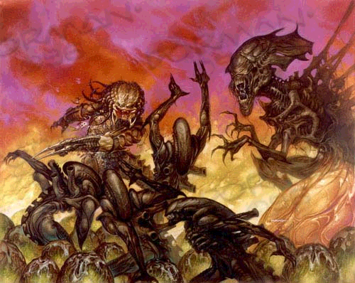

Aliens/Predator Marvel Superhero

Sourebook

By chris Schmitz:

http://www.angelfire.com/rpg/marvelclassic/index.html

Table of Contents:

Alien/Xenomorph- 3

~>characters- 6

Predator/ Yautja- 9

~>characters- 20

~>weapons- 15,21

~>code- 13

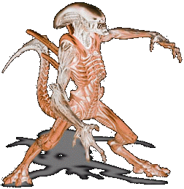
ALIENS (XENOMORPH)
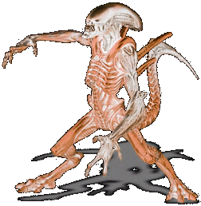

There are three types of Xenomorph Aliens, The Queen, The Soldier or Praetorian, and the worker or drone.

The Praetorian is a male xenomorph which cannot lay eggs, as do the other 2 genus’ of xenomorphs. He is the second most common and usually stays near the queens domain. His primary purpose in life is to protect the queen at all costs and eliminate any threats to her. He also fertilizes the queen when necessary; their eggs are the second largest. He attacks threats on instinct and is the fastest to reach full maturity. After a Praetorian facehugger plants an embryo in a host, the praetorian chestburster emerges within a few hours of implantation. They have the largest sized eggs produced. Some hives might have no praetorians-in cases where there are an overly large number of drones.

The Queen xenomorph is a female. She is the largest of her breed and takes the longest time to develop from an embryo into a chestburster (about 12-48 hours.) She also takes the longest time to reach maturity. The queen is fairly large at the time of its eruption from the host with large well-defined arms. A queen in an unpopulated area is impregnated by a Praetorian then grows her egg sac which produces thousands of eggs like an assembly line. She also possess a reserve egg sac within her insides. Included therein are 3 eggs, each which contain a chestburster for each type of xenomorph. There is in general only one mature queen in each hive. A hatched queen within an existing, occupied hive will either leave to start a new colony, or attempt to slay the existing queen for control of the hive. The queen chestburster’s eggs are the smallest and the queen will only detach from her egg sac when her life is immediately threatened. She may later re-grow her egg sac. She is often so encumbered by her egg sac that she does not move herself and is moved by her hive workers, a smaller version of xenomorph drones. Queens can form any kind of egg desired and needed at the moment.

The drone xenomorph is a hermaphrodite. It takes the second longest time to develop into a chestburster from an embryo as well as from embryo to maturity. It usually takes between 8 and 12 hours for the incubated embryo to erupt as a chestburster. Drones possess poisoned stingers that may temporarily paralyze its victims and also may lay up to 2 eggs which it carries. All drones possess an egg to create a Praetorian and a queen-thus insuring that one drone could colonize an entire planet. Drones are the most common of the xenomorph genus and have the second-largest of the eggs. One sub-class of drones are the egg-attenders or queens servants. They are non-aggressive and have a singular purpose-the gathering and safe conduct of the queen’s eggs. They also might move an encumbered queen at her bidding.

Face Huggers: All "face-huggers" behave similarly. But, like the egg-stage, appear different in some respects. The Praetorian "face-hugger" is relatively larger than a drone, this concurs with the theory of different sizes between sub-genus, at all stages of development. It is not beyond reason to assume that the Queen "face-hugger" is somewhat smaller than a Drone's, but may grow larger before "death". The "face-hugger" is strong, single-minded, and relentless. They are positioned with their tail to leap out of their egg to attach themselves to a host, they might not do this so aggressively when their host is cocooned within the hive. Face-huggers are selective and will try and attach itself to the most prime specimen and will attempt to avoid injuring its host. They die after implanting their embryo. They often give the best host to the queen bearing face-hugger. They have no need to breathe, their survival tools are all internally included, but are limited which regulates their lifespan once they leave their egg-but gives them the advantage of going anywhere in any conditions to find a host.

Xenomorph Growth: After erupting as a chestburster, the xenomorph grows at a rapid rate into maturity (timeframe dictated by it’s genus,) they may shed their skin (molt) up to three times during this process which may take from just hours to a week depending upon conditions.

The Hive: Xenomorphs may excrete a substance within the hive that is a kind of slime coating. They often take live victims and cocoon their limbs into this wall coating and place an egg near them, a host for a face hugger. This substance makes it even easier to move in for the xenomorphs as well as providing a formidable camoflauge.

Xenomorph Behavior: they have only 2 modes to them, a survival instinct (except when the queen wills it otherwise,) and their singular purpose to proliferate their species.

Xenomorph Characteristics: they may adapt to any environment by taking characteristics of survival from it’s host, eg. A face-hugger implants a humanoid that breathes only pure nitrogen which is in the host’s atmosphere, they resulting chestburster will now be able to breathe this in addition to any other survival modes it’s ancestors possessed-all passed down through the gene-pool. They will often also retain their hosts characteristics, but these are however not added to their gene-pool’s genetic database of characteristics. This is how some of the drones often differ, such as predator-alien hybrids as well as xenomorphs which have been melded with animals to give them slightly differing characteristics. Most drones seen (the ones from the Aliens movies) are the result of humanoid hosts since a humanoid is the most optimal host figure for a face-hugger.

Xenomorph gameplay: these are some characteristics that all Xenomorphs possess:
acid blood EX20, also may spit this on a victim up to 3 areas (but with only GD intensity)
Claws, teeth, tail spike allow edged damage at +1CS to strength
Sensory organs-no ears, eyes, or nose, all interior sensory organs which may do the equivalent of human senses at +2CS.
Pheremone detection, RM30
Wall crawling, RM30
Exoskeleton provides at least TY6 body armor.
Xenomorphs at full health gain an additional attack with no penalties.
Weakness: Fire does +3CS damage to Xenomorphs and burns for 1additional round
Weakness: A bullseye on the head piece with a ranged weapon does +1CS damage
Hyper-metabolism- mandibles do UN100 damage, with a successful FEAT roll, may bite through a skull and eat the brain therein which will give the xenomorph a +1CS bonus to all physical attributes for 1-20 turns as well as heal 25 points of damage. They may eat the brain of any creature with a functioning body (that has not entered rigor mortis).
Eggs have GD10 material strength
Xenomorphs move at 1 additional space per round

Common Xenomorphs

Face Hugger
Alien, no gender
Generally found only within a hive or an egg.

F A S E R I P HLTH
PR EX GD EX FE EX PR 34

-Acid Blood-may cause itself to bleed in certain situations, but will not on a prime host.
-Implants genus specific embryo into host body. Provides all necessary life functions for host during this time.

Chest Burster
Alien, Xenomorph, male-female-hermaphrodite
Erupts from chest cavity of victim-xenomorph stage 2

F A S E R I P HLTH
EX RM GD TY PR IN RM 65

-TY6 armor
-gains size, strength, and endurance ranks until it becomes fully mature, begins at about the size of a cat

Drone/worker
Alien, Xenomorph, hermaphrodite

F A S E R I P HLTH
EX RM RM EX PR IN RM 100

-TY6 armor
-6-7 feet tall
-tail spike may give off a toxin on contact causing temporary paralysis. This toxin is RM30 in intensity

Drone/worker #2
Alien, Xenomorph, hermaphrodite
Subspecies 2- queens attendants, egg handlers

F A S E R I P HLTH
GD EX IN EX PR IN RM 90

-TY6 armor
-4-5 feet tall
-Non-aggressive, will not attack unless first damaged

Praetorian (Royal Guard) Soldier
Alien, Xenomorph, Male

F A S E R I P HLTH
RM EX AM IN PR IN IN 140

-EX20 body armor
-oversized armored skull provides AM armor to head piece, MN75 material strength (often used for ramming)
-approx. 9ft tall

Queen (Hive Mother)
Alien, Xenomorph, female

F A S E R I P HLTH
EX RM MN AM GD MN ShY 175

-EX armor
-telepathic link with all drones and offspring within the hive
-creates eggs while egg sac is attached
-resides in center of the hive
-15-25 ft tall
-oversized armored skull provides AM armor to head piece, MN75 material strength

Other known Xenomorph mutations:

Animal Hybrid-drone
Alien, Xenomorph

F A S E R I P HLTH
RM IN EX RM FE IN IN 130

-GD10 armor
-4-7ft tall
-move yet 1 more additional space per round

Animal Hybrid-soldier
Alien, Xenomorph

F A S E R I P HLTH
IN AM EX RM FE IN IN 140

-EX20 armor
-4-7ft tall
-oversized armored skull provides AM armor to head piece, MN75 material strength (often used for ramming)

Alien-Predator Hybrid-drone
Alien, Xenomorph

F A S E R I P HLTH
IN IN AM RM GD IN IN 160

-EX20 armor
-9ft tall
-head damage does not do +1CS damage
-Predators will relentlessly attack these with no regard to anything else-they view these as an abomination
-tail spike may give off a toxin on contact causing temporary paralysis. This toxin is RM30 in intensity

Alien-Predator Hybrid-Soldier
Alien, Xenomorph

F A S E R I P HLTH
AM AM MN IN GD IN IN 215

-EX20 armor
-9ft tall
-head damage does not do +1CS damage
-Predators will relentlessly attack these with no regard to anything else-they view these as an abomination
-tail spike may give off a toxin on contact causing temporary paralysis. This toxin is RM30 in intensity

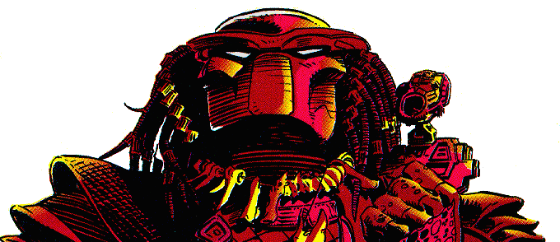



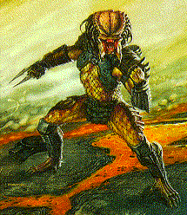

The Caste System of the Yautja

As our entire culture revolves around the HUNT our social order is based on the number of kills and/or trophies a Hunter has acquired. Though there is much overlapping between the classes, these are the basic Castes:

The "Eta"
The untouchables of the Yautja. Mostly they are the lame or the crippled, who are unable (or too cowardly) to join the HUNT. Instead, they serve as slaves and do menial jobs for the Hunters. They are ridiculed and humiliated on a daily basis by the other Yautja.

The "Unblooded"
Our children are trained for their future HUNTS. Before their first HUNT they are considered the "Unblooded," juveniles who have yet to prove themselves. They represent about 40% at any one time.

The "Young Bloods"
These are the recently "blooded" warriors. They are usually reckless and depressingly keen, trying to make a name for themselves. Many of them are proud of their petty trophies, which amuses the more experienced hunters. About 30% of Yautja at any one time is considered a "Young Blood."

The "Blooded"
Though all hunters are considered "Blooded", this usually refers to those who are far from being Young Bloods but not yet an "Ancient" or one of the "Honored." This represents 20% of the Yautja population.

The "Warriors"
These are the Yautja who don't hunt with a clan, but engage solo in combat and war. They are violent types, yet well-respected. Special equipment and wepons are given to these conquering Hunters, who travel the galaxy alone as part of their birthright. There are many tales of powerfull Warriors, passed down through generations. They are an elite sect, comprising barely 5% of our race.

The "Honored"
These Hunters are the elite of the our society. Not only have they survived many HUNTS, they have gathered many more trophies than the average hunter or have performed a great service to the entire Yautja community. They comprise approximately 10% of the populace.

The "Ancients"
The mightiest of the Yautja are the veterans known as the "Ancients." Almost all had been one of the "Honored" and continued to survive for centuries of hunts. Ironically, these are the least concerned by the hunt anymore, focusing their attention to their arthritis instead. They are still great Warriors; they just have too many trophies to care anymore. As a result, they are more compassionate and disciplined than most other Yautja. Many have learned new fighting techniques over the ages. For example, one "Ancient" who had hunted in 16th century Japan learned "Hira Baraki," or two sworded combat, and continues to use it today, and has two custom swords. These represent less than 1% of the entire population.

The "Bad Bloods"
The criminal caste. They have gone insane, and are a danger to the Clan. Many have committed crimes such as: murder of another Yautja, killing prey that is not game or failing in the HUNT. These are constantly being tracked by the "Arbitrators." About 5% of all Yautja are "Bad Bloods," and in the above castes the number of these criminals have been added to the total amount.

This is an excerpt of the language of our race. We communicate in clicks and gurgles, but this is how the written words would be pronounced.

Awu'asa - full body ensemble

Bakuub - "Straight Spear"

Cetanu - God of Death

Ch'hkt-a - hyper active

C'jit! - "Damn!"

C'ntlip - type of drink

Dachande - "Different Knife"

Dahdtoudi - "Little Knife"

Dhi'ki-de - final rest

Dtai'k-dte sa-de nav'g-kon dtain'aun bpide - "The fight begun would

not end until the end."

Gkei'moun - easy or simple

Gkinmara - video camera

Gry'sui-bpe - stampede

Hiju - fighting position

Hulij-Bpe - crazy

Hult'ah - rear guard or look out

Jehdin/Jehdin - hand-to-hand combat

Kainde amedha - Hard Meat ( Xenomorph Aliens)

Kainde amedha chiva - the Hard Meat Trial

Kehrite - battle arena

Ki'cte! - "Enough!"

Ki'cti-pa - double-bladed wrist knife

Kv'var - excercises

Kwei - tricky or sly

Lou-dte Kalei - "Child Maker"

M-di H'chak/M-di H'dlak - "No mercy/No Fear"

Mei'hswei - bother

Nain-de - type of hunt

Nain-desintje-da - The Pure Win

Nan De-Than Gaun - "Kiss of Midnight"

Nan-ku - alive

Naxa - type of fruit

N'dui'se - Yautja's musk

Nok - unit of measure (equivalent to 13 inches)

Pauk! - expletive

Paya - a god, conquering warrior

Payas Leitjin-de Hma'mi-de - "Remember God's Practice"

Pyode amedha - Soft Meat (humans)

Rjet - type of animal

S'yuit-de - low and demeaning description of something

Setg'-in - deadly and quick

Tarei'hasan - small insect

Te'dqi - xenomorph secretion

Thei-de - death

Thin-de le'hasuan 'aloun'myin-del bpi-de gka-de hasou-de paya -

"Learn the gifts of all sights,

or finish in the dance of the fallen gods."

Thwei - blood

Tjau'ke - hard packed dirt or type of rock

Tyioe-ti - esape pod

Ui'stbi - geography

U'sl-kwe - final rest

Yeyinde - "Brave One"

Zabin - type of insect

Z'skvy-de - birth of xenomorph from host, eruptive phase

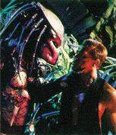

This is the Code of HONOR For our race. It is the highest law of our kind, and something of a religous code. It is taken with the utmost seriousness, and one can not even joke about breaking it. A false accusation of an Honor Code violation will get you torn limb from limb when the news of your discresion is made public. To break the Code is stop being a Yautja, and becoming something that is to be killed with as little consideration and honor as an illness insect carrying.
1.Hunting Worthy Game:
When hunting, the Hunter must be sure that his prey is considered game, and lawful to kill. Sometimes the hunter will equal the odds (not using the plasma-castor or some other weapon). Worthy game must fill the following criteria: Can defend itself and/or is able to kill the hunter himself, of age (killing children is considered the height of bad manners,) not linked to other lives (so that removing the prey will not doom another, e.g. pregnant women) and unwilling to be hunted (what HONOR in killing one who wants to die?)
2.Failing in the Hunt:
If the Hunter fails in his HUNT he usually takes his own life, preferring to die than to live in shame. However, some cowards prefer to live in obscurity rather than die. This is considered to be dishonorable and suicide is then "assisted" by an Arbitrator.
3.Claiming the Kill of Another Hunter:
To take the trophy of another Yautja, living or dead, is considered to be a great insult. For example, two Unblooded go on their first HUNT. One Yautja takes on a Black Death and both are mortally wounded. While the wounded hunter is dying, the other hunter conveniently finishes off the prey and claims the kill as his own, abandoning the wounded Yautja. This is the most embarrassing crime, and the hardest to prove.
4.Murder of Another Yautja:
To kill another Yautja intentionally. This excludes self defense and killing a foe in a wrestling match to settle a dispute (see below.) This is the worst crime.
5.Killing while cloaked:
It is very dishonorable for a Hunter to kill prey while he is cloaked. It ignores all laws of fair and HONORABLE hunting, and giving the prey a fighting chance. A Yautja who is discovered doing this is usually banished from the Clan, and is considered fair game for other Hunters. The only exception with this is to "remove" anything standing between the Hunter and his prey,or if the Hunter is attacked by a creature he is not Hunting.
6. Never harm the innocent.
Those who have done no harm should have no harm done to them.
7. When hunting for food, take only the weak. This is to purify the species' line.
8. When coming upon game wounded by another hunter, and the animal is dying without sport, show honor to another's kill. If the game still shows sport, it is to be joint trophy.
9. Do not join another's hunt, or hunt in their territory, without their permission. All trophies taken by this manner are stolen trophies, and shall be dealt with by the rightful owner.
10. Those who defeat you in a fair hunt and show you Mercy are to be considered our equals. You must either kill them and yourself, or treat them as an eaqual.
11. Those who break the Code are renegades, and no longer considered to be a Yautja. They are to be destroyed when encountered.
Most of these crimes are obvious, and are dealt with by an Arbitrator. However, sometimes when each party is accusing the other, the case is resolved by a wrestling match. Usually this is only to the knock out or off ring, but in the case of one side accusing the other of claiming the kill of another, it is to the death. The most common reasons for a match is as follows, with the first as the most common: Right to hunt, right for hunting grounds, to settle a petty dispute, to reclaim honor, claiming the kill of another. However, for the most obvious or heinous crimes an Arbitrator is called in. He represents judge, jury and executioner. They are usually an HONORED one who has shown justified rulings before, and there is no appeal for his decisions. There are a few subtle differences between the normal hunter and the Arbitrator.

Clan Systems

The Yautja clan system works much like the early English feudal system. There is a clan of Hunters who interbreed amongst themselves and have a number of Untouchables who attend to them. This clan interbreeds amongst itself as a clan-or with other clans for political alliances, though the only real politics that ever happen amongst the Yautja are the judging of the hunting code and the hunting rights and domains of particular clans. Clans will also vote on new members if the situation should ever arise, but even after the vote-the one in question must survive and win a trial by combat-hand to hand duel. This is also how the few who will attend a hunt are given admittance: if there is limited space-the Yautja hold a contest for the limited number of clan members who wish to participate.

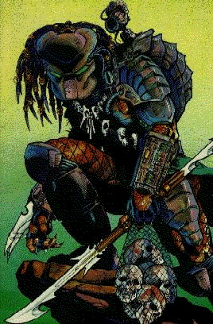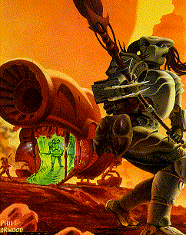

The Hunt

The HUNT is the cornerstone of our race.
A Yautja must always Hunt in accordance with the Code of HONOR. One Hunts to gain prestiege and HONOR in our society.
There are a variety of wepons prescribed for hunting different prey. A Hunter wears armor in the HUNT for two reasons: It is an established ritual, and has an amazing array of offencive/defencive capabilities. It is resistant to most wepons of the Soft Meat technology, and cannot be burned by the Black Death's acidic blood. It has a pack in the back which stores energy for the wepons, and has some necesary equipment, such as a "first-aid" kit.
The armor is composed of a mask, chest and back pieces, and outer-thigh and lower-leg protection, under which is a heated body mesh.

These are a few of the weapons:
1. Plasma Castor:  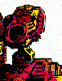 | Fires a blast of super heated plasma. It has a 180 degree firing arc horizontally and 90 degrees verticaly. It is calibrated with the mask targeting system, and is powered by the suit's power pack. It is one of a Yautja's most powerful wepons, and is used only in hunting prey with similar capabilities.

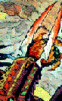  2. Wrist Blade: | These serrated blades are mounted on one of the Wrist Gauntlets, and are retracted until needed. Fighting with these is considered very honorable, because the Hunter has to be face-to-face with his prey, and this is especially dangerous against the Black Death.

3. Wrist Gauntlet: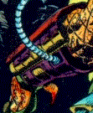 | Usually one is worn on each wrist, they have micro wepons, computers, and monitors.  Some are equipped with micro-darts, nets, lasers, or the above mentioned Blades. The computer monitors the Hunter's health, has a scanner with a range of 100ft, and can be set to self-destruct if the Hunter has failed in his HUNT. It is also tied in with his landing ship, and can locate, pilot, and even destroy the ship if nessicary.

4. Mask:  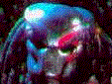 | The mask allows the Hunter to see in numerous spectrums, but the most common is infra-red. It is linked to the Plasma Castor for auto targeting. It can also target for weapons, to disarm the prey. It has a built in air filter; we can not breathe the air on Earth. It also records and projects sounds, so a Hunter can communicate or attract prey by piecing bits of conversation together. A Yautja operates the mask by pressing buttons with its tusks.

5. Cloaking System:  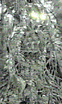 | This is a sophisticated method of reflecting and polarizing light so that the Hunter is hardly visible. A Hunter cloaks to get close to his prey unseen, but if one kills while cloaked it is a great dishonor.

A Hunter also has other ritual weapons at his disposal:
1. Combi-Stick:  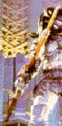 |  | Many are retractable to a length of about 2ft. On one end is the blade, with which the Hunter slashes its prey to pieces. The other end shoots a web with razor sharp lining that cuts the target as well as disabling him.
2. Smart Disk: | Also called the "Disk of Death", it is a returning circular disc of pain and misery. Only the most experienced of the Hunters can wield this weapon well. When activated, it creates a disruptive feild around itself, which can cut through the hardest of metals. It's used mostly for ranged combat, but it can also be used in melee combat. The first blow is deadly, and it may even strike twice (once when it is incoming, then when it returns).

3. Yautja Fighting Style:  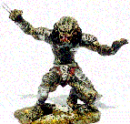 | Our race has its own fighting style prescribed for the HUNT, but many others have evolved by observing creatures on other planets. The Soft Meat's Martial Arts have become a favorite among certain Hunters.

The Black Death

The Black Death, sometimes refered to as the "Hard Meat", are more-than-worthy prey for many reasons. They are the Finger of the Gods,pointing out the weak and undeserving. Only the greatest Warrior can defeat one in combat. The skull of a Black Death is a Hunter's prize trophy, and he is well respected among his peers. These are the different stages in a Black Death's life, from least Honorable kill to most.
Egg | The first stage is the egg, which are made mostly by a Queen. A ritual we've had for only the last few hundred years is the seeding of planets with eggs, in preperation for the Rite of Passage. The eggs are about three feet tall, and kept in a large chamber of the hive with the Queen.
Carrier/Embryo | Inside the egg is a creature with eight legs, and a strong prehensile tail, which serves as carrier for the embryo of a new Black Death. It latches onto a victim's face, then implants the embryo down its throat. The embryo grows inside the host, until it is big enough to survive on its own. During this time, it gathers information from the host's DNA, in order to better adapt to the host's envirionment. It uses the information to alter its growth, and inherits certain key traits that the host possesed. This way, the deadlier the host, all the more deadlier the Black Death. When the embryo is ready to leave the host, it punches through its chest, killing the host. This is known in our toungue as "Z'skvy-de." It is against the rules to kill a Carrier attempting to pregnate a host, otherwise they're simply an annoyance.
Adult | It then grows into the most deadly stage, Adulthood. A fully-grown Black Death is two meters tall, with a powerfull tail almost as long; crushing jaws with a toothed toungue; and at least two pairs of limbs. They are quick, agile, and silent, which makes detecting one very difficult.

Lou-dte Kalei--The Child Maker | Also known as the "Queen", she makes the eggs, manages the Hive, and cares for her young. Her primary concern is the lives of future young, whom she will protect at the cost of the lives of her brood. The skull of one, acheived Honorably, makes a Yautja very high in the eyes of the rest of his clan. The Yautja may not use energy weapons to honorably claim the trophy of a queen.

Character Stats

Predator (Eta, Untouchable)
Alien, Yautja, only found aboard ships or Yautja colonys as slaves

F A S E R I P HLTH. KRMA.RES POP
GD GD EX PR EX EX GD 44 30 PR FE

-The Eta will always have 1 sort of physical weakness or deformity.

Predator (Unblooded)
Alien, Yautja, young & untrained, usually found within Yautja colonys training

F A S E R I P HLTH. KRMA.RES POP
EX EX EX RM EX EX GD 90 30 GD PR

Predator (Young Blood)
Alien, Yautja

F A S E R I P HLTH. KRMA.RES POP
RM EX RM IN EX RM EX 120 70 GD TY

Predator (Blooded)
Alien, Yautja

F A S E R I P HLTH. KRMA.RES POP
RM RM RM AM EX RM EX 140 70 EX GD

Predator (Warrior)
Alien, Yautja, though a clan member, they are always found alone while hunting

F A S E R I P HLTH. KRMA.RES POP
RM RM RM AM EX RM EX 140 70 EX EX

Predator (Honored)
Alien, Yautja

F A S E R I P HLTH. KRMA.RES POP
RM RM IN AM EX IN EX 150 80 EX RM

Predator (Ancient)
Alien, Yautja, usually at least 2 centuries old with thousands of trophies

F A S E R I P HLTH. KRMA.RES POP
AM RM RM EX RM AM RM 130 110 IN RM

Common traits of all Yautja Characters:
Blood- is of a fluorescent green color that glows in any kind of light
Mask- All Yautja have a mask and mesh-suit available to them at the point of their first hunt
Scaly hide- provides TY6 body armor vs edged and energy attacks
Talents: Weapon Master, Martial Arts B, Pilot-Spacecraft, First Aid(self or own species only)
Stealth: RM30
Tracking RM30

Weapons:

Wrist blades- (40) Material strength, double edged, retractable blades attached to the forearm that inflict (30) edged damage.

Shoulder Cannon (Plasma Caster)- A lightweight, shoulder mounted mini-cannon that
inflicts (50) energy damage to a single target or (40) explosive force damage to several targets in close proximity. A tri-laser targeting beam may be used in surprise or sniper type attacks to hit with (50) ability, otherwise it targets with (30) ability. Draw a lot of energy, thus with every shot, cloaking device may dim if used.

Self-Destruct Mechanism- Located on the wrist. Once programmed, a feat which takes 2 rounds, the devise detonates in 3 rounds, inflicting Shift-Z force damage at ground zero and at -1CS per area after that until 0. (may not used while cloaked)

Hunting Mesh-Suit- provides heating on cold worlds, cooling on hot worlds, and camoflauge cloaking that makes him –4CS to be hit with ranged weapons and –2CS to be hit in melee combat.

Mask- filters out any harmful elements in the atmosphere, provides oxygen for the user, and allows the user to see in 4 different spectrums which all but negates any form of hiding from the user. Also provides Sound mimicking with TY6 ability

Combi Stick- (50) Material strength telescoping spear, that inflicts (40) edged or blunt damage. The material is of such exceptional quality that it can penetrate up to (75) strength material or body armor. It may also shoot out a razor net that is of MN75 strength. This net inflicts EX15 edged damage as well as causing a stun check if damaged, the net is considered electrical. (may not used while cloaked)

Smart Disk- UN100 material strength, inflicts MN75 damage. when thrown, may electronically guide it as long as the target is within sight. May penetrate forcefields and body armor of up to AM50 strength. (may not used while cloaked)

Speargun- inflicts AM50 edged concentrated shrapnel damage up to 5 areas away. Non-electrical. (may not used while cloaked)

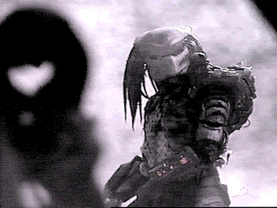

Karma
Karma is given for the following:

Honorable soft meat kill- 10 with trophy: 25
Honorable hard meat kill- 20 with trophy: 45
Praetorian- 35 with trophy: 55
Queen- 50 with trophy: 215
Pred-alien- 10 (culture forbids taking its trophy)
Face Hugger- 10
Destruction of an attacking face hugger (non-self): -15
Destruction of a xenomorph egg: -5
Successful seeding mission (transplanting queen and some eggs to a new world for population): 600 with clan, alone: 1,500
No karma loss’ for honorable kills. Full karma loss for dishonorable kills and breaking the code.

Predator starships have regular starship stats and may hold up to 15 persons.

