DETERMINING COMPRESSION RATIO

By George M. Davila

One of the most important factors in engine building is determining your engine’s final compression ratio. Compression ratio (C/R) has far reaching effects on the performance of any internal combustion engine. If the C/R is too low, you’ll have a real dog on your hands. Too high and you won’t be able to run pump gas without incurring pre-ignition and destructive detonation. Ignore the C/R and you could be in for a very unpleasant surprise.

First we’ll identify and define the components necessary for completion of a formula that determines C/R. You’ll need each one of the bold type measurements to accurately determine your C/R. For this example, we’ll use a 1970 Ford 385 Series 460 with 78cc cylinder head combustion chambers. For your engine, substitute the measurements from your components. With most engines, all specifications are available from your shop manual. All measurements are in inches.

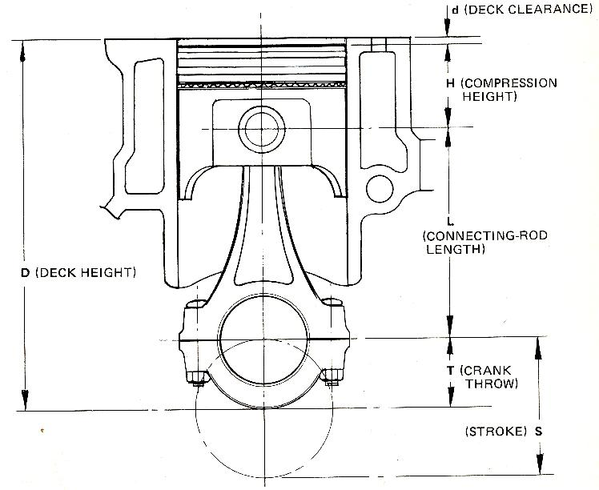

D - BLOCK DECK HEIGHT = 10.322
H - COMPRESSION HEIGHT = 1.76

L - CONNECTING ROD LENGTH = 6.605

S – STROKE = 3.85

T – CRANK THROW = 1.925 (1/2 OF STROKE)

d – DECK CLEARANCE = 0.032
DECK CLEARANCE CALCULATION: Compression height (1.760) + connecting
rod length (6.605) + crank throw (1.925) = 10.290
Block deck, 10.322, minus 10.290 = 0.032 deck clearance

This calculation uses a standard dished 460 piston with a dish size of 12cc. If your pistons have valve relief cuts (eyebrows), dishes or domes, that must be included in the calculation as a cc measurement. Any piston manufacturer can provide this information and the piston compression height.

Cylinder bore 4.360
Head gasket compressed thickness is 0.040

Head gasket bore size is 4.460

Now that we have all the required measurements, we can put them into a formula that will give us the exact C/R for this engine:

Compression ratio = S.V. (swept volume)
----- + 1
C.V. (clearance volume)

Since most of are do-it-yourselfers and not engineers, we’ll do it the easy way and go to one of the websites that allows us to enter our measurements and instantly calculates the actual C/R:

These are the actual measurements required for the suggested automated calculator on this application:

Bore: 4.360
Stroke: 3.85
Cylinder head volume: 78cc
Deck height clearance: 0.032
Head gasket bore: 4.460
Compressed head gasket thickness: 0.040
Piston dish: 12.1cc

http://www.smokemup.com/auto_math/compression_ratio.php (there are many websites with free C/R calculators)

Final compression ratio = 9.959:1

As you can see, thanks to Internet access, determining your actual compression ratio is no longer a task best left to machinists and engineers. This will help you to put your dollars to the best usage in building an engine.

I suggest utilizing one of the software programs currently available to determine what C/R is best for your engine combination. When you input all your engine’s various components into the program, it takes the guesswork out of what C/R you should run by showing ‘what if’ results in torque and horsepower graphs. Then you can adjust your C/R with deck height, pistons, bore and stroke to fit your cam, ignition, and fuel delivery and exhaust systems.

Suggested Compression Ratios for Street Driven Engines

Anything under about 9.0:1 will not provide the most efficient engine and, naturally aspirated, is dog country.

With cast iron heads, 9.0-9.3:1 is considered the maximum C/R for regular (87 octane) pump gasoline.

10.5:1 is about maximum for today’s premium (91-94 octane) pump gasoline with a cast iron head. And that’s assuming you keep the rpms up without lugging the engine, you’ve cleaned up the combustion chambers of sharp edges and rough spots to reduce the possibility of pre-ignition and use a zero deck clearance, or close to it, to enhance quench.

Aluminum heads will generally allow 11.5:1 C/R on premium pump gasoline, again assuming you have clean combustion chambers and a zero deck clearance.

If you run A/C, take .5 off the maximums.

Note: This information is intended for usage in the calculation of internal combustion engine compression ratios and the author makes no claims as to its accuracy or warranties its usage by any individual or company other than the author.

Copyright 2002, George Davila, all rights reserved

