Blind Spot Elimination

August 13, 2003

Submitted to Ford Motor Company

Completed By: Faisal AlSarraj

CC: Ford Motor Company, Safety Department. Ford Headquarters, CEO. Public Newspaper.

Overview of Blind Spot Elimination Project
The Blind Spot Abstract info
The blind spot is an area behind and on the side of the car. An elephant can hide in the blind spot without the notice of the driver. The problem arose when a lot of children got killed by run over in their drive way. A lot of car accidents occurred in the road from changing lanes without realizing a car is in the blind spot.

Table of Contents

The Proposal introduction | 3
The Camera System | 4
The Sensory System | 5

List of Illustrations

The Blind spot estimate on normal cars | 3
The Camera | 4

Proposal to Implement Sensors in all vehicles
The Proposal introduction
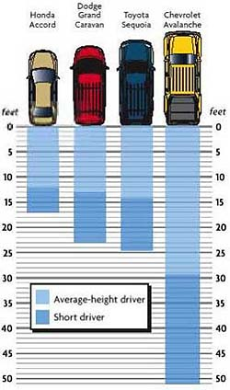The purpose of the research is to maximize the safety in cars. Eliminating the “blind spot” behind the car will increase the safety. This research will prove that a sensor all around the car will increase the safety. The blind spot figure in the bottom shows that SUVs have a bigger blind spot than smaller cars. It is very necessary that a sensor device would be mounted on SUVs. The proposal has been taken by Ford Motor Company. The main ethical purpose of installing “blind spot” detection devices is to keep the safety of human lives. These devices will not only protect passengers in the car but also other people involved in the accident. These devices will save lives. Government policy makers should look into mandating that every car manufacturer install these devices on their cars. Children death because of “blind spot” is very high, as the Omaha channel states “Experts with the child advocacy group Kids 'N Cars said so far this year 16 children have been backed over in their own driveways and 10 of those children died”

The Camera System
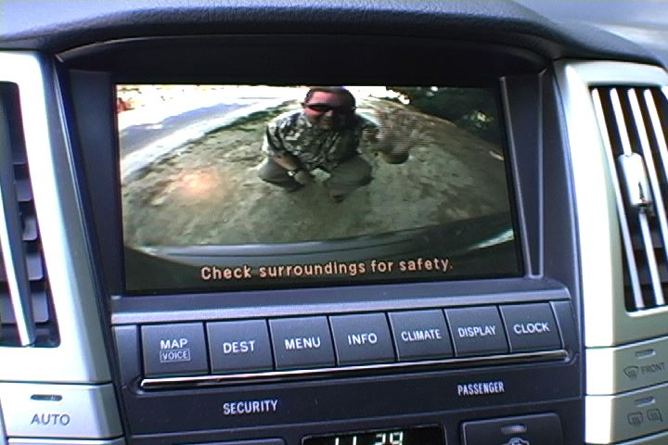

The proposal to install a camera system was dropped by Ford Motor Company.
The camera system cost too much to manufacture and has a lot of flaws. The camera system has a very short angle for the view. As the picture above shows the angle is very narrow and the bottom does not show the ground.

The sensory System
The sensory system has been adopted by Ford Motor Company because of its feasibility. The sensory device will be mounted on all Ford cars. The SUVs will be the first car to have the system installed on them.

The Recommendation of the use of the sensory device
The use of a camera device
The installation of a camera in the rear of all cars will cause the prices of cars to increase. The camera will also need a monitor inside the car. The monitor and the camera will need more professionals in the electrical field at the car manufacturer’s factory. This means that the price tag for cars will increase. The wage of these professionals plus the cost of the camera and the monitor will be included in the price of the car. The camera and the monitor will help electrical professionals to get jobs in the car industry. They will be working either in the car factory or in the aftermarket repair business
The use of a Sensory device
The sensory system will also include a sound alarm which gets louder as the object gets closer. This device is a lot cheaper than the camera. Having the sensor around the car will be effective while driving. A driver will have the ability to monitor any approaching cars next to him. This shows that the senor is a more useful device than the camera.
Final Evaluation of Recommendations
The use of any safety device will help save lives. The final recommendation would be the use of the sensory device due to its feasibility and ethical way. This device will save around 100 children a year from car accidents. This device will also protect all the passengers of a car.
Conclusion
From a month of research all the research teams have concluded that the surround sensor system is more efficient than the camera. The research also found that the senor does not break down or get damaged as much as the camera. The sensor is also less expensive to fix and repair. The warranty on the senor is four years while the warranty on the camera is three year. I highly recommended the use of the surround sensor system and hopefully you make a wise decision on which to install. The death of 58 children due to drive way accident shows that these devices are very necessary. Insurance companies should implement a discount to encourage the public to install “blind spot” devices. The data shows that these devices will not increase car prices dramatically. Beside this there will be more jobs in the car manufacturing business.

Reference Material
Work Citied
- http://www.halfbakery.com/idea/
- http://www.theomahachannel.com/7canhelp/2217249/detail.html
- http://www.cato.org/research/articles/taylor-030219.html

