THE MOLECULE

A molecule is a combination of two or more atoms of one or more elements that are held together by ionic or covalent chemical bonds, i.e. – nitrogen; scientific name – N₂. In a pure substance, it is the smallest particle that can be found. However, one must be able to differentiate between a molecule and a molecular substance. For example, carbon dioxide is a molecule and not a molecular compound. Substances such as sugar are molecular compounds. A molecule maintains its chemical composition and properties, but a molecular substance does not. A molecule’s atoms are joined by shared parts of electrons in a chemical bond. The hydrogen molecule (H₂) is the smallest molecule. “The empirical formula of a molecule is the simplest integer ratio of the chemical elements that constitute the compound.”

“Molecules have fixed equilibrium geometries – bond lengths and angles – about which they continuously oscillate through vibration and rotational motions.” A pure substance consists of molecules with the same average geometrical structure.

Molecular spectroscopy is the study of the molecule’s response (or spectrum) to a signal of known energy. This signal is normally an electromagnetic wave or a beam of electrons. However, new molecular spectroscopies, such as the positron spectroscopy, are under development. Molecular responses can be signal absorption (absorption spectroscopy), emission of another signal (emission spectroscopy), a change in its [a molecule’s] chemical nature, or fragmentation.
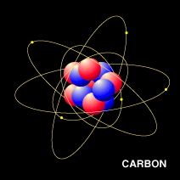
Above: The molecular structure of carbon.
Below: This is a model of some typical molecules. 