
St Peter and St Paul, Seal

OPENING THE BIBLE
June 2010

Before you begin, please read the notes on the back page.

READ THE FOLLOWING PASSAGE : Luke 8.26-39 (set for 20th June)

Jesus and his disciples arrived at the country of the Gerasenes, which is opposite Galilee. 27 As he stepped out on land, a man of the city who had demons met him. For a long time he had worn no clothes, and he did not live in a house but in the tombs. 28 When he saw Jesus, he fell down before him and shouted at the top of his voice, ‘What have you to do with me, Jesus, Son of the Most High God? I beg you, do not torment me’— 29 for Jesus had commanded the unclean spirit to come out of the man. (For many times it had seized him; he was kept under guard and bound with chains and shackles, but he would break the bonds and be driven by the demon into the wilds.) 30 Jesus then asked him, ‘What is your name?’ He said, ‘Legion’; for many demons had entered him. 31 They begged him not to order them to go back into the abyss.
32 Now there on the hillside a large herd of swine was feeding; and the demons begged Jesus to let them enter these. So he gave them permission. 33 Then the demons came out of the man and entered the swine, and the herd rushed down the steep bank into the lake and was drowned.
34 When the swineherds saw what had happened, they ran off and told it in the city and in the country. 35 Then people came out to see what had happened, and when they came to Jesus, they found the man from whom the demons had gone sitting at the feet of Jesus, clothed and in his right mind. And they were afraid. 36 Those who had seen it told them how the one who had been possessed by demons had been healed. 37 Then all the people of the surrounding country of the Gerasenes asked Jesus to leave them; for they were seized with great fear. So he got into the boat and returned. 38 The man from whom the demons had gone begged that he might be with him; but Jesus sent him away, saying, 39 ‘Return to your home, and declare how much God has done for you.’ So he went away, proclaiming throughout the city how much Jesus had done for him.

SOME BACKGROUND:

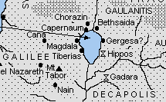
The country of the Gerasenes
Biblical experts argue about where exactly this story took place. What is certain from the context is that Jesus has crossed over the Sea of Galilee from Galilee to the region known as the Decapolis (map – right*), which was a Gentile area. He is in foreign territory. The people he encounters there are not Jewish (something we could have guessed, because they are keeping pigs.) It was also an area in which many Roman troops were garrisoned, and it is entirely possible that the local inhabitants had been more or less forced into providing provisions for the occupiers. Their fears that Jesus will cause disruption and affect their livelihoods may well have good foundation. It also casts into a new light the fact that the man who Jesus heals calls himself “Legion”. It is as if he has been occupied, just as the land had.

Demon possession
The people of Jesus’ time lived in a world which they believed to be teeming with spirits, good and bad, all jostling for space and influence in the world. While we might today assume that this man is suffering from some sort of mental illness, it is important that we don’t simply try to superimpose our understanding onto the story. Instead we need to try to enter into the thought world of this tale and see its internal logic. Demons were thought to dwell naturally in wild places, which is why the story says that they keep trying to drive this man out into the wilderness. They are associate with chaos – the kind of chaos which characterised the world before, in Genesis 1, the Spirit of God brought order. It is no accident that this story follows straight on from Jesus calming of a storm on the sea of Galilee. Both stories reveal him to be filled with that same order-inducing Spirit of God.

READING THE BIBLE WITH YOUR HEAD, HEART AND HANDS
We need to read the Bible with the whole of ourselves if it is really to make an impact on our lives. In our Bible studies, therefore, we’ll be asking three sorts of question; “Head” questions, about what we think, “Heart” questions, about what we feel and “Hands” questions, about what we might do in response to this passage.
* www.ccel.org/bible/phillips/CP051GOSPELMAPS.htm
TO TALK ABOUT:

What do you think about this passage? (“Head” Questions)
- Look at this passage in its context, reading from the beginning of Chapter 8. Jesus sets out to proclaim the good news of the kingdom of God. What sort of good news do we hear about in this chapter?
- Why do you think Jesus tells the man who has been healed to return to his own people, rather than letting him join his disciples?
- People still say “I don’t know what came over me” when they behave in ways they feel are uncharacteristic of them. How might such a way of thinking help or hinder as they deal with whatever troubles them?

What do you feel about this passage (“Heart” Questions)
- Imagine a “back-story” for this man. What do you think his life has been like? What about his family and his community – how might they have felt about him? What sort of impact might he have had on their lives?
- Have you ever had times in your life when you felt that chaos was overwhelming you? How did you deal with it? What helped you?
- When he was healed, they react with fear? Why do you think this was?
- Have you ever pushed away someone who was trying to help you and regretted it later?

What might you do in response to this passage?
(“Hands” Questions)
- Look at some newspapers, or keep an eye on the television news or online . How are people with mental illness portrayed? What do you think about they way they are treated?
- Mental illness is very common. One in four of us will have a diagnosis of mental illness at some point in our lives. This may include depression or anxiety, or some sort of psychosis. If you have had direct experience of this yourself, or within your family, reflect on what helped you, and what made it harder. If you haven’t experienced this, find out more about mental illness and the way it is treated. Mind (mind.org.uk) has information and resources. How can we help those with mental illness feel safe and at home in our church?
PRAYER FOR THE MONTH
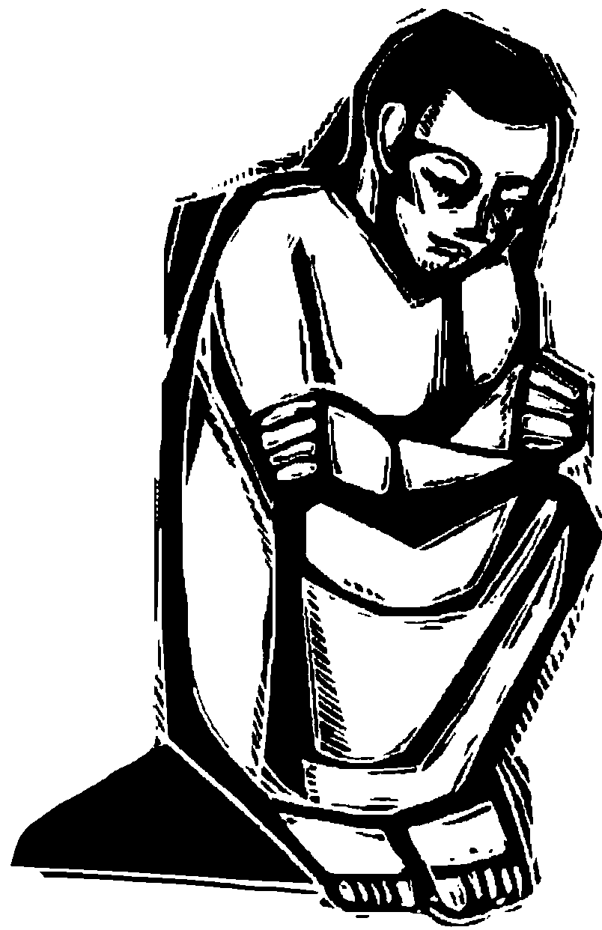
As the rain hides the stars,
as the autumn mist hides the hills,
as the clouds veil the blue of the sky,
so the dark happenings of my lot
hide the shining of thy face from me.
Yet, if I may hold thy hand in the darkness,
it is enough.
Since I know that,
though I may stumble in my going,
thou dost not fall.
Amen.
Gaelic prayer. Translated Alistair MacLean.

NOTES
- You can use this Bible study on your own or you can get together with a friend or two to talk it through together.
- You don’t have to be a Bible expert to take part or to use this material on your own. All you need is to be open to listening honestly to God, to yourself and to others if you are in a group.
- I have printed out the Bible passage we are looking at in full, but you’ll need a Bible to hand as well to get the most out of this study
- Bible references are written “Book, Chapter, Verse” – so Mark 13.3 means the book of Mark, Chapter 13, verse 3.
- If there is anything you would like to ask or to say – an unresolved question or issue that has arisen from this study – please contact me to talk.

Anne Le Bas, The Vicarage, Church Street, Seal, TN15 0AR,
priest@sealpeterandpaul.com This sheet can also be downloaded from the church website www.sealpeterandpaul.com

