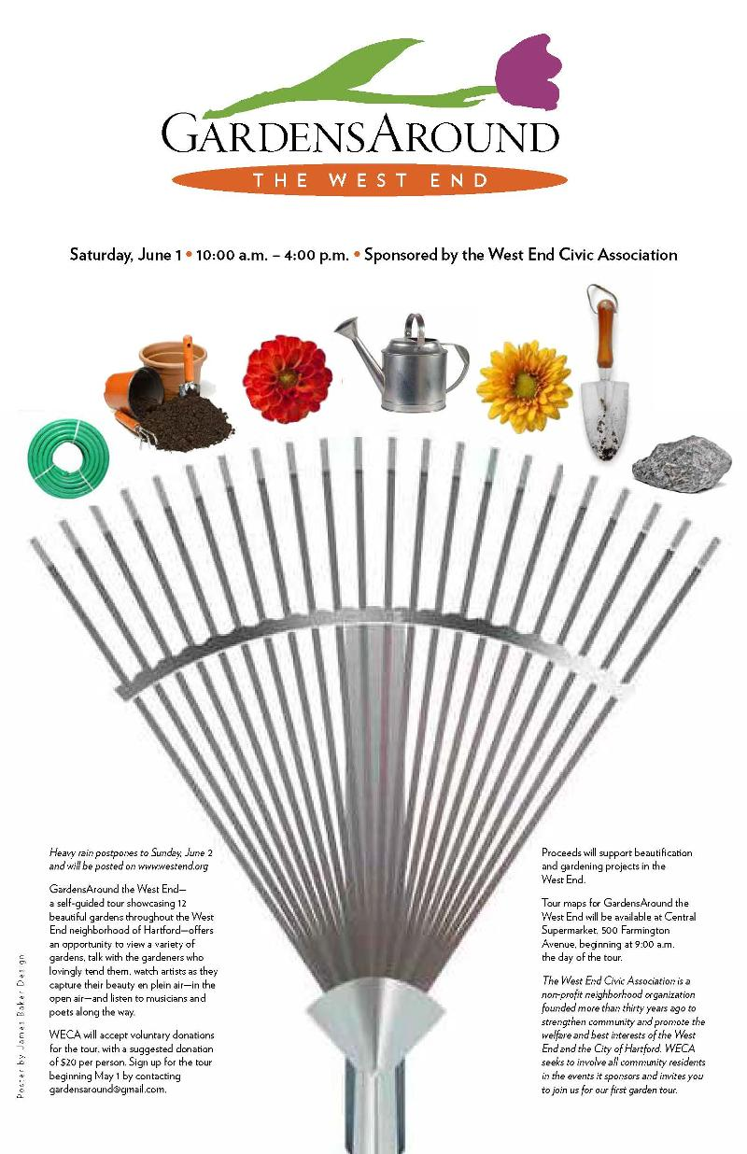
GardensAround the West End: a self-guided tour of 12 neighborhood gardens
Join us for GardensAround the West End,
sponsored by the West End Civic Association (WECA),
on Saturday, June 1, from 10:00 a.m. to 4:00 p.m.
(Heavy rain postpones to Sunday, June 2nd.)

Brochure and tour maps at Central Supermarket, 500 Farmington Ave, Hartford, from 9 am
Free parking and shuttle service will be available along the tour route.
This self-guided tour, showcasing 12 gardens in the historic West End neighborhood, offers an opportunity to view beautiful gardens of all different types, talk with the gardeners who lovingly tend these gardens, watch artists as they capture the beauty of the gardens en plein air (in open air), and hear several musicians and perhaps a poet or two along the route!
Proceeds will support beautification and gardening projects in the West End. While there is no fixed charge to participate in the tour, WECA will gratefully accept donations, suggested $20 per person.
For info: contact Lelaneia Dubay at ljd12@ymail.com or JoAnne Bauer at 860.233.7852
The West End Civic Association (WECA) is a non-profit neighborhood organization founded more than thirty years ago to strengthen community and promote the welfare and best interests of the West End and the City of Hartford. WECA seeks to involve all community residents in the events it sponsors and invites you to join us for this first garden tour.

