Section 14 (Housing Plan), page 27:

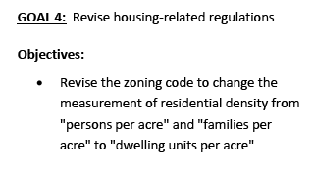

Section 13 (Neighborhoods), page 11 (West End)

