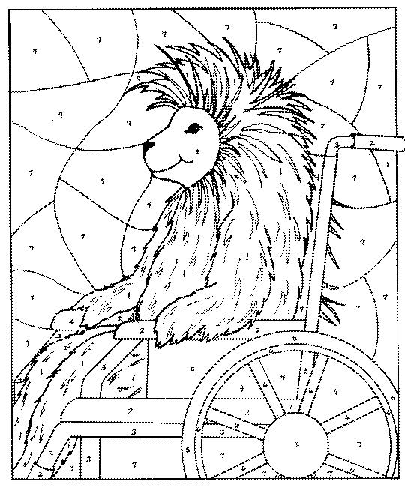1 – Brown  2 - Dark Blue  3 - Purple  4 - Light Blue | 5 - Purple  6 - Yellow  7 - Green

