How To Make a Rose out of Polymer Clay

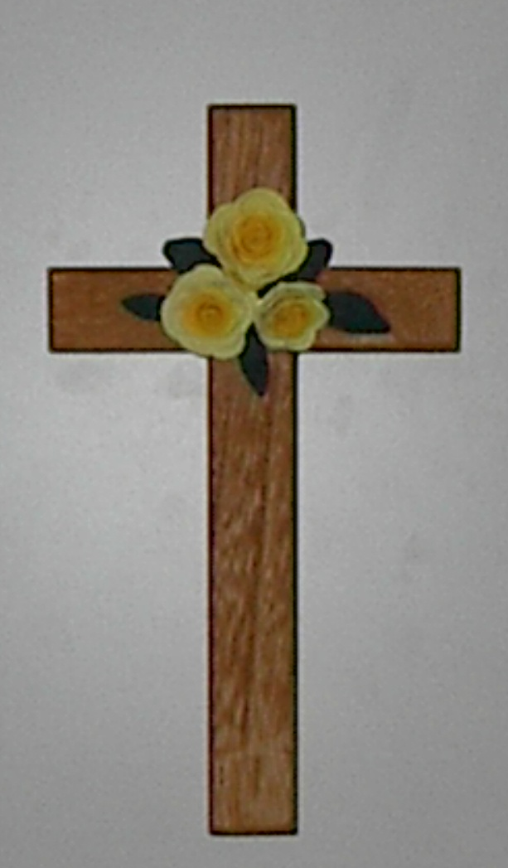


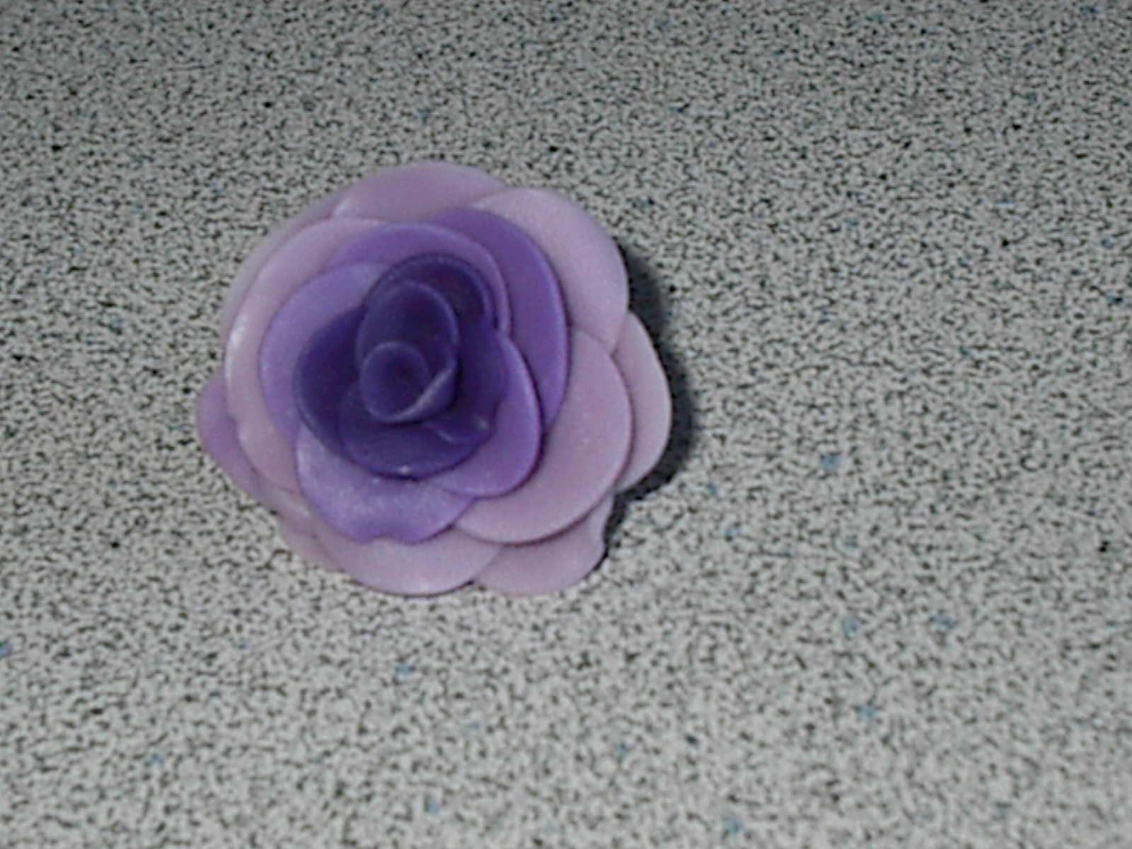

Step 1: Mix three different shades of the color you are using. Make sure that the lightest shade is the biggest.

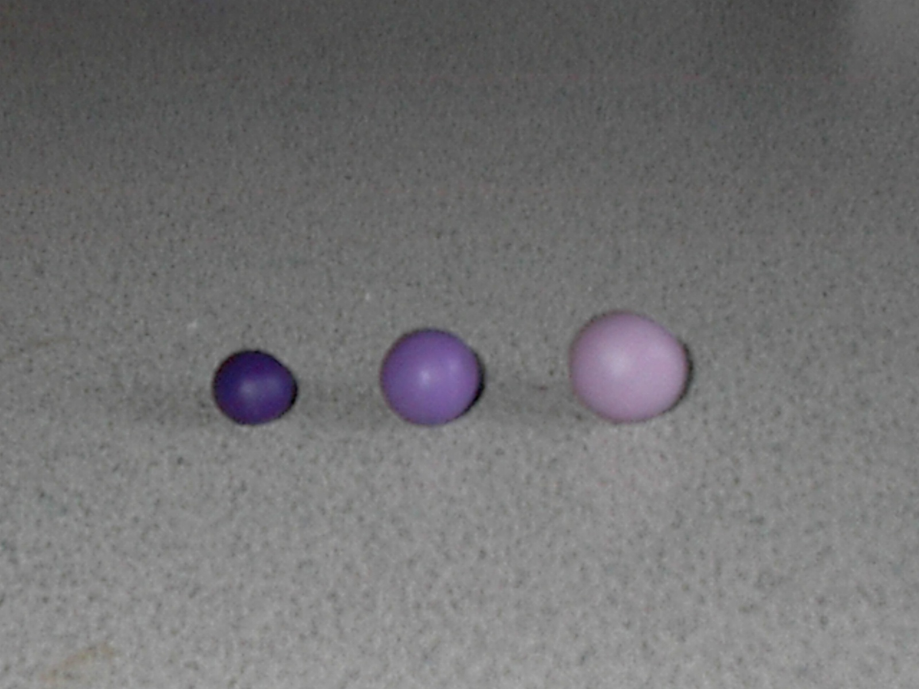

Step 2: Make the clay into flattened circles. These will be the petals.

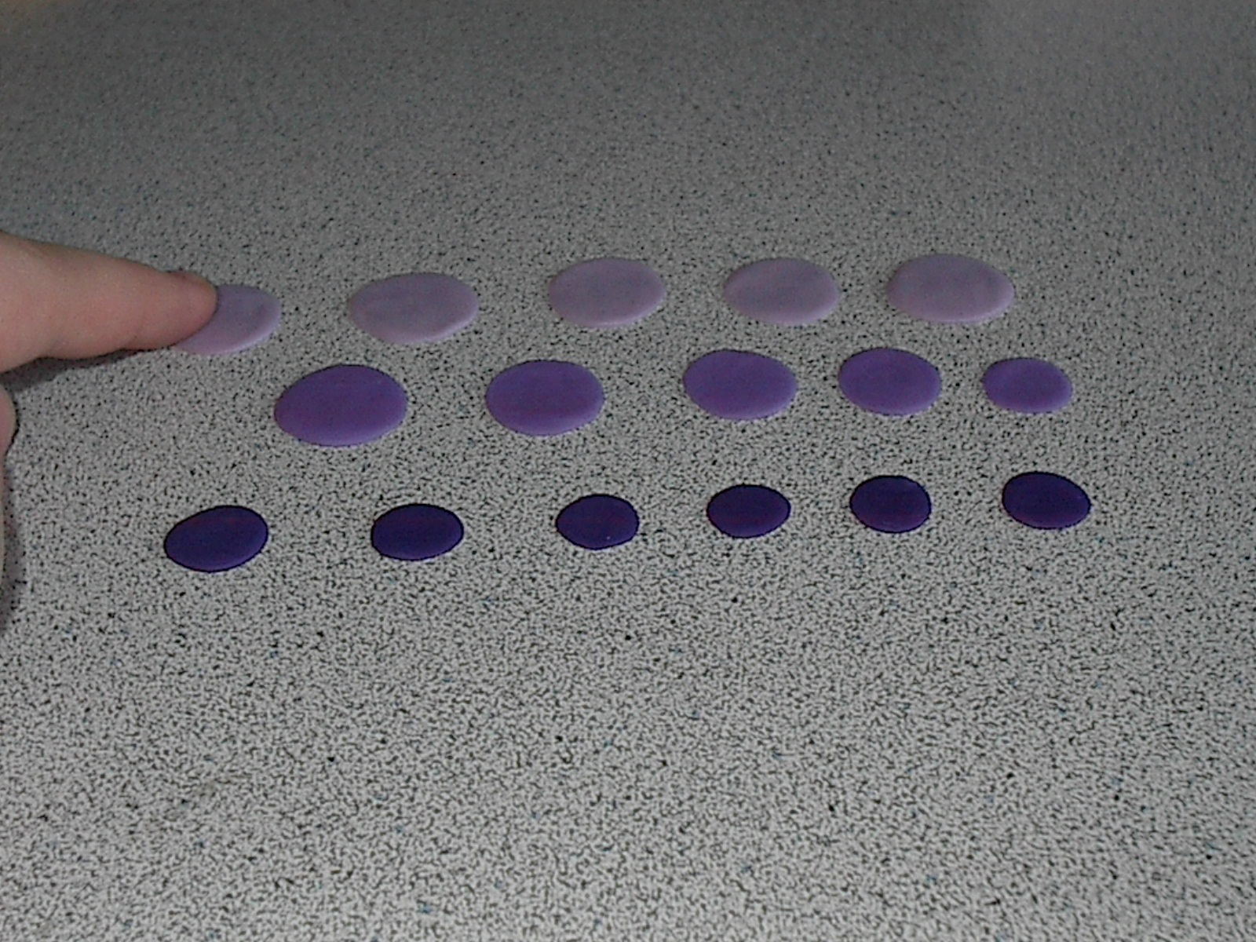
Step 3:Take a petal of the darkest color, and roll it in your fingers, squishing the bottom together.
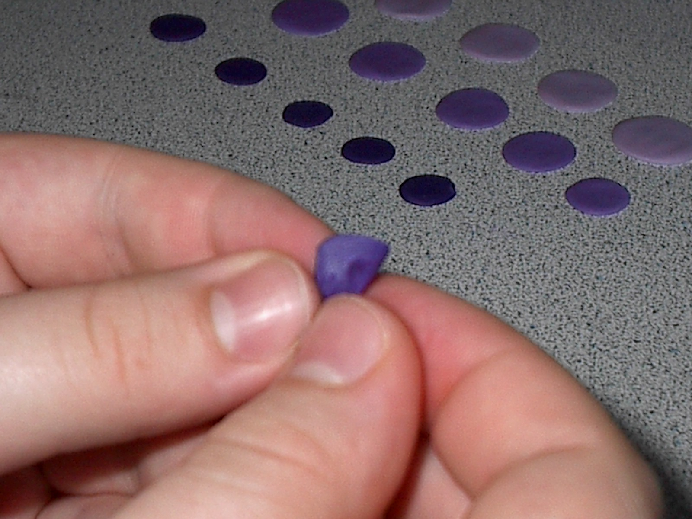

Step 4: Wrap another petal around the first petal.
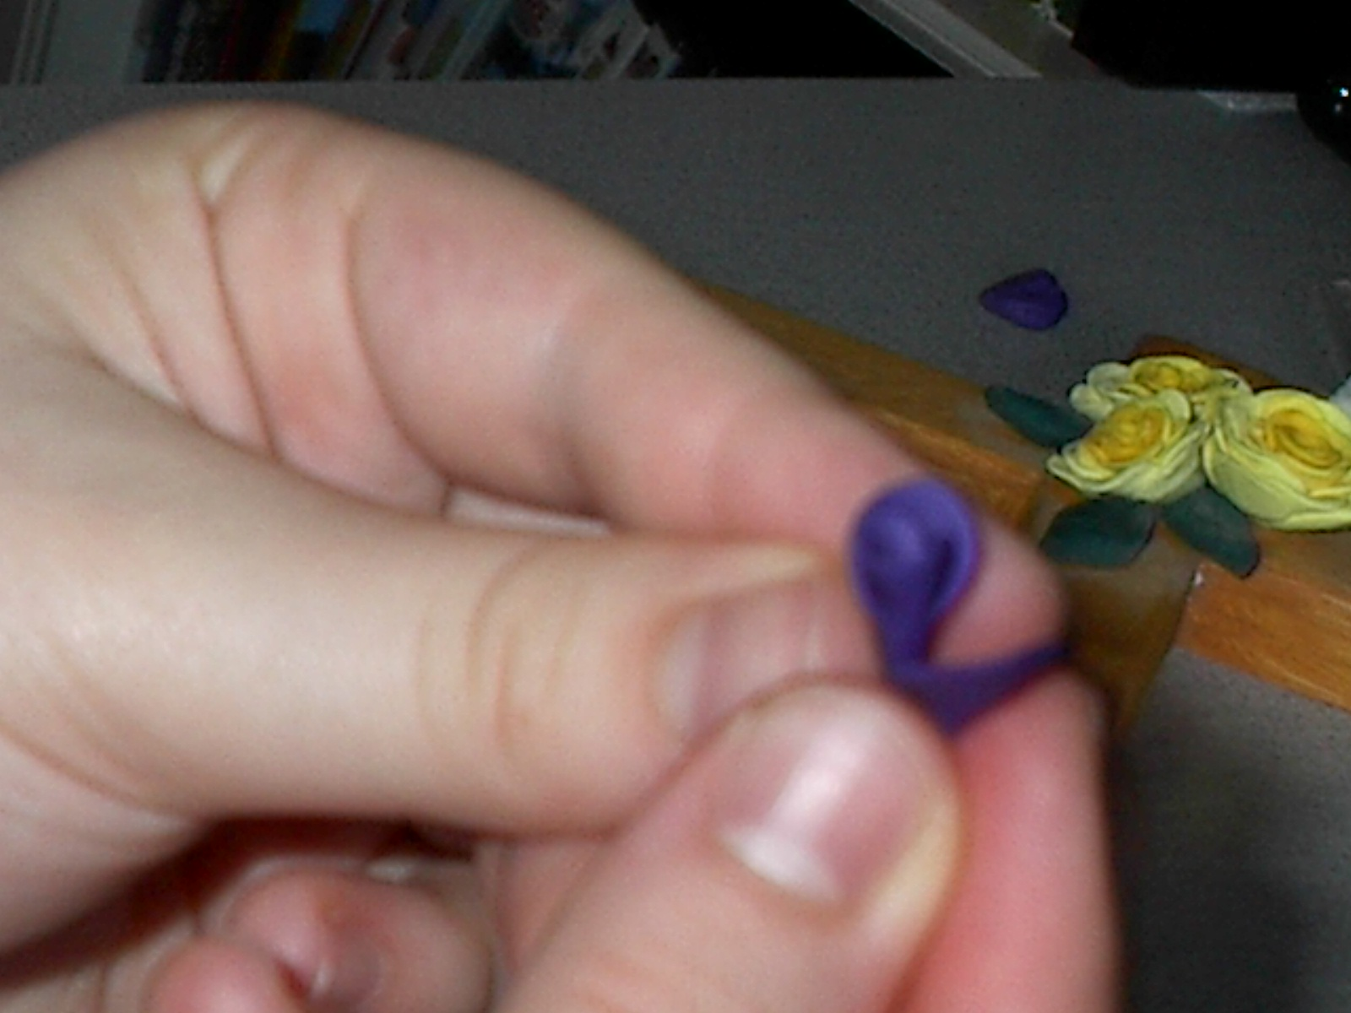

Step 5: Add the rest of the dark petals in this way.

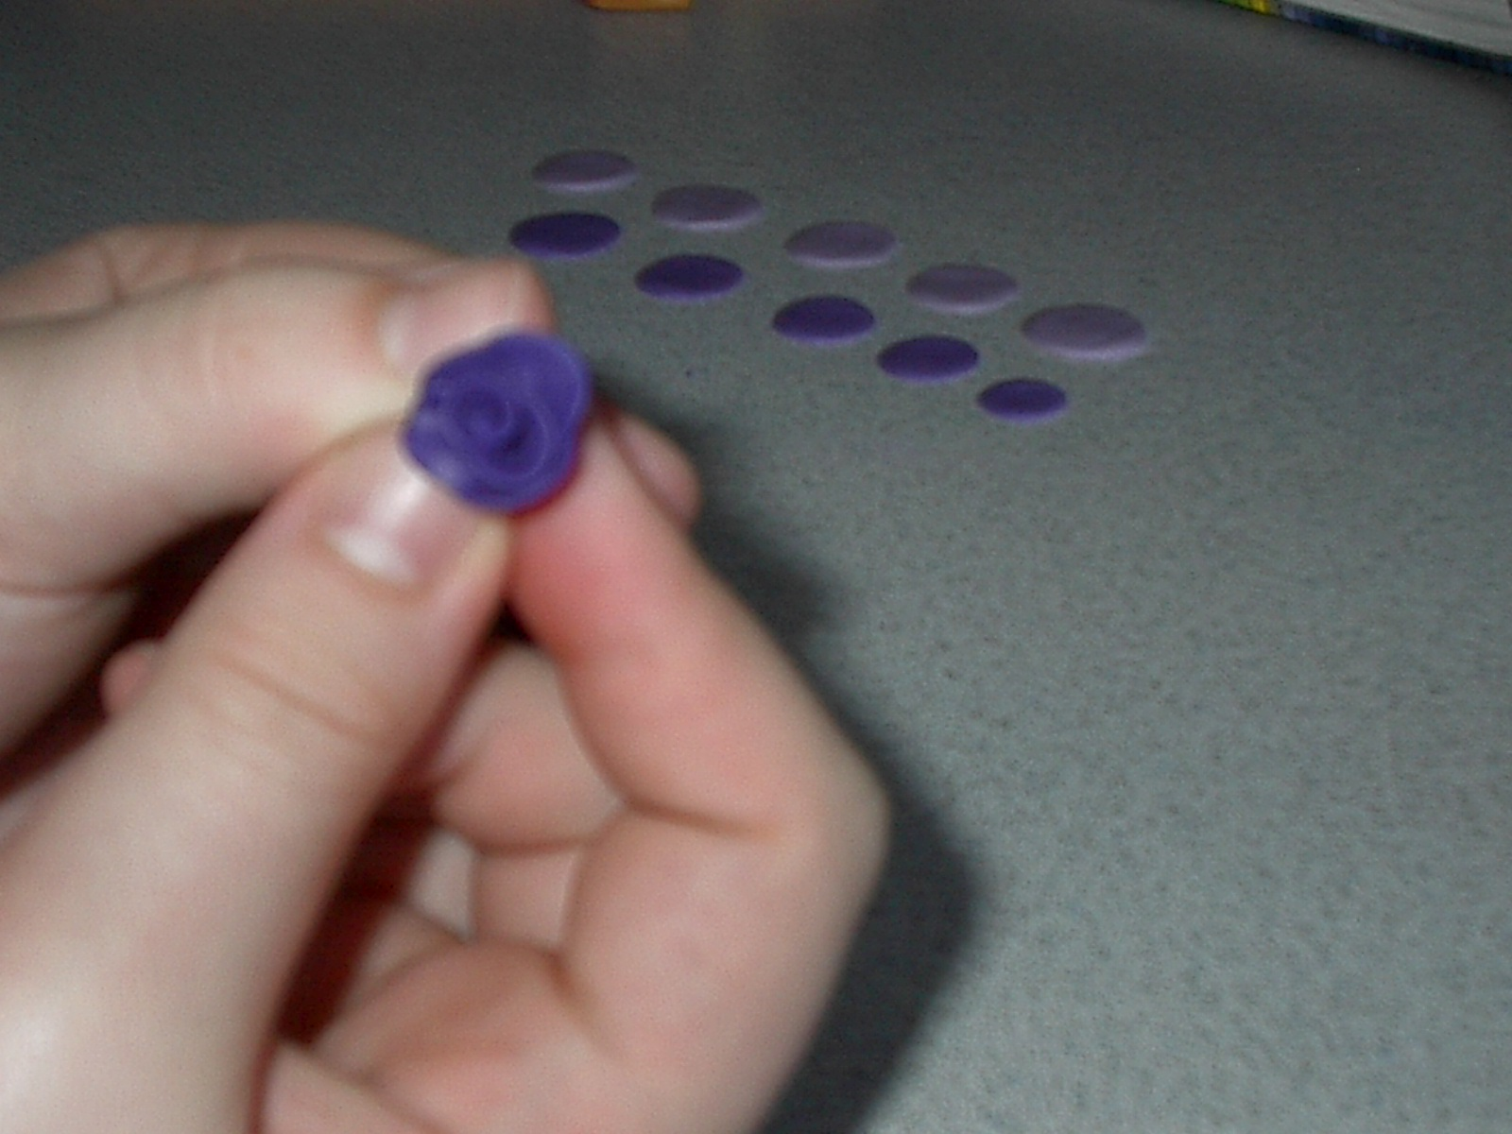

Step 6: Begin adding the medium coloured petals.
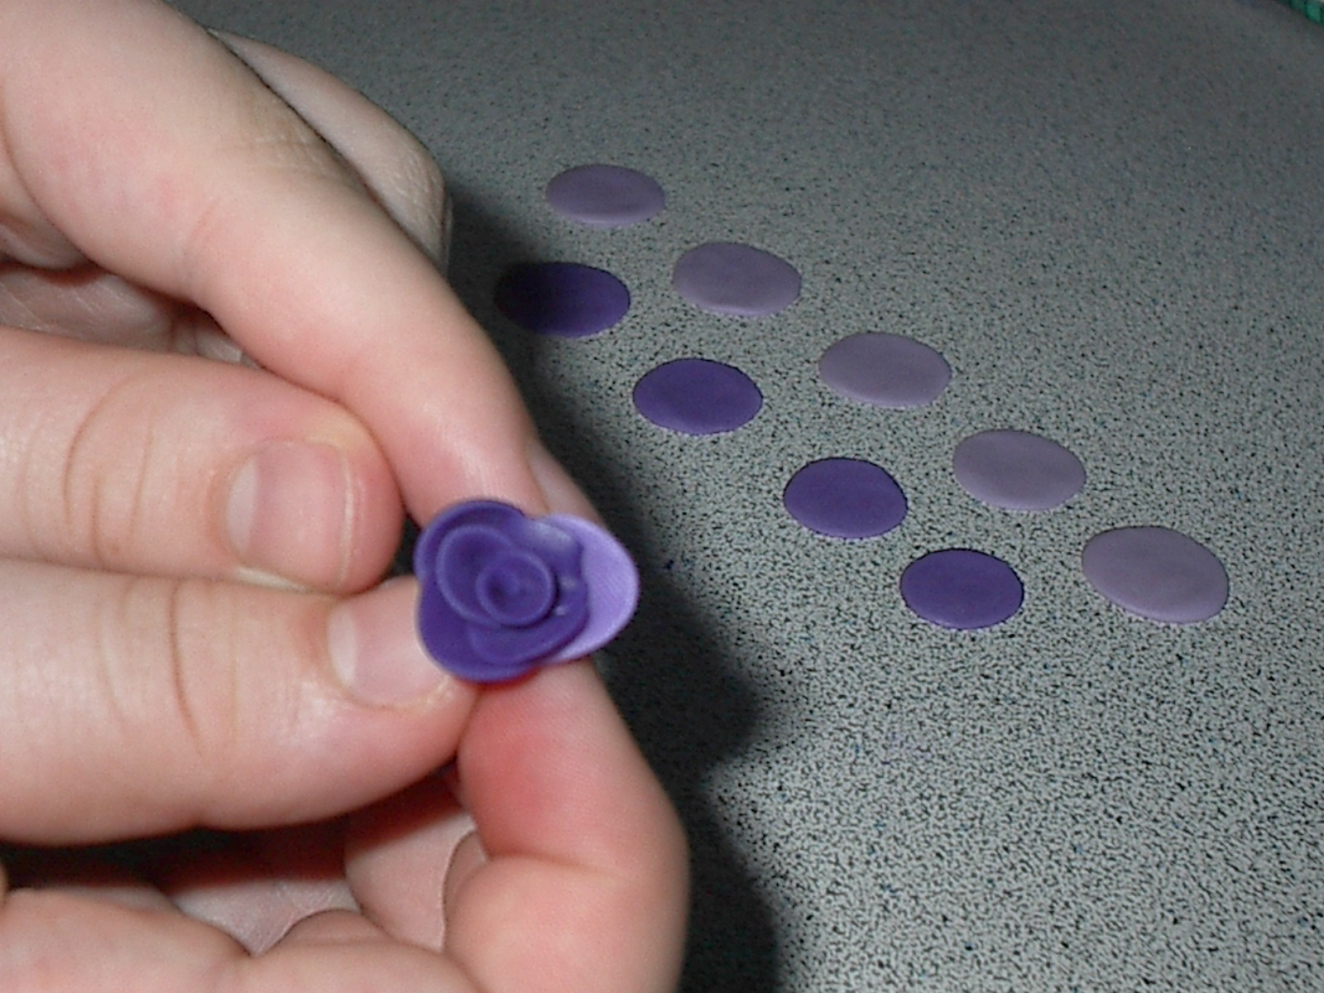

Step 7: Add the lightest petals to the outside of the flower. 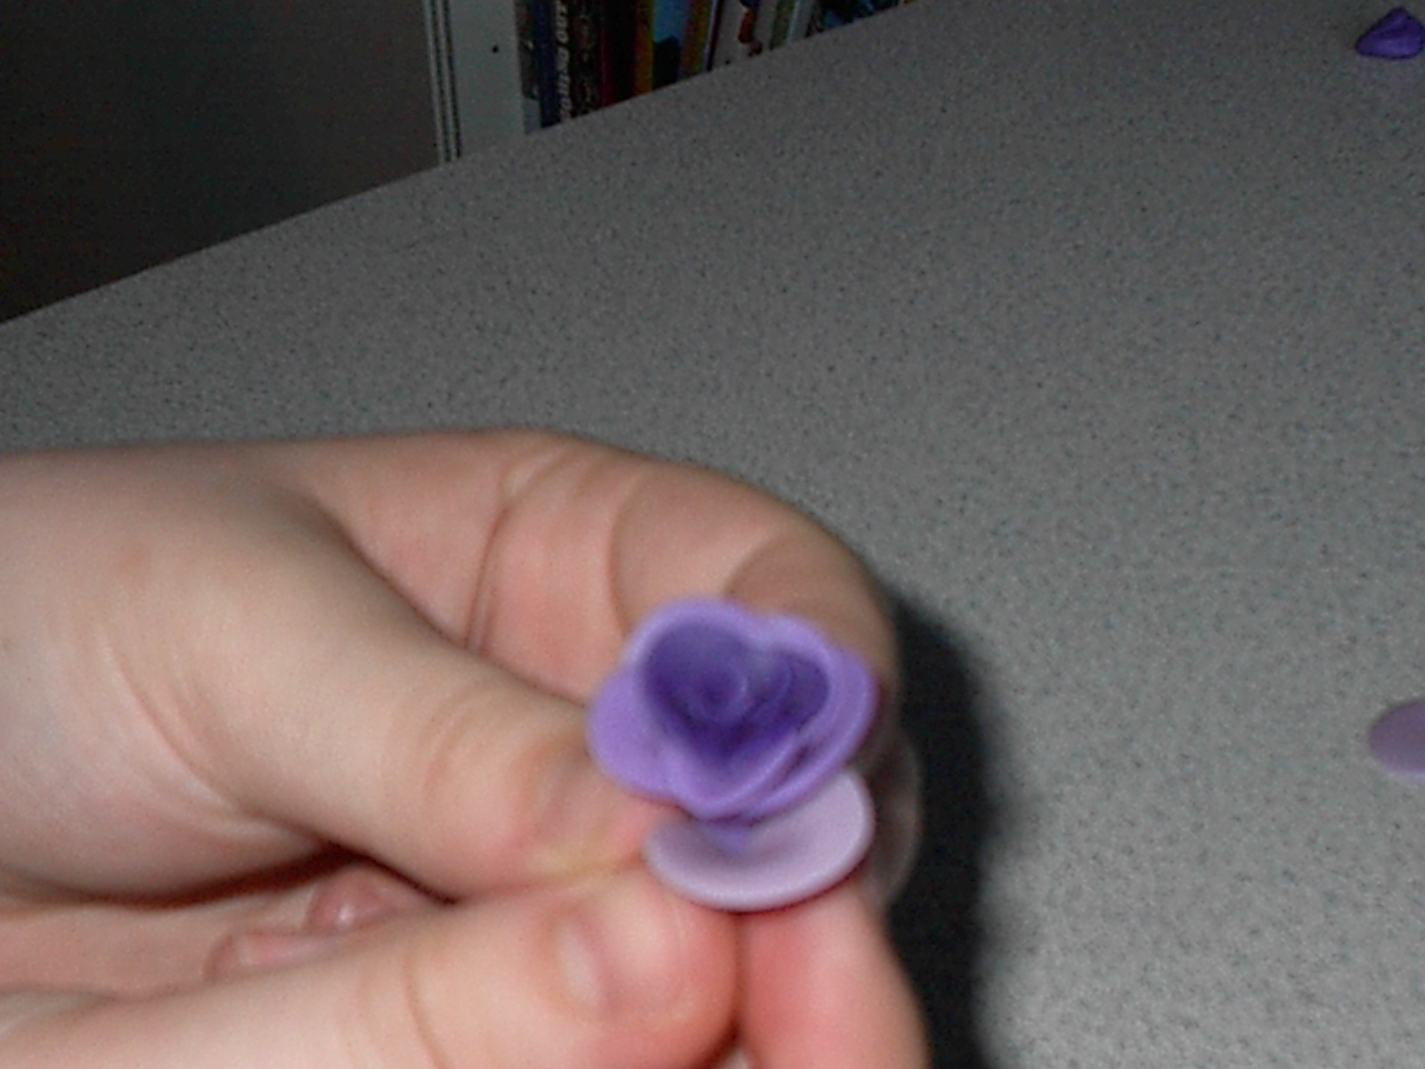
Step 8: When you are finished, cut off the extra clay from the bottom of the flower.
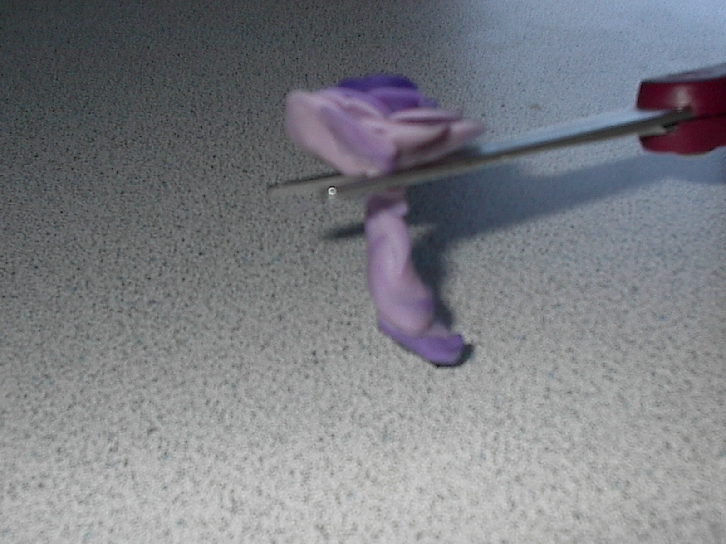

Step 9: Bake according to the instructions on your clay.

