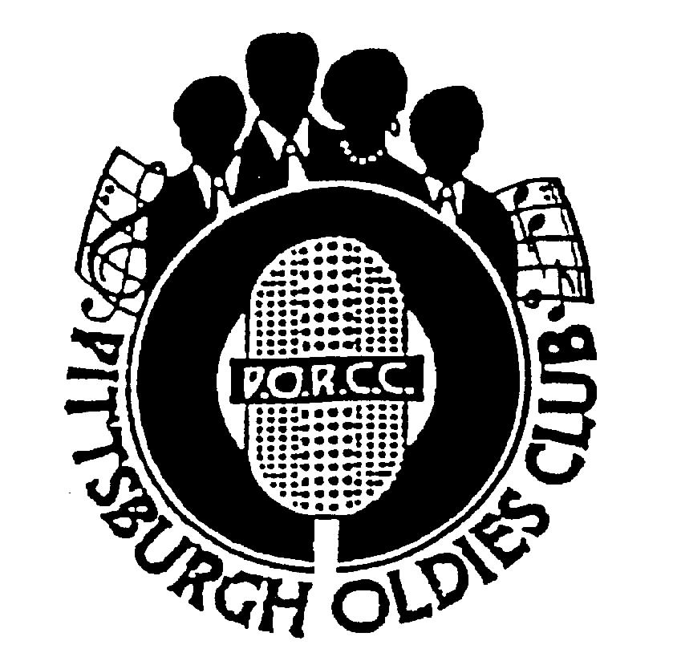
P.O.R.C.C. Newsletter
President: Jan Taper
Treasurer: Bob Azen

NEXT SHOW DATE:
SUNDAY JANUARY 21, 2007

HOLIDAY INN – GREENTREE

Dinner Served at 5:30 PM
Shows start at 7 PM

Merry Christmas and Happy New Year – From the PORCC Board


Our Next Show: January 21, 2007 - THE SKYLINERS
It is hard to believe a year has almost gone by, Eight (8) shows! It’s been a good year for us and hope you all have enjoyed the groups. We start off next year with The SKYLINERS on January 21, 2007, and are looking forward to their wonderful music. We have so many great artists and groups from Pittsburgh. They are long overdue.

Please join us and welcome THE SKYLINERS. Wishing you a Merry Christmas and a prosperous New Year. See you in 2007!!

Review: THE DIABLOS - By Jim Sanders
I think everyone in the audience was well aware that Nolan Strong, the great DIABLOS lead, had passed away some thirty years ago. So, how, we wondered, could this group succeed without the inimitable voice of Nolan Strong? Well, let me tell you, the DIABLOS exceeded any expectations I might have had for them. Let me emphasize here that this has nothing to do with the fact that they invited me up on stage to perform the ‘talking part’ of “The Wind”. Although, that was a personal thrill, I will try to be objective regarding the group’s performance. No, the DIABLOS show was successful for several distinct reasons.

First, their performance; I cannot over emphasize here the absolute perfection accomplished in their rendition of “The Way You Dog Me Around”. This song, though not the DIABLOS trademark, is certainly one of the group’s best. The way Jay Johnson and the boys did it brought chills to all the audience.

Additionally, their rendition of “Daddy Rockin’” Nolan Strong was done to perfection. But to me, the absolute highlight of the evening was the storytelling ability of Jay, bass of the DIABLOS since 1958. All too often, a group takes the stage and performs song after song. I’m often left with the feeling that I wish they told us more about themselves. Well, let me tell you, Jay’s numerous anecdotes regarding Noland Strong were so personal and insightful that I feel I spent the evening with Nolan himself. That was entertaining!

The bottom line is the DIABLOS show was an enjoyable experience to all – whatever your reason for being in attendance. Thanks guys.
Jim Sanders
BUFFET SURVEY:

The cost of the Holiday Inn Buffet will increase in 2007 to $20.00 per person. For many folks – it is no big deal, but for some it may be. Please complete this brief survey and either bring it to our January show or mail to my home address:

Jan Taper 1075 Mapleview Drive, Washington, PA 15301. or call me for your convenience with your comments.

____I WILL continue to attend the Buffet
____I will NOT attend the buffet any longer due to the price increase.

Comments and/or suggestions: How to still offer food but keep cost down. ______________________________________________
_________________________________________________________________________________________________________________________
_________________________________________________________________________________________________________________________
_________________________________________________________________________________________________________________________
_____________________________________________________________________________________________________________ Page 1
PORCC News and Events:
Check Out PORCC’s newly updated web site, the correct address is:
http://www.angelfire.com/pa4/pgholdiesrecordclub/
Or you can go to www.yahoo.com or www.google.com and enter PORCC under search.

Check out our sister club CODA at their new website: www.codakeepthemusicalive.com

EVENTS:

- Looking for something to do Thursday nights - Atria’s Restaurant, PNC Park starting 8PM,hear accappella groups like
JOHNNY ANGEL & HALOS, WILLIAM DELL and the WEE JAMS, The FOUR DOTS. Come down and enjoy great evening with our kind of music.

- Do you have 45 or 78 records come play DJ at Lexon in Greentree every first Monday of the month.
Call Dave at 412-276-2956. Another way to spend an evening with our kind of music and you be the DJ.

- Roots of Rock and Roll XXXIII -- Porky Chedwick’s 89th Birthday!
Saturday Feb. 3rd at the Benedum Center – Tickets $38.75 and $24.75 Show Times: 5 PM and 8:30 PM

Fresh line-up. The PORCC Club supports all the DOO WOP shows. Call for tickets ASAP – you’ll have a great time!!

The DUPREES- first RRR concert since 1981 (25 years)
The VIBRATIONS – last in Pittsburgh 1977 (Marriott, Greentree)
The JIVE FIVE – first RRR concert in 18 years
Jimmy Charles – first RRR appearance
Kathy Young – first RRR since Volume XXVII (27)
Pure Gold (email at pgold@verizon.com or see their website www.puregoldmusic.com or call 412.867.6222)
KID KYLE – introducing to Benedum Stage

TICKETS: Ticket order form will be mailed in early December, order form available at www.puregoldmusic.com and the Benedum Box Office (412-456-6666) available December 18th. Best Tickets are thru mail order.
DUES: Don’t Forget!! 1st Quarter dues – DUE $40.00 per quarter - Thanks!!!

Dues Mailing Address:
707 Flint Road  Allison Park, PA 15101 | Regular Members . $40/per quarter, payable quarterly  Associate Members $25/per year, payable yearly

PORCC Logo Items for Sale:

Looking for that special gift – PORCC is selling it’s logo items. They make nice gifts and show the pride of the PORCC
members. See Marsha at the next show.

VIDEO SALES: We have a list** of Unclaimed Videos! Also See next page for list of Available Club Video Inventory.

Do you wish you could see that show again that you loved so much? See Jan at the video table and order your video on the night of the show. Only $15.00!!! Can’t make a show, just send Jan a check made payable to: Media Quest for *$20.00 no later than 5 days before the show, and she’ll order a video and have Media Quest mail it to you. Send a check for the video to:

Jan Taper, 1075 Mapleview Drive, Washington, PA 15301.

Feel free to call Jan at (724) 745-6898 if you have any questions.

*Increase $18.00 to $20.00 – to help cover postage. **See list of unclaimed videos, next page.

CD SALES: All proceeds from the sale of CDs sold by PORCC go to the PORCC Club.

SHOWS IN 2007 Mark your calendars!: Jan 21, Mar 4, Apr 22, Jun 10, Jul 15, Sep 9, Oct 7, Nov 11

Greentree Holiday Inn, Located at 401 Holiday Drive,
Pittsburgh, PA 15220 (412) 922-8100

Page 2
DINNER RESERVATIONS
Sunday January 21st, 2007

Pasta Primavera with Chicken, Swiss Steak, Three Bean Salad, Garlic Mashed Potatoes, Green Beans Almondine, Tossed Salad, Rolls and Butter, Beverages, and Dessert.
NAME: _______________________________________ Number of Persons ______ @$20.00 each = $________. Reservations and Payment are Due by January 18th, 2007, the Thursday before the show. Call Larry for Reservations at 412-921-8352. Mail payment to: PORCC Club, P.O. BOX 16184, Pittsburgh, PA 15242. Reservations are not refundable or transferable.
If you have menu suggestions let Jan know!

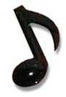
People who have Unclaimed PORCC Show Videos

Silvia Welson | Joe Gaydos | Karen Sue Johnson | Lloyd Stares (2 videos)
Joanne Long | Dave Richards | Mary Wentroble | Ken Pizzica
Barry Shaffron | Pat Olszewski | Mike Husentes (2 videos) | Jim Saunders
Mike Wozniak | Larry Zollner | Frank Trinkala
Al Heslet | Marc Mantini | Peter McCormick

Inventory of PORCC Show Videos for Sale

For those of you who do not order videos regularly – We have extras you can purchase!!! The following is a list of the clubs inventory. Anyone interested in purchasing one of these tapes, they only cost $5.00 each, call Jan at 724.745.6898, she’ll bring them to the show or mail them.

Performers | Show dates and Number of Videos avaliable | Performers | Show dates and Number of Videos avaliable
La Vern Baker | 9/8/96 - 1 Copy | The Calvanes | 4/02 – 1 Copy
Elgins And The Olympics | 9/28/97 - 1 Copy | Accapella-Cornerstone, Things To Come And William Dell & Wee Jams | 10/02 – 1 Copy
The Dubs | 1/19/97, 2/20/03, 9/11/05 -1 Copy Each Date | Pearl Mckinnon & The Kodiaks | 6/02 – 1 Copy
The Four Dots And The Medallions | 4/26/98 – 1 Copy | Otis Williams & The Charms | 12/02 – 1 Copy
The Eternals | 5/98, 1/02, 11/03 – 1 Each Date Except 1/02 – 2 Copies | The Sheps | 9/02 – 1 Copy
The Eldorados | 1/18/98 , 1/23/00 – 1 Copy Each Date | The Hurricanes | 3/02 – 1 Copy
The Edsels | 10/17/99 - 1 Copy | The Fiestas | 10/03 – 1 Copy
The Jacks And The Cadets | 4/25/99 - 1 Copy | The Limelites | 4/03 – 1 Copy
The Solitaires | 5/99 - 1 Copy | Cliftones, William Dell & Wee Jams, Johnny Angel & The Halos, Marvin Brown & Four Dots | 5/03 – 2 Copies
The Jewels | 8/29/99 - 1 Copy | The Velors | 2/04 – 4 Copies
The Harptones | 5/21/00 - 1 Copy, 5/06 – 7 Copies | Norman Fox & The Rob Roys | 4/04 – 1 Copy  6/06 – 5 Copies
The Five Discs | 8/20/00 - 1 Copy | 1st Annual Porcc & Rodfather Cruise And Show | 9/04 – 1 Copy
Earl Lewis And The Channels | 4/9/00 - 1 Copy | James Dozier (Avalons) And Frankie Avery (Larells) | 10/04 – 1 Copy
Legends Of Doo Wop | 7/9/00 - 1 Copy | Joe Weaver And The Falcons | 2/05 – 1 Copy
The Emotions | /5/00 - 1 Copy 3 | The Lyrics | 4/05 – 4 Copies
The Quotations | 11/00 - 1 Copy | The Solitaires/Johnny And Joe | 10/05 – 1 Copy
Bobby Lester’s Moonglows | 11/00 - 1 Copy | The Counts | 11/27/05 – 11 Copies
The Hearts | 3/01 - 1 Copy | Frankie And The Fashions | 1/06 – 5 Copies
The Clickettes | 3/05 - 3 Copies | Bobbie Lewis/ The Royal Jokers | 7/06 – 6 Copies
Eugene Pitt And The Jive Five | 1/01 – 1 Copy | Maryland Pierce And Five Keys | 9/06 – 1 Copy
The Swallows | 7/01 – 1 Copy


Doo Wop Holiday Concert – Mellon Arena December 8, 2007 – 7 PM

This was a great show – Nader Productions put together a great line-up of performers. If you never have gone to one of these shows you should treat yourself to one next year. Deborah Nader called me to ask about the show and asked the PORCC club for suggestions/requests for next years show. Please share them with me and I’ll let Deborah know this is who Pittsburgh Oldies Lovers from all over, want to see.
Page 3


DJ’S ON THE AIR

Music Power 104 FM – WLSW

Who | Day | Time
JukeBox | Monday – Friday | 7 PM to Midnight
JukeBox – with guests Georgio, Johnny O and Big Ed | Wednesday | 7 PM to Midnight
Jeff Allen | Saturday | 6 AM to Noon
Charlie Apple | Saturday | Noon to 6 PM
Jerry Braverman | Saturday | 6 PM to Midnight
Giorgio’s Oldies Café | Sunday | 7 AM to 12 PM
Sunday oldies showcase, with Jeff Allen, Charlie Apple, Stan Wall, Cindy Gaich, Big Ed | Sunday (DJs alternate) | Noon to 6 PM
Charlie Erb | Sunday | 6 PM to 11 PM

3WS 94.5 FM

RD Summers – Sunday Oldies Diner | Sunday | 7 PM to Midnight

WJPA 1450 AM / 95.3 FM

Jim Dudas | Sunday | Noon to 6 PM
WKFB 770 AM
Request Line: 412-829-7100 Email: frankieday@comcast.net Website: http://www.frankieday.com

Frankie Day and Caveman Ralph  Morning Memory Show | Monday - Friday | 6:30 AM to 10 AM
DJ George | Monday | 5 PM to 7:30 PM
Mike and Candy Long | Tuesday | 5 PM to 7:30 PM
Frankie Day and Bernie Chimiel | Wednesday | 5 Pm to 7:30 PM
Mike and Candy Long | Thursday | 5 PM to 7:30 PM
Frankie Day | Friday. | 5 PM to 7:30 PM
Caveman Ralph | Saturday | 6:45 AM to 9 AM
Frankie Day with DJ George and Bernie Chimiel | Saturday | 12 PM to 7:30 PM
DJ George | Sunday | 3 PM to 7:30 PM

Listen to Rich and Sunny and Have Some Fun With A Great Radio Show!!
Street Harmony Review Can be heard on the internet – www.KLAV1230AM.com

Mondays at 8-10 PM Las Vegas Time Or on www.alltalkradio.net for the show Archives

PEP RADIO – Ed Kowalski
DJ, OldiesKnight - Friends Playing Music for Friends
The Home of Doo Wop, R&B, R&R, Oldies, Vocal Group Harmony
www.DooWopRadio4U.com

The Doo Wop Show
with Host: Jim McCardle
Sundays 6-9 PM WIUP, 90.1 FM and Streaming Live at www.IUP.edu/WIUPFM

Any content to be added/removed/ changed on the PORCC Newsletter, Email me at mevans@icubed. com, Subject: “PORCC Newsletter”. This is your Newsletter, tell me the news!!
Page 4

