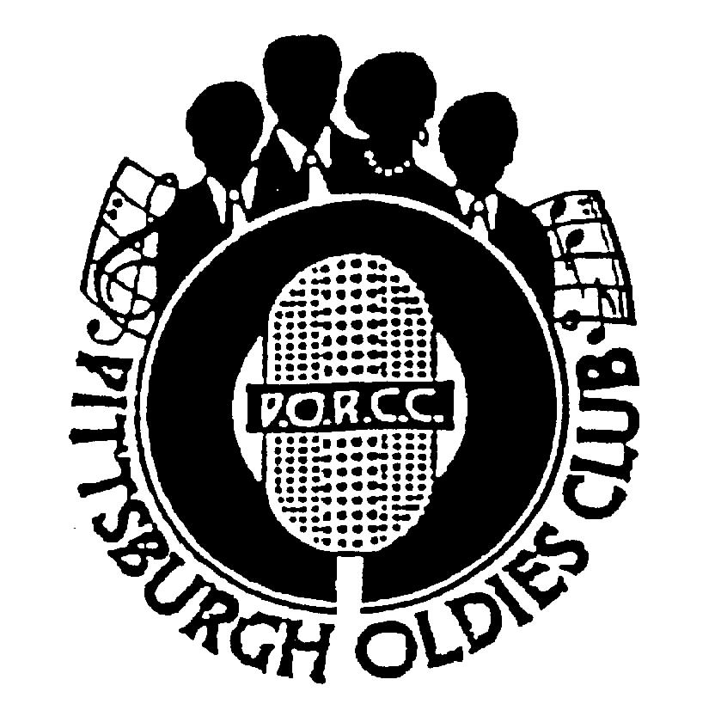
P.O.R.C.C. Newsletter
President: Jan Taper
Treasurer: Bob Azen

NEXT SHOW:
SUNDAY July 23, 2006

HOLIDAY INN – GREENTREE
Dinner Buffet Served at 5:30 PM,
Shows start at 7 PM

Our Next Show – Bobby Lewis also The Royal Jokers
Bobby Lewis!!! He recorded a big hit – “Tossing and Turning”, at that time in 1961 he also recorded “One Track Mind” and “What a Walk”, which broke into Billboards 100 list. I understand that he was backed up by a girl group called the Swanettes. Also The Royal Jokers will be performing. They haven’t performed for the PORCC Club for 10 years. They promise a great show!! Please join us for our next show featuring these two great acts!!! See you then.

Review of Norman Fox and The Rob Roys: – By Frank Yourick:
This Show was Dedicated to Eddie Voynick, John Barone and Barb [Bobbie] Yatsko

Norman Fox and the Rob Roys returned to Pittsburgh after a three year absence and brought with their trademark singing style of tight, five part harmony. Graciously dedicating their performance to the memories of PORCC members Ed Voynick and John Barone, the group demonstrated its versatility by offering five lead singers each of whom headlined their vocal talents on various songs throughout the evening.
We eagerly anticipated hearing them sing their own material such as “Tell Me Why”, “Pizza Pie”,the incomparable 1959 ballad “Dream Girl” and enjoyed an added bonus of hearing their original tune “Dance, Girl, Dance” and up tempo classic later made famous by Gerry Granahan. The group was wise to pick five part harmony songs recorded by others to fill out the evening’s entertainment and for me, the highlight was Tito Alverez’s dead-on version of “For Your Precious Love” in which every Jerry Butler nuance was faithfully addressed. A delightful time featuring a charming gentleman in Norman Fox, still able to bring back the group harmony memories of the 1950’s.

Mark Your Calendar:

Mellon Arena DooWop Concert December 8, 2006:

- Little Anthony and the Imperials
- Kenny Vance and the Planotones
- Shirley Alston Reeves
- The Drifters Featuring Charlie Thomas
- The Dubs
- Larry Chance and The Earls
- William Dell and The Wee Jams

PORCC Club members will be offered a $3.00 discount as in the past. Flyers are available at our next show.

El Capris:

Lead singer – Eddie Jackson passed away on Saturday June 10, 2006. Bill Germany, also of the El Capris said he had been ill for several years. He will be missed by all.
Page 1
PORCC News and Events:
Check Out PORCC’s newly updated web site, the correct address is:
http://www.angelfire.com/pa4/pgholdiesrecordclub/
Or you can go to www.yahoo.com or www.google.com and enter PORCC under search.

EVENTS:
- Looking for something to do Thursday nights - Atria’s Restaurant, PNC Park starting 8PM,hear acappella groups like
JOHNNY ANGEL & HALOS, The WILLIAM DELL and the WEE JAMS, The FOUR DOTS. Come down and enjoy great evening with our kind of music.
- Do you have 45 or 78 records come play DJ at Lexon in Greentree every first Monday of the month.
Call Dave at 412-276-2956. Another way to spend an evening with our kind of music and you be the DJ.
- Conneaut Lake Park’s Oldies/Doo Wop Shows for 2006 In the Historic ‘Dreamland Ballroom’

July 15, Saturday @ 900 PM – Johnny Angel and The Halos
July 29, Saturday @ 900 PM – Pure Gold
September 1, 2, and 3 - Doowop Weekend –Featuring The Sweethearts of Harmony,
William Dell and the WeeJams with Headliners The Edsels on September 3rd , Sunday @ 8:30 PM

Note: Other shows are in the planning stages so watch for this spot in future newsletters for updates. Ticket prices for these shows are typically $12.00 in advance and $14.00 the day of the show, making these shows extremely affordable event. For additional information or room reservations at the Hotel Conneaut, please call Conneaut Lake Park directly at 814-382-5115 or go to the Park’s website at www.conneautlakepark.com.

DUES: Don’t Forget!!
- ^{3rd} Quarter dues – DUE, $40.00 per quarter - Thanks!!!

Dues Mailing Address:
707 Flint Road  Allison Park, PA 15101 | Regular Members . $40/per quarter, payable quarterly  Associate Members $25/per year, payable yearly

PORCC Logo Items for Sale:
Looking for that special gift – PORCC is selling it’s logo items. They make nice gifts and show the pride of the PORCC members. See Marsha at the next show.

VIDEO SALES:

Do you wish you could see that show again that you loved so much? See Jan at the video table and order your video on the night of the show. Only $15.00!!! Can’t make a show, just send Jan a check made payable to: Media Quest for $18.00 no later than 5 days before the show, and she’ll order a video and have Media Quest mail it to you. Send a check for the video to:

Jan Taper, 1075 Mapleview Drive, Washington, PA 15301.

Feel free to call Jan at (724) 745-6898 if you have any questions.

CD SALES: All proceeds from the sale of CDs sold by PORCC go to the PORCC Club.

SHOWS in 2006: Jul 23, Sept 10, Oct 15, Nov 19
Greentree Holiday Inn, Located at 401 Holiday Drive,
Pittsburgh, PA 15220 (412) 922-8100

DANCES in 2006: Help us find a new Home!!!.

Page 2
DINNER RESERVATIONS
Sunday July 23rd, 2006

Herb Roasted Chicken, Sliced Ham With Pineapple Glaze, Coleslaw, Rice Pilaf, Green Beans Almondine, Tossed Salad, Rolls and Butter, Beverages, and Assorted Desserts.
NAME: _______________________________________ Number of Persons ______ @$18.00 each = $________. Reservations and Payment are Due by July 18th, 2006, the Tuesday before the show. Call Larry for Reservations at 412-921-8352. Mail payment to: PORCC Club, P.O. BOX 16184, Pittsburgh, PA 15242. Reservations are not refundable or transferable.
If you have menu suggestions let Jan know!


More Events Coming Your Way…
KUZMANS

The Place Where All Good Dancers come to Meet
1025 S. State Street, Girard, Ohio 44420
330-545-8521 or 330-545-8995
Less than an hours drive from Pittsburgh

Wednesday Night Jitterbug Dancing,
Also Cha-Cha along with Line Dancing and Ballads

7:30 – 12:00
DJ – “Dr Jive”

Wednesday 7/5, 7/19, 8/9, 8/23, 9/6, 9/20
Special Saturday Edition – July 8

“Just Get There – He’ll Take Your Feet The Rest Of The Way”
Admission $2.00

PORCC 15Th Anniversary Show
September 10, 2006

Maryland Pierce and the Five Keys

Advanced Ticket Sales Only
Reservations and money must be received by August 25th!!

Call Bob 412-486-5827 or Larry 412-921-8352 to make your reservations.

Send money to PO Box 16184,
Pittsburgh, PA 15242

PORCC Member: Dinner and the Show – Per Couple:$56.00 – Per Single: $28.00
Just the show – Usual Price*
*$10.00 per member as usual but we are asking if you can, a donation to help reduce costs.

Non Member: Dinner and the Show – Per Couple:$105.00 – Per Single: $55.00
Just the show – Per Person: $35.00

There will be ONLY Advanced Ticket sales, Cutoff Date August 25th, 2006!

Page 3


DJ’S ON THE AIR

Music Power 104 FM – WLSW

Who | Day | Time
JukeBox | Monday – Friday | 7 PM to Midnight
JukeBox – with guests Georgio, Johnny O and Big Ed | Wednesday | 7 PM to Midnight
Jeff Allen | Saturday | 6 AM to Noon
Charlie Apple | Saturday | Noon to 6 PM
Jerry Braverman | Saturday | 6 PM to Midnight
Giorgio’s Oldies Café | Sunday | 7 AM to 12 PM
Sunday oldies showcase, with Jeff Allen, Charlie Apple, Stan Wall, Cindy Gaich, Big Ed | Sunday (DJs alternate) | Noon to 6 PM
Charlie Erb | Sunday | 6 PM to 11 PM

WJPA 1450 AM / 95.3 FM

Jim Dudas | Sunday | Noon to 6 PM
WKFB 770 AM
Request Line: 412-829-7100
“We Are Oldies Proud!!”

Frankie Day and Caveman Ralph  Morning Memory Show | Monday - Friday | 6 AM to 9 AM
Mike and Candy Long | Monday - Friday | 1 PM to 4 PM
Frankie Day  Email frankieday@comcast.net  Website http://www.frankieday.com | Mon., Tues., Thur., Fri. | 5 PM to 8:45 PM
Frankie Day and Bernie Chimiel | Wednesday | 5 Pm to 8:45 PM
Caveman Ralph | Saturday | 6:45 AM to 9 AM
Frankie Day with DJ George and Bernie Chimiel | Saturday | 12 PM to 8:45 PM
DJ George | Sunday | 3 PM to 8:45 PM


Listen to Rich and Sunny and Have Some Fun With A Great Radio Show!! Street Harmony Review Can be heard on the internet – www.KLAV1230AM.com
Mondays at 8-10 PM Las Vegas Time
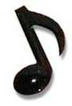
Or on www.alltalkradio.net for the show Archives

PEP RADIO – Ed Kowalski

DJ, OldiesKnight - Friends Playing Music for Friends
The Home of Doo Wop, R&B, R&R, Oldies, Vocal Group Harmony

www.DooWopRadio4U.com

Any content to be added/removed/ changed on the PORCC Newsletter, Email me at mevans@icubed. com, Subject: “PORCC Newsletter”. This is your Newsletter, tell me the news!!

Page 4

