P.O.R.C.C. Newsletter
President: Jan Taper
Treasurer: Bob Azen
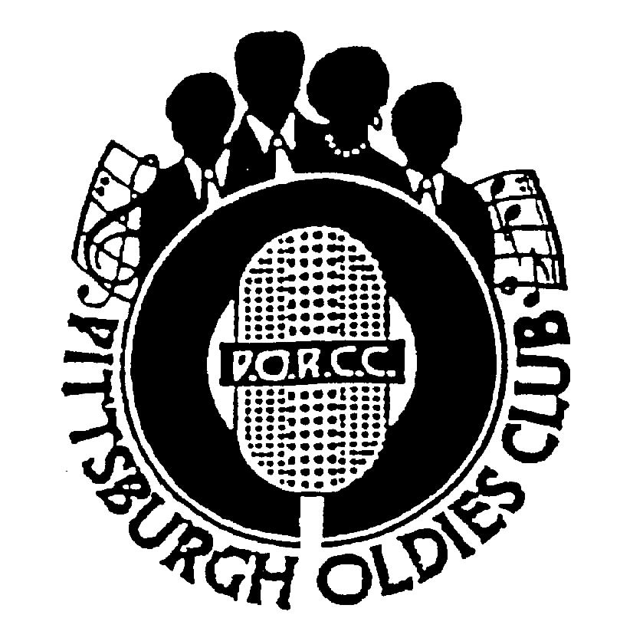
NEXT SHOW:
SUNDAY May 7, 2006

HOLIDAY INN – GREENTREE
Dinner Buffet Served at 5:30 PM,
Shows start at 7 PM

Our Next Show – The Harptones
Just when you thought it couldn’t get any better – well it does!!! Performing May 7th, for the PORCC club, the one, the only, THE HARPTONES. “Sunday Kind Of Love” (it will be a Sunday), “My Memories of You”, “Loving A Girl Like You”, “What Is Your Decision”…I hope your decision is to come and join us to hear this fabulous group from New York City.
Under the superb direction of Raul Cita, music director and writer, you’ll hear one of the best Doo Wop groups ever. So don’t let “Life Is But A Dream” stay a dream. See THE HARPTONES perform in person on May 7th!!!

Review of Kenny Vance and The Planotones – by Jim Saunders
I was probably was the only person in the room who had never seen Kenny Vance and The Planotones perform before. It was obvious by the number of people who crowed into the room that those who saw them loved them.
My initial reaction to their first several numbers was somewhat skeptical. True, they had excellent voices but their arrangements were far from my concept of Rhythm and Blues group harmony. Their first several numbers were all covers of tremendous group songs. I felt that they all sounded like The Innocents - no baritone or bass. Additionally several were done in pop harmony with the entire group singing on the melody line. Well, it didn’t take long for them to set me straight!!!
As their guitar player boomed out one of the best Wally Roker imitations ever, the guys covered the Heartbeats’ immortal ballad “Your Way” to absolute perfection. Oh, yes!! This is my kind of group harmony! Oh, yes!! The show got nothing but better from there!
Congratulations, Kenny Vance and The Planotones, you have another fan in your corner.

A Letter From the President – Jan

I talked to Debbie Nader, of Nader Productions, the other day on the phone. She wanted to tell me about the “tentative” line up of groups slated to perform for this years Holiday Doo Wop Concert at the Mellon Arena. I can’t divulge the groups yet, but the lineup looks great!!! As soon as I get the okay, I’ll put the names in the Newsletter. This years show will be earlier than the years before – December 8th at 7PM.
She cares very deeply about the opinion of the PORCC Club and its members. She wants to be sure her choices of performers will be ones that the PORCC Club members will want to see. So – I’ll keep you posted.

OOPS!!!
Amidst the hustle and bustle of the Kenny Vance and the Planotones show, these wonderful discographies were not circulated to all our members. So, for those who attended the show and for those of you did not – we’ve included them with your newsletter. Enjoy!!!
Jan
Page 1
PORCC News and Events
Check Out PORCC’s newly updated web site, the correct address is:
http://www.angelfire.com/pa4/pgholdiesrecordclub/
Or you can go to www.yahoo.com or www.google.com and enter PORCC under search.

EVENTS:
- Looking for something to do Thursday nights - Atria’s Restaurant, PNC Park starting 8PM,hear acappella groups like JOHNNY ANGEL & HALOS, The WILLIAM DELL and the WEE JAMS, The FOUR DOTS. Come down and enjoy great evening with our kind of music.
- Do you have 45 or 78 records come play DJ at Lexon in Greentree every first Monday of the month. Call John at
412-488-3166 or Dave at 412-276-2956. Another way to spend an evening with our kind of music and you be
the DJ.
- Conneaut Lake Park’s Oldies/Doo Wop Shows for 2006 In the Historic ‘Dreamland Ballroom’

May 26, 27, 28 – Doowop Weekend - - Featuring William Dell and the WeeJams
With Headliners “Richie Johnson and The Students” on May 28, Sunday @ 8:30
July 15, Saturday @ 900 PM – Johnny Angel and The Halos
July 29, Saturday @ 900 PM – Pure Gold
September 1, 2, and 3 - Doowop Weekend –Featuring The Sweethearts of Harmony,
William Dell and the WeeJams with Headliners The Edsels on September 3rd , Sunday @ 8:30 PM

Note: Other shows are in the planning stages so watch for this spot in future newsletters for updates. Ticket prices for these shows are typically $12.00 in advance and $14.00 the day of the show, making these shows extremely affordable event. For additional information or room reservations at the Hotel Conneaut, please call Conneaut Lake Park directly at 814-382-5115 or go to the Park’s website at www.conneautlakepark.com.
DUES: Don’t Forget!!
- 2nd Quarter dues – DUE, $40.00 per quarter - Thanks!!!

Dues Mailing Address:
707 Flint Road  Allison Park, PA 15101 | Regular Members . $40/per quarter, payable quarterly  Associate Members $25/per year, payable yearly

PORCC Logo Items for Sale:
Looking for that special gift – PORCC is selling it’s logo items. They make nice gifts and show the pride of the PORCC members. See Roseann at the next show.

VIDEO SALES:

Do you wish you could see that show again that you loved so much? See Jan at the video table and order your video on the night of the show. Only $15.00!!! Can’t make a show, just send Jan a check made payable to: Media Quest for $18.00 no later than 5 days before the show, and she’ll order a video and have Media Quest mail it to you. Send a check for the video to:

Jan Taper, 1075 Mapleview Drive, Washington, PA 15301.

Feel free to call Jan at (724) 745-6898 if you have any questions.

CD SALES: All proceeds from the sale of CDs sold by PORCC go to the PORCC Club.

SHOWS in 2006: May 7, Jun 11, Jul 23, Sept 10, Oct 15, Nov 19
Greentree Holiday Inn, Located at 401 Holiday Drive,
Pittsburgh, PA 15220 (412) 922-8100

DANCES in 2006: Help us find a new Home!!!.

Page 2
DINNER RESERVATIONS
Sunday May 7th, 2006
Pasta Primavera with Chicken, Sliced Pork Loin with Hunter Sauce, Three Bean Salad, Whipped Potatoes, Glazed Baby Carrots, Tossed Salad, Rolls and Butter, Beverages, and Assorted Desserts.
NAME: _______________________________________ Number of Persons ______ @$18.00 each = $________. Reservations and Payment are Due by May 2nd, 2006, the Tuesday before the show. Call Larry for Reservations at 412-921-8352. Mail payment to: PORCC Club, P.O. BOX 16184, Pittsburgh, PA 15242. Reservations are not refundable or transferable.
If you have menu suggestions let Jan know!

More Events Coming Your Way…


50’s Sock Hop
Saturday, April 29th
8 PM ‘til 12AM

Greentree Holiday INN
To Benefit the Porky Chedwick Commemorative Plaque in Homestead

Cash Bar – Chinese Auction – 50/50 Raffle
Come Spend the Evening with us,
“Moving your feet to the PORKY Beat!”
Donation $20.00

Thunder in the Burg…
June 9-10 at Heinz Field

Car Cruise and Drag Racing –
Co Sponsored by Pittsburgh Raceway and Fox Broadcasting,
Car Cruise by Rod Fathers

Rod Fathers Car Cruise – With 3WS


Cruise-A-Palosa

June 24 at Clearview Mall, Butler, PA
June 25 at Downtown Butler, PA

Featuring:
Johnny Angel and The Halos
William Dell and The WeeJams
and Pixie 3 on June 25

Page 3


DJ’S ON THE AIR

Music Power 104 FM – WLSW

Who | Day | Time
JukeBox | Monday – Friday | 7 PM to Midnight
JukeBox – with guests Georgio, Johnny O and Big Ed | Wednesday | 7 PM to Midnight
Jeff Allen | Saturday | 6 AM to Noon
Charlie Apple | Saturday | Noon to 6 PM
Jerry Braverman | Saturday | 6 PM to Midnight
Giorgio’s Oldies Café | Sunday | 7 AM to 12 PM
Sunday oldies showcase, with Jeff Allen, Charlie Apple, Stan Wall, Cindy Gaich, Big Ed | Sunday (DJs alternate) | Noon to 6 PM
Charlie Erb | Sunday | 6 PM to 11 PM

WJPA 1450 AM / 95.3 FM

Jim Dudas | Sunday | Noon to 6 PM
WKFB 770 AM
Request Line: 412-829-7100

Frankie Day and Caveman Ralph  Morning Memory Show | Monday - Friday | 6:15 AM to 9 AM
Mike and Candy Long | Monday - Friday | 1 PM to 4 PM
Caveman Ralph | Saturday | 7 AM to 10 AM
Porky Chedwick | Monday | 5 PM to 8 PM
Brandon Cunning | Tuesday & Thursday | 5 PM to 8 PM
Frankie Day and Bernie Chiniel | Wednesday | 5 Pm to 8 PM
Rick J | Friday | 5 PM to 8 PM
Caveman Ralph | Saturday | 6:45 AM to 9 AM
Porky Chedwick | Saturday | 12 PM to 3 PM
Frankie Day with DJ George | Saturday | 3 PM to 8 PM
Frankie Day with DJ George  Email frankieday@comcast.net  Website http://www.frankieday.com | Sunday | 3 PM to 8 PM

A Great Radio Show:Street Harmony Review Can be heard on the internet – www.KLAV1230AM.com
Mondays at 8-10 PM Las Vegas Time
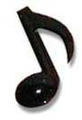
Or on www.alltalkradio.net for the show Archives

PEP RADIO – Ed Kowalski

DJ, OldiesKnight - Friends Playing Music for Friends
The Home of Doo Wop, R&B, R&R, Oldies, Vocal Group Harmony

www.DooWopRadio4U.com

Any content to be added/removed/ changed on the PORCC Newsletter, Email me at mevans@icubed. com, Subject: “PORCC Newsletter”. This is your Newsletter, tell me the news!!
Page 4

