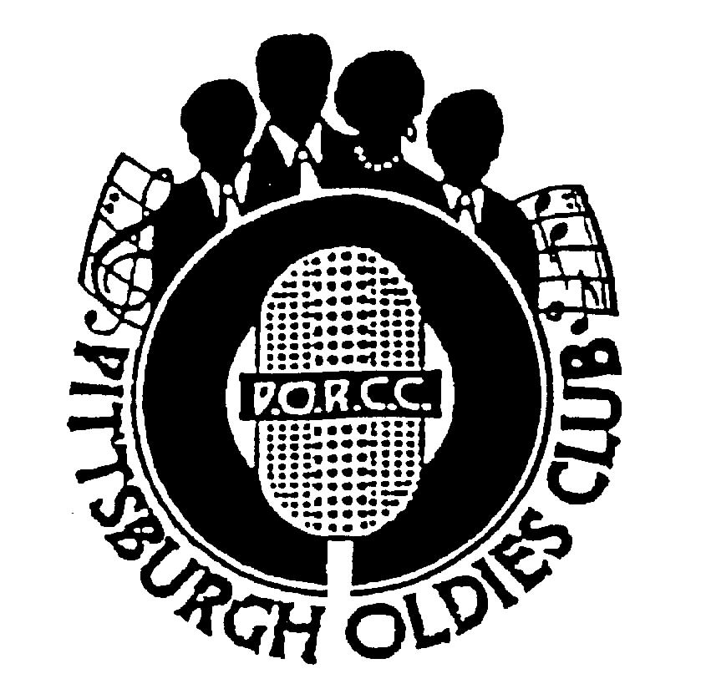
P.O.R.C.C. Newsletter
President: Jan Taper
Treasurer: Bob Azen

NEXT SHOW DATE:
SUNDAY November 19, 2006


HOLIDAY INN – GREENTREE

Dinner Served at 5:30 PM
Shows start at 7 PM

Our Next Show: THE DIABLOS

“The Wind”; “Mind Over Matter”; “Dog Me Around” – THE DIABLOS! PORCC has the honor of bringing this group down from Detroit for our November show. Marilyn Bond, who brought us The ROYAL JOKERS and BOBBY LEWIS promises we won’t be disappointed! Never before a PORCC show - Please join us and welcome THE DIABLOS.

Review: THE CAPITOLS - By Jan Taper

If you were unable to attend THE CAPITOLS “Coming out Show”, you missed an amazing performance. Rick, Mickey, Eddie, Calvin and Dora, better know as “Spike” wowed the audience. Singing “Day By Day”, “Rose Marie” – well known CAPITOLS songs, but the others they sang! Being a TURBANS fan “Let Me Show You Around” and “I’ll Always Watch Over You”, and the “high-note” ability of Rick Toliver – well it made me smile.

The entire show was great. We had a lot of local folks attend and we hope they’ll come back for all our shows. CAPITOLS – Thank you for allowing us to be the first!


Jan

Page 1
PORCC News and Events:

Check Out PORCC’s newly updated web site, the correct address is:
http://www.angelfire.com/pa4/pgholdiesrecordclub/
Or you can go to www.yahoo.com or www.google.com and enter PORCC under search.

Check out our sister club CODA at their new website: www.codakeepthemusicalive.com

EVENTS:

- Looking for something to do Thursday nights - Atria’s Restaurant, PNC Park starting 8PM,hear acappella groups like
JOHNNY ANGEL & HALOS, WILLIAM DELL and the WEE JAMS, The FOUR DOTS. Come down and enjoy great evening with our kind of music.

- Do you have 45 or 78 records come play DJ at Lexon in Greentree every first Monday of the month.
Call Dave at 412-276-2956. Another way to spend an evening with our kind of music and you be the DJ.

- EUGENE PITT and the JIVE FIVE – Saturday, December 9, 2006 – RD Productions presents, coming to the White Oak American Legion. Music starts at 8 PM. Tickets $25.00, call Roy and Grace Deer at 412-670-1904 or Mike and Candy at 412-751-0313 or Ina Marton at 412-403-8553. MC is WLSW’s Jerry Braverman.

- Pure Gold – see our website www.puregoldmusic.com Here are some upcoming dates:

Sat. November 18, 2006 – 8:00 Pm – Palisades – Advanced tickets $15.00 door tickets $20.00
Sat. February 3, 2007 – Mark you Calendar – Roots of Rock and Roll Volume XXXII at The Benedum
Two Shows 412-681-0652 or contact Pure Gold at email pgold@verizon.net or phone 412-687-6222.
DUES: Don’t Forget!!
- 4th Quarter dues – DUE, $40.00 per quarter - Thanks!!!

Dues Mailing Address:
707 Flint Road  Allison Park, PA 15101 | Regular Members . $40/per quarter, payable quarterly  Associate Members $25/per year, payable yearly

PORCC Logo Items for Sale:

Looking for that special gift – PORCC is selling it’s logo items. They make nice gifts and show the pride of the PORCC members. See Marsha at the next show.

VIDEO SALES: We have a list** of Unclaimed Videos!

Do you wish you could see that show again that you loved so much? See Jan at the video table and order your video on the night of the show. Only $15.00!!! Can’t make a show, just send Jan a check made payable to: Media Quest for *$20.00 no later than 5 days before the show, and she’ll order a video and have Media Quest mail it to you. Send a check for the video to:

Jan Taper, 1075 Mapleview Drive, Washington, PA 15301.

Feel free to call Jan at (724) 745-6898 if you have any questions.

*Increase $18.00 to $20.00 – to help cover postage. **See list of unclaimed videos, next page.
CD SALES:


All proceeds from the sale of CDs sold by PORCC go to the PORCC Club.

SHOWS IN 2006: Nov 19
SHOWS IN 2007: Jan 21, Mar 4, Apr 22, Jun 10, Jul 15, Sep 9, Oct 7, Nov 11

Greentree Holiday Inn, Located at 401 Holiday Drive,
Pittsburgh, PA 15220 (412) 922-8100
Page 2
DINNER RESERVATIONS
Sunday November 19th, 2006

Herb Roasted Chicken, Broiled Fillet Tilapia, Dilled Cucumber Salad, Garlic Mashed Red Skinned Potatoes, Green Beans Almondine, Tossed Salad, Rolls and Butter, Beverages, and Dessert.
NAME: _______________________________________ Number of Persons ______ @$18.00 each = $________. Reservations and Payment are Due by November 15th, 2006, the Wednesday before the show. Call Larry for Reservations at 412-921-8352. Mail payment to: PORCC Club, P.O. BOX 16184, Pittsburgh, PA 15242. Reservations are not refundable or transferable.
If you have menu suggestions let Jan know!

More Events coming your way…

PORCC Dance: Returns!!! YES, We’re Back!

When: Saturday - November 18, 2006 from 8 PM until 12:30 AM
Where: East Coast House (At the Avalon Motel Route 65, Ohio River Blvd)
DJ: Uncle Al – All your favorite 50’s and 60’s oldies.
Cost: $7.00 per person, for the best dancing and romancing in town!!!


For more information and tickets call:

Bob @ 412-486-5827, Jan @ 724-375-3752 or “Uncle Al” @ 724-375-3752

Tickets are also available at the door.

50/50 raffle Cash Bar Food Available

All proceeds benefit Pittsburgh Old Records Collector’s Club and keeping the music alive!!

Mark Your Calendar:

Mellon Arena DooWop Concert December 8, 2006:

- Little Anthony and the Imperials
- Kenny Vance and the Planotones
- Shirley Alston Reeves
- The Drifters Featuring Charlie Thomas
- The Dubs
- Larry Chance and The Earls
- William Dell and The Wee Jams

412-642-1977 9am-5pm

PORCC Club members will be offered a $3.00 discount as in the past.
Flyers are available at our next show.

People who have Unclaimed PORCC Show Videos

Silvia Welson | Joe Gaydos | Karen Sue Johnson
Joanne Long | Dave Richards | Mary Wentroble
Barry Shaffron | Pat Olszewski | Mike Husentes (2 videos)
Mike Wozniak | Larry Zollner | Frank Trinkala
Lloyd Stares (2 videos) | Jim Saunders | Marc Mantini
Ken Pizzica | Peter McCormick | Al Heslet

For those of you who do not order videos regularly – We have extras you can purchase!!!

Page 3


DJ’S ON THE AIR

Music Power 104 FM – WLSW

Who | Day | Time
JukeBox | Monday – Friday | 7 PM to Midnight
JukeBox – with guests Georgio, Johnny O and Big Ed | Wednesday | 7 PM to Midnight
Jeff Allen | Saturday | 6 AM to Noon
Charlie Apple | Saturday | Noon to 6 PM
Jerry Braverman | Saturday | 6 PM to Midnight
Giorgio’s Oldies Café | Sunday | 7 AM to 12 PM
Sunday oldies showcase, with Jeff Allen, Charlie Apple, Stan Wall, Cindy Gaich, Big Ed | Sunday (DJs alternate) | Noon to 6 PM
Charlie Erb | Sunday | 6 PM to 11 PM

3WS 94.5 FM

RD Summers – Sunday Oldies Diner | Sunday | 7 PM to Midnight

WJPA 1450 AM / 95.3 FM

Jim Dudas | Sunday | Noon to 6 PM
WKFB 770 AM
Request Line: 412-829-7100 Email: frankieday@comcast.net Website: http://www.frankieday.com

Frankie Day and Caveman Ralph  Morning Memory Show | Monday - Friday | 6:30 AM to 10 AM
DJ George | Monday | 5 PM to 5:45 PM
Mike and Candy Long | Tuesday | 5 PM to 5:45 PM
Frankie Day and Bernie Chimiel | Wednesday | 5 Pm to 5:45 PM
Mike and Candy Long | Thursday | 5 PM to 5:45 PM
Frankie Day | Friday. | 5 PM to 5:45 PM
Caveman Ralph | Saturday | 6:45 AM to 9 AM
Frankie Day with DJ George and Bernie Chimiel | Saturday | 12 PM to 5:45 PM
DJ George | Sunday | 3 PM to 5:45 PM

Listen to Rich and Sunny and Have Some Fun With A Great Radio Show!!
Street Harmony Review Can be heard on the internet – www.KLAV1230AM.com

Mondays at 8-10 PM Las Vegas Time Or on www.alltalkradio.net for the show Archives

PEP RADIO – Ed Kowalski
DJ, OldiesKnight - Friends Playing Music for Friends
The Home of Doo Wop, R&B, R&R, Oldies, Vocal Group Harmony
www.DooWopRadio4U.com

The Doo Wop Show
with Host: Jim McCardle
Sundays 6-9 PM WIUP, 90.1 FM and Streaming Live at www.IUP.edu/WIUPFM

Any content to be added/removed/ changed on the PORCC Newsletter, Email me at mevans@icubed. com, Subject: “PORCC Newsletter”. This is your Newsletter, tell me the news!!
Page 4

