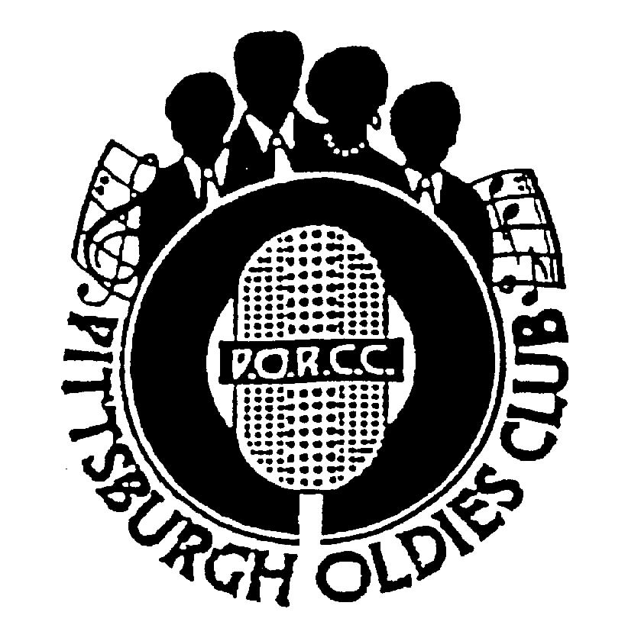
P.O.R.C.C. Newsletter
President: Jan Taper
Treasurer: Bob Azen

NEXT SHOW DATE: Our 15th Anniversary Show
SUNDAY September 10, 2006

HOLIDAY INN – GREENTREE
Sit Down Dinner Served at 5:30 PM
(This Show Only)
Shows start at 7 PM

Our Next Show – Maryland Pierce and the Five Keys

The PORCC Club is so very happy to present for their 15TH Anniversary, Maryland Pierce and the Five Keys. “I Dreamed I Was In Heaven”, “My Saddest Hour”, “You Broke The Only Heart”, so many great songs. They’ll be here, to perform for the PORCC Club, Sunday, September 10, 2006. Please join us for our 15th Anniversary Celebration.

Review of Bobby Lewis also The Royal Jokers: – By Jim Sanders:

The members of PORCC were treated to a truly special performance provided by two acts on July 23, 2006. Opening the show (and the ears and hearts of the audience) was the exciting, entertaining and personable Bobbie Lewis. Bobby’s “Tossin’ And Turning” may make him a “one hit wonder” but his talent captivated our audience. His is the complete package and it says here he could be a successful Vegas act. Not only did he sing, but 81 years of age he cut a mean rug. Additionally, he is an accomplished storyteller and comedian. (I’ll never hear the word molasses again without experiencing a private chuckle). Yes, Bobby Lewis did it all and was a pleasure to meet and watch.
If you much prefer the group sound then you didn’t have to wait long. When Bobby exited the stage, up sauntered one of the most entertaining groups ever. Willie Jones’ Royal Jokers were a rare treat. As I mentioned on stage, Willie is indeed a rare commodity to possess the exact same tenor voice in 2006 that he had in 1952 – UNBELIEVEABLE!!! Like Bobby Lewis, the Royal Jokers also demonstrated considerable dancing talent and their act with “The Bug” crawling down everyone’s back was a scream. In addition to performing their own material “just like the record” the guys also did an admirable job on several covers. Standing out among these and bringing the crowd to it’s feet was an outstanding version of “Smoke Gets In Your Eyes”.
It’s been ten years since Willie and the guys graced the PORCC stage. Let’s hope their next visit is sooner than that.

Mark Your Calendar:

Mellon Arena DooWop Concert December 8, 2006:

- Little Anthony and the Imperials
- Kenny Vance and the Planotones
- Shirley Alston Reeves
- The Drifters Featuring Charlie Thomas
- The Dubs
- Larry Chance and The Earls
- William Dell and The Wee Jams

PORCC Club members will be offered a $3.00 discount as in the past. Flyers are available at our next show.
Results of the “Survey”:

There were 24 surveys completed and returned. There were 101 groups/performers named. The following show the groups that received the top votes:

- The Dubs ………………...…………………..….….…..…..9
- Teenagers, Moonglows, Cadillacs ..………..………..…7
- Jive Five …..………………………………………..……..….6
- Harptones, Students, Johnny Maestro, Jimmy Gallagher, Capris, Spaniels, Charts, Flamingos .…….5
- Earl Lewis, Shells, Chantels, Lee Andrew & Hearts, Duprees Cleftones ..………………………………..….…..4
- Five Satins, Lillian Leach .…..……………………..….…..3

Page 1
PORCC News and Events:
Check Out PORCC’s newly updated web site, the correct address is:
http://www.angelfire.com/pa4/pgholdiesrecordclub/
Or you can go to www.yahoo.com or www.google.com and enter PORCC under search.

EVENTS:
- Looking for something to do Thursday nights - Atria’s Restaurant, PNC Park starting 8PM,hear acappella groups like
JOHNNY ANGEL & HALOS, The WILLIAM DELL and the WEE JAMS, The FOUR DOTS. Come down and enjoy great evening with our kind of music.
- Do you have 45 or 78 records come play DJ at Lexon in Greentree every first Monday of the month.
Call Dave at 412-276-2956. Another way to spend an evening with our kind of music and you be the DJ.
- Conneaut Lake Park’s Oldies/Doo Wop Shows for 2006 In the Historic ‘Dreamland Ballroom’

September 1, 2, and 3 - Doowop Weekend –Featuring The Sweethearts of Harmony,
William Dell and the WeeJams with Headliners The Edsels on September 3rd , Sunday @ 8:30 PM

Call Conneaut Lake Park directly at 814-382-5115 or go to the Park’s website at www.conneautlakepark.com

- Pure Gold – see our website www.puregoldmusic.com Here are some upcoming dates:

Sat. August 19, 2006 – 7:30 Pm - Pleasant Hills Community Days – Mowry Park, Pleasant Hills, PA
Sat. August 20, 2006 – 6:30 Pm - Irwin Park – Music In The Parks – Irwin Park Amphitheater, Irwin, PA
Sat. September 9, 2006 – 7:00 Pm - Beaver County Cruise At Beaverun
Beaverun Motorsports Complex, Penndale Rd. Beaver Falls, PA
Sat. September 16, 2006 – 9:00 Pm - Scottdale Fall Festival – Gazebo Park, Scottdale, PA
Sat. November 18, 2006 – 8:00 Pm – Palisades – Advanced tickets $15.00 door tickets $20.00

DUES: Don’t Forget!!
- ^{3rd} Quarter dues – DUE, $40.00 per quarter - Thanks!!!

Dues Mailing Address:
707 Flint Road  Allison Park, PA 15101 | Regular Members . $40/per quarter, payable quarterly  Associate Members $25/per year, payable yearly

PORCC Logo Items for Sale:
Looking for that special gift – PORCC is selling it’s logo items. They make nice gifts and show the pride of the PORCC members. See Marsha at the next show.

VIDEO SALES:

Do you wish you could see that show again that you loved so much? See Jan at the video table and order your video on the night of the show. Only $15.00!!! Can’t make a show, just send Jan a check made payable to: Media Quest for $18.00 no later than 5 days before the show, and she’ll order a video and have Media Quest mail it to you. Send a check for the video to:

Jan Taper, 1075 Mapleview Drive, Washington, PA 15301.

Feel free to call Jan at (724) 745-6898 if you have any questions.

CD SALES: All proceeds from the sale of CDs sold by PORCC go to the PORCC Club.

SHOWS in 2006: Sept 10, Oct 15, Nov 19

Greentree Holiday Inn, Located at 401 Holiday Drive,
Pittsburgh, PA 15220 (412) 922-8100

Page 2
DINNER RESERVATIONS
Sunday September 10th, 2006 SIT DOWN DINNER – THIS SHOW ONLY –

Please arrive a little early so you can be seated, by 5:15 PM.

Chicken Marsala, Glazed Carrots, Red Skinned Potatoes, Tossed Salad, Rolls and Butter, Beverages, and Anniversary cake will be the dessert.

NAME: _______________________________________ Number of Persons ______ @$18.00 each = $________. Reservations and Payment are Due by August 24th, 2006, two Thursdays before the show. Call Bob for Reservations at 412-486-5827. Mail payment to: PORCC Club, P.O. BOX 16184, Pittsburgh, PA 15242. Reservations are not refundable or transferable.
If you have menu suggestions let Jan know!

More Events coming your way…

KUZMANS

The Place Where All Good Dancers come to Meet
1025 S. State Street, Girard, Ohio 44420
330-545-8521 or 330-545-8995

Wednesday Night Jitterbug Dancing,
Also Cha-Cha along with Line Dancing and Ballads


Wednesday 9/6, 9/20 (7:30 PM – 12:00PM) DJ – “Dr Jive”

Admission $2.00

PORCC 15Th Anniversary Show

September 10, 2006

Maryland Pierce and the Five Keys

Advanced Ticket Sales Only

Reservations and money must be received by August 24th!!

Call Bob 412-486-5827 to make your reservations.

Send money to
PO Box 16184,
Pittsburgh, PA 15242

PORCC Member: Dinner and the Show – Per Couple:$56.00 – Per Single: $28.00
Just the show – Usual Price*

*$10.00 per member as usual but we are asking if you can, a donation to help reduce costs.

Non Member: Dinner and the Show – Per Couple:$105.00 – Per Single: $55.00
Just the show – Per Person: $35.00

There will be ONLY Advanced Ticket sales, Cutoff Date August 24th, 2006!

Page 3


DJ’S ON THE AIR

Music Power 104 FM – WLSW

Who | Day | Time
JukeBox | Monday – Friday | 7 PM to Midnight
JukeBox – with guests Georgio, Johnny O and Big Ed | Wednesday | 7 PM to Midnight
Jeff Allen | Saturday | 6 AM to Noon
Charlie Apple | Saturday | Noon to 6 PM
Jerry Braverman | Saturday | 6 PM to Midnight
Giorgio’s Oldies Café | Sunday | 7 AM to 12 PM
Sunday oldies showcase, with Jeff Allen, Charlie Apple, Stan Wall, Cindy Gaich, Big Ed | Sunday (DJs alternate) | Noon to 6 PM
Charlie Erb | Sunday | 6 PM to 11 PM

3WS 94.5 FM

RD Summers – Sunday Oldies Diner | Sunday | 7 PM to Midnight

WJPA 1450 AM / 95.3 FM

Jim Dudas | Sunday | Noon to 6 PM
WKFB 770 AM
Request Line: 412-829-7100 Email: frankieday@comcast.net Website: http://www.frankieday.com

Frankie Day and Caveman Ralph  Morning Memory Show | Monday - Friday | 6 AM to 10 AM
DJ George | Monday | 5 PM to 8:15 PM
Mike and Candy Long | Tuesday | 5 PM to 8:15 PM
Frankie Day and Bernie Chimiel | Wednesday | 5 Pm to 8:45 PM
Mike and Candy Long | Thursday | 5 PM to 8:15 PM
Frankie Day | Friday. | 5 PM to 8:45 PM
Caveman Ralph | Saturday | 6:45 AM to 9 AM
Frankie Day with DJ George and Bernie Chimiel | Saturday | 12 PM to 8:15 PM
DJ George | Sunday | 3 PM to 8:15 PM

Listen to Rich and Sunny and Have Some Fun With A Great Radio Show!!
Street Harmony Review Can be heard on the internet – www.KLAV1230AM.com

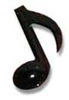
Mondays at 8-10 PM Las Vegas Time Or on www.alltalkradio.net for the show Archives

PEP RADIO – Ed Kowalski
DJ, OldiesKnight - Friends Playing Music for Friends
The Home of Doo Wop, R&B, R&R, Oldies, Vocal Group Harmony
www.DooWopRadio4U.com

The Doo Wop Show
with Host: Jim McCardle
Sundays 6-9 PM WIUP, 90.1 FM and Streaming Live at www.IUP.edu/WIUPFM

Any content to be added/removed/ changed on the PORCC Newsletter, Email me at mevans@icubed. com, Subject: “PORCC Newsletter”. This is your Newsletter, tell me the news!!

Page 4

