The Environment for Our Children

Think of the Generations of Children that will come after you
Just a little science
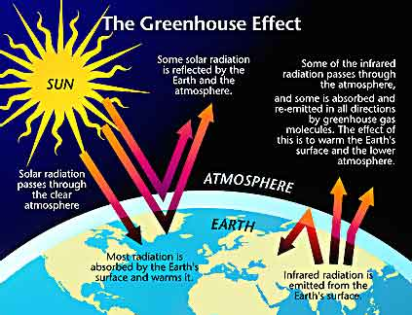
Scientists have concluded that human activities are contributing to global warming by adding large amounts of heat-trapping gases to the atmosphere. Our fossil fuel use is the main source of these gases. Every time we drive a car, use electricity from coal-fired power plants, or heat our homes with oil or natural gas, we release carbon dioxide and other heat-trapping gases into the air. The second most important source of greenhouse gases is deforestation, mainly in the tropics, and other land-use changes.
What you can do
You use a lot of energy for heating and cooling your home, running appliances, heating water, and lighting the rooms. Space heating uses the largest amount of energy of all these activities. Anything you can do to reduce your home heating will help reduce your GHG emissions and your monthly bills. Buy a hybrid car, such as the Toyota Prius which limits harmful climate change producing gases from being emitted into the environment.
Become active in your community; you can create a positive environment in which to live. Share more than sidewalks – share an enthusiasm to make your neighbourhood an environmentally educated one.
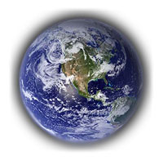
Protect the world for the Future

