Reconciling Three Faiths in Peace
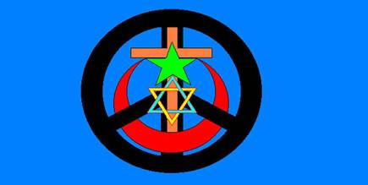
Christmas Peacewalk 2005

Bethlehem to Jerusalem Interfaith Peace Prayer Pilgrimage
To Reconcile the Three Faiths of Jerusalem

2001-2010 United Nations International Decade of Creating a
Culture of Peace and Nonviolence for the Children of the World

Offering Sacred Circle Interfaith Prayer Ceremony Peace Council

6AM Sunrise Circle outside Church of Nativity, Bethlehem
~4mi Peacewalk to Jerusalem “Western Wall” Circle
Afternoon Circle Ceremony outside Al Aqsa Mosque

23Dec05 Core Group Peacewalkers-Convener*s: Bethlehem to Jerusalem Sacred Circle

Dr. David Leighton (MD ret., UK) Wadi Rum - www.leigthon.de
Rabbi Moishe Geller, Jerusalem Camp - www.jerusalemcamp.org
Yehuda Stolov, Interfaith Encounter - www.interfaith-encounter.org
Dr. Yitzhaq Hayut-Man, Academy of Jerusalem - www.thehope.org
Mrs. Eileen Fleming (RN ret.), Florida USA - www.wearewideawake.org
*Eliyahu McLean, Jerusalem Peacemakers - www.jerusalempeacemakers.org
Ibrahim Abu El-Hawa, Mount of Olives - www.jerusalempeacemakers.org/ibrahim
Rev. Horikoshi, Nipponzan Myohoji - www.dharmawalk.org www.peacepagoda.org

http://www.angelfire.com/on/GEAR2000/jerusalem.html
http://groups.yahoo.com/group/Jerusalem-Peace-Walk

--- end flyer/poster of/at: ---
http://www.angelfire.com/on/GEAR2000/09Nov05ChristmasPeacewalkPoster.doc

If you think this peacewalk offering the indigenous peoples’ spiritual precedent culture of peace practice of the sacred circle interfaith prayer ceremony and council format to reconcile the three holy faiths of Jerusalem is a good idea, help us make this happen!

If you can walk, offer support, ideas, help, networking, please contact:

Global Emergency Alert Response 2000 – gear2000@lightspeed.net
General Agency Services of California – (661) 867-2877
David Crockett Williams III, Jerusalem Peace Walk Initiator

http://www.angelfire.com/on/GEAR2000/09Nov05ChristmasPeacewalkPoster.doc
http://tinyurl.com/8pzpt
Jerusalem Peace Walk Project
(Christmas, Easter, August 15th)

