

EECB423

DATA COMMUNICATION AND NETWORKING

Research Paper on
Functional Computer Networking

At:

Tenaga Nasional

Headquarters - Bangsar

BY:

Nasrul Hadi Bin Mahmad EE 01746
Bakhtiar Ariff Bin Baharudin EE 01234
Mohd. Yazid Bin Ahmad EE 01251

INSTRUCTOR: Dr. H.S. Ong

Table of Content
- Introduction. …………………………………………………………… 4

- Network Background. …………………………………………… 4

- Philosophy of Backbone design and Network Infrastructure. ……. 6

- Network Infrastructure………………………………………………… 6
  - Network Application. ……………………………………………. 7
  - Network Topologies…………………………………………….. 7
  - Current Network Capacity, Expansion and Scalability. ..… 8
    - Routers. ……………………………………………………. 8
    - Switches. …………………………………………………… 9
    - Hub. …………………………………………………………. 10
    - NIC cards. ………………………………………………… 10
  - Vendor. …………………………………………………………… 10
  - Communication medium. ……………………………………… 11
    - Fiber Optic cabling system. ……………………………… 11
    - UTP Cabling. ……………………………………………… 13

- Local Area Network (LAN). ………………………………………… 14
  - LAN Overview. ………………………………………………….. 14
  - Structured Cabling System. …………………………………… 15
  - LAN – HQ Campus ATM Network. ……………………………. 15

- Hardware and Software Details. …………………………………… 19
  - Cisco 7000 router. ……………………………………………… 19
  - Netbuilder II Router. ……………………………………………. 19
  - CoreBuilder 7000HD (CB 7000) ATM Switch. ………………. 19
  - SuperStack® II Switch 3000 Switch. ………………………… 21
  - Transcend® End-to-End Network and Device Management Solutions. ………………………………………………………… 22

- Wide Area Network (WAN). ……………………………………………18
  - WAN Introduction………………………………………………… 24
  - WAN Network Structure………………………………………… 24
  - WAN Fiber Optic Connection………………………………….. 26

- Technologies/Systems. ………………………………………………. 29
  - Customer Information Billing System (CIBS). ……………… 29
  - File Database Management System (FDBMS). …………… 34
  - Financial Management Information System (FMIS). ……… 34

- Managing The Network. ……………………………………………… 34
  - Tools. …………………………………………………………… 34
  - Traffic Monitoring and Congestion Avoidance. …………… 34
  - Preventive Maintenance and records ……………………… 34
  - Disaster and Recovery Planning Procedures. ……………… 34

- Request for Proposal (RFP), Tendering and Solution Provider Selecting. ……………………………………………………………… 36

- Future Developments. ………………………………………………… 37

- Our Comments. …………………………………………………………41
  - Comments on This Network. …………………………………. 41
  - Problems Faced When Doing This Research Paper. …… 43
  - Build a Network. ……………………………………………… 43

- Summary and Conclusion…………………………………………… 43
- References. …………………………………………………………… 44
- Glossary. ……………………………………………………………… 45
- Appendix. ……………………………………………………………….

- Introduction.

This research paper is a requirement for EECB 423 that is Data Communication and Networking, an elective course in UNITEN. In this research, we are required to work in a group of three students to have a research on real-life functional computer network. “It was designed to drive the student to focus a particular network and to contemplate on the existing network philosophy and to understand the reason for specific technologies or configurations was chosen as the network solution. Computer network is always designed to ease information flow. To understand how this was achieved in a particular location is really a big footstep toward understanding of the intricate of computer network design and analysis.” At the end we are required to submit this full report of 30 pages minimum. Since this is a research paper, we have to do some research. We have to make a site visit, interview appropriate personnel, collect the network diagram and relevant information on the site, and do catalog and web searching. This fulfilled the requirement of so-called research.

This research paper is about computer networking on Tenaga Nasional Berhad (TNB) mainly in its headquarters situated in Bangsar. As we all know, TNB is Malaysia’s well-known electricity supplier. It is a big company with many branches and subsidiaries where computer networking is very important. In fact, TNB has its own network communication system, i.e. without depending on other communication service provider like Celcom and Telekom Malaysia. TNB has its own communication subsidiary that is TNB IT Sdn. Bhd., launch on September 2000, to handle things that are related to computer networking and information technology. “The use of IT to pursue the company’s goal of quality and as an important tool in business is top on the agenda” .

This research paper will discuss the local area network (LAN) and wide area network (WAN) technology used as well as the computer systems used etc. Other than that, we will discuss about the philosophy of the network and backbone design, managing the network, and request for proposal (RFP), tendering and Solution provider selecting. At the end we include our comments on the network and the problems faced. In brief, TNB uses fiber optic communication for WAN, connecting every branches and the headquarters. The computer systems used are computer Customer Information Billing System (CIBS), File Database Management System (FDBMS), and Financial Management Information System (FMIS).

Special thanks to those that has been involved in this research paper especially to our lecturer Dr. H.S. Ong. Not forgiven to TNB and TNB IT staffs, En. Azrul, En. Syufree, En Faizul and En Murad. Thank you for your cooperation.

- Network Background.

Tenaga Nasional Berhad headquarter is situated at Jalan Bangsar. There are 6 main buildings in the area. There are main headquarter building, NLDC building, generation building, transmission building, FMIS building, and EIS buildings. The main HQ buildings is where the main offices situated. These main offices act as the administrator for the subsidiary companies. NLDC building is where the IT people lives. In fact, TNB IT Sdn. Bhd. is located there at 4th floor. The generation building and transmission building are the buildings where the two subsidiaries' main offices are located. They are TNB Generations Sdn. Bhd. and TNB Transmission Sdn. Bhd. Their top management executives offices situated there. FMIS stands for financial management Information system-FMIS is a computer system used by TNB to control the financial things. Please refer to the section 7.3 of this paper for more details. The FMIS building was initially built only to support the FMIS system management and as servers farm for the system. But, currently, because of the expand of capacity, FMIS buildings also accommodate the other offices. The EIS building occupied by the top management of TNB. The Chief of Executives (CEO) and other 'big' person's offices situated here.

HQ Bangsar
Network
Transmission building
Main HQ building
EIS building
Generation building
NLDC building
FMIS building

Figure 2.1
HQ Bangsar Network - Virtual LAN

All the 6 buildings are connected to the same LAN. This LAN connection is called virtual LAN. There are two main switches as the network backbone located in the NLDC building. The switches are connected to each building to smaller switch - each building have the switch / switches. The connections are using multimode fiber optic. For more details of LAN please refer to the LAN section.

The current network LAN was designed and built in 1996. The main network structure and design was built by the 3COM. That why in the LAN backbone, the design are using mostly 3COM product - starts from backbone switches, router and to the smaller switches and hubs.

- Philosophy of Backbone design and Network Infrastructure.

The philosophy behind the backbone and network infrastructure is the first thing to think of before a particular network infrastructure can be set up. The Bangsar Headquarter is the center of all the electronic data arriving from branches and subsidiaries from all over Malaysia, and also, of course, from all over the world. For this reason, the network design must satisfy certain criteria or philosophy. This includes reliability, simplicity, speed, security and lastly the cost.

Reliability. In simple words reliability means something that can be trusted of dependable. In network design, a reliable network means less corrupt, efficient data transfer, low data lost, less damage and efficient database management. TNB deals with millions of customers throughout Malaysia. Some of them are large power consumers (LPC). When it comes to LPC, a reliable system is important because they really use electricity very lot. Some of them uses electricity power up to several millions Ringgit a month. For example, UNITEN’s electric bill is nearly one million Ringgits a month. Please refer to section 7.1 of CIBS system on how the data is managed starts from small computer by the meter reader, database management, to the computer where the payment is made.

Simplicity. From the dictionary, the word simple linguistically means easy to understand, not difficult and without anything added (pure). In network design, simplicity is needed for easy maintenance and future upgrades.

Speed. In any network design, speed is the requirement. “Today, everybody is rushing and speed is crucial. Without speed, means we will left behind”. Speed is needed to save time and this will surely improve productivity.

Security. Here security is defined as a protection against illegal data entry or damage made by hackers or the insiders. Using Firewall is one solution for this. For illegal data entry, the network have personal password so that only certain database can be modified by a person, corresponding to his job scope.

Cost. The last aspect is cost. Cost is important for a company like TNB. To make it easier and cheap TNB have launch its own subsidiary, TNB IT Sdn. Bhd. TNB IT deals with all the IT things in the TNB including the design and the maintenance of the computer network. Other than that, TNB also make its own communication medium using fiber optic. The fiber optic connected the headquarters to the branches all over peninsular Malaysia. So, TNB don’t have to pay to communication service provider like Telekom Malaysia and Celcom anymore.

- Network Infrastructure.

  - Network Application.

The application of the network here are purely on data only. This is because the size and the speed of the network are not sufficient for other application such as voice and video network. As we know, the voice application such as the VoIP uses real-time method that needs high bandwidth, speed and synchronization.

  - Network Topologies.

As in system networks, four basic optical networks prevail: bus, star, ring, and collapsed backbone. All of these connections have their own capability that could differentiate it.

We could say that the network here uses the STAR connection as their network topology. This network was drive by the ATM Q3 system, which support about 2000 notes. A star topology features a single internetworking hub providing access from Internet works into the backbone and access to each other only through the core route. Figure illustrates a packet-switched star topology for a regional Internet work.

PC
PC
PC
PC
Switch (24 Nodes)
Server
Printer

UTP Cat 5

PC

In the Star topology, it uses a central computer that communicates with other devices in the network. Control is centralized; if a device wants to communicate, it does so only through the central computer. The computer, in turn, routes the data to its destination. Centralization provides focal points for responsibility, advantages over a star topology. The lack of central control makes adding new devices easy because no device needs to be aware of others. In addition, the failure of the central computer brings down the entire network.

Star topologies often involve a single mainframe computer that services many terminals and secondary storage devices. With appropriate terminal emulation software, PCs can communicate with the main frame. Data Transfer between terminals or between terminals and the storage devices occur only through the main computer.

The advantages of a star approach are simplified management and minimized tariff costs. Stars are attractive because they minimize the number of DLCIs required and result in a low-cost solution. However, a star topology presents some inherent bandwidth limitations. Consider an environment where a backbone router is attached to a Frame Relay cloud at 256 Kbps, while the remote sites are attached at 56 Kbps. Such a topology will throttle traffic coming off the backbone intended for the remote sites. A strict star topology does not offer the fault tolerance needed for many internetworking situations. If the link from the hub router to a specific leaf router is lost, all connectivity to the leaf router is lost.

One more thing, the disadvantages are significant. First, the core router represents a single point of failure. Second, the core router limits overall performance for access to backbone resources because it is a single pipe through which all traffic intended for the backbone (or for the other regional routers) must pass. Third, this topology is not scalable.

Adding more arms with separated nodes, and their connecting cables can expand the star connection. As long as cableways are available and the central device has enough capacity, expansion is straightforward. Moreover, it is possible for units to be added while the network is up and running.

In a star layout, if the central node is especially at risk of destruction, one option is to duplicate only the star node. It is usually not necessary to duplicate the outlying nodes, because other portions of the system can continue to operate if one node fails. Even duplicating only the star node can be expensive. This is because the central node is very powerful or complex. As with duplicate cables, the duplicate central node should be located some distance from the first, which also increases costs. Thus, for most industrial applications where operations must be preserved in the face of anticipated cable damage, a ring network cabled in a self-healing configuration usually provides the reliability needed at the most moderate cost.

  - Current Network Capacity, Expansion and Scalability.

This section will give s a clear view of the current network capacity view by each network devices that they used.

    - Routers

The CISCO 7000 router was use to connect to the WAN. Routers work in a manner similar to switches and bridges in that they filter out network traffic. Rather than doing so by packet addresses they filter by specific protocol. Routers were born out of the necessity for dividing networks logically instead of physically. An IP router can divide a network into various subnets so that only traffic destined for particular IP addresses can pass between segments. Routers recalculate the checksum, and rewrite the MAC header of every packet. The price paid for this type of intelligent forwarding and filtering is usually calculated in terms of latency, or the delay that a packet experiences inside the router. Such filtering takes more time than that exercised in a switch or bridge, which only looks at the Ethernet address, but in more complex networks network efficiency is improved. An additional benefit of routers is their automatic filtering of broadcasts, but overall they are complicated to setup.

A router translates information from one network to another; it is similar to a super intelligent bridge. Routers select the best path to route a message, based on the destination address and origin. The router can direct traffic to prevent head-on collisions, and is smart enough to know when to direct traffic along back roads and shortcuts.

While bridges know the addresses of all computers on each side of the network, routers know the addresses of computers, bridges, and other routers on the network. Routers can even "listen" to the entire network to determine which sections are busiest -- they can then redirect data around those sections until they clear up. Routers can:
- Direct signal traffic efficiently
- Route messages between any two protocols
- Route messages between line bus star and star- wire ring topologies

Route messages across fiber optic.

    - Switches

The normal switch that they use are normally has 12 or 24 port. However not all of these port are currently used where by an average of 6 ports are used to connect to the hubs.

Each of these Ethernet switches is assigned to each floor within certain building in the HQ to connect to PC and Hub. LAN switches can link four, six, ten or more networks together, and have two basic architectures: cut-through and store-and-forward. In the past, cut-through switches were faster because they examined the packet destination address only before forwarding it on to its destination segment. A store-and-forward switch, on the other hand, accepts and analyzes the entire packet before forwarding it to its destination.

There are two reasons for switches being included in network designs. First, a switch breaks one network into many small networks so the distance and repeater limitations are restarted. Second, this same segmentation isolates traffic and reduces collisions relieving network congestion. It is very easy to identify the need for distance and repeater extension, and to understand this benefit of switching. But the second benefit, relieving network congestion, is hard to identify and harder to understand the degree by which switches will help performance. Since all switches add small latency delays to packet processing, deploying switches unnecessarily can actually slow down network performance. So the next section pertains to the factors affecting the impact of switching to congested networks.

Both cut-through and store-and-forward switches separate a network into collision domains, allowing network design rules to be extended. Each of the segments attached to an Ethernet switch has a full 100 Mbps of bandwidth shared by fewer users, which results in better performance (as opposed to hubs that only allow bandwidth sharing from a single Ethernet). Newer switches today offer high-speed links, either FDDI, Fast Ethernet or ATM. These are used to link switches together or give added bandwidth to high-traffic servers. A network composed of a number of switches linked together via uplinks is termed a "collapsed backbone" network. The switch then is connected to a hub. Normally, a single switch will be connected to a total number of 6 hubs.

As we mentioned above, a single switch are normally used in the network connection are refer to a certain floor. Normally, each of this floors have a wiring closet and 300 nodes, which consists of server, printer, PC and etc. All of this is connected in a star connection. Detailed networks for a floor are shown in figure below.

3COM SSII 3000 Switch
Hubs
6 link
6 link
5 link
6 link
50 nodes
50 nodes
50 nodes
50 nodes
50 nodes
50 nodes

    - Hub

The normal switch that they use are normally has 12 or 24 port. However not all of these port are currently used where by an average of 6 ports are used to connect to the hubs. The other port are reserved for any future use. Each of the hubs will then be use to connect to 50 nodes. Hub is a device that provides a central connection point for cables from workstations, servers, and peripherals. In a star topology, twisted-pair wire is run from each workstation to a central concentrator. Hubs are multi slot concentrators into which can be plugged a number of multi-port cards to provide additional access as the network grows in size.

    - NIC cards

The NIC they used here are different depending on the type of computer manufacturer such as COMPAC, and 3COM.The network interface card (NIC) provides the physical connection between the network and the computer workstation. All NICs are internal; with the card fitting into an expansion slot inside the computer Network interface cards are a major factor in determining the speed and performance of a network. The 2 network interface connections are Ethernet cards, and Token Ring cards

  - Vendor

The network here was first implemented by 3COM technologies in 1996, which act as their primary or main vendor. 3COM technologies are responsible for the designing process, supplying appropriate network devices and installation process. By right, these explain us why there are about 95% of the whole network devices here uses the3COM product such as switch, hub and NIC card.

  - Communication medium

    - Fiber Optic cabling system

The entire network was drive by the ATM Q3 system, which support about 2000 notes. The system operates at the speed of 155 Mbps using multimode fiber optic as their transmission media. They use the Multimode fiber because it is cheaper than other type of fiber.

Fiber optics are normally installed in a star configuration and/or used to connect two wiring systems–other than the FDDI hub topology. Before fiber optic networks can be constructed, they must be properly designed and, once constructed, they must be managed. Efficiencies in these processes translate into lower cost layout and construction, more productive system migration and field operations, lower optical loss budget, and greater business profitability by bringing fiber to the desk.

Due to the fact, TNB HQ used star topology for the fiber optic backbone; therefore any damage in any particular node can be easily found. Trouble-less for breakdown troubleshooting and maintenance work.

The fiber optic network layout design plays an important role in error-free system reliability. Choice of the proper type of network layout depends on the type of process controlled, the possible need for expansion, and the degree of failure immunity desired–all of which must be balanced with cost considerations.
Below shows this fiber;
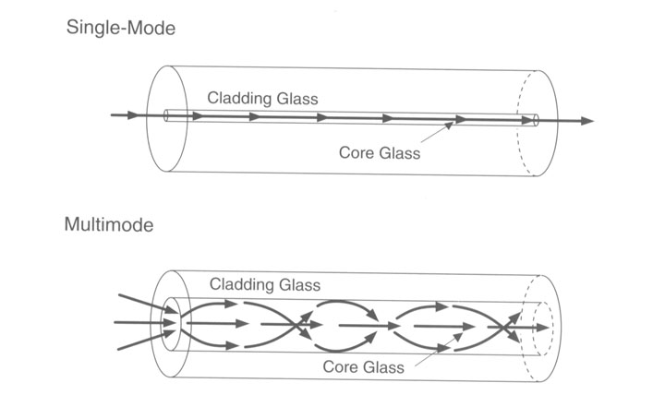

The network figure of the whole system is shown in the figure below (HQ campus ATM network)

The Nine Advantages of Fiber

• Information-carrying capacity.

Fiber optic cable offers bandwidth well in excess of that required for today’s network applications. The 62.5/125-micrometer fiber recommended for building use has a minimum bandwidth of 160 MHz-km (at a wavelength of 850 nm) or 500 MHz-km (at 1300 nm). Because bandwidth is a product of frequency and distance, the bandwidth at 100 meters is over 1 GHz. In comparison, Category 5 cable is specified only to 100 MHz over the same 100 meters.

• Low power loss.

A fiber optic cable offers low power loss. Low loss permits longer transmission distances. A principal drawback of copper cable is that loss increases with the signal frequency. This means high data rates tend to increase power loss and decrease practical transmission distances. This are the comparison with copper cable where it is important in a network, the longest recommended copper distance is 100 meters; with fiber optic, it is 2000 meters

Parameters | Copper | Fiber
Mode | Multi-mode | Multimode mode
Bandwidth (100 meters) | 100Mhz | 1GHz –100GHz
Transmission distance | 100 meters | 2000-40,000 meters
FCC EMI concerns | Yes | No
EMI susceptibility | Yes | No
Cross-talk | Yes | No
Ground loop potential | Yes | No
Weight | Heavier | Lighter
Size | Larger | Smaller

. • Electromagnetic immunity.
Fiber optic cable is a dielectric; it is immune to electromagnetic interference (EMI). It does not cause crosstalk, which is a critical limiting factor for twisted-pair cable. What’s more, it can be run in electrically noisy environments, such as a factory floor, without concern because electrical noise will not affect fiber. There’s no concern with proximity to noise sources like power lines or fluorescent lights. In short, fiber is inherently more reliable than copper.

• Light weight.
Fiber optic cable weighs less than comparable to other cable. A dual-fiber cable is 20% to 50% lighter than a comparable 4-pair Category 5 cable. Lighter weight makes fiber easier to install or pulling especially in tight placed.

• Smaller size.
Fiber optic cable has a smaller cross section than the copper cables it replaces. Again, relative to Category 5 twisted-pair cable, a duplex optical fiber takes up about 15% less space.

• Fiber Optic Cable is Fragile
An optical fiber has greater tensile strength than copper or steel fibers of the same diameter. It is flexible as shown in Figure 10—5 [AMP, 3], bends easily and resists most corrosive elements that attack copper cable. Optical cables can withstand pulling forces of more than 150 pounds–about six times that recommended for Category 5 cable.

• Cheaper
On the installed cost side, fiber optic cable and Category 5 components are comparably priced. On the life cycle costs, fiber may be cheaper in the long run. Many users have found fiber optic cable installations easier to maintain and more reliable.

• Safety.
Since the fiber is a dielectric, it does not present a spark hazard. What’s more, cables are available with the same flammability ratings as copper counterparts to meet code requirements in buildings.

• Security.
Fiber optic cable is quite difficult to tap. Since it does not radiate electromagnetic energy, emissions cannot be intercepted. And physically tapping the fiber takes great skill to do undetected. Thus, the fiber is the most secure medium available for carrying sensitive data.

    - UTP Cabling.

Twisted-pair cable is the most prevalent type of cable used in wiring new buildings. These cables come in several grades based on performance: Category 3 for applications to 16 MHz, Category 4 for applications to 20 MHz, and Category 5 for applications to 100 MHz. Each supports cable runs of up to 100 meters. A standard fiber optic cable for building use can handle applications of several hundred megahertz at distances in excess of 2000 meters. Category 5 cables required for emerging high-speed applications like asynchronous transfer mode (ATM) and 100 Mbps Ethernet, present some challenges in installation and operation

The requirement of Fast Ethernet nowadays are at least have a speed of 100 Mbps of data transfer. "CAT-5" is a UTP network cabling system. It refers to a standard defining the properties of copper cable infrastructure utilized in communications. These are the advantages of using this cable:

i) Improved Network Performance
The CAT-5 Cable Initiative will change this by restructuring how the network is set up. The new architecture will provide much improved network performance.

ii) Easier to Use TCP/IP Environment
An additional benefit to the user will be a user-friendlier TCP/IP environment. Each building will be one large network or "Virtual LAN", and users will be able to move about within that building without re-registering or reconfiguring their machines.

iii) Simplified IP Registration Process
A simplified IP registration process has been implemented as part of this project to allow users to register their own machines and receive their IP addresses immediately.

iv) Supports Future Technology
The CAT-5 Initiative will be ready to provide connectivity as the evolve of switches and Hub. It will also provide a cost effective migration path to additional bandwidth in the future.

v) Cost Savings
By utilizing Ethernet technology and existing interface cards, significant network performance improvement will realized in a cost effective manner.

vi) Improved Network Management

Network utilization is monitored and a proactive system maintenance and upgrade strategy will be employed to assure excellent network response and availability as Center needs grow and evolve.

- Local Area Network (LAN).

  - LAN Overview.

TNB Headquarters mainly consists of 6 main building that is the HQ building, NLDC, TNB Generation (TNBD), TNB Transmission (TNBT), Financial Management Information System (FMIS), and EIS (Top Management). All of these building are connected in a complete networking call Virtual LAN whereby; each of this building has their own LAN but then they all are connected in a large LAN connection which similar to a WAN connection.

LAN is a communication network that serves users within a confined geographical area. It is made up of servers, workstations, a network operating system and a communications link. Servers are high-speed machines that hold programs and data shared by network users. The workstations (clients) are the users' personal computers, which perform stand-alone processing and access the network servers as required.

Diskless and floppy-only workstations are sometimes used, which retrieve all software and data from the server. Increasingly, "thin client" network computers (NCs) and Windows terminals are also used. A printer can be attached locally to a workstation or to a server and be shared by network users.

Small LANs can allow certain workstations to function as a server, allowing users access to data on another user's machine. These peer-to-peer networks are often simpler to install and manage, but dedicated servers provide better performance and can handle higher transaction volume. Multiple servers are used in large networks such as this TNB Headquarters.

The message transfer is managed by a transport protocol such as TCP/IP and IPX. The physical transmission of data is performed by the access method (Ethernet, Token Ring, etc.), which is implemented in the network adapters that are plugged into the machines.

  - Structured Cabling System

The structure cabling system here actually follows the requirement of ANSI/TIA/EIA 568 A, 569, 606, 607 system- The commercial building Telecommunications Standard which specifies a certain level of performance. This standard was taken as a guideline for the cabling system. The horizontal cabling uses the UTP cable that is the Category 5 that has speed of 100 Mbps. The backbone itself using the Multimode fiber that runs on the ATM system.

When they install the cabling system, a few things there are few things that take into account such as;

- They uses only two of the four pair of wires available in the cable
These are meant to avoid any near-end crosstalk

- The cable are to move freely and be protected from sharp edges
Too much stress and bending can change the electrical characteristic of the cable and degrade its performance.

- The routing cables are being placed far from electromagnetic interference such as fluorescent light.

They use some sort of plastic cable to cover up the fiber and UTP. However not all of the UTP cable are being in this plastic cover. The data cables are not in the same conduit as in the electrical wiring.

  - LAN – HQ Campus ATM Network

The headquarter (HQ) here uses the ATM technology provided by the 3COM technologies. This network was drive by the ATM Q3 system, which support about 2000 notes. This actually was a Concurrent Switching, which have special features that is it’s diversity of access speeds, easy scalable and component cost can be contained. It is also an Enterprise ATM system, which provide security, wide area and multiple service choices.

The backbone system operates at the speed of 155 Mbps using multimode fiber optic as their transmission or communication media. They use the Multimode fiber because it is a lot cheaper and less complexity than other type of fiber.

As we mention before, all the LAN referring to each building are connected by a virtual LAN. Although this system seem to be disadvantages in term of their performances, but actually they are quite good. This system able to support the whole network with less trouble or traffic congestion. This is mainly because of the core ATM switch CB 7000 and the NetbuilderII router, which support the whole traffic. The netbuilder help to route the packet in the ATM system which require ATM; Ethernet; Fast Ethernet; Frame Relay; Token Ring and X.25. They uses;

- 2 ATM switch
- 7 SSII (Superstack II) Ethernet switches
- 6 LS 2700 Ethernet switches
- 5 Server
- 1 NetbuilderII Router

These are the overall view of LAN system there;

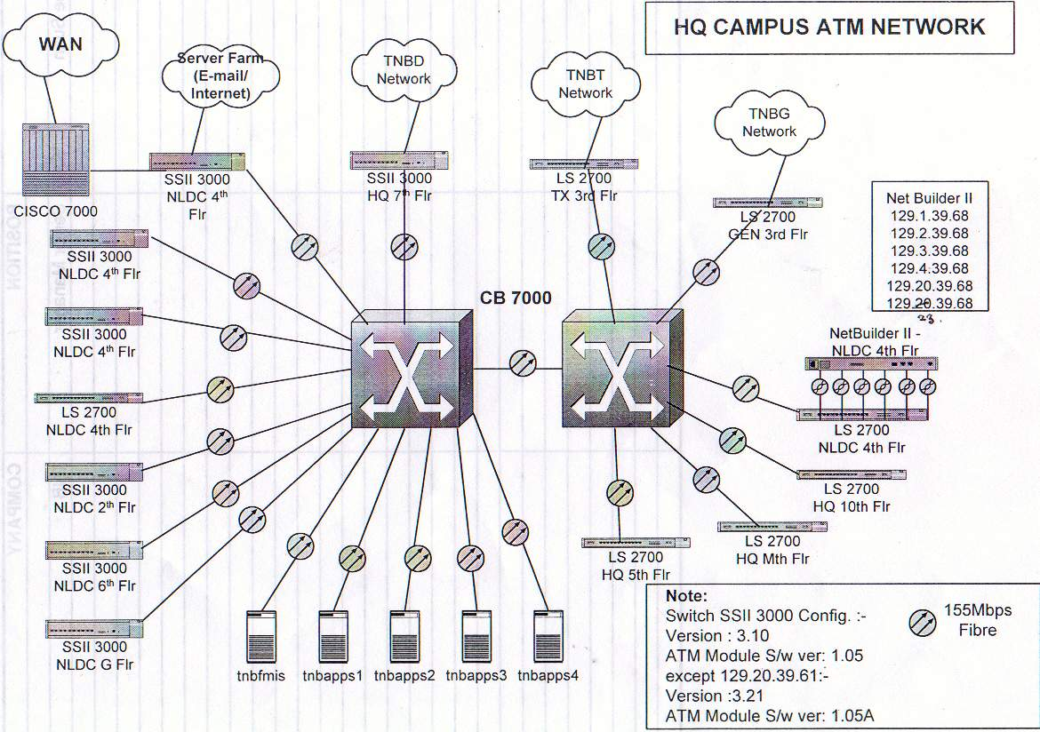

The CISCO 7000 router was use to connect to the WAN for the routing process. Before the router, there is what they call a Server Farm after the routing processes that are use for E-mail and Internet. The whole network uses 2 of the 3COM CB 7000 switch, which are able to give maximum performance to the network itself.

Both of this ATM switches act as star connection whereby all the data will be centralized and conducted by this two devices. This ATM switches being placed at the NLDC building ground floor for the reason of safety. Furthermore this ATM switch will then connect to a 3COM SSII 3000 switch as shown in the figure above. All of these switches are referring to certain floor as shown in figure above. The locations of the switches also depend on the number of user available. They use multimode fiber for the connection from the ATM switches to the normal Ethernet switches.

The switches further then connected to a hub. Normally, a single switch will be connected to a total number of 6 hubs. The normal switch that they use are normally has 12 or 24 port. However not all of these port are currently used where by an average of 6 ports are used to connect to the hubs. The other port are reserved for any future use. Another reason is that they want to prevent from traffic in the network. From this onwards they use the UTP (unshielded twisted pair) CAT 5 cables for the connection onwards. This CAT 5 is able to give 100 Mbps of data transfer. Each of these switches is assigned to each floor within certain building in the HQ.

Each of the hubs will then be use to connect to 50 nodes. Normally they may use a hub, which consist of 30 ports parallel. These nodes include PC, Printer and etc. The NIC cards that they used here are from different manufacturer which depending on the type of computer manufacturer such as COMPAC, and 3COM.

We could say that HQ here uses the Fast Internet that was also called "100 Base T," it is a high-speed version of Ethernet (IEEE 802.3u standard). Fast Ethernet transmits at 100 Mbps rather than 10 Mbps. Like regular Ethernet, Fast Ethernet is a shared media LAN. All nodes share the 100 Mbps bandwidth. It uses the same CSMA/CD access method as regular Ethernet with some modification. 100BaseT uses two pairs of Category 5 UTP.

As you can see above the TNB IT uses the class B IP address. This class could support about 10000 user or more. All of this address starts from 129.X.XXX.

The figure 3 next page shows us the current network diagram of the NLDC building.

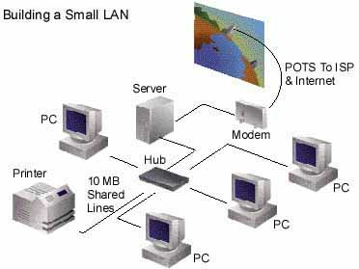
SSII 3000 Switch (12 or 24 Nodes)
3COM CB 7000 ATM Switch
Figure 3: Typical LAN technology (ATM) employed at each floor of the NLDC Offices
SERVERS
Multimode Fiber
UTP Cat 5
Workgroup with Ethernet Hub
Normal 50 nodes are attach to a single Hub
SERVERS
Certain Floor In NLDC
or Other Building
NLDC Ground Floor
Refer to different Building
Wiring Closet
UTP Cat 5
100 MB
Hub

- Hardware and Software Details

  - Cisco 7000 route

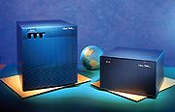

This is known as Cisco 7000 Modular Router Base Unit, 7 Slot. The Cisco 7000 network interfaces reside on modular interface processors, which provide a direct connection between the high-speed Cisco Extended Bus (CxBus) and the external network. Distributed processing is accomplished by the Route Processor (RP), Switch Processor (SP), and Silicon Switch Processor (SSP).

  - Netbuilder II Router

Product: NETBuilder II, NETBuilder II FDDI, NETBuilder II WAN Extender, NETBuilder TR
Technology: ATM; Ethernet; Fast Ethernet; Frame Relay; Token Ring; X.25
Product Family: Bridges/Routers
Product Line: NETBuilder - Ethernet, NETBuilder II, NETBuilder II - WAN, NETBuilder Token Ring

More information on this can be found at ; http://infodeli.3com.com/notes/relnotes/bridrout/8566_0.gif

  - CoreBuilder 7000HD (CB 7000) ATM Switch

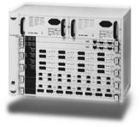

The CoreBuilder 7000HD switch is an integrated switching system for both the core and the edge of the enterprise ATM network. The 3Com CoreBuilder® 7000HD switch is a uniquely versatile, modular, chassis-based switching system that delivers high performance and high availability for both the core and the edge of an enterprise ATM network. Configurable as either a pure ATM switch or as an integrated system for both ATM and high-throughput local area network (LAN) switching, the CoreBuilder 7000HD switch provides the full benefits of ATM in the core and to connect high-speed Ethernet LANs into an ATM backbone without loss of end-to-end performance. This is the most popular platform for solving this networking challenge that normal companies are using.
This powerful flexibility allows servers, desktops, workgroup switches, and other devices to attach to a CoreBuilder 7000HD switch easily, using either the simplicity of high-speed Ethernet technology or the high functionality of ATM. The advantages of using this are;
- Flexibility: Simplify Internet working and make virtual networking practical with centralized configuration services, intuitive administration tools, and built-in fast setup wizards.
- Availability: Increase reliability and ensure nonstop networking with redundant switching engines and multiple active backbone links for load sharing and fault tolerance.
- Convergence: Integrate voice and video with data traffic over the network backbone through advanced Quality of Service (QoS) and traffic management capabilities.
- Throughput: Speed up response time for Ethernet-attached clients from distributed applications and servers that are centralized across the backbone by employing the industry’s highest throughput from 10/100 and Gigabit Ethernet to ATM.
- Scalability: Progress with ample growth potential in terms of speed, distance, and network size relying on scalable bandwidth, high port density, and multiple interface options that can be directly connected to SONET/SDH and native ATM services.

  - SuperStack® II Switch 3000 Switch

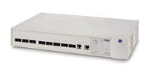
3Com® SuperStack® II Switch 3000

The 3Com® SuperStack® II Switch 3000 provide high-speed switching with unparalleled ease of installation and support, plus the added security and redundancy of fiber cabling support. It features 12 and 24 multimode fiber Fast Ethernet ports, and two autosensing 10/100 ports. This makes the SuperStack II Switch 3000 the ideal switch for interconnecting remote hubs and switches over fiber optic cabling.

The SuperStack II Switch 3000 also features an optional expansion slot. This allows them to easily add such features as Gigabit Ethernet in the future. The advantages are;

- Affordable. The 3Com® SuperStack® II Switch 3000, with one of the optional Gigabit Ethernet modules, reduces the cost of migrating to Gigabit Ethernet in the future
- Investment protection. This switch works with your existing LS2700 and SuperStack II or 3 Switch 3000 switches easy for mixing in one stack.
- Easy management. 3Com® Transcend® Network Supervisor software is included with every unit. This powerful application lets you discover, map, and monitor your network with ease
- Policy enforcement with FastIP, IGMP snooping, IEEE 802.1D (incorporating 802.1p prioritization) and IEEE 802.1Q standards-based VLANs
- Dual queues to help prioritize multimedia traffic
- Elastic port buffering for on-the-fly port buffer memory allocation, enabling automatic performance optimization based on network traffic
- Flow control to maximize performance and minimize packet loss under heavy network loading
- Automatic detection of full- or half-duplex operation on all ports to maximize performance without manual configuration

  - Transcend® End-to-End Network and Device Management Solutions

For Windows NT

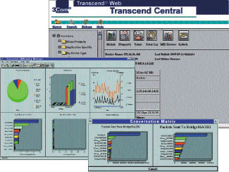

3Com’s graphical Transcend end-to-end network and device management solutions give unprecedented power for managing 3Com networking systems. From the workgroup to the data center, Transcend end-to-end network and device management solutions deliver complete system wide control for ease of configuration and administration, comprehensive monitoring and analysis, simplified control and navigation, and responsive troubleshooting.
Based on an easy-to-use interface, proactive end-to-end management solutions tailored for Windows NT environments integrate all of your 3Com device management into one powerful package. Transcend end-to-end network and device management solutions use advanced technologies such as RMON and 3ComSmartAgent® intelligent agents to reduce the administrative burden on the network and network manager, while providing innovative management features. In addition, these SNMP-compliant solutions let you manage your entire network successfully from any location, whether you are in front of the management console or working from a remote desktop with a Web browser.
3COM Transcent Network Control Center or the actual name is the Transcend End-to-End Network and Device Management Solutions gives them ;

i) Simplified Access, Control, and Navigation

Transcend Central simplifies navigation and management operations through an intuitive, easy-to-use graphical interface to provide a well-organized and customizable listing of all 3Com equipment in a network, grouped into convenient categories. In addition, inventory management activities, such as generating a detailed device report or accessing module and port information, are as easy as point and click.

ii) Graphical Device Views and Configuration
The Device View feature delivers clear, graphical device renderings that provide real-time, color-coded port status and statistics that show traffic and error loads. Depending on the capabilities of each device, clicking on a specific port brings up a window that further simplifies tasks such as setting thresholds and administering ports.

iii) Automated Network Device Upgrade and Administration
Upgrade Manager is an agent distribution feature that lets upgrades on groups of devices (bulk upgrades) as well as on individual devices. By automating this task, Upgrade Manager reduces the burden on the network management staff when multiple devices need to be upgraded simultaneously

iv) Streamlined Network Device Configuration
Configuration Manager lets you apply identical configuration settings to multiple devices with a single operation to provide attribute templates that can be associated with a group of devices. The association of the template with its devices is tracked closely, ensuring that the template will stay in sync with the configuration of any device within a given group.

v) Automatic Alarm Notification and Action on Event
The Alarm Manager feature set alarm thresholds at a device for exception notification. They can specify their own device alarms and thresholds or use default settings, including automatic notification of a fault. Using the SmartAgent Autocalibrate feature, they can automatically set alarm thresholds relative to actual traffic baselines. The SmartAgent intelligent agent in each device can be configured to take action automatically when an event occurs. They will define the type of corrective action to be taken, which can include launching packet capture or disabling a port when the broadcast packet rate exceeds a certain threshold (as in a broadcast storm).

vi) Comprehensive Network Traffic Monitoring and Analysis
LANsentry Manager is a Remote Monitoring (RMON) tool that draws on RMON data collected from SmartAgents and from SuperStack® II Enterprise Monitor to provide a comprehensive, graphical view of LAN and enterprise network activity. LANsentry’s comprehensive summary screen shows packet size distribution, top talkers, utilization, and error rates to give a detailed view of the network for current status and historical trend analysis. For distributed fault detection, LANsentry enables RMON alarms to be set, which monitor overall network health and alert the network manager of network overload or error conditions.

vii) Detailed Performance Monitoring
Status Watch optimizes network performance by letting they monitor a variety of operational parameters in real time, and configure thresholds and notification actionsThis level of detail lets you respond quickly to operational problems and fine-tune performance. For example, they can monitor the operational status of devices, as well as ports and interfaces. Also, they can graph or display, in real time or for trend analysis, the utilization loads and system metrics down to the interface/port level.

viii) Proactive MAC Address Tracking
The Address Tracker feature lets monitor and track Media Access Control (MAC) address activity for all 3Com devices on the network. For example, using Address Tracker, their can locate end stations throughout the network or group and view all MAC addresses associated with each external port interface on every managed device. In addition, MAC-to-IP address translation is provided, assisting in troubleshooting.

ix) Flexible Web-Based Management
The Transcend Web feature gives secure, effective, and easy Web-based management and control of 3Com devices from a Web browser. With Transcend Web, they can quickly and remotely troubleshoot a network and take corrective action, including the configuration of key network device parameters. This flexible feature lets they check device status, access device-specific views (with a device picture for easy navigation), and run statistics or diagnostic tests. ATM and VLAN management are fully integrated, as is status reporting

All of the Transcend End-to-End Network and Device Management Minimum Requirements are shown in the appendix behind

- Wide Area Network (WAN).

  - WAN introduction.

The Wide Area Network (WAN) in TNB is very important, as TNB is a very wide company with the offices all throughout Malaysia. There are over a hundred nodes all over Malaysia. There are many links of data to be sent and to be received. Some of the data are secret such as financial data and customer data. For this, TNB must have a very sufficient data transfer system. There are 3 main systems in TNB. The three systems are Customer Information Billing System (CIBS), File Database Management System (FDBMS), and Financial Management Information System (FMIS). Each of these computer system used by TNB are fully explained in section 7 (Technologies/Systems).

In TNB, the TNB HQ is the center of information. There are Large District Offices (LDO) and Small District Offices (SDO). There are all over 36 LDO in peninsular Malaysia. A LDO usually connected to 3 SDO - depend. TNB HQ is connected to the SDO through the LDO. For best illustration please refer to figure 6.1.

TNB HQ
LDO
SDO

Figure 6.1
Connection of HQ, LDO and SDO.

  - WAN Network Structure.

The HQ is connected to the subsidiaries and the LDO directly, or from TNB CRF located in Kelana Jaya. The main backbone is between TNB HQ Bangsar and TNB CRF Kelana Jaya. Refer to figure 6.2 next page for the WAN structure.

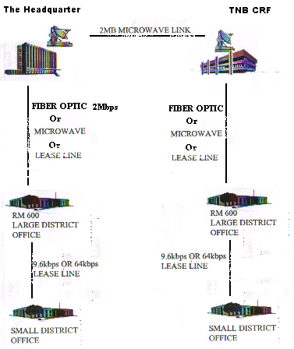
Figure 6.2
The WAN connection.

The main backbone is between TNB HQ Bangsar and TNB CRF Kelana Jaya. The connection is using satellite-microwave and the speed is 2Mbps. There are 3 types of WAN connection:
- Fiber optic (fully owned and managed by TNB).
- Microwave (provided by Celcom).
- Lease lines (provided by Telecom Malaysia).

The HQ and the LDO is connected by the fiber optics. There are also microwave lines and lease lines. The fiber optic used is fully owned and managed by TNB. So, currently TNB is using the fiber optic for cheaper cost and higher speed. The microwave and lease lines are just for backup when the fiber optic connection is down. For more stories on fiber optic in TNB please refer to section 6.3.

The LDO and the SDO is connected using the microwave and fiber optic.

  - WAN Fiber Optic Connection.

TNB is a big company with many-many branches all over Malaysia. These branches and the HQ need to communicate well. The sufficient data transfer system is required. Twenty years ago they are using Pos Malaysia as their ‘data transporter’. The connection is then developed and then the lease line is used and then microwave.

Then came the idea ‘why don’t we have our own communication system?” The electrical wiring networks are there. In fact the electrical ‘connection’ is everywhere. The poles are there, so all they got to do is just put the communication medium. They choose fiber optic as the communication so that the connection is really fast. The first fiber optic project was started in 1998 as a trial version. The connection was done in the state of Melaka. It has proven to be successful. So, from the date, TNB started to connect all the LDO and SDO using the fiber optic. By current time, all the LDO and almost all the SDO have fiber optic connection.

The fiber optics used are single mode with speed up to 2Mbps. Each fiber optic unit has a length of approximately 3.5 km and is connected to each other using fiber optic connector. The fibers travel through the electrical poles – high voltage and also low voltage lines. The pictures below illustrate the fiber optic connections.

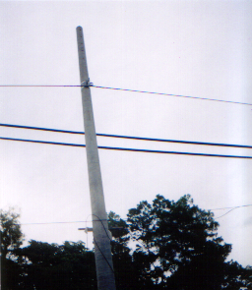
The fiber optic lines
Figure 6.3
Picture of Fiber optic at low voltage electrical pole
Note: This picture was taken near UNITEN.

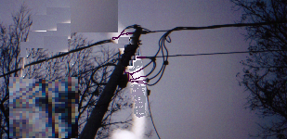
Electrical Lines
Fiber optic lines
Fiber optic connector
Figure 6.4
The Fiber optic connector.
Note: the fiber lines is connected below the electrical lines.
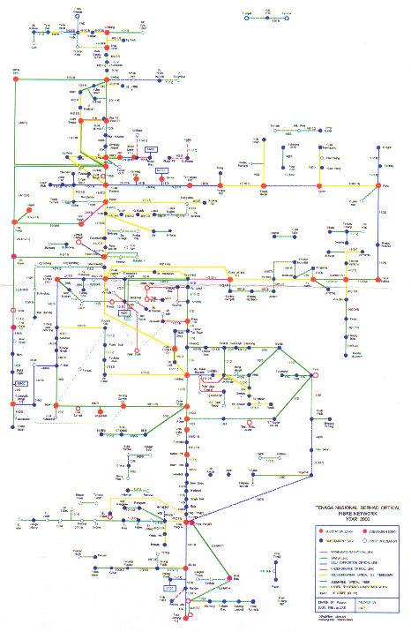
Figure 6.5
The TNB optical fiber network for year 2000

- Technologies/Systems.
  - Customer Information Billing System (CIBS).

CIBS is generally the system that TNB uses to store data of the customers. In this way, the data can be processed very fast and more sufficient.

To understand the main job of the CIBS, let study the figure below:

CIBS
MHA
RM 600 SERVER
MHB
CRM

PCs:
Customer service clerk (CSC)
Meter reader examiner (MRE)
Credit control.
Planning & building
Chief cashier
Back Room Machine
HHTs
RM 20
(counters)
Two ways
Figure 8.1

The data are stored in the RM 600 server located in the System administration room. Each TNB main office has a RM 600 server. We called the server as main head A or MHA.

There are only 5 person who can enter the RM 600 server and then chance the particular data inside the server according to their job scope. This 5 person are listed in figure 8.1 above. MRE is the chief of the meter reader. The job of MRE is to select the data from the RM 600 server to put into the hand help terminals (HHT). HHT is the small electronic kit that the meter reader carry to collect data from the service meters. The back room is the terminal where HHT can obtain data from the RM 600. After the meter reader had read the meters, the data then entered to RM 600 server trough the backroom again.

CSCs are the person who serves the customer inquiries usually located at the counters. They also handle the new application of electric power. So they enter the CIBS, check the data required from the customer and also to key in the data of the new customer.

The counters where people pay their electricity bills cannot enter the CIBS system. But they can update the payment from the customer to the system trough the CRM. The staff in the counter entered the payment data to the computer which called RM 20. At the end of each day the data must be sent to CRM, and then to the CIBS.

The chief cashier and credit control clerk handle jobs of money flowing from the payment of electric bills. For example, they monitor the money flow trough the post office or other TNB station. I.e. the customer pay their electricity bills elsewhere and the data will arrive in the original station. This is where the network is important.

In CIBS, the network system used is called Cross Station Application (CSA). CSA allow us to link data from TNB stations from all over Malaysia. Look figure 8.2 below. For example, one customer pay his electricity bill at Kuala Lumpur (KL). TNB KL will link his pay to the LDO of the original location. Another example, one customer pay his bills at Pos Malaysia counter. Pos Malaysia will save it in a disc tape then post it to Pos Malaysia’s head quarter. Computer server in Pos Malaysia will send data of the payment to the to TNB’s headquarter in Bangsar. Then using CSA the headquarter will send data to RM 600 server in LDO.
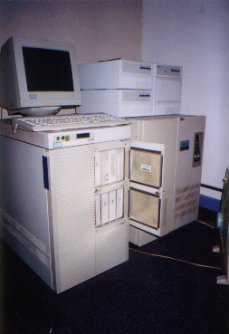 RM600 server.
Battery (as backup)
Server

Cross Station Application (CSA).

HQ Bangsar
RM 600 server
Headquarter.

MHA
RM 600 server

LDO

LDO
Large District
Office

SDO

SDO

SDO
MHB
CRM
Small District
Office

Figure 8.2

The connection from SDO to LDO are one way street. So they cannot read or chance the data from the server. Anyway they have MHB and CRM in their section. All application connection network currently using Celcom line.
Software used for CIBS.

Two main software for CIBS system are SINIX and SAP. SINIX is the software to save data while SAP is the software to pick up data from SINIX. SAP operation is like disc operating system (DOS). Please refer figure 8.3 below for best illustration.
SINIX

Figure 8.3

SAP

To avoid any data loses, the system administrator in duty will make a backup files and save it in tapes. The backup files are in compression type file. Usually, the daily backup file will cost 3 tapes and the weekly backup will cost up to 3 tapes. A backup process usually take times about 2 hours per session.
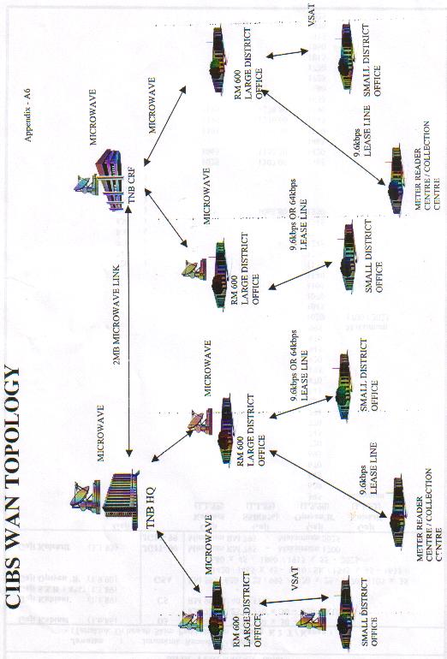

CIBS WAN Topology.
Note: the figure is an old figure without fiber optic yet.

Batch Processing System Interface (BPSI).

BPSI in simple words is like a virtual clerk that processes the data in the CIBS. In general, BPSI will process the data received from the CSA, CRM, and the backroom for the meter reader. It will control, update and automatically calculate the debit and credit for each customer after all account of the day are closed. For example, they set it in HQ to be 5 p.m. By 5 p.m. all the data needed must have been already sent to the MHA for the system administrator to operate daily BPSI. During this BPSI all the person entering CIBS must have logged out from the system to prevent any data corruption.

  - File Database Management System (FDBMS) or Electronic Database Management System (EDBMS).

The FDBMS or EDBMS is a method of storing data. The data stored are about the drawings of the 11kV lines data. The drawings are divided into two categories that is key map (geographical location) and the schematic drawings. The data are stored in the server in each district. The EDBMS is nicely designed in a web base that it can connect the servers all over Malaysia. In other words, the data in anywhere else for example in Bangi can be read from Kota Bharu.

Other than 11kV cable details, the EDBMS also contains data about the substation, transformers, switchgears, fuse, circuit breaker, and feeder pillar. All these important things in distribution medium voltage are named and numbered. For example, a transformer is named “UKM 1” and numbered ‘TX A01’. This means the transformer is connected from feeder A and there are more than one substation in Kampung Dusun Muda. The schematic diagram is drawn using AutoCAD.

  - Financial Management Information System (FMIS).

FMIS was launched in 1996. FMIS system is a system to control TNB assets all over Malaysia. There are over 1000 users all over Malaysia that can enter this system. Each of them is given a password. The software used in this system is SAP-R3 (Version R3).
Unlike the CIBS and EDBMS, which servers are located at each LDO, FMIS servers are centralized and the server farm is located at FMIS building located at the headquarter.

For safety step, the technicians at FMIS buildings make daily backup of the file in the servers into tapes. There is also a mirror server located at Petaling Jaya. The mirror server receives and saves the same data as the server at FMIS building receive. In case if the FMIS building have disaster e.g. combustion of fire, the data will be safe.

- Managing The Network.

So far the normal problem they encounter are such as the hub, fiber and UTP. These kind of problems are such as hub port not working, a hole in the fiber connection, and slow data transfer. They realize this problem by report that been made by the workers, monthly report and software. For the fiber, what they do is check the fiber manually by looking at the fiber cable to see whether there is light or not. After that they will repair it if they are capable. Whenever big problem such as ATM switch, there are three levels of step to overcome it. The levels are as below:

- In House - repair by their own workers
- Contractor (by agreement) – call the contractor to solve the problem
Principal (3COM) – main vendor that are responsible in designing and implementing the network

  - Tools.

For the time being, they do not have specific testing and debugging tool for troubleshoot even though nowadays there is many hardware device used to check the error such as the cable, fiber, and hub. Hand-held field tester or cable scanner which are available in the market nowadays are found to be useful. This devices are capable of measuring channel parameters such as attenuation, near-end crosstalk (NEXT) and pin point channel problem such as cable short or open by the built in time domain reflectometer (TDR).

  - Traffic Monitoring and Congestion Avoidance.

For the purpose of network management, they use 3COM Transcent Network Control Center software. 3Com's Core Builder High-Function Switches are key to its three-part Transcend® Networking framework for making networks easy-to-use, or “transparent” to users, as well as simpler and more cost effective to design and manage. This software is capable to trace down a network problem down to the hub, and also to measure and perform the traffic monitoring and congestion. However, this software cannot pin point the exact location of the problem. Transcend
Networking framework includes hardware and software solutions for:
- scaling the performance;
- extending the reach; and
- managing the growth of enterprise networks.

This software works by sending signal to the nodes (from ATM Switch to the hub) in the network device and then the network device suppose to give back or response to the signal as a sign of acknowledgement. The signal is send by the program every 30 second to each network node. Whenever a device fails to do so, therefore we know that there is a problem in the network device. Using this signal, they also know the current traffic and the congestion within the network which shown by percentage form.

  - Preventive Maintenance and Records.

The preventive maintenance is made during 6-month time period. This kind of preventive maintenance are such as cleaning dust in the cable, hub, switch only. However whenever a problem encountered, they have their own Maintenance records. This record was use for troubleshoot, future planning and also judging network performance.

  - Disaster and Recovery Planning Procedures.

Disaster recovery plan involve a server that being place at Disaster Recovery Center (DRC) situated in Tabung Haji Kelana Jaya Building. The current information in HQ will be sent to DRC from time to time as backup procedure. This uses microwave as their communication medium, which uses satellite or disc to direct it and pick up by the antenna at the DRC center.

- Request for Proposal (RFP), Tendering and Solution Provider Selecting.

During our interview with the personnel of the TNB Headquarters, we have known that TNB Headquarters have opened a tender for the setup of the new network implementation. At the time when we interview them they have opened the tender for the new network system and is in the process of selecting vendors. TNB Headquarters is strict in choosing their vendor in which only vendors with legal license by the government and registered with Tenaga Nasional Berhad will be chosen. They will reject immediately vendors without license and not registered with them. Other characteristics that are considered are such as; network vendor or solution provider that will provide them with the necessary solutions, equipment and a good deal (cost). There are a few general steps involve for setting a new network.

- Proposing a new network system – information about the place to setup the network, the characteristic of the new network system to be, the network capacity etc. to upper management. In this case the TNB Headquarters itself is the place to setup the new network. They have done a research about their network system and have come out with the conclusion that they will need a new network system.
- Open the tender – advertising it in the newspaper etc. Only vendors registered under Tenaga Nasional Berhad only are allowed to apply for the tender. During this process each vendor will send their Request for Proposal for selection purposes.
- Choosing the Vendor – choose the most suitable vendor to do the job with a good deal (cost) reliable network, good reputation and good Request for Proposal.
- Proposal by the Vendor – the Vendor will propose a network in the respective place, equipment to be use and cost. This includes the design and diagrams.
- Proving the network -the vendor will be given a trial by setting up the demo of their network system. Usually they will be given time limit for example 1 week to proof that their system could work. They will be given the chance to troubleshoot the network system problem until the system works.
- Installation – setting up the new network at the site: implementing the system, installing equipment, software, tests runs etc
- Creating a department – setting up a department for that place where the staff perform maintenance, troubleshooting, management and system monitoring of the network system . For the TNB Headquarters a department has been set for this purpose which is the TNB IT. Staff of TNB IT are responsible for the network system of the TNB Headquarters and also other TNB offices.

- Future Developments.

TNB have done some judgment on their network performances from time to time. These include a monthly report consist of an analysis on their network performance, a study of the capability of their transmission media such as measurement of speed and bandwidth and the level of maintenance performance. All of this contributes to the future plan that had been made. TNB will implement new network system by the end of 2001 due to several factor. There are three big reasons to build a new network and a couple of lesser ones.

The three biggest are:
- A substantial increase in the number of users on your network.
- A substantial change in the power and load of the average user's workstation
- There is no reliability and balancing in the network such as no appropriate device and method for the troubleshooting.
- New applications emerge that demand more or different network services.

Lesser reasons include:
- The fast growing of technologies in networking and application nowadays that are meant to give a more reliable business application and management.
- Making the network more manageable for changes, moves and adds
- Adding redundancy and improving reliability of the network
- Updating out-of-date equipment

The new networking system that they plan to use is the Gigabyte Internet. The purposes of the new network are
- They want to centralize or combine all the CBIS, FMIS, and FDBMS system in one big system that needs a higher networking performance.
- 3COM itself has announced EOL (End Of Life) for the old product that are currently being in use. This means that they don’t want to manufacture all of these old devices that will end up in no more expertise when there are problem occur.
- They plan to install a few new technologies such as VoIP and video conferencing

The networking technology is vast and wide. Everyday new technology is being develop and produced. There are few factors that catalyst the invention of new technologies. The first factor is the speed of the communications and data transfer. Secondly, new technologies are needed to cope with the expansion of the number of users. More users are using the network technology as more company is venturing into e-commerce and network services. Other factors are improving the current network technology.

The current infrastructure at the TNB headquarters is the technology that is used in 1996. Now is the year 2001 that is 6 years has passed since its network is first installed and implemented. By the end of 2001, TNB Headquarters has planned to implement new network system to replace the old one. There are a few factors that contribute to this.

The first factor is that 3COM, the main vendor for TNB Headquarters has announced an end-of-life notice for some of its network devices. This is because 3COM has decided to venture into new business and technology and will not produce its this type of product anymore. This is a business strategy that has been taken by 3COM. AT TNB Headquarters, about 90% of its core network system consists of 3COM devices. This means that TNB Headquarters will face with problem if it continued to use the 3COM products. This is because if a problem occurs and a device need to be changed, it may be out of stock.

The second factor is the expansion of capacity of network use and the increase of the number of users. The current network is already full loaded and could not be expanded anymore. To increase the capability of its system, TNB Headquarters need to install new network system

TNB Headquarters will issue a tender to find a new venor to implement the new network system. The new system will include gigabit ethernet. The current system only use fast ethernet technology.

- Gigabit Ethernet
The newest version of Ethernet, which supports data transfer rates of Gigabit (1,000 megabits) per second. The first Gigabit Ethernet standard (802.3z) was ratified by the IEEE 802.3 Committee in 1998. At ten times faster than Fast Ethernet, Gigabit Ethernet is the next evolutionary step in high-speed networks. Now a formally approved IEEE
standard, Gigabit Ethernet offers a natural upgrade path for current Ethernet installations, making it an attractive choice. Gigabit Ethernet combines in-depth technical knowledge with the ability to see the 'big picture'--Gigabit Ethernet as a specific technology and its relationship to other technologies.

Concept

It is fully compatible with existing Ethernet, and promise to offer seamless migration to higher speeds. Existing networks will be able to upgrade their performance without having to change existing wiring, protocol or applications. Gigabit Ethernet is expected to give existing high speed technologies such as ATM and FDDI a run for their money. The IEEE is working is working on a standard for Gigabit Ethernet, which is expected to be out by the beginning of 1998. A standard for using Gigabit Ethernet on twisted pair cable is expected by 1999.

The Advantages to Gigabit Ethernet
Gigabit Ethernet has evolved from 10base5 to 10baseT to 100baseT to 1000baseF. It is an aggregating technology that fills the void in the 2nd and 3rd thier network hierarchy. Gigabit Ethernet also provides high speed server access. By retaining both the framing and access method of existing Ethernet, gigabit is desirable as it is compatible with existing Ethernet tools and can ensure fast switching times by not having to reframe. Gigabit Ethernet is best used in non - redundant, high speed workgroups, or in smaller networks under 250 nodes.

Other technology that will be included is video conferencing, voice over IP, NIC at PABX and wireless network. The wireless network will be implemented at small buildings in the are of the Headquarters, such as the lab building to save cost of implanting a fiber optic connection.

The video-conferencing technology is allows people to have meeting at different places but at the same time. With this technology, a group of people could communicate with each other easily. The TNB headquarters will need this technology for uses such as having a between the, managers from their TNB headquarter to others at TNB offices. This will ensure direct meeting between each manager and decision could be make.

VOIP?
VOIP (voice over IP - that is, voice delivered using the Internet Protocol) is a term used in IP telephony for a set of facilities for managing the delivery of voice information using the Internet Protocol (IP). In general, this means sending voice information in digital form in discrete packets rather than in the traditional circuit-committed protocols of the public switched telephone network (PSTN). VOIP, now used somewhat generally, for sending voice (audio) and video using IP on the public Internet and within intranets. In addition to IP, VOIP uses the real-time protocol (RTP) to help ensure that packets get delivered in a timely way. Using public networks, it is currently difficult to guarantee Quality of Service (QoS). Better service is possible with private networks managed by an enterprise or by an Internet telephony service provider (ITSP).

A technique used by at least one equipment manufacturer, Netspeak, to help ensure faster packet delivery is to ping all possible network gateway computers that have access to the public network and choose the fastest path before establishing a TCP socket connection with the other end.

Using VOIP, an enterprise positions a "VOIP device" at a gateway. The gateway receives packetized voice transmissions from users within the company and then routes them to other parts of its intranet (local area or wide area network) or, using a T-1 or E-1 interface, sends them over the public switched telephone network.

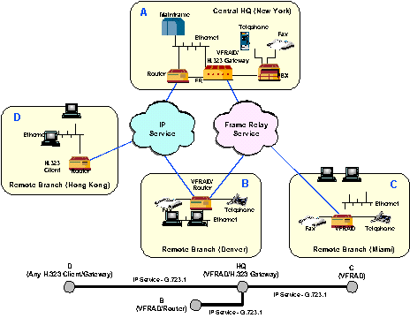

Figure 11.1

A combination Network using a VOIP and VOFR

Advantages of VOIP!

VoIP realizes a better workload of the bandwidth. In an analog telephone network, voice is transmitted at a frequency of 3.1 kHz. Even in ISDN only 8 kHz (64kbps) is available for telephony, but since a telephone connection has sufficient quality at 5.3 to 6.4 kbps, the rest of the bandwidth is more or less wasted. Transmitting voice over data lines (VoIP), however, enables several voice connections on one line—called the multiplex process—resulting in a better workload of the bandwidth.

Standard Phone Speech  64 Kbps | G.729  Compression  8 Kbps | With IP  Overhead  17.5 Kbps | Silence  Suppression  7 Kbps | 25% Duty Cycle Over a 15- to 20- Minute Interval  1.75 Kbps
Table 1: Showing the bandwidth for the standard phone and with IP

Because all participants are connected to the data network, the telephone costs fall back to the fees for the data network (such as the Internet). These advantages have the greatest impact with long-distance calls conducted over an already existing data network, such as the intranet.

Beside cost savings, VOIP does, however, offer other advantages:
- The systems are easy to expand in a nearly unlimited number of ways. This expansion can occur on the one hand by expanding the network, or by adding additional ports to the VOIP gateway as needed.
- A standard computer process the voice data—in data format—can be easily. Calls can be chopped up, and messages from the answering machine or voice mail can be saved or forwarded.
- The features of VOIP-based PBX are realized in the software, meaning that additional features—such as conferencing, forwarding and answering machine—can be implemented without great expenditure.
- PC-based PBX can be designed and implemented with standard PC components, resulting in enormous price advantages over the conventional method.
- One single network topology for the local network is sufficient for wiring an entirely new office. Additional telephone wiring does not need to be considered.
- Not to be forgotten is the simple configuration of the system via the network. Existing resources—such as the graphical user interface or Simple Network Management Protocol (SNMP)—can just be applied to the task at hand.

Wireless communication is the transfer of voice and data either in analog form or digitally across a wireless network. The data is transmitted through radio waves throughout the network. Wireless LAN uses access points. These access points is much more cheaper than implementing fiber optic cable.

Other essential ingredients that make up the wireless network are the satellites, PSTNs, MSCs, base stations, and the more familiar gadgets such as the mobile phone, laptop computers, palm tops and modems that we carry around with us every day. It can be clearly understood that all of these hardware offers users one thing, that is – MOBILITY. In a nutshell, a wireless communication system provides TNB Headquarters with the network wireless access between its building.

With the implementation of the new network system, the TNB Headquarters will be able to solve some of its network problem and increase its capability to adapt to future expansion.

- Our Comments.

  - Comments on This Network.

It is hard to comment on this well designed network whereby this network was design by those brainy and expert from the 3COM technologies. We could only comment on the network management since it is so obvous.
The network management regarding the preventive maintenance is poor whereby there no technical aspect involved. There current procedures are only involved cleaning dust. They don’t perform network testing such as cable testing, end-to-end power measurement, electrical specification and performance and leakage error.
A simple method that we suggest is ‘Life Performances Indicator and Checklist ’ whereby, the following steps are;
- Record keeping of cable or network devices damages. This includes damages such as hole in cable and etc.
- Trouble shooting record keeping clearly determines step to be taken when an error occurs
- Gathered damage information in more suitable presentation method such as graph.
- Analysis of problem source and preventive taken
- Find the correct guidelines and random error location.
- A checklist be made whereby it include error detection and solution. As an example, a schedule being made whereby at a certain time of period, a location such as patch panel, cable connection and etc being check by workers.
- Continuous improving of the preventive maintenance.
Gathered damage information in more suitable presentation method such as graph.
Record keeping of cable or network devices damages and solution
Analysis of problem source and preventive taken and correct guidelines and random error location
A checklist be made whereby it include error detection and solution
( eg: 3 month )
Continuous
Improving
Preventive Maintenance

  - Problems Faced When Doing This Research Paper.

During the process of doing this research paper we have encountered some problems. Some of the problems could be solved and some could not. The problems that we encounter are as follows:

- Difficulty to get an interview with the TNB headquarters personnel .- Firstly, we have the difficulty of setting the time of the interview. The personnel that we wanted to interview is always busy. We have to call the office for a few times But we managed to get an interview. During the interview, we could not obtain much information. We also have to go interview a few times and interview different personnel. This is because of different expertise such as, one person is expert in WAN system and the other is expert in the LAN system.

- Don't understand about the network technical jargon and material - during the research there are many technical jargons that we do not know. We also have to understand each information that we receive and digest it before writing the report on the Research paper. To solve this problem we have done research on the internet and refer to books and lecture notes.

- Don't get enough information - The company has its rule and regulations where some of its information cannot be made known to the public. Such document is the Document Control Copy(DCC) such as the Request for Proposal and detailed design of the company's network system. During the interview we could not obtained a more detail explanation on the network system. This is because some of the information are just an overview and general. To solve this we have to do some research on the internet. For example, we are not given the specification of the Cisco 7000 router. To obtain more information about Cisco 7000 we have to find it in the internet.

  - Build a Network

Of course! All the process of building a network system is referred or bounded to the budget, time, current technologies and requirement. However this may be the step that we should consider to follow if we were to design the network

- Survey the network location. Who is going to use it? For what application they are going to use for? How many users (assume the max user). ?etc.
- Gather the network rib managers' and system managers' connectivity requirements.
- Seek and reach out to all the major vendors such as 3COM, CISCO, Microsoft (CERTIFIED PROFESSIONALS), Bay, and network solution provider for advice and clues. This may cover all the network topologies.
- Meet with FMD to plan installation around their activities.
- Develop Request for Quotation (RFQ) for procurement of cabling services.
- Cable contractor survey.
- Final planning meeting with cable contractor, rib and network managers.
- Start installation.

- Summary / Conclusion.

The review of this research paper proven to be very knowledgeable and useful in the area of data communication and network especially on the network analyzing part. Whereby, we use our knowledge learned from Data Comm. & Network EECB 423 and apply them in our research project analyzing the network they have been using in practical term and point of view. There is no right or wrong in Data Communication & Network installation. But there is always room for upgrading and expansion.

In this research paper, we have learned the overall network infrastructure and the network applications. the network topology of the TNB Headquarters is a ring topology. We have also known the network capacity, expansion and scalability. We have also touched on the physical devices of the network such as routers, switches, hub and NIC cards and the communication medium that is used such as fiber optic cabling and UTP cabling. We have also learned about the LAN system. that is used at the HQ. and ATM network. We have also learned about the hardware and software details that are used in the system such as Cisco 7000 router, Netbuilder II Router, CoreBuilder 7000HD (CB 7000) ATM Switch, SuperStack® II Switch 3000 Switch, Transcend® End-to-End Network and Device Management Solutions.

The overview of how a company manages the network could be seen by the Tools,Traffic Monitoring and Congestion Avoidance Preventive Maintenance and records, Disaster and Recovery Planning procedure. From the research we have also learned about Future Planning of Network system that will be used by the company.. Lastly, we have given our comment on the network and give our own views about the network that has been implemented there.

- References.

An Introduction to Parallel & Distributed Computing, 2nd Edition, Joel M. Crichlow , Prentice Hall Europe , 1997.

Communication Networks – Fundamental Concept and Key Architectures, Alberto Leon Gracia & Indra Widjaya, McGraw-Hill, 2000.

La Info Netica, Compact Disc, Dr. HS Ong, 2000.

Dictionary of Contemporary English, 21st edition, Longman Group UK Limited.

TNB Annual Reports.

http://www.cisco.com

http://www.webopedia.com

http://www.whatis.com

Class notes and ‘nicenet’ conferencing site on http://www.nicenet.org.

- Glossary.
10BaseT - Ethernet specification for unshielded twisted pair cable (category 3, 4, or 5), transmits signals at 10 Mbps (megabits per second) with a distance limit of 100 meters per segment.

Asynchronous Transfer Mode (ATM) - A network protocol that transmits data at a speed of 155 Mbps and higher. It is most often used to interconnect two or more local area networks.

Bit - Short for binary digit, the smallest unit of information on a machine. The term was first used in 1946 by John Tukey, a leading statistician and adviser to five presidents. A single bit can hold only one of two values: 0 or 1. More meaningful information is obtained by combining consecutive bits into larger units. For example, a byte is composed of 8 consecutive bits.
Graphics are also often described by the number of bits used to represent each dot. A 1-bit image is monochrome; an 8-bit image supports 256 colors or grayscales; and a 24- or 32-bit graphic supports true color.

Byte - Abbreviation for binary term, a unit of storage capable of holding a single character. On almost all modern computers, a byte is equal to 8 bits. Large amounts of memory are indicated in terms of kilobytes (1,024 bytes), megabytes (1,048,576 bytes), and gigabytes (1,073,741,824 bytes). A disk that can hold 1.44 megabytes, for example, is capable of storing approximately 1.4 million characters, or about 3,000 pages of information.

Client/server - Client/server describes the relationship between two computer programs in which one program, the client, makes a service request from another program, the server, which fulfills the request.

Database - A database is a collection of data that is organized so that its contents can easily be accessed, managed, and updated. The most prevalent type of database is the relational database, a tabular database in which data is defined so that it can be reorganized and accessed in a number of different ways. A distributed database is one that can be dispersed or replicated among different points in a network. An object-oriented programming database is one that is congruent with the data defined in object classes and subclasses.
Databases contain aggregations of data records or files, such as sales transactions, product catalogs and inventories, and customer profiles. Typically, a database manager provides users the capabilities of controlling read/write access, specifying report generation, and analyzing usage. Databases and database managers are prevalent in large mainframe systems, but are also present in smaller distributed workstation and mid-range systems such as the AS/400 and on personal computers. Structured Query Language is a standard language for making interactive queries from and updating a database such as IBM's DB2, Microsoft's Access, and database products from Oracle, Sybase, and Computer Associates.

Ethernet - A local-area network (LAN) protocol developed by Xerox Corporation in cooperation with DEC and Intel in 1976. Ethernet uses a bus or star topology and supports data transfer rates of 10 Mbps. The Ethernet specification served as the basis for the IEEE 802.3 standard, which specifies the physical and lower software layers. Ethernet uses the CSMA/CD access method to handle simultaneous demands. It is one of the most widely implemented LAN standards.
A newer version of Ethernet, called 100Base-T (or Fast Ethernet), supports data transfer rates of 100 Mbps. And the newest version, Gigabit Ethernet supports data rates of 1 gigabit (1,000 megabits) per second.

Fiber Distributed Data Interface (FDDI) - A network protocol that is used primarily to interconnect two or more local area networks, often over large distances.

Gigabit Ethernet - An Ethernet protocol that raises the transmission rates to 1 Gbps (gigabits per second). It is primarily used for a high speed backbone of a network.

Network Interface Card (NIC) - A board that provides network communication capabilities to and from a computer.

Repeater - A device used in a network to strengthen a signal as it is passed along the network cable.
RJ-45 - Standard connectors used for unshielded twisted-pair cable.

Router -A device that routes information between interconnected networks. It can select the best path to route a message, as well as translate information from one network to another. It is similar to a super intelligent bridge.

Terminator - A device that provides electrical resistance at the end of a transmission line. Its function is to absorb signals on the line, thereby keeping them from bouncing back and being received again by the network.

Thicknet - A thick coaxial cable that is used with a 10Base5 Ethernet LAN.

Transport protocol - A communications protocol from the transport layer of the OSI network architecture, such as the Transmission Control Protocol (TCP) or the User Datagram Protocol (UDP).

Twisted-pair cable - A type of cable that consists of two independently insulated wires twisted around one another. One wire carries the signal while the other wire is grounded and absorbs signal interference. Twisted-pair cable is used by older telephone networks and is the least expensive type of local-area network (LAN) cable. Other types of cables used for LANs include coaxial cables and fiber optic cables.

WAN (Wide Area Network) - A network connecting computers within very large areas, such as states, countries, and the world.

Nicenet conferencing homepage.
TNB annual report 1997
Source: TNBD staff Bangi.
Rahsia menuju Kejayaan by Wan Mohd Zahid Wan Nordin.
Some SDO are too far from the town that they don’t have fiber optic connection. So, these SDO used lease lines.
A system administrator is the person in charge to operate and maintain the CIBS.
The customer can also pay their electricity bills to post office and other agents.

