EKG
BEST BILLIARDS
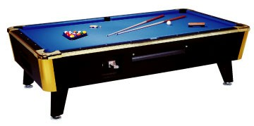

1332 BETHEL ROAD
COLUMBUS, OHIO 43220
614.273.0497
bbilliards.com

Tuesday, July 28, 2026

To whom it may concern:

This is a letter written for the purpose of recommending Scott Bosley as a database programmer. The following is a list of tasks he has done for us that has resulted in an increase in organization, revenue, and efficiency of operations:

- Altered our website, giving a more appealing visual effect and adding features not available before.
- Marketed our company on the web, attracting new sales referrals.
- Designed a database that we use to track customers and sales.
- Designed mail merge functions in MS Word we use to send mass mailing to current and future customers.
- Educated us with MS Office related skills.
- Upgraded one of our machines from 2 gig 24mb RAM to 20 gig 64mb RAM.
- Reinstalled MS Windows OS on several machines.

You are welcome to call anytime should you have any questions regarding the abilities of Mr. Bosley.

Sincerely,

Thomas Ryan
VP Sales Manager – Best Billiards, Inc.
Email: thombilliards@yahoo.com
Phone: (614) 263 - 3728
Work Phone: (614) 273-0497

