Reminiscences

by

Dennis DeCoste



REMININSCENCES BY DENNIS DECOSTE

INTRODUCTION

I thought you might be interested to know that there was life before the 'rats'. I got a sudden inspiration, after about ten snowstorms one winter, that underneath all that snow there was history. So here are a bunch of reminiscences that I jotted down on those stormy days.

The following is not intended to be a history lesson, rather it is an account of stories that I, Dennis DeCoste, and my brother, Benedict, have heard over the years from the people we grew up with. I feel that the failure to record such stories would mean the loss of some very fascinating pieces of folklore.

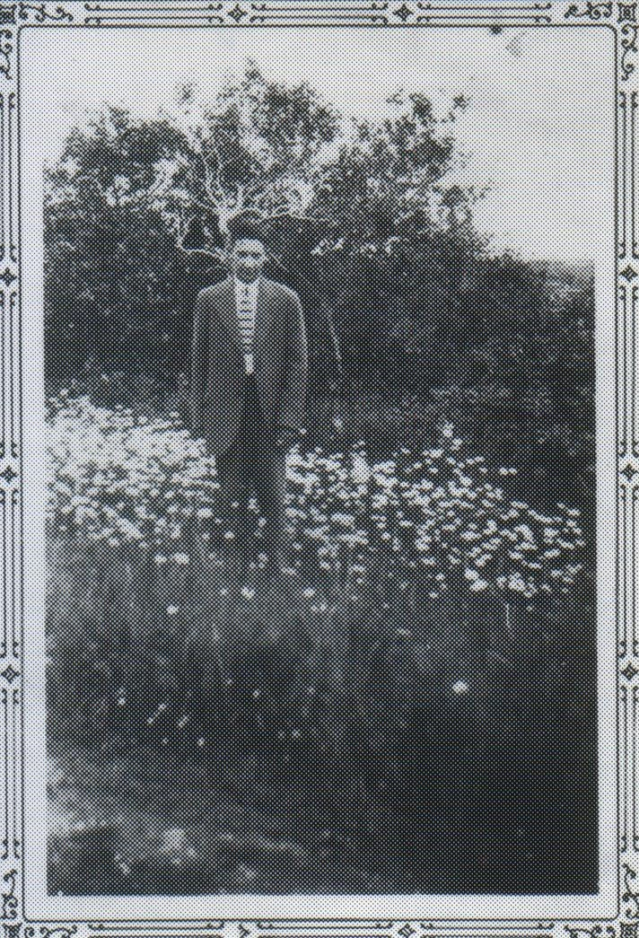

Having been orphaned early in life, I never thought much about my ancestry until the subject of ancestry became interesting. The Coties were historians of local history. There was Mrs. Joseph Delorey, her brother Michael and two Cape Breton Coties, Lauchie and Dave. When Lauchie heard my name and who I was he seemed to know all about the family. "You are a direct descendant of Captain Paddie Coste who sailed out of Arichat to the South Seas" he said.

Captain Paddie was no ordinary Captain, as there were hundreds of vessels in these parts and so hundreds of captains. He sailed square-riggers around the Horn. He was a big man with a big reputation. If you weren't the hardest man on the ship in those days you weren't the Captain. Somewhat like the fastest gun, I guess! A lot of vessels stopped at Arichat then; fishermen, rum runners etc. There were also a few jealousies. One day as Paddie walked toward his vessel, one of the other Captains said to the gang of sailors hanging around the wharf, "Captain Paddie may be the hardest man on his vessel, but I'll show him he's not the hardest man on this wharf." Paddie had heard about the boast so he was ready. There was a big wharf timber laying on the ground, 1 foot square and 30 feet long; it must have weighed close to half a ton. Well, when Paddie saw the other guy coming near he bent down and picked up one end of it and sighted along the edge to see if it was straight. "Looks straight to me, you look at it", he said, tossing the timber to the other man; it threw him to the ground and near killed him. "Anyone else", says Paddie; there wasn't.

The Costes were a seafaring family as far as we could gather from the older people. We often heard about John Bison, our great grandfather, but we didn't know how the name came about until a few years ago. Augustus Levangie asked me if I knew what the name meant, as nick-names used to be a touchy subject with most people. "I don't know", I said, so he got telling me about his grandfather and old Peter Brow reminiscing about their sailing days, and according to them John Coste was so stubborn they called him the 'Bison'. He was first mate on a vessel that went aground on a reef about a mile from shore. All efforts to launch a boat failed as they would get smashed in the breakers before anyone could get into them. John Bison started to undress and the Captain (I never heard his name) asked him what he was going to do. John told him that, as there was no hope of being rescued, he would try swimming; and as he was a very good swimmer he might make shore. The captain then passed him his gold watch and said, "If you get saved, would you give this to my only daughter", and John Bison said, "the only weight I'm going to carry are my drawers as the least weight may slow me down." Then he left, he and the ships dog, with the dog ahead. The dog struck a sharp ledge that probably saved John’s life, as the dog was bleeding John was able to see the worst edges. Well John Bison made it, but he never went back to sea. At about that time the name changed from Coste to DeCoste, I never heard why, but of course most French names changed too. I never gave it too much thought. From then on the family were cooks and cooked on the railroad and Western Union; later Father had cooked for Bridge and Building, as far as I can remember.

Everybody in the country had a little farm and the women of the family had to do the farm work while the men were away at work or at sea. Late fall when the snow and ice came, most work stopped and the men came home; they cut and hauled the firewood, cut logs and got them sawed for whatever repairs and additions that were needed, and if they got a break in the weather they ploughed the ground and got things ready for an early garden. Every year we had a small piece of land, about half an acre, where the wood had been cut and the brush burned. The stumps were still there but holes were dug with a hoe and potatoes were planted in them. Everything possible was done by hand as horsepower was scarce. We see pictures of the developing countries, compared to us they are amateurs. We had to contend with six months of ice and snow and clear the forests in land that was half rock and these had to be cleared. Where the ground was very stony, as it is where we live, so many stones were picked that our gardens were lower than the ground around them. The whole family had to pick stones that were hauled away. As there was no good bug poison the bugs were picked by shaking the plants over the side of a bucket than you poured hot water in the bucket to kill them. As soon as we were able to walk we were taught to do something useful; pick berries, stones, or potato bugs. I remember stone walls that were used as fences, hundreds of feet long; most of these have since sunk into the ground. As far back as I can remember we were poor, although I was not aware of it, as we did not see enough of the outside world to make comparisons.

We had been a family of nine boys, the two oldest having died in infancy. So I just remember when we were seven: Thomas, Arthur, (I, Dennis), Berchmans and Benedict. The two youngest, Malcolm and Gerard were sickly. Malcolm was three or four but we knew he would never walk; Gerard, the baby, would never talk, he had what I think they call a cleft palate. I don't know if we were ever told this or if we just felt it. Mother was not strong, she had to work too hard, as none of us were big enough to help with all the work that had to be done, and father was away working all the time. There was the crop to look after, besides cooking, washing and mending for us. In winter (and they all seemed to be bad) Father shoveled snow on the C.N.R. That took dozens of men as it was quite common to shovel snow that was over the telegraph wires. The ploughs would get stuck and then the ploughs and engines would have
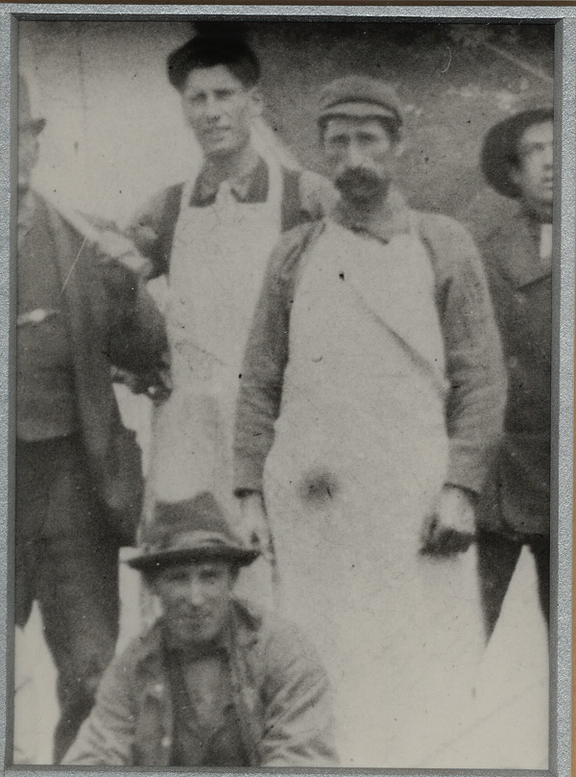
Left: Father, Patrick
Right: Grandfather, Alex (circa 1905)
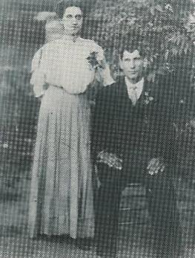
Margaret (nee Muise) and Patrick (circa 1905)

to be shoveled out, sometimes Father was out all night; then when he came home he would make us something to eat as Mother was mostly sick in bed. Those were the years of the old time flu that struck at the end of WW1. People died like flies. Grandfather, Mother and the two younger boys died that year (1920), (Malcolm at 10 months and Gerard at three years old). Mother had known she would not live much longer so she tried to find homes for us. I was placed with an old couple (Mr. and Mrs. Jerry Delorey); mother had known their daughter in Boston, which was where she and dad had got married and where the older children were born. Two of the other boys Arthur and Benedict were placed in an orphanage in Halifax, as Sister Jean Berchmans would keep an eye on them (she was Dad's sister and was cook at Mount St. Vincent Convent and Orphanage in Halifax). Father was in poor health then, and no wonder, he must have been desperate with a family to look after and not able to go out to work. I was the only one away so far. Well, the story goes that he had known this woman in Boston, Kitty Blake, and she had been very much in love with him. So he wrote to her and explained his predicament. Well, she must have been wonderful. She came down and they got married and she took over the responsibilities of the family for a period of three or four years until Father died (around 1922). She looked after Dad and fed the family. She must have had quite a bit of money as when Dad died there were no debts on the farm. She then took Thomas and Berchmans with her to the States and they lived there and brought up families until they both died. Tom, who died in about 1950, had one son. John Berchmans was a chef in a turnpike hotel and raised eight children.. He died in a fire while trying to rescue a friend he worked
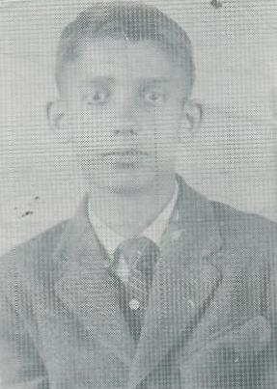
John Berchmans at 16
with. Arthur grew up with a family in Cape Jack, N.S., and later moved to Montreal where he raised a family of three boys and two girls. He was an airplane technician and worked on hydraulics at Canadair till 1945. He started a family business in Montreal selling and servicing chain saws, snow blowers and lawnmowers, etc. He died in 1989. Benedict was later adopted by a couple in East Tracadie, which was next door to where I was adopted, and it was a nice change as we grew up together and have stayed pretty much together every since.

To get back to my life with this old couple, Mr. and Mrs. Jerry Delorey, they were good people who had their share of hard knocks. Their daughter lived with them for awhile until she got married and left. It was lonesome for a kid used to a family. My main job was to take the cows to the pasture in the morning before school and get them back at night, a distance of two miles round trip. This took me on top of the Linwood hills and from there I could see my old home where I had left my brothers, Father, and my dead Mother who I missed dearly. I would sit there and look at the house, five miles away, and I'd cry until I had to leave so that I wouldn't be late for school. Being late was unforgivable. The rules were hard, but they seemed to be the same for everyone.

It was then the rule for older couples with a home to get a young
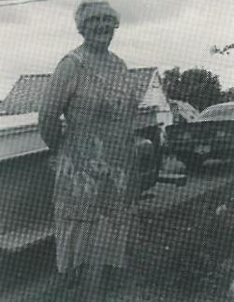
Bertha Pettipas (mid 1980's)

couple to move in with them and look after them till they died and so inherit the home. As I was too young for that the old folks made arrangements with Willie and Bertha Pettipas (she was a Gerrior by birth) to look after them. They got a home, but at a price. It wasn't easy to please an old couple in their own home.

For me it was a wonderful change. They were the parents I had never been able to enjoy. They used me like one of their own. I worked hard but I always felt it was a privilege to grow up with people like that. I learned to survive; they seemed to know everything. We had a small farm with cows, horses, sheep, pigs and hens. I learned to fish herring, cod, lobsters and clams. We cut logs, firewood, posts and poles for fences. When I think back it seems we were poor people with more of the good things than the rich. They could take the wool off a sheep and turn it into socks and mitts or weave it into real nice cloth that they call homespun. We took the beef hides and tanned them into a nice golden colored leather. The big ones for harness leather and sole leather half tanned. Smaller hides for shoe laces, skate straps, horse reins and the like. Calf hides were mostly used in shoes, mitts and hand bags. I worked with Bennie Pettipas, Willie's brother, at this. We were never idle, as just getting ready for tanning was a months work. First we would get in touch with someone who was cutting hemlock logs. Then we would go there and cut the logs into four foot lengths and peel the bark off. Then we would haul it out of the woods on a wood sled with horses. We needed about a cord of this bark, 128 cubit feet for the season. These sheets of bark, about four feet square, were made into wigwam like tents to dry. When dry, in about two weeks, they were piled inside to make them nice and flat. Then we peeled the rough outside off them (as this spoiled the color of the hides) with draw knifes. Next, we would chip this bark by rubbing it on an upside down plane with a big wooden tub under to catch the chipped bark. It took about two barrels of this chipped bark to tan an average hide. When the weather got fairly warm and after the crops were in the ground, we would start on the hides. First the hides were packed in big tubs made by cutting a pouncheon or hogshead (large barrels which held about 200 gals.) in two, then a layer of hide and a layer of lime (home burned) were placed inside. After a couple of days when the hair would loosen, the hides were taken out and the hair scraped off using big glass-like draw knifes. This was done over a big round surface and you would also get out any lumps in the hide such as those made by the hipbones. After the hides were stretched and flat they were trimmed of any rough edges and were ready for coloring, which was done by packing a small amount of bark packed between the layers of skins. It seemed the only way to get a uniform color. Most hides were a dull red. A few were colored a golden yellow by using oak bark. When black was desired, lampblack was used. The whole tanning process took about three months and was fitted in with all the other farm work. When the hides were tanned they were rubbed with three coats of dogfish oil. There was no way you could sneak up on a person after you had been doing this; they would smell you before they could see you.

I often wonder if there was anything those people could not do. They seemed to be good farmers, fishermen and woodsmen. They built boats, made their clothes and footwear, and in winter ice fished eels, smelts and sea trout. I remember one stormy day being bored as they would not let me go fishing, and I wanted a change for supper. The old man sent me to get a big barn door and showed me how to prop it up about a foot off the ground, then we put a bag of hayseed on the barn floor underneath it. Then hundreds of snowbirds would come and when about thirty or forty or so were under the door I would pull on a string to trip it and in no time we had enough for supper. They were bite size little tidbits but they were a nice change. Snowbirds have since disappeared. They seemed to feed on the seeds in the manure from our hundreds of horses. When we changed to trucks and tractors it may have spelled doom for a lot of birds. We always took time off and picked berries and cherries to preserve for the winter. We also picked elderberries, sarsaparilla and choke cherries for wine. We picked hazelnuts and ripened them in the haymow for Christmas. In spring we raided seabird nests and enjoyed different flavored eggs. In the fall we hunted wild ducks, partridge and rabbits. I also got to be a good big game hunter over the years. I likely bagged about fifty moose and maybe one hundred deer and none of these were wasted. My friends were never without meat when I had any, and the woods were full of meat. I often counted twelve moose in a yard and might pick out two. I've seen twenty-five deer in a day in Cape Breton and got two, it was all I needed. The moose have died off where we live. At the same time our dogwood has disappeared. Cape Breton is full of dogwood and full of moose, so hunting and pollution is not always to blame.

I never enjoyed hunting for fun, it was mostly for survival. I prided myself on being able to survive when lost. I remember once I had nothing to eat until Benedict would come in with supplies for the camp. I went out and found a porcupine's tree and tracked the porky to where he was feeding. I skinned him and roasted him for dinner. Delicious! I could also have had rabbit but never in all my life did I or my family ever come near being hungry.
There are hundreds of things that come to mind about the changes over the years. When I worked with Bennie Pettipas, it could be compared with trade school. First, there was the main barn that had a space for the cows and younger animals, about twenty of them. Nearby was a big haymow for about thirty tons of hay, mostly clover. Then there was a section for the horses' four stalls and a haymow for about ten tons of Timothy hay, best suited for horses. Last, there was the sheep section for a total of about thirty sheep and lambs with storage for about ten tons of finer hay (brown top). Next, in a sheltered yard was the pump house and water had to be pumped by hand every day for these cattle. Then there was the blacksmith shop about 20x24. That's where all repairs were made, the horses shod, wagon wheels and sleds fixed. Bennie could make a pair of skates, a boy’s sled or ice creepers. Next there was the wagon shed; inside were a big double sleigh with three seats, and the riding sleigh that sat two. Then there were truck wagons, tip cars, mowers, rakes and the land roller. There was also a place to do whip sawing and carpentry and there were tools to make barrels. There was also a stock of lumber both soft and hardwood to replace anything that broke. I helped to make a coffin and rough box for a neighbor who died. Bought caskets did not get common until 1950. The first one I ordered for a neighbor cost $60. I often acted as undertaker. You didn't think about it you just did it. When I'd give a haircut or a shave the corpse seemed pleased; I never asked questions. To get back to the farm, there was a woodshed big enough to hold two years supply of wood and store a lot of the gear needed around the farm. There was the feed and pots for cooking potatoes, as most of the pigs were fed potatoes mixed with oats and barley. We mostly dug eighty to one hundred barrels of potatoes. Then there was the henhouse and that was a fair sized building. They kept usually about forty hens and sold the eggs to pay for tea, sugar, tobacco and a few other things they couldn't grow. We kept a rooster with the hens and there was no shortage of clucking hens that wanted to set. A hen could set and hatch out 12 to 18 eggs depending on the size of the hen. Paul said he had a rooster (a Shure Hatch) that couldn't be duplicated.



Then, last but not least, there was the little shack out back. The old man told me about digging a well about twenty-five feet deep and ten feet wide. There was a little water in it but not enough for farm use so they put an outhouse over it. Apparently it was very popular with neighbors who liked the echoes and sound effects.

The amount of feed and food needed on a family place (it could hardly be called a farm as we only raised our own needs and enough to feed the stock) was at least forty tons of hay, and one hundred and fifty bushels of oats and barley. Some of this was ground for oatmeal, hulled for soups and we also grew wheat for flour; I remember it was ground at Beauly, a distance of twenty miles. Also needed were a barrel of pork, one of beef, one of cod, half a barrel of herring, half a barrel of salt onions, pickled beets, chow and three or four barrels of flour (depending on the family). Ella's mother, Mary Ellen, kneaded a barrel of flour every two weeks and her father, Hubert Myette, bought a half a carload, 24 barrels, of flour at a time with his brother Abraham who was a merchant. We mostly had about fifty to one hundred barrels of turnips, most of which were used for stock feed. These had to be cut up so the animals wouldn't choke on them. We also picked wild apples, which we cooked and mixed with oats and barley for the pigs. How we found time to do all these things I can't remember, and we call them the good old days.

Around 1928 I started fishing lobsters, then 3 1/2 cents a pound for canners and 5 cents a pound for market lobsters (one pound average). These were shipped alive to Boston by boat. It was hard work and I was just using a rowboat, but it was better money then working for the packers at $1 a day. They found me a good man so I got $30 a month. They called those years the Hungry 30's out west. Well for us, we didn't get hungry as we were self sufficient, but most of us had a cash income of less than $100 a year but everything was according. One hundred pounds of sugar was $2, overalls $1.50, and tobacco was 5 cents a package with enough papers to roll about twenty cigarettes. About 1935 I remember going to the store in Monastery and asking Sam Gundor if I bought a $10 order, would he drive me home in his car and he said "sure if it's cash". Well I got a 100 pound bag of flour, 20 pounds sugar, 10 pounds lard, yeast, baking powder, a pair of overalls, 10 packages of tobacco, cigarette papers, and I can't remember what else. I remember a neighbor butchered a cow, it was nice and fat and as he didn't need it he went from house to house selling it for 5 cents a pound. Try to imagine what a 10 pound roast would cost now

*************************

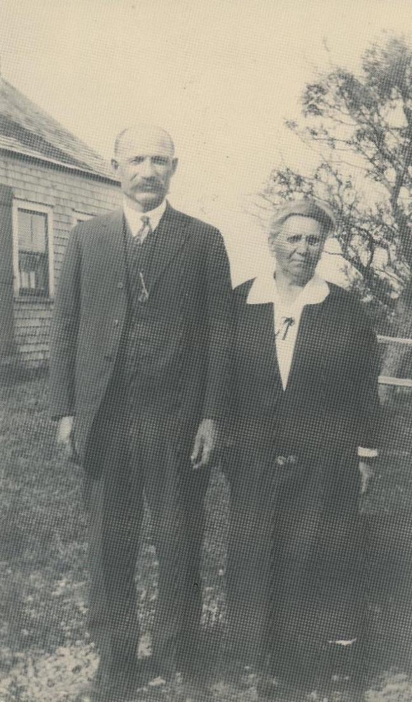
Mary Ellen (nee Gerrior) and Hubert Myette (Ella's parents)

East Tracadie
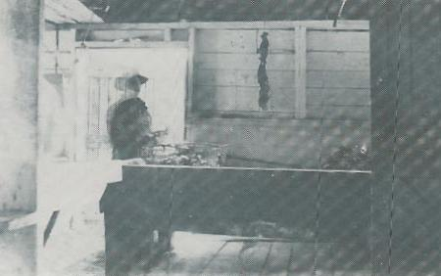

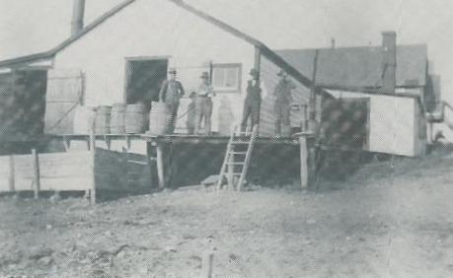
Lobster cannery at East Tracadie
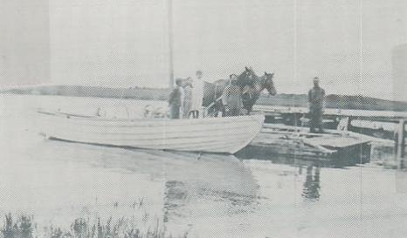

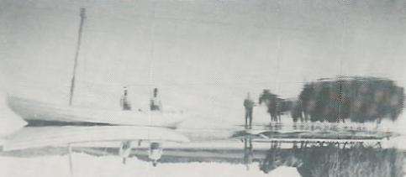
Isadore and Peter Boudreau hauling hay from
Alex's Island (boat 5hp Fraser)
In 1919 I was adopted by Jerry Delorey of East Tracadie. He was a man proud of his name and heritage and had his mail addressed as Jeremiah DesLaurier, Esquire. He was a cousin to Joe Delorey and a member of an old seafaring family, real sailors.

Jerry prided himself on being able to climb to the topmast of a schooner at 135 feet and stand on his head on the ball at the top. He told yarns of fishing on the Grand Banks in Bluenose like vessels. There would be two men in each dory and six to ten dories depending on the schooners size. They sometimes got lost from the mother ship in fog or a storm. They fished on shares, half for the men and the other half for the Captain and the ship. There was never any shortage of work. These sailors may have started on small local built vessels at Tracadie or Havre Boucher. Some of the Boudreau family built and sailed their little ships to Boston and so did the Crispo's who were merchants in Havre Boucher.

Lobsters were a big business in the 1920's to 50's. There was a big lobster cannery in Bayfield, one in East Tracadie and also a lobster hatchery, a cannery at Blue Rock and Linwood, two in Havre Boucher and more of the same all along the shore. Each of these employed at least 40 people, some as many as 80 men and women. Most of these people stayed at the cannery in bunk houses kept by the company. Quite a few of the help came from villages in New Brunswick and parts of Cape Breton to follow the lobster seasons which lasted about two months in each area, from early spring to late fall.

Most people in the Tracadie area had little farms and raised their milk beef and pork, kept a few hens, grew potatoes, turnips, cabbage, carrots, green peas and beans which they dried, along with wild strawberries, raspberries, blueberries, fox berries and gooseberries. In fact if they needed it they grew it. We raised hops that was made into yeast for bread. This process was quite simple, like sourdough you always kept a cup or so of the old batch. Bertha always made her own. She would grate a few potatoes, add some other ingredients to which she would add a cup of the old yeast. It was kept in a gallon earthenware jug, left to ferment for a few days and then it was ready to use. One cupful was equal to one yeast cake. Yeast cakes cost one cent each and your cash income was very small. We sowed wheat and that was ground at Beauly, at Charlie Punch's Grandfathers. They also hulled our barley for soups and made oatmeal from our oats. Most of these people had boats of various sizes and fished their own herring, cod, eels, smelts and also clams, oysters and anything else they could get.
Most people had onion beds called sieves that were planted in the fall for an early crop and the tops were salted for winter use. The main onion crop and shallots were planted in the spring. We always had a plot fenced in from the stock to grow all our seed and it was a lot more dependable than what we buy now. The seed on most vegetables grow in pods like peas. For turnip seeds we would plant one big turnip like we wanted to grow early in the spring and that would give us enough seed for 50 or so barrels of turnips, a half cup of seed would sow a lot of ground. For carrots, parsnips and beets it was the same. Most people made good wine from choke cherries, elderberry and sarsaparilla. Some were as potent as today's rye and rum. Just living was a year round job.

There was a schoolhouse on a corner of Bennie Pettipas' land near Joe Boudreau's barn. The first teacher I remember was Charlotte Delorey, mother of John Broussard of Tracadie.

As East Tracadie had grown so much by 1920, a new school was built in John Boudreau's field as it was located at about the center of the district.

The last house toward Monastery belonged to Stanley Borden. They were a big family Gordon, Alex, Ed, Cecil, Bernard, Stanley, Susan and Viola (I don't remember the oldest girls name).
Next was Charlie Boudreau, father of Rev. Father Donald Boudreau. He was brought up at Tom Redman's. I went to school with him and also I worked with him in Mulgrave loading pulpwood boats for S.W. Haggerty. Next was Mike Cotie and his mother, then Tom Redman where Henry Bonvie now lives. Across the road was the home of Martin Johnson, later occupied by Jim Lynch and family. Next was Jerrie Boudreau, a blacksmith (I still have a claw bar and a crowbar he made). They moved to the States and Elva Prest moved in. The oldest boy Billie died in World War II.

Daniel Bowie lived down at the shore almost a mile from the road. He butchered local beef and peddled it in Mulgrave. Next was Frank Cotie, a tinsmith, and his family. I enjoyed watching him make buckets, cream cans, funnels and
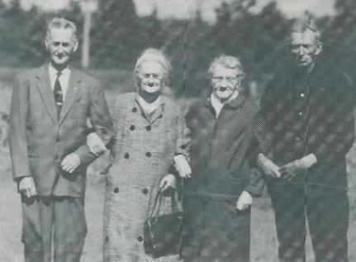
Frank Cotie, his sister Mrs. Bary, Mrs. Joe Delorey and her brother Mike Cote

other things. Narciss Cotie lived across the road. They mostly traveled to the States and they had one of the first gramophones with good dance records, so we spent a lot of our evenings there. Narciss told me about working in the States for a year and coming home with $700.00 in gold coins hanging from his neck. I guess a $5.00 gold piece was close to an ounce then. Next lived two Boudreau families, John and Simon (Larry) who was likely their father as they were always referred to by that name. They left a large family who mostly settled close by and became farmers, fisherman, CN operators, carpenters and some of them now live in Ontario.

The school was next. It was removed when all the Parish of Tracadie were joined to form an Elementary school at Tracadie, primary to grade 6, and a High School in Monastery in about 1969.

Charlie Bonvie built a lovely house and barn about 1918. He then moved to the United States. His wife's brother Hubie Cotie came home from the U.S. and moved there. It was later occupied by his daughter Edna and her husband, Willie Cotie. It has since changed hands.

Norman Beshong was next. He was married to Jane DeCoste, a sister to Joe and William John. Norman had three sons, Elmer, John and Anthony. John built a beautiful house on the old stand that is occupied by his wife Lila and two sons. They were descendants of Molloyo Beshong (who was said to have broken the bears jaw with a blow for trying to kill his pig). Hurbert Bonvie was next. He was father of Joe, Charlie and Amelia who was married to Dave Bouchie. As Hubert got old I would go and give him a haircut and shave when he needed one. When he died I acted as undertaker. If you were capable it was your duty.

I also helped other people. Joe Delorey kept a stock of wide boards for caskets. Isadore Boudreau showed me how to prepare a corpse as he had a lot of experience. The corpse was measured a casket was built as neatly as possible. The women Ida Fougere and Bessie Boudreau made the linings. Quite a few other people helped, most of whom I have forgotten about. As we were the only ones to have a phone when Paul Guthro died I ordered a store bought casket from Jack MacIsaac in Antigonish. It cost $60.00 and was shipped by freight to Monastery. As Mary Jane (his wife) had no income we made arrangements to pay $5.00 a month when she got her widows allowance that averaged $12.00 a month. Faithfully she took me the $5.00 and I mailed it to Jack. I don't think I charged her the 2 cents postage stamp it cost or the 5 cent phone call to Antigonish. The method of sending a casket by train was to find someone going that way and the casket would be sent on the same ticket. A few times Gregor Myette (Ella's brother) would point me out to the undertaker and say, "That feller is going to Monastery, so put that dead duck on his ticket". Gregor would also point out to Jack who was the dead one when they booked a stiff on my ticket, which never failed to get a laugh.

I remember when Gregor died Jack MacIsaac's hearse ran out of gas in South River on the way to Tracadie and held up the procession for nearly an hour. I went to Elmer Frasers and got a can of gas and I told Jack, Gregor must be laughing. We got another laugh out of that when Jack forgot to pay me for the $3.00 worth of gas and his wife Jennie noticed it. I can imagine he didn't forget that one.

John Benoit lived across from Hubert Bonvie. They had a son, Willie, who carried the mail to Monastery from East Tracadie, a daughter Lilly married to Joe Bouchie and a grandson Wilfred who died in a tragic accident leaving his wife and infant daughter. John was a strong man. He had carried 2 bushels of potatoes (120 pounds) from Havre Boucher, a distance of 5 or 6 miles. He said he had to put it down and rest about half way! He said he had rowed a boat to Bayfield, a distance of 6 miles to get a barrel of flour 25 cents cheaper than it was in Monastery. There were stories about a brother, they called him White Hair (Povill Blanc) and he claimed to have sailed all over the world. Supposedly, the highlight of this trip was a visit with the Pope and using the Pope's washroom. The description of that would be very entertaining on video. Something like an upside down car wash!

Across the road was a new house and barn (since gone) build by Charlie Boudreau. He died of tuberculosis. His wife lived at Joseph Delorey's for a few years. She was a McKenna from P.E.I.

Jerry Delorey's was next, which was where I was brought up. His wife was always sick. In later years Willie and Bertha Pettipas moved there, which I mentioned earlier.

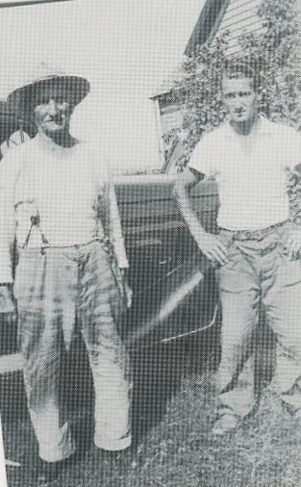
Joe Delorey with Benedict

Joe Delorey, a cousin was next. They had both sailed most of their lives and could tell hair-raising tales especially about the damage and deaths caused by the August gale of 1873. Joe could name every lightship along the New England coast. In those days where there was a lot of water traffic, lightships were visible from one another and when it was foggy they used foghorns. They averaged about 20 miles apart. According to Joe they had a small crew and so grew most of their food on board and kept a few hens, pig, etc. Joe had freighted granite to all those cities along the coast and could tell you the difference between Queensport and Rockport varieties, how they were cut and lifted even in 20 ton blocks.

The Gorman family were bigger farmers compared to the rest of us. Eddie had died before I got to East Tracadie. He was married to Evangeline Gerrior that makes them close relatives with our family. His son Joe was the head farmer but they all worked hard, Edmund, Gerald, Kathleen and Mary. In haying time they were all in the field. When I grew up I worked with Joe making hay. I got $1.00 a day that was good, and as I helped with the chores they gave me my meals. This meant getting up at 4:30am, milk 2 or 3 cows, run the separator, feed pigs and chickens and have breakfast about 7 o'clock. Then we got in the field and as the weather was good we finished the hay in 9 days. We mostly stayed in the field till 8 o'clock, then had supper. I'd get home at 9:30 and had no trouble getting to sleep! This may seem a bit hard but fisherman and farmers all worked long hours. Alfred Cotie worked with me at Joe Gormans and being younger he was paid 75 cents a day but he was a good man. Joe paid the two of us $15.00 for making his hay. At the same time Dr. Brean made a house call to his place and didn't do anything and charged $15.00 plus got a bed for the night and his breakfast. Joe had a few select expressions for that kind of unfairness.

Next were the Boudreau's. The ones before my time were the builders. They had put up the first mill, as near as I know, in these parts. It was a few hundred yards above the mill now operated by Bernard DeCoste. They sawed lumber for their vessels and buildings. They also sawed shingles. All these people had woodlots at Mattie (still have) so in off seasons they spent a lot of their time there. Mostly all of them were related with the Mattie people. The same thing with us after we moved to Mattie. We still traveled to East Tracadie for fishing. They had built a sort of central community that was the heart of the district. The centre was the forge operated by Tom Boudreau. He could mould steel like we mould clay. He was a machinist and a millwright. He even made nails and spikes. The Post Office was at Mike Boudreau's. His sister Maggie Ann did the book work. The first mail driver I knew was John Mattie. He had lost a leg in a railway accident and so had a wooden leg. After some years William John DeCoste took over and had it for 5 or 6 years. After that Hubert Bonvie and after him that Post Office moved to Isadore Boudreau's place.

The wharf where most of the summer work was done was located below Alex Boudreau's place. A lobster cannery operated there employing 30 to 40 men and women, about half who stayed and ate at the bunkhouses provided for by the owner. Between fishing and canning everyone that wanted a job worked. I fished some years and worked there some years. Wages were around a $1.00 a day depending on the kind of work you did. I started out at the wringer. The wringer was about the same as a clothes wringer except it had brass rollers and it was run by the same gas engine that ran the sealing machine. All lobsters then were canned and shipped to European and American markets. The rest of the power for cooking was supplied by a coal fired boiler. A man cut the small legs off the lobster's bodies and I put them through the wringer. Nobody ever replaced me. I was good at it. I could squeeze 1 pound of fish every 10 minutes and I had no competition. Some cannery operators were Will Irving, P.S. Howatt, and Roy Savage. Prices then were 3 cents for canners and 5 cents for markets. There were never market problems or labor problems. Everyone was busy and happy. All our advances have not been such a good thing.

The last house towards the harbour entrance was (and still is) Joe Boudreau's where Ernest and Anthony live. Walter built a house on the same field and so did Rose who was married to Gilbert Gallant, the violin player that I will get back to. A very sad accident happened in 1928 when Clarence Boudreau & John Delorey (first cousins) fell through the harbour ice and drowned. We had been going to school together and it was an awful shock to the community. Clarence was a brother to Sadie. The other homes in this area belonged to Tom the
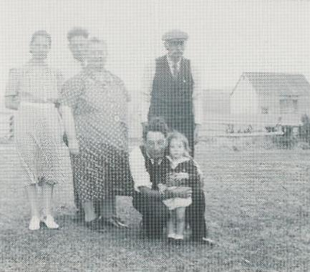
Joe Boudreau Sr., Irene, Anthony, Louise, Walter with daughter

blacksmith, Mickel, the Post Office, Alex at the cannery, Joe at the beach. Isadore had a fish trap and our first call with the boats was at the trap to get bait for, our lobster
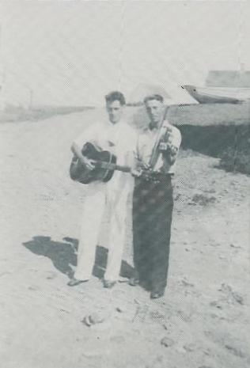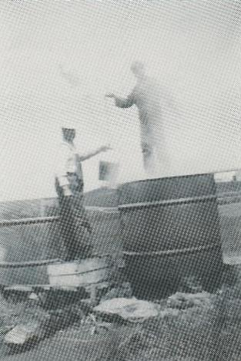
Anthony Boudreau and Henry Delorey Isadore tanning trap nets
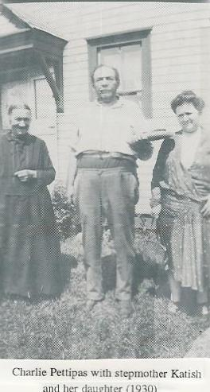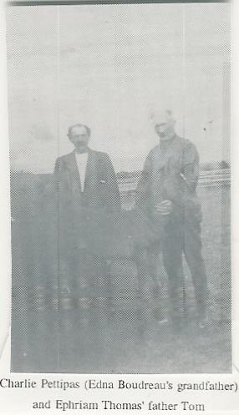

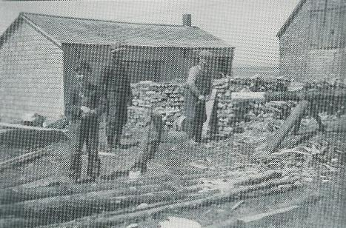
Bernard Bonvie, Isadore And Joe Bonvie at sawmill (1954)

pots, herring, flounders or whatever. At first they were quite a distance from the beach but as the sea cut in at the rate of 13 feet per year they used to farm where people now catch lobsters. Charlie Pettipas lived next and his daughter Marie married to Peter a brother to Isadore and Alex. He was Edna's father.

I did not mention Bennie Pettipas' family as I have mentioned them before (where we tanned hides, etc.). They had been a big family. Peter, Desire, Bennie and Willie (where I was brought up). There was Hubie who had either died in WW 1 or the after effects of it. There was Catherine married to Charlie Brow, Ella married to Joe Bonvie and Bertha married to Joe Mattie, and some others I may have forgotten.

I remember when there was a lobster hatchery at the shore. Lobster bought from fisherman were hatched in water like other fish eggs. This did not prove successful so the hatchery was torn down after a few years.

Another man, but of a different kind, was John Pascal. They called him the Jerseyman, which was where that family was from. All these families were related and still make up a close community. Boudreau's, Joe, Leonard, Josephine, Eunice at East Tracadie; Isabel, Stella, Mary and Florella (these three girls moved away); Edgar, Calvin and Edna, Peter's family are still living in the area. I went to school and grew up with most of these people. Quite a few of the third or fourth generation like Buddy, and Gerald Fillmore and Tommy, grandsons of the blacksmiths. Many of the others I have either forgotten or did not know. The old Pascal place was bought by Francis Mattie (Glady's husband) and the buildings torn down. A new place was built by Fraser where Mike Delorey and his family now live. John Pascal died in Boston at an old seaman's home, as far as I know. He operated big steam lighters (a steam powered boat with a crane on it) most of his life and could tell stories about lifting huge motors into steamships with such precision that they were where they belonged on the first try.

Over the hills towards Linwood was Nicholas Delorey, related to Besook. Besook was a real character who could always get a laugh. He had moved to Boston and took jobs and hired local people to work for him. He seemed to have short changed everyone who ever worked for him. As the local people who landed there didn't know anyone, Besook would meet them and give them work until they could find something better. Everyone that met Besook in Boston had a story to tell. He had a way of calculating the balance, being illiterate, 'one and three plus two, all for me and none for you'. It didn't always work and sometimes the other guy had the last word.

Across the big pond (our skating rink) lived the Joe Webb's (really DeCoste's). Apparently the old people were brought up by the Webb's. (Other DeCoste's called Webb's were Hubert and Michael in Linwood). Sophie was married in Havre Boucher, grandmother of Christopher and Francis DeCoste. (There were girls but I don't remember their names). There was Joe Webb, father of Johnie who was deaf and Arthur who stayed at the shore. They fished lobster for a living. They had enough traps that the family could fish all day. That was around 1900. They got 1 cent apiece for all sizeable ones, the small ones didn't count. I heard all this from Arthur. He could keep you on the edge of your chair night after night. We would be there most nights. Lilly played the accordion and we danced. There was Willie, Bennie, Bella, Charlie, Clarence (my age), Irene, Florence, Mary, Francis and Raymond. There was another girl who I think drowned when still a child. Johnie moved to a house on the Linwood road. His son Joe fished lobster, salmon and farmed. Johnie DeCoste, Glady's Grandfather had bought his place from a Wm. Pettipas. He had moved to Antigonish and worked on the railroad but he came back almost every week. In a part of Johnie's farm there was a stone quarry on a little hill; that's where most of the stone house foundations came from. There are also some in Mattie Settlement. Some of the blocks were 10 feet long and hauled by oxen. I remember when the quarry hole was about 60 feet deep. The rock was all in seams and was wedged apart and lifted up to be hauled. A big swamp extending to three lots was called the Ash swamp and quite a few houses had hewed ash floor beams from where Joe Delorey had quarried stone and hewed beams. Ash was strong and more durable than other species. Joe, William John and I fished together for a few years (three years using a 45 foot boat). We had bought the boat from Munroe for $100.00 and installed a Chev motor
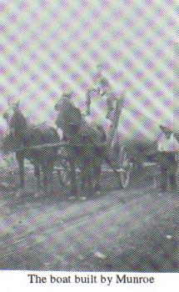
The boat built by Munroe

and a hauling gear. I guess it was the most modern gear around at that time except for the big New Brunswick fisherman who were then fishing two seasons. (That has since been outlawed). William John was carrying the mail then and had bought the old home of Eddie Boudreau's (Munroe’s), later owned by Francis and Gladys. William John and I lived together for a few years and he gave me two acres across the road where I built a house. I never lived in it but I ran dances at first. They were real lively. Gilbert Gallant played the
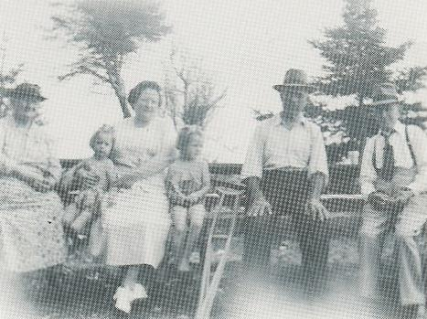
Rosie, Ida, Isadore and Gilbert Gallant
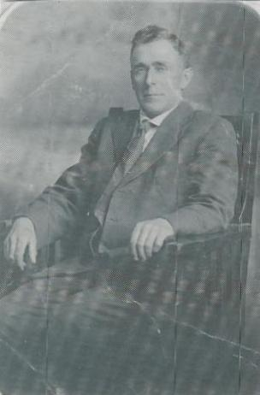
Gilbert Gallant
violin, Henry Delorey the guitar and Rollie Wilkie the banjo. The dances went right through till daylight. I think I paid the musicians $2.50 each, sometimes a little home brew was thrown in. Things went quite smooth. I don't remember any fights and there are still a few people who remember those dances.

Even if radios and TV had not come out we had no lack of entertainment. Stories of buried gold were favorites. It was so talked about that you made it real. Islands in the harbour were quite dug up making them almost a miniature of Oak Island.

It was said if you dreamed three nights in succession where gold was buried, it was there for sure. Arthur had those dreams so we
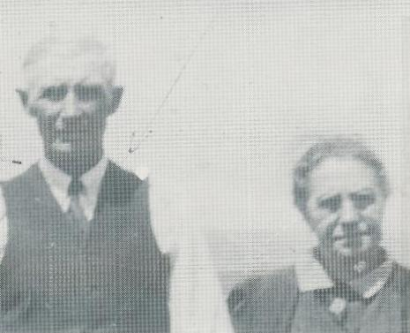
Arthur

made plans to go and dig it up. No one must hear about it. Arthur, Benedict and I decided to go, but with buried treasure waiting, there was always something that would come up. The first night we had visitors who stayed all night. The next night it poured rain. After about a week we got a chance to go. While you were there it was said that you must not talk or the gold would sink. Also, if you struck the gold you should have a few coins of your own to mix with them, it also helped to kill a black hen and pour the blood all around. We never got to that! Well we dug down 6 or 7 feet in a place that had been dug before till we came to a big flat rock that was completely level. That was very unusual as flat rocks are mostly slanted. We knew the gold was there. With two big pries we finally got the stone up. Under that was more flat rocks! So the gold is still there, at least until someone dreams about it again.

Another interesting topic was witchcraft. One old guy explained it to me. If you wanted to overpower someone you put sewing needles in sour milk and brought it to a boil. If it was a bad case you added a snakes head; if it was a love potion you threw in a little honey. I didn't believe all this but it was good entertainment. If you got a streak of bad luck you could be sure some bad friend had witched you. There was this old guy who was having a streak of bad luck. His wife ran away, his horse went lame and his cow went dry. He went to a friend witch to see what he could do. He was told to try to figure out what the offending witch looked like; than draw the picture on the door and shoot it and you should get rid of it. Well the pig house door was the nearest so he drew the picture and got the musket and shot the witch right in the gizzard. His son who was watching said 'I think you got him. I heard a squeal'. Alas, when he went to feed his pig it was dead. He had shot it!

People kidded one another about being able to witch each other. As we worked on the road Eddie, a neighbor asked Howard if he could still witch. "When you were bad friends with me my horse died". "Yes", Howard says, "that's right but than you witched me my pig died". "Well", says Eddie, "if I had been able to witch it wouldn't have been the pig that died".

About 1928 we were hearing about the boom. The Guysborough Railway was being built. The huge amount of $3 million would be spent to build track from Sunny Brae, the end of CN, to Guysborough. It was hard to get on the crew at first as I was just a boy and they wanted big men. The distance of the Guysborough Railroad was 60 miles and the $3 million spent then would hardly make a survey on it now. Then it meant work for 2000 men.

I got work at the Sonora Timber Company cutting and peeling pulpwood. You cut a wood road 20 feet wide and piled a cord 8 feet long and 4 feet high, the wood being 4 feet long, 128 cu. ft. We got $3.50 a cord, a day’s work for 2 men with axe and bow saw. We had a log cabin for 8 or 10 men with a stove and a brook for water handy. Camp supplies came in by boat once a week: bakers bread, salt fish, bacon (not sliced), flour, sugar, tobacco and whatever. If you were a good cook you ate alright. Very few of us washed dishes very much. At the end of the month when the scaler measured your wood it took a good man to average $1.00 a day.

At about every second log cabin at Sonara Timber Woods were Indians from Bayfield and the Cape Breton Reserves. They were real good people, but different, as some had their families with them and we got to know them well. Levi Lafford played the violin at dances and his buddy played the guitar. There was George Marshal, John Paul and a lot of others who I can't remember. They had an advantage over us as they had free trade. They could go to the States and work at picking berries, etc., and get things cheaper than in Canada (and still can).

The next year I had worked in the Mattie woods for MacKay and McChesney (Clarence's father). When we cut pulp back in the woods we would get word when a pulp boat came in to Guysborough to be loaded. We just dropped everything and walked there (20 or 30 miles) and stayed in Guysborough until the ships were loaded. Sonora Timber had big camps below where the hospital was. The food was good and we were maybe 100 men and about 50 men that lived home. It was a nice change. Then it was back to camp. When the wood stopped about the first of September we were hired by the company to cut the main roads. Everything was cut down and laid across the road and when the snow came it would be all level. The peeled pulp would be all hauled to the lakes and streams and floated down to the harbour, put in great big booms until the ship came to pick it up. MacKay and McChesney got a contract to put up some of the high bridge abutments like you still see from Guysborough on. In this case we had to build a tram road across a soft field. We used three or four inch wooden planks that had to be carried on your shoulders for about a half mile. Rollie Myers, father of Mrs. Ham Morrow, had two trucks and all gravel, cement and tools had to be hauled over this road. When the planks were wet the trucks would slide off and we had to get them back on, some times having to haul the gravel and cement with a wheelbarrow. Lawrence Mattie and I worked together there. Two of the men who drove trucks for Rollie Myers were Alex and Ed Borden. As near as I remember some of the places were North Ogden, Lollars Lake also Erinville. We did not get to know the local people as we did not stay in one place too long. Men came from all over the world. There were Swedes, Poles and Hungarians. I'd ask them how they came to be there, mostly their idea was that Canada 'was it'. Just get there. In most ways they were right, you could get work here. They usually landed in Halifax and got a map from the railroad. The first thing they looked for was the railroad (broken lines meant under construction). That summer was dry and hot and we had to dig in hard ledge to get solid rock for a base for those pillars. The day I got there nine men had quit before noon on that section. They were mostly big strong men but not hardened to that kind of work. They would get together and take a job to move a hill and fill a gulch by the cubic yard. Lawrence and I were little men with no extra meat to carry. We had to swing a pick and shovel for about two hours until the trucks came with gravel and cement, then George would start the big mixer. We had to wheel the cement on little narrow walks about 30 feet high that was about the height of the pillars. The cement was heavy, 1000 pounds of mix, split into three wheelbarrows. There were no rubber wheels then so every pebble that those steel wheels rolled over jarred even your teeth. At the end of the walk you dumped your load, but not before you gave a yell to let the men underneath know. If they didn't have time to get out of the way they got three or four hundred pounds of wet cement on their back and we would get a proper cussing. But we couldn't always be sure they heard us and we could not stop our wheelbarrows. It was the survival of the fastest and being down to 98 pounds I could outrun anything, let alone a guy plastered with cement. By the time they would catch me they would be too out of breath to do me any harm. My bones were so sharp you could cut yourself. I could laugh at anything. They often told me, "even if you're guilty you still look innocent". Still do!!

One day a little colored guy came on the job and said he could drive a truck so Rollie let him try one. The first trip he ran the truck off the planks and was chased out. The next day he came back asking for Rollie who was away just then. We told him he should get paid even if he had put the truck off the road. At last Rollie came back and the little guy went up to him and said 'I wants my pay and I wants it all and I wants it now'. Rollie turned and yelled 'Get the hell out of here or you'll get a kick in the ass and you'll get it now and you'll get it good'. We near died laughing!

************************

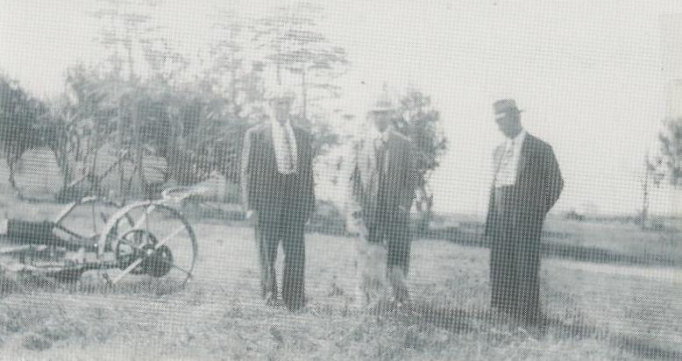
Bernard Bonvie, Isadore and Joe Bonvie at sawmill (1954)
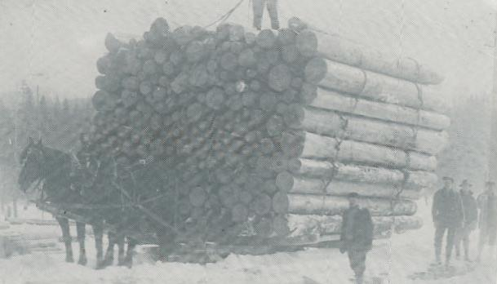
Some of the old Maine lumbermen used to tell stories about grooved ice roads on level ground.
I can't swear to this, I wasn't there, but if a picture is worth a thousand words....

**************************

The Upper

Village

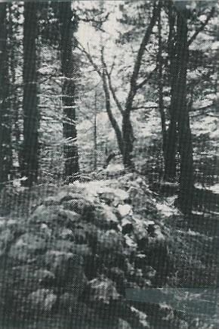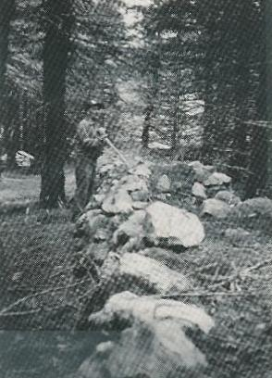
What remains of the old stone fences in the Upper Village (mid 1980's)



The first residents in this area looked after the land; lived in harmony with it and made it produce more. The Upper Settlement or Village, located about two miles south of present day Mattie Settlement, has gone back to the wild, and anyone not familiar with the area would never know that a village of twenty families had once existed there. We don't know how long they lived there, but we do know that most of them moved to the Boston States and it is quite likely that many of their descendants are still living in the States today.

When I walk there now I see coyote tracks; some deer and the odd bear can also be seen, as well as some big timber where their gardens were once located. The only signs of habitations are the stone walls, some old cellars and wells. The last living resident of the Upper Village, John Guthro, told me a lot about life up there. He told me a story that centered around the large wooden tubs, which were kept by the lake shore, and used by the women to wash clothing. One day just for fun, John and his cousin Paul got into one of the tubs and pushed it out into the lake. The wind blew them away from the shore and it took them all day to get to the other side, where they received a hot reception from their mothers. John said that was the longest time he went without sitting down.

There were other people who remembered a lot about the Upper Village, such as Mr. and Mrs. Joe Delorey, of East Tracadie. In 1865, Mr. Delorey build a house in East Tracadie from logs that he had purchased and hauled himself from the Guthro people. Being orphaned at an early age, we were to be seen
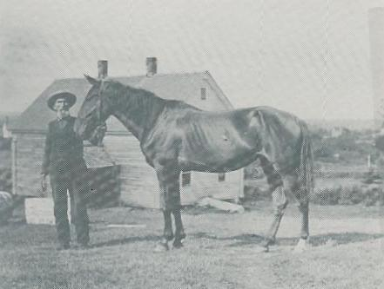
Ephriam Thomas' grandfather Ephriam at the house that now belongs to Benedict DeCoste (circa 1915)

and not heard, so we listened carefully to people like Ephriam Mattie (grandfather of Ephriam Thomas), Fred Mattie, and Virginia Guthro; and their stories kept us on the edge of our chairs. Virginia (nee Cordeau) was born in Poireville, Cape Breton, and in 1890 she married Charlie Guthro and move to Basil Guthro lake, named after the first settler. At that time the Village was well established with eleven houses that could be seen from where
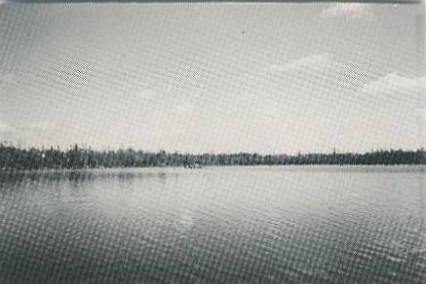
Basil's Lake (1987)

she lived and, as far as she knew, people had lived there for hundreds of years.

These people were completely self-supporting. They raised sheep, which they sheared, the wool was washed, carded, and spun and then articles were knitted and woven as they were needed. The dying of the wool was done by using moss, onion skins, bark and other natural agents. They also grew flax from which they made linen. They ploughed their own fields with wooden ploughs hauled by oxen. One of the wooden ploughs used in the Village came into my possession and can still be seen today at the Guysborough Museum. Large, straight logs used in the building of churches and vessels were cut there. In fact, the frame in the Tracadie Church, erected by Remi Gerrior, was built using Mattie timber. Joseph, Mr. Gerrior's son, told me about how the church was blown off its foundation by a heavy August gale in 1865, and how it was lifted back into place by about 100 men using pries. In 1884, another church was built using the same plans as were used for the Tracadie church (except this one was to have twin steeples), and again Mattie timber was used. This church was framed in Tracadie, taken apart, loaded onto vessels and set up at its present site in Arichat. This timber was also used by the Boudreau families of Tracadie, who built and sailed vessels to Boston loaded down with farm produce, coal, salt, timber and pine from Anticosti Island, which is in the Gulf of St. Lawrence. Anticosti pine was also used for making sea chests and most of the houses got their finish and siding from it.

Joe Gerrior had been in the States about 1900 and when his father Remi got too old to run the farm he came home. He had two teams of horses. At 4am he would feed one team, put the harness on the other and plough or harrow till 7am. Then he would feed and water that team, have breakfast then take the other team out till noon and do the same for the rest of the day. He was not exaggerating. I worked with him moving houses. He took the job to move a house in Afton for a veteran called Merlan for $100.00. We had to move it about a mile from where Louis Rogers lived to DeCoffe's at the Antigonish road. There was him, his two sons, Leo, Bernard and myself. The ground was soft as the frost was breaking, the land was hilly and the building had to be kept level. A family of eight people lived in the house. Joe and I stayed in most nights so we could get a start at daylight. Leo and Bernard had to go home every night to keep feed for three horses and four men. We had an old barn frame of hewed 8x8 timbers, about a truckload from 10 to 30 feet long and about 50 rollers of about 100 lbs. each. All this had to be moved by hand at every move. There was also a 200 pound anchor sunk in the ground to anchor the tackles and cables starting with 1 inch steel and hundreds of feet of rope as the three horses provided the power to move the house. It took us two weeks of 16 hour days. The people in the house seemed to have enjoyed the move. Some weeks after Joe passed me a two dollar bill and said I wish it was more but after I paid expenses that's all there is left. We set up a house at Monastery after that for Francis Mattie. It had been Frank (Sandy) MacDonalds. Two snow ploughs hauled that one. At that time it did not seem odd to work free, if someone needed a turn you just helped them.

About 1965 when we wanted a telephone line for Mattie 15 men got together and worked for two weeks and put in two miles of line to ten houses. We scoured old lines and got enough wire, insulators and braces. All we had to buy was our phones. Maritime Tel & Tel sent us three men to do the hookups and make sure everything was done right. The bank manager told me he didn't think such companies could be formed any more. Maritime Tel & Tel cost us a rate of 50 cents a month and 5 cents a call to call other exchanges.

Many of the villagers were coopers and made fish barrels for the American vessels that sailed to the Grand Banks. These barrels were carried on a mans back from the Village to Mulgrave, a distance of about eight or ten miles. One resident set a record by carrying sixteen barrels in one trip. He succeeded in doing this by removing the tops and bottoms of the barrels and tying them into a bundle. He then strung the empty barrels onto two poles, eight on each, and centered one pole on each shoulder, and the bundle on his back. It was not uncommon to see a man carrying a 200 pound barrel of flour. In fact, feats of strength were the rule in those days. One story tells of how Molloyo Beshong was awakened one night by the sound of squeals coming from the pig pen. When he got to the pig pen he found a bear chasing the pig. Well, Molloyo hit the bear so hard that he not only broke the bears jaw, but he also dislocated his own shoulder. The bear eventually died as he was unable to eat; and the pig...well he lived only to be later eaten by his friends.
Some of the vessels built by the Boudreau's were the Seaflower, the Mary Jane, and many more. An old composer told of the first vessel to sail into Tracadie Harbour at the new channel (the present one):

First came moccasin, next came shoe
What came next, but old Dadeau
His bows were made of spruce,
His sails were made of cotton,
He sailed right in the harbour
And never touched bottom.

Vincent Dadeau's Grandfather, 1865

Even without schooling, rhymes and songs were composed, but most have been lost.

Many of the buildings in the Upper Village were log cabins, unlike those in the Lower Village, which had foundations of rock (some were ten feet long) and were quarried in East Tracadie. One quarry that I remember was sixty feet deep. These blocks were hauled with oxen. Most homes had a cellar for vegetables and other food and another separate cellar outside for the late crop and insurance; in case of a fire you still had food and shelter. According to Virginia, families started winter with at least a 200 pound barrel of pork, beef, herring, also dry cod, eels, rabbits, and half a barrel of salt onions. Wheat was also grown and milled at the Trappist Monastery.

The Boudreau family built the first mill in Mattie Settlement about 200 yards upstream from the present one. The time is not recorded, as far as I know. The timber for vessels was milled here and also shingles were sawn.

Before 1900 Ephriam Mattie (Grandfather of Ephriam Thomas) built a water mill at the present site. It was powered by a wooden undershot wheel and used an up and down saw similar to the one at
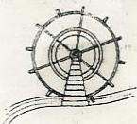  Undershot Wheel | Sherbrooke Village, except that all the iron was forged locally. This mill was built after the Boudreau mill was
out of repair, so that may date the other mill before 1850.

The Mattie mill was leased to John Somers (grandfather of Miles) and was gradually built into a very important business under Thomas Somers employing about ten men. Timber was sawed and planed here for wharfs for the fish plants at Mulgrave, Canso, Queensport and many other places. I remember the first auto trucks of S. W. Haggerty hauling timber to Canso. The first one had solid rubber tires and you could hear them a mile away. He had eighteen horses and at least one hundred men employed (George Tramble was blacksmith). They cut pit wood and chuck blocks for the mines; about one hundred carloads were shipped yearly to Sydney, mostly cut in the Mattie woods. Quite a few boats were built by Eddie Boudreau (Munro). There was a boathouse below where Doug Boddy now lives. Eddie built two tugs 45 feet long for the Forestry Enterprise Pulp Company for use in Chedebucto Bay. He also built fishing boats. We bought one from him and used it for lobster and salmon fishing until WWII. I helped at putting in the ribs that was the only thing he couldn’t do alone. Some of the first birch logs for WWII Mosquito Bombers were cut and shipped by Eddie Mattie. They had to be perfectly round without knots and at least 18" in diameter. Hundreds of scaling poles were hauled to the Canso Causeway (built 1950-53) and used for dislodging dangerous rocks. They were mostly about 60 feet long and 2 feet wide. They were stood up in the shovel bucket and reached up over 100 feet to ram any loose rocks dangerous to men and trucks.

About 1943 the Mattie Mill burned and Thomas Somers built a steam mill near his home in Grosvenor. About 1950 the Somers mill burned down. It was rebuilt and operated by John and Miles Somers and burned again in 1971 in a fire that burned from Mattie to Frankville destroying both Alexander Tate's and George Tate's homes. I rebuilt the water mill in Mattie in 1946 after it had been vacant for three years. At first only shingles were sawed; three men averaged about 40 bundles a day or 10 squares. Local farmers brought in their logs and either paid $1.00 per bundle or left half to pay for the sawing, which was sold to people who had no wood. This form of payment had been used for a lifetime. A hammer mill was added in 1948 and farmers brought their grain, oats, and barley for stock feed and wheat for whole wheat flour. Farmers from South River to Melford brought their grain to be ground. An average lot was charged $1.00 or 10 cents per bushel. About 1950 Benedict DeCoste bought the mill and it was gradually improved, as it did not compete with the Somers Mill. It had a new concrete penstock and dam with plainer, shingle mill, lath mill, and is now mostly automatic. Today it is run by Bernard DeCoste and his family, descendants of Nicholas Oathes (Great Grandfather of Mrs. Benedict [Irene] DeCoste). As our family acquired most of the lands in
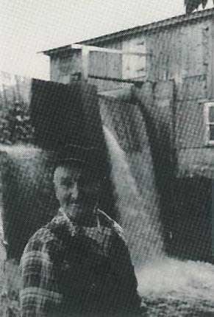
Benedict DeCoste - Mattie Mill (1986)

the Upper Village most of it is being passed on to the descendants of the original. As the land of Nicholas Oathes was not granted I managed to get that done in 1946. (One hundred acres of the land we had bought from Dassonville had been owned by Nicholas Oathes )

Most of what is written here I have experienced. I grew up with pioneer families. I fed the pigs, milked cows, fed the hens, cut the kindling, and took in the wood before going to school and the same again after school. I helped Bennie Pettipas tan about twenty hides every summer. I helped to clear land, build log cabins, and lived in them. We composed verses to remind us of the dates such as:

The month was November
The date twenty nine
The year thirty seven
The day it was fine
We hitched up the grey mare
And away we did go
Till we came to the road
That goes by Munroe’s'
We stopped at a spot
Well wooded and fair
In French we still call it
"La trou vas des Pierre"
We built us a cabin
About nine or ten square
A hard looking shack
But was cozy in there
We bought us a stove
For a dollar or so
With a rusty old oven
To cook the torteau
We built a log cabin
For the little grey mare
Near a spring full of water
So cold and so clear
We ate everything
From rabbits to bear
We'd take out the guts
But we'd leave on the hair
We cut all the logs
From the mill to the crown
And the little grey mare
She's hauled them all down
And now that our mitts
And our socks are worn out
We'll get ready for fishing
When the bay ice goes out.

by Dennis and Benedict DeCoste
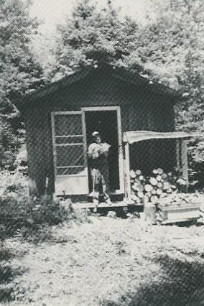
Cabin built by Dennis DeCoste (early 1980's)

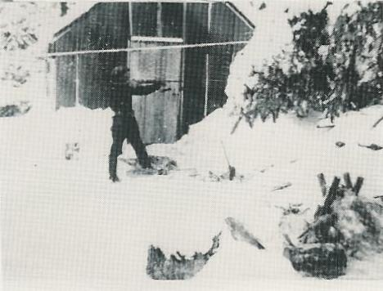
Cabin built by Dennis and Benedict DeCoste in 1937

Wild animals were quite plentiful, rabbits, deer, and moose were the main species. Bear were quite common. Most every home had one or two large robes, called buffaloes, made from bear or moose skins. When wrapped up in one of these in a sled or cart you were well protected even if the conveyance tipped over. In about 1890, according to Virginia, there was a strip of land about two miles long cleared by Nicholas Oathes on the East end. At the west end there is a deep cellar on a hill where Basil Guthro lived. The land was cleared to the lake on one side and
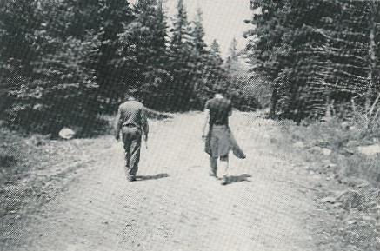
Road leading from the Upper Village to Nicholas Oathes as it looks today

the MacDonald road was on the other, so named as it came out at Mary Jane MacDonalds where Paul Guthro now lives. Both villages were settled by people from France and the Channel Islands as the french names indicate: Cartos, Mathey, Gauthro, Beshong, Oathes, Perro, Delorey, and many more that I have likely missed. There are still people who live in the area with some of these names. For example, Patricia DeCoste works with a lady who was an Oathes from Guernsy.

These people were not mentioned in local history as they kept a low profile. It was quite likely they were persecuted as immigrants trying to settle in the wilderness. People were charged with faked crimes and could get absolved if they would go to live in the New World. History supports this. I never heard of any protests. If people didn't like the conditions, they found alternatives. Most of these people went to work in the Boston States, as they were called in those days. They would leave in the spring by schooner from Mulgrave, the fare, according to Joe Delorey, was around $3.00. You didn't get room and board, you just slept on top of the cargo and you took your own grub. They came back after the farm work was finished in the fall and they usually hired someone to put up their winter supplies. Most of them eventually remained permanently in the Boston States. But the money was a good help. It gave them the means of building a home. Marian Boudreau, a widow, took two of her sons with her and left one son (Henry, he was blind) and a daughter (Margaret) home to get a crop for the winter. They came back in the fall and had enough money to pay Dave Perro to cut and hew a frame and had the house ready to move into the next spring. Ben Boudreau told me all this when I wrote letters for him to his sister, Mrs. George Laraway, who lived somewhere out West. His brother Tom was the first to be buried in the Upper Cemetery in Tracadie.

It is hard to write about Mattie without getting involved with the past of Tracadie of which we were always a part. There are traces of Mattie farms and Mattie construction all over North America from Florida to the Arctic as many former folks from Mattie moved away to start businesses elsewhere. East Tracadie families had woodlots and at the first snow some would leave very early in the morning as their only transportation were a pair of yoked oxen, their only harness a long chain. These animals were very slow, about 3 to 6 miles an hour. They would carry an axe and an auger (forge made). When they got to their woodlot they would cut two small beach logs for sled runners and two cross pieces for bunks. The runners were bored and fitted with wooden pins and then the bunks were bored and fitted with stakes and they were then ready for their load of wood. On the way home the oxen went much faster. When the runners wore out, they hewed out soles or shoes that they fastened with wooden pins. Some of these sleds were fastened to a wooden pole that could hold back the sled on a down hill and could be fastened to the yoke with wooden pins and could even do away with the chain.

*********************

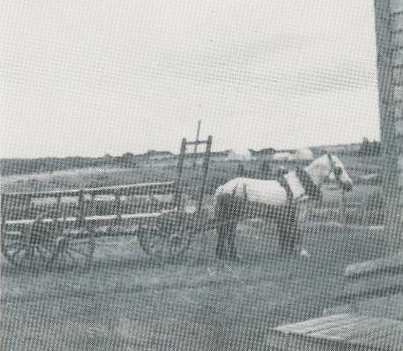
The little grey mare

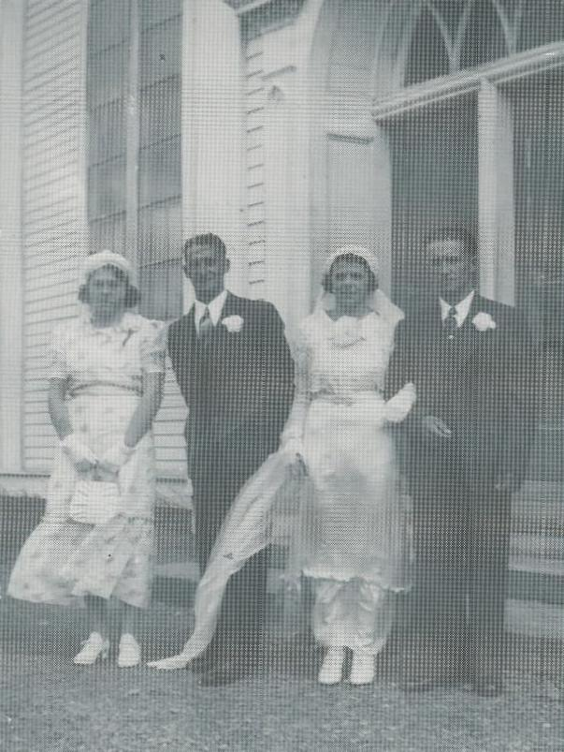
Irene and Benedict's wedding in 1940 Mary, (maid of honor) Dennis (best man), Irene and Benedict

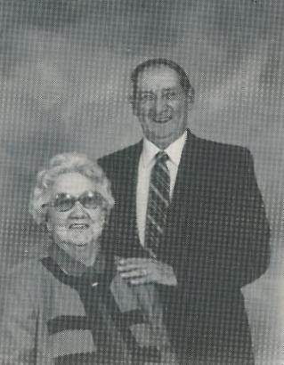
Mr. and Mrs. Dennis DeCoste

THE MAIN VILLAGE

OF MATTIE



The main village of Mattie was settled about 1800, by mostly Mattie families, and as I have not found anything written about it I have to depend on hearsay. Beginning at the East end was David Perro's lot, and that lot is still called Perro's. It consisted of an interval that was occupied by a Perro man who they named Shinoque as he was married
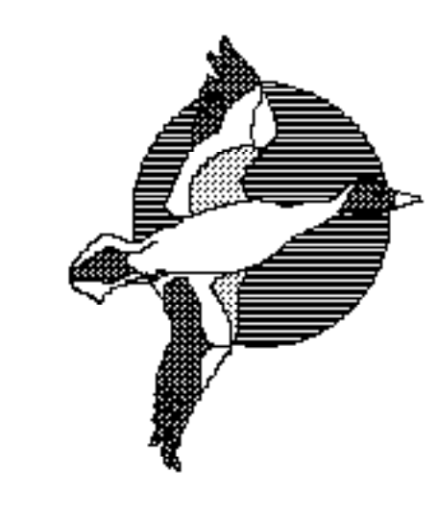
to an Indian. As a child I heard this story. It seems he had got some credit from D. G. Kirk who was one of the only big merchants of that time. (I remember the family well from when I was a kid). His son J. Ralph Kirk had a bungalow, where Jackie Myette's cottage is now that was formerly Bennie Mattie's house. Well, about 1920, I would see Ralph Kirk whiz through Tracadie harbour in a speed boat that had a 22 H.P. Ford Motor. (As far as we were concerned today's space vehicles didn't come close to that class.) Well anyway, Shinoque owed Kirk $30 and he couldn't pay, so his house had to be sold. Dave Perro took the job to tear it down and move it, I suppose he needed the money, but the neighbors said that there could be bad luck in taking a man's home. Well, in the process Dave Perro fell off the roof and broke his neck, so his wife and daughter had to move to the States to live with relatives. I remember their daughter coming back for a visit some years later.

The next family were Boudreau's. We moved their old house to our place to use for a barn after our barn burned, about 1950. I don't remember the old people, Ben and Marion Boudreau. Tom was the oldest and was the first to be buried in the new graveyard in Tracadie around 1926. I was about 14 then. Henry was blind but far from helpless as he would do all the barn work and drive a horse and wagon anywhere the family wanted to go. He must have been able to see some sideways, as his head was always turned somewhat. There was a daughter, Margaret, which I never saw but I would write letters to her for Ben (old Ben's son). She went out West, in the 40's I think, and married George Larraway. He was so glad to hear from Ben that he sent him a pocket watch, a Westclock (pocket Ben), they cost about 95 cents then but were a fairly reliable timepiece. By the time we moved to Mattie the old age pension came out. At that time it was paid at age 70. When Ben received his, this old lady moved in with him. Her house was falling out of repair and after the move each of them earned about $12.00 a month, making them quite independent. Being next door and literate, I was very much in demand as they liked to communicate weekly with their relatives. The lady was Virginia Guthro who had married and moved to Basil Guthro Lake about 1890. She had a son who died about 1930. Her daughter Sophie was Veronica Tate's (Mrs. Willie Tate) mother. She had a sister in Poireville, Cape Breton. So after some years she and Ben moved down there and lived out the rest of their days there. I recall when Ben died, as it was at the same time as our first daughter who died at the age of 6 months. The weather was awful, one blizzard after another. Ben's remains had to be taken back here to be buried in Tracadie. Nelson Melong had a new pickup so they got him to go down there, about 60 miles one way. In places the road was blocked and they got stuck. At one point they went off the road and Ben ended up in a snow bank. Well, a truck pulled them out and they dragged Ben and casket back to the pickup. I think it took a whole day before he finally landed at Gordon Mattie’s (married to Ben's daughter Alice, now deceased). Ben's son Bennie Boudreau married Mary MacDonald and later moved to Frankville (he has since passed away). His family now live in various parts of Canada ranging from the Territories to Nova Scotia. His two sons, Raymond and Mark moved back to Nova Scotia after 10 or so years in Ontario.

Across from Ben lived Eddie Boudreau. He lived in a small building that had been built near the Boudreau mill for the crew to live in. Munro, as Eddie was called, was a very capable man. He built houses in Boston and would tackle anything. He made tombstones of any design, quite a few of which are in village cemeteries. He made his own forms and imported different colors of cement to get the desired effect. He used gold leaf to brighten the cut letters that was very hard to do. When I first knew him he would take me with him prospecting for gold. He had a variety of claims, none of which were of much value. The one we worked at had been essayed for $2.50 per ton when gold was $16.00 per oz. All these prospectors had their window sills full of rock samples and prided themselves on knowing good quartz by sight. I'd often pocket one of their rocks when they weren't looking and take it out and show it to them telling them I had found it maybe 20 miles away. Mostly they would say, "That's not gold at all", and then they would pick up a rock that came from the same place and tell you how much more traces that one showed. I never let on that I knew the difference. Those people had a sense of humor that would have done credit to Walt Disney. Once when I asked Ben about a neighbor’s health, he just said, "Well he might last one more clean shirt!" Now I don't know to what degree of soilage that family allowed! One old woman went to see a doctor about her heart and the doctor told her she was as sound as a potato. Ben said his potatoes were all rotten that fall. She died shortly after. I could go on and on with Ben's jokes. To get back to Munro, if he got an order for a boat he would make a set of moulds or forms and he figured out the length, width, depth and strength needed, whether it was to be used as a tug or a fishing boat. He did not use paper or figures. Most of his boats were from 40 to 50 feet long and were very seaworthy. He seemed to know the strength needed to carry about 50 to 60 men in rough sea. I've been out in the Bay of Fundy, where we loaded pulp offshore on freighters, and when a gale came up suddenly the men had to be taken ashore fast. We worked from 15 to 25 hours straight until the boat was loaded, at 25 cents an hour. We were loading German boats getting Hitler ready for war and we didn't know it. We loaded the last one a week before World War II was declared in 1939. Munro made most of his own tools, forged in a home-made forge with a bellows blower that he had made himself. About 1947 I helped him build a small boat and he forged two moss rakes better than the ones we could buy and we fished Irish moss at East Tracadie. Most Irish moss was sold to Kraft Cheese and was used as an additive when refining cheese, from cheddar to spread-cheeses to cheese slices. It is also used in puddings as it dissolves into a gelatin and also as

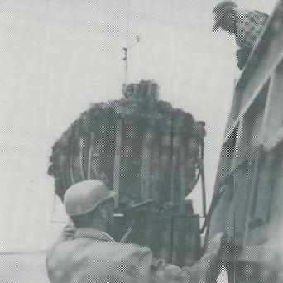
Weighing moss at East Tracadie wharf. Calvin at scales and Joe in truck (1979)

an additive for beer to make it sparkle and settle sediment. Its uses are almost endless. We ended up with about four tons of it at 20 cents a pound. That was big money then. Munro was sick most of the time that summer. That fall he died with cancer.

Ephriam Mattie lived in the house that Benedict and I bought from Dassonville's in 1938 (price was $1200 at $200 a year--this is now the home of Mr. and Mrs. Benedict DeCoste). Dassonville had bought it from Ephriam about 1925. That house had been remodeled about 1880, according to Charlie Alex Mattie. At that time it was raised by about 4 feet and was finished with some new pine siding, lovely moldings and windows, all of which are still looking good; newly painted in 1988. Our home was originally purchased for $250 that included three acres of land. I remember Ephriam well from his scary ghost stories when he would come to visit Jerrie Delorey's where I lived. I would be sent to bed early, so I would wrap myself in a blanket and hide at the head of the stairs and listen to hair-raising yarns that would shame Alfred Hitchcock. Soon I was too scared to go to bed. I guess that accounts for why, even to this day, I can do with very little sleep. Ephriam had a son, Thomas and at present there are four generations that go by names like Ephriam Thomas, etc. They are a remarkable and well-known family of which Mattie construction is just a part.

Norman Mattie's family lived in the house across from Eddie Mattie's, (now Berkley's Mattie's). Arthur was a carpenter and worked on many new projects such as weather stations and radio towers. He was councilor for our district and was Warden for Guysborough County. There is his sister Delia who lived in the old home for years and is the only living member of the family at this writing. Willie lived in New Glasgow. I didn't know much about him. Joe lived in the U.S. and was married to Bennie Pettipas' sister. Gordon was married to Alice, Ben Boudreau's daughter (he passed away in Ontario in 1991). Arthur had married Mary Jane DeWolf and they both died here. They also had a large family. Clifford, the fiddler, played in many contests and got a lot of prizes. Clarence died in WWII. Arthur was also in the war and lives at home. Lucy lived in Halifax and Rose Marie in Bauley. (I believe one other died young, but I am not sure). Eugene, Mike and Harold moved away and are still living at this time.

This is a story Bennie Pettipas told me about old Tom Mattie, a brother to Charlie, I think he had worked on a farm in Boston for years. One day his boss took him aside and told him he was sorry to put him out of a job but he had to sell the farm. Tom told him, 'Don't feel sorry for me I'm buying it. You see every dollar you paid me, I lived on 75 cents and saved 25 cents and for 30 years I've been going to the bank so if I need any more that banker knows me well enough to lend it to me.' (I know this Mattie family has a big dairy farm near Boston).

Alex Mattie's son Charlie had a son, Simon. Simon had a large family: Berkley, Walter, Russell, Theresa, Kay, Josephine, and Dora. This family is settled all around here, none have strayed very far from home. The descendants of these two families would make a sizable gathering at a wedding or funeral. The other Charlie Mattie, of which most of the family moved to the States, also had a large family: Mae, Ann Alice, Bertha, Eddie, Pierce and Pat. Eddie was the only one who lived out his life here (where Berkley Mattie now lives). Charlie, Pierce and Pat all died in United States; Ann Alice and Bertha are living in Florida (I may have missed some of the children).

The other Mattie families such as Old Joe Ben did not leave many, if any descendants. He had two sons as far as I know. Old Joe Ben married Maggie Landry and had two sons (George and Bennie, they had no families). She was a remarkable friend of our family and an asset to the Settlement. She was midwife and had assisted in 212 births, including one of our son's, Raymond, by the time of her death in the mid-1960's. She had also kept the first Post Office in Mattie that was later moved to Ephriam Thomas and later to Josephine Tate's (Mrs. Edward Tate). Mail boxes took over from there. Aimable Mattie, brother to Ephriam, lived at Simon Bowie's, which had been occupied by Vincent Tramble and his sister, (they had no families). Alex Mattie, father of Charlie, Lawrence and Tom; the latter two went to the States where they did quite well.

I remember Fred Mattie quite well, as he died at Mrs. Bennie Pettipas, his daughters home (where I lived). He was father of Freddie Mattie, who was a camp cook, and many were the winters I spent in his camps. He used me like a son and what a sense of humor he had. About 1920 he put up the first carload of Christmas trees to be shipped from here to Boston. They were loaded on a flat car (open) and he had to travel with them. At the border he had to unload them and shift them to a boxcar. They had frozen together and you can imagine the job it must have been for a man alone. Well, they brought up a big family, Jimmie, Lawrence, Mabel, Francis, Willie, the twins Aloysius and Anthony, Margaret, Pius and Bernard (Brother Bernard). Sometime, I'd like to write more about this Mattie family and at a later date I may get to the Delorey's, Bonvie's and Clinton's.

Where we lived was about three miles from Monastery, the shopping area. One day Old Joe Ben, Maggie's husband, had some help putting a new roof on and had run out of shingle nails, so Maggie had to run down to Monastery and get 5 pounds of nails (5 cents a pound). As it was near dinner time she put her potatoes on to cook and running both ways, she was back by the time they were cooked. I sometimes wonder who really ran the first four minute mile. I have personally seen her put her bread in the oven and run to Monastery for a pound of baloney. Old Joe Ben got killed one night when he stopped his horse and buggy right on the track in Monastery at midnight thinking he was still on the road. There was nothing left of horse, wagon or man. After that Maggie married Alex Delorey who had a big family (from his previous marriage) that still occupy most of the west part of the Settlement.
Others names were introduced into the area like Curteau (Cartoes), Delorey, Brophy, Fitzpatrick, Welsh, Jameson, and Carter plus some I have likely missed.

The Haywood family formerly from P. E. I. also moved in, Ed Haywood having married into a Mattie family. His daughter Margarete married Jerome Delorey and had quite an influence on Mattie. They had 6 boys and 6 girls who mostly settled around here.

At the west end of the settlement, in an old place lived Frank Bonvie, who with others had taken part in the Fenian Raid. I'm not sure if they ever got there because after walking hundreds of miles (as there was no railroad then) the raid was likely over. I never found out for sure. This place is now occupied by Garfield Delorey, our godchild.

Other people who lived on that road were Mary Jane MacDonald (hence MacDonald Road) and Paul Guthro who was likely born in the back settlement, as he had a piece of land there; then Ben Bonvie later occupied it and then Emil Septon. Alex Mattie's, later occupied by Ed Haywood, was the last place. There was an old road that connected with the MacDonald road and came out at Jeffery DeCoste's near Monastery. The road was called Gero's, after a colored man that owned that land. Then there was the so-called Mulgrave Road, then the trunk road that connected with the ferry to Cape Breton. It was quite a busy road. This ferry took about ten cars, so when it unloaded them, ten cars started speeding for Monastery. At that time the road was so crooked that you couldn't see more then a hundred feet ahead of you and you were supposed to toot your horn at every turn. As we hauled everything with horses, the horses would get used to this and would move to the edge of the road on their own accord.

Ambrose Clinton lived on this road with his mother. He is a very interesting man who has survived two world wars. In 1917 they had landed at Vladivlastock in Siberia
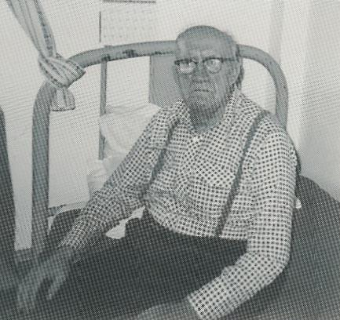
Ambrose Clinton
with a division of Canadian soldiers. I can't remember much about it but he was likely an important part of his unit in the second war. He was in charge of a prisoner-of-war camp in Western Canada. Everything about Ambrose was according to the book. The rules were to be followed to the letter. Every decision was carefully considered. At 92, he is still the same. With his experience he could write a book.

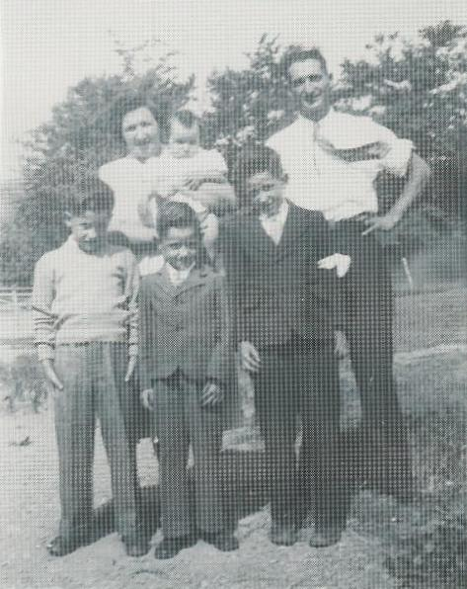

Ella (holding Linda) and Dennis DeCoste, Tony, Raymond and Hughie (1950)

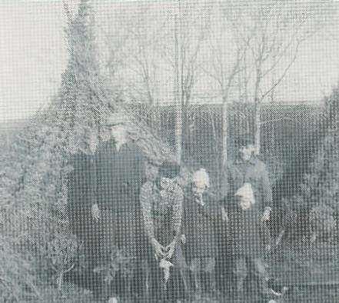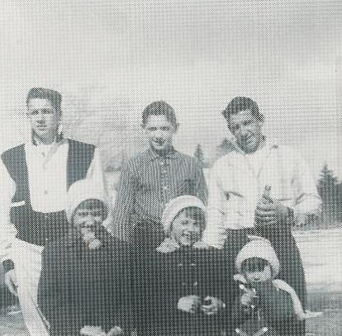
Hughie, Tony, Linda, Raymond and Judy Tony, Raymond, Hughie, Linda, Judy and Shirley (1959)

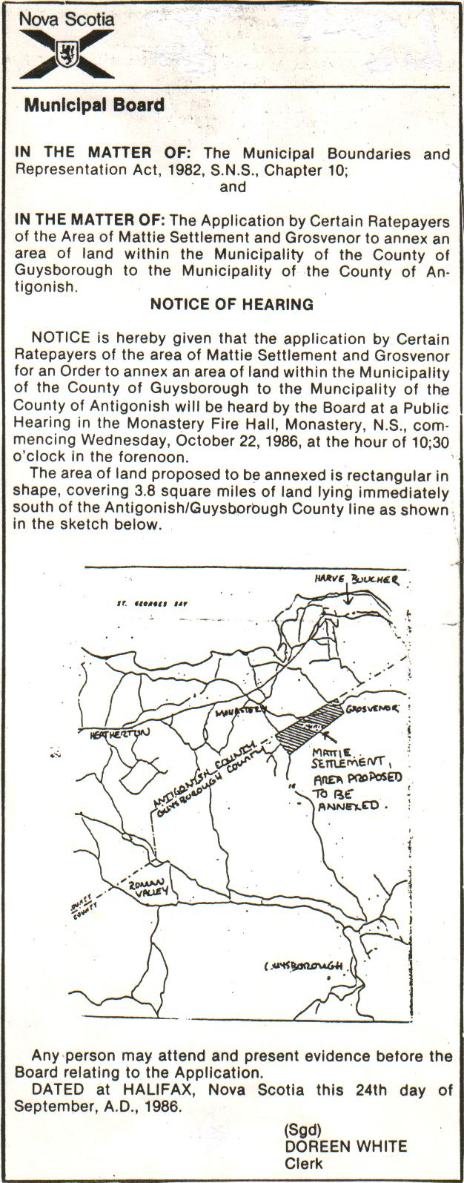
In 1986, after all our school age children had attended school in Tracadie and Monastery, Antigonish County, for twenty years, the school board threatened to send In 1986, after all our school age children had attended school in Tracadie and Monastery, Antigonish County, for twenty years, the school board threatened to send them back to Guysborough school without our consent. They had not reckoned with our determination. So after bingos, dances and donations, we raised $15,000 to pay lawyers, surveyors and auditors. We had a two day public hearing and changed the boundaries of the county. As far as I know this was a first in Nova Scotia, maybe even in the Maritimes.
them back to Guysborough school without our consent. They had not reckoned with our determination. So after bingos, dances and donations, we raised $15,000 to pay lawyers, surveyors and auditors. We had a two day public hearing and changed the boundaries of the county. As far as I know this was a first in Nova Scotia, maybe even in the Maritimes.

THE

HISTORY

OF

GROSVENOR

AND AREA

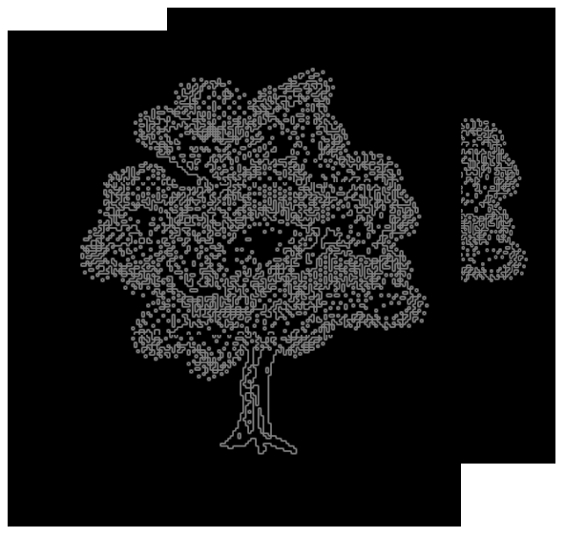

INTRODUCTION

These typed pages are part of the last Grosvenor School Yearbook, set up by Ann Wallace in 1958-1959. As it was written thirty years ago, notes (in italics) have been added by Mr. D. DeCoste to make the reader aware of some, although not all, of the changes in the area over the years

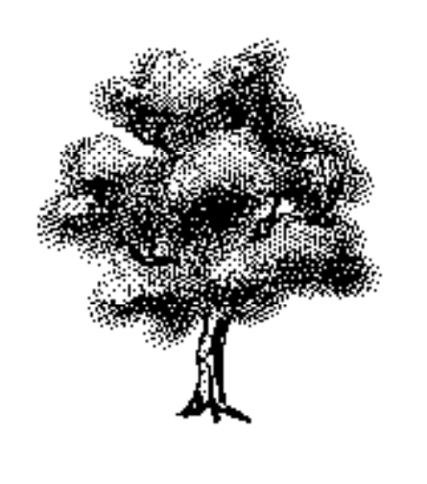

THE HISTORY OF GROSVENOR

The first settlers in Grosvenor came from England. They were a family of Smith's. The next settlers were the O'Neills and Somers' who came from Ireland around 1820. The Tait's came next. The first official name of the settlement was The Back Lands of Little Tracadie. In 1875 the name was changed to Grosvenor, at the suggestion of Mr. Hadley who was at that time Postmaster at Mulgrave.
The first business in the district was a sawmill that was owned by George Howard from Wallace. The Somer's mill that is now in operation was first located in Mattie Settlement. A small grocery store was for a time operated by Catherine Mann.
There has never been a church in the district, but in the days before transportation to Mulgrave or Tracadie services were as easily provided as they are today, a priest used to come to say Mass in one of the homes.
Mass was therefore said in the homes of Neil MacIsaac and Alex Tait. The MacIsaac home is now owed by Albert Green, and the Tait home is now owned by William Tait.
The district however has its own cemetery. The first person to be buried there was Mary MacIsaac who was born in 1842 and who died in 1855. The land belonged to this girl's father, and was part of the property that is now owned by Albert Green. The last person buried there was John M. MacKeough who died in 1958. (Since this, Archie MacKeough, Albert Green and the last Catherine, Mrs. Albert Green (died-1988) were buried there.)
At first the mail was carried to Grosvenor from Linwood. Early mail carriers included the late Robert Tate, the late John MacKeough, and Albert Green. The Post Office was at the home of Samuel O'Neill (ancestor of Leonard O'Neill-M.P.). From there it went to Alex Tate's. Mary Ann Tait was the next postmistress. Then the mail route was changed to Monastery from Linwood. The carrier from that time until the present day was William A. Tait, and the Post Office has been at the home of Alexander Tait.

MATTIE SETTLEMENT

The first settlers in Mattie were Cartoes who came from France. (According to the Delorey's, who claim to be descendants of Cartoes, the reason the Cartoes were not mentioned very much was because that family consisted of seven girls.)
The oldest house in the district now is the one owned by Mrs. Margaret Delorey. Mattie has always been a part of the parish of Tracadie.
The first sawmill in Mattie was built by Ephriam Mattie (for more information, see "The Upper Village", page 11). It was bought by the late John Somers of Grosvenor, and was later operated by his son the late Thomas Somers. It was finally destroyed by fire, and was rebuilt in Grosvenor.
In 1945 a very tragic fire in the district claimed the lives of Mrs. Thomas DeLorey and her two children. The victims were buried in Tracadie. Funeral Mass was said by Rev. Walter Roberts, P.P.

Among the natives of Mattie Settlement were the following: Ann Mattie, Ada Mattie who were teachers, and Mae Mattie who was a nurse.

Others include:
Mary DeCoste who taught school before leaving to work in the United States, where she now resides.
Ellen Clinton who was a nurse.
Bessie Green who was a teacher.
Anthony O'Neill M.A., Principal of Mulgrave School, who attended school in Grosvenor.
Evangeline Somers, stenographer with Trader's Finance.
Melinda Bowie, student at Saint Joseph's Convent, Mabou.
Edward Tait who served overseas during the first World War.
Mr. Swain who was killed in action during the war.

The following men served during World War II:

Ambrose Clinton Simon Bowie
Walter Carr Lawrence Mattie
Leonard Mattie, Killed in action
Arthur Mattie Pius Mattie
Anthony Mattie Francis Mattie
Damian DeCoste William DeCoste
Thomas Huntley William Mattie
Howard Isnor

Brother Bernard, Order of Saint Augustine, the former Alphonsus Mattie of Mattie Settlement are also a former students of Grosvenor School. (Brother Bernard left the Order of St. Augustine and is married and doing social work in Toronto.)
Other people who attended Grosvenor School- members of the DeCoste family- were Hughie DeCoste, who drives a truck for Loebs in Toronto; his wife Patricia (nee Bowie), a Dietician at Oshawa General Hospital; Linda DeCoste, Co-ordinator of Cancer Research at St. Michaels Hospital in Toronto; Judy Morley, manager of Accounting at Royal LePage in Toronto; Shirley Thompson, word processing secretary at the Hospital for Sick Children in Toronto; Tony DeCoste, boilermaker; Raymond DeCoste, boilermaker.

GROSVENOR SCHOOL

The first school was built on the Linwood road about 1800. The first teacher was Michael Green. The present school was built in 1860 on a plot of land that is now at the point where the Linwood road meets the main road. The carpenters were Eli Perrault and James Tait. William Tait was in charge of the project. The first teacher was Mary Ann O'Connor. While the school was located on this site one of the pupils was Mr. John Pitt, who is still living in Grosvenor.
When the section boundaries were moved to include Mattie Settlement it was decided to move the school to a more central location. It was consequently moved to its present site. In 1930 it was enlarged and placed on a concrete base (now Pattie DeCoste's home).

Teachers since 1899 included:
Annie MacLennan 1899-1900 Ann MacKeough 1900-1901
Katherine Chisolm 1901-1902 Annie Fitzgerald 1902-1904
Angus Gillis 1904-1906 J.J. MacGrath 1906-1907
Alice Purcell 1907-1908 Bessie Green 1908-1909
Willian Fraser 1909-1910 Thomas Somers 1910-1911
Catherine Mann 1911-1912;
1919-1920; 1949-1950; 1951-1952
D. M. Chisolm 1913-1914 Isabel Grant 1914-1915
Hilda Tobin 1915-1916 Lillian Strachan 1916-1918
Mary A. Somers 1918-1919 Louise M. Grant 1920-1921;
1923-1924
Mary MacIsaac 1921-1923 Flora MacIsaac 1924-1926
Isabel MacPherson 1926-27 Katherine MacGillivary 1927-1928
Anna MacDonald 1928-1929 Mary Daigle 1929-1930
Mary DeCoste 1933-1936 Helen Stuart 1931-32
Mary Carey 1936-1937 Alice Morrison Tait 1937-1939;
1942-1947; 1950-1959
Marjorie Cogswell 1939-1941 Elizabeth Connors 1941-1942
Christina MacKeough 1947-1948 Grace Somers 1948
Teresa Carrigan 1948-1949 Joe Connolly 1949-1950
Emily MacKeough 1954-55 Mrs. Bill MacKeough 1955-1956
Ann Walace 1956-1959 Mrs. Alice Tait 1959 -1967

(the Grosvenor School closed in 1967, children from Mattie now attend school in Tracadie)

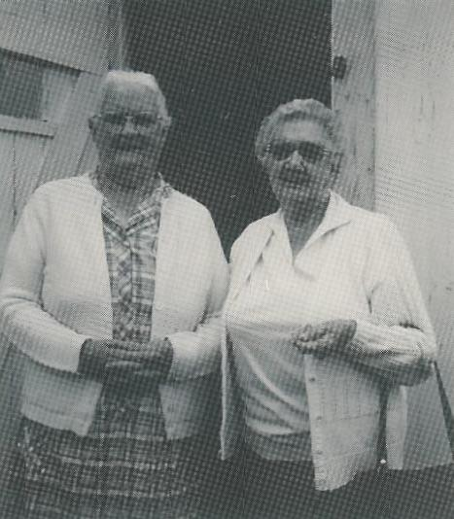

Mrs. Alice Tait and Mrs. Dennis DeCoste
GROSVENOR NATIVES

Sister Mary Antoinette (Margaret Tait), she entered the Order of Saint Francis in 1919. She is presently Mother Superior in a convent in Rhode Island.
Sister Margaret Ann (Margaret Tait), she entered the Order of Faith of Our Fathers in Rhode Island in 1801.
Mary Grace Somers; she completed her high school course at Mount Saint Bernard in 1945 at the age of fourteen. On this occasion she was awarded the Governor General's Medal. Four years later she graduated from Saint Francis Xavier University with the degree, Bachelor of Arts, Magna cum laude (with great distinction). She later received an MSc. degree from the University of Illinois. In June 1956 she was awarded a PhD in biology from Radcliffe College, which is affiliated with Harvard University, Cambridge, Mass. She is presently on the faculty at the University of Iowa, as is her husband Lucien Brush PhD.
Francis Elizabeth Somers; she attended Saint Joseph's Convent Mabou and Saint Francis Xavier University from which she received her BSc. degree in Home Economics in 1952. She successfully completed a year of internship at Saint Michael's Hospital in Toronto, thus securing her diploma as a registered dietician. She now resides in Halifax with her husband Roland MacDonagh and her three children. She has been on the staff of Camp Hill Hospital, Halifax.
Catherine Mann; a teacher who has made a noticeable contribution to education in the elementary schools of Eastern Nova Scotia.
Grace, Mary Alice, Margaret Somers; These three teachers were among the first teachers to go from Eastern Nova Scotia to teach in the Canadian West.
Thomas Somers, who as a teacher and business man made an outstanding contribution to advancement of Grosvenor.

ACKNOWLEDGEMENTS

Research for all the material of the history of the districts and the school was done by Jeneva Bowie and Maureen Tait.
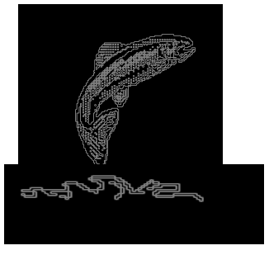
To the reader:
It is hard to be exact when one is reminiscing, but as these pages have been written according to my memories I apologize where my facts have been inaccurate.

I also make apologies for the important people and facts that are left out due to lack of information. Somewhere, someone may have them.

Dennis

Acknowledgements

The family of Mr. DeCoste would like to thank all those who contributed to this manuscript by kindly giving of their time, their memories and those wonderful photographs.

•Last writing completed winter 1991.
•Last edits completed July 1992.

