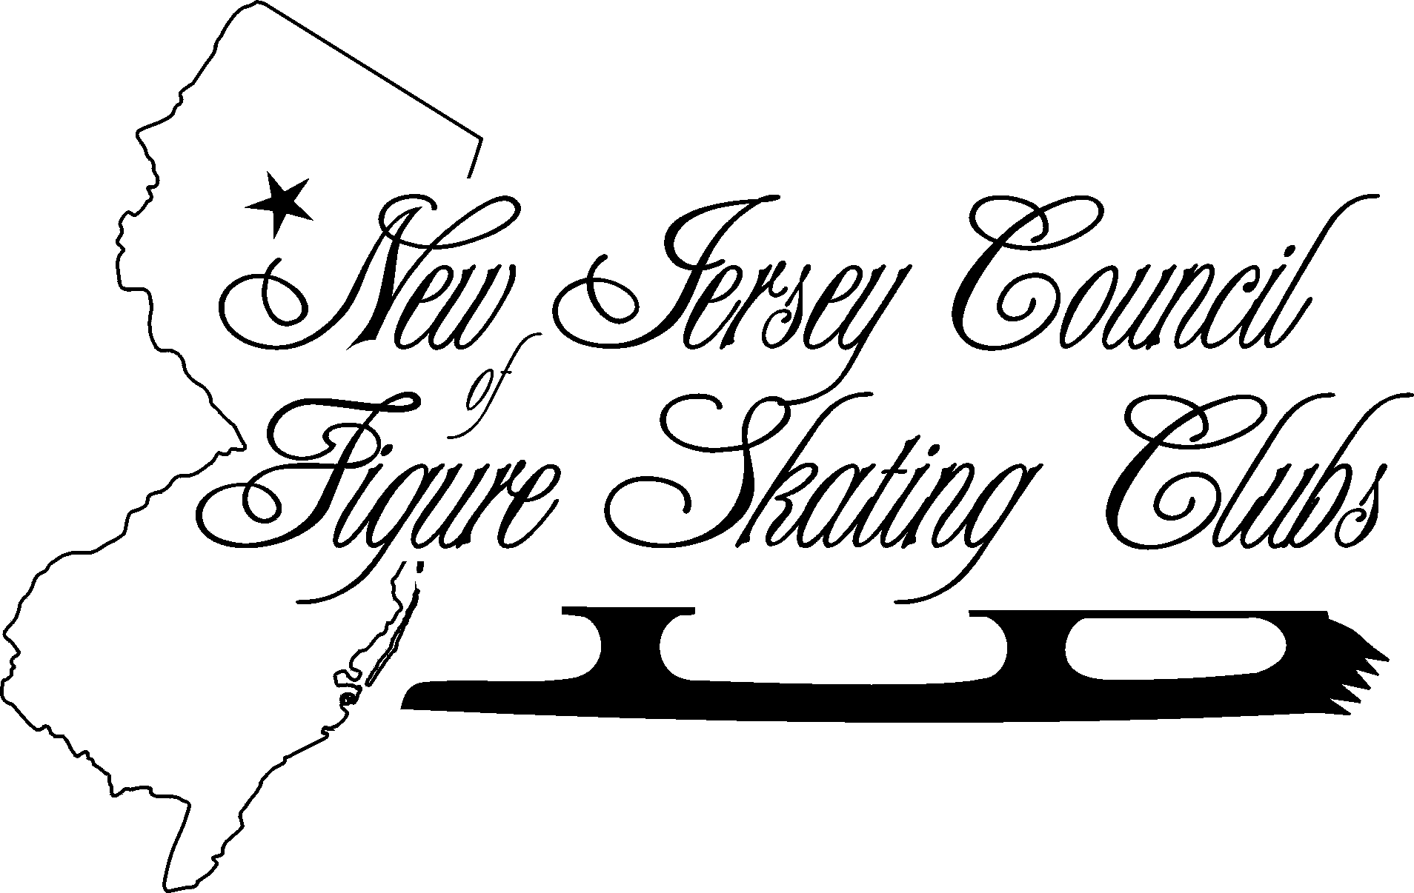

PROXY

I, _____ _________ DELEGATE of ______________________________
(PRINT NAME) (PRINT VOTING CLUB NAME)

do hereby constitute and appoint one of the following with full power to vote in my name as my proxy at ANY Regular Meeting of the New Jersey Council of Figure Skating Clubs during the 2006-2007 Season.

□ Elizabeth M. Field, NJCFSC Vice-President
□ Susan M. Welsh, NJCFSC Secretary
□ Jay Leslie, NJCFSC Treasurer

________________ _________________
SIGNATURE DATE

___________________________ __________________
E-MAIL ADDRESS* PHONE

If you or your alternate can not attend a NJCFSC regular meeting, please sign and return your proxy by regular mail, fax or e-mail to:
Susan Welsh
73 Sam Bonnell Drive
Clinton NJ 08809
By e-mail to Secretary Susan M. Welsh at susan.welsh@patmedia.net
By FAX to Susan M. Welsh at 908-218-4610

To activate your PROXY, your notice must be received by mail, fax or e-mail no later than Friday before the scheduled meeting.

###

