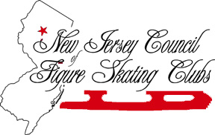
2006-2007 FULL MEMBERSHIP ORGANIZATION REGISTRATION FORM
Please type or print in each box below
Name of Organization
Type of Organization | □ USFSA Club □ College Club □Elected High School**
Club USFSA #
Registered Delegate (Required for Voting Privileges)
Name of Delegate
Office in Club
Street Address
City/State/Zip
Home Phone
Business Phone
Fax Number
E-mail address*
Delegate USFSA #
Occupation
Company
Designated Alternate (Required)
Name of Alternate
Office in Club
Street Address
City/State/Zip
Home Phone
Business Phone
Fax Number
E-mail address*
AlternateUSFSA #
Occupation
Company
Please return this form by September 1, 2006 to:
Susan M. Welsh, NJCFSC Secretary, 73 Sam Bonnell Drive, Clinton, NJ 08809
or FAX to 908-218-4610 or e-mail to susan.welsh@patmedia.net
No dues are required with your registration.
Note: Organizations must be full member clubs of the USFSA in order to exercise voting privileges with NJCFSC. *E-mail capability is required for communication. **Only the high schools (one private, one parochial, and one public) elected by the High School Network should use this form. All other high schools should use the High School form.

