- Photographed by Hamad Al Shuaily, SQU

PYROXENEZIRCON
ZIRCON
TURMALINE

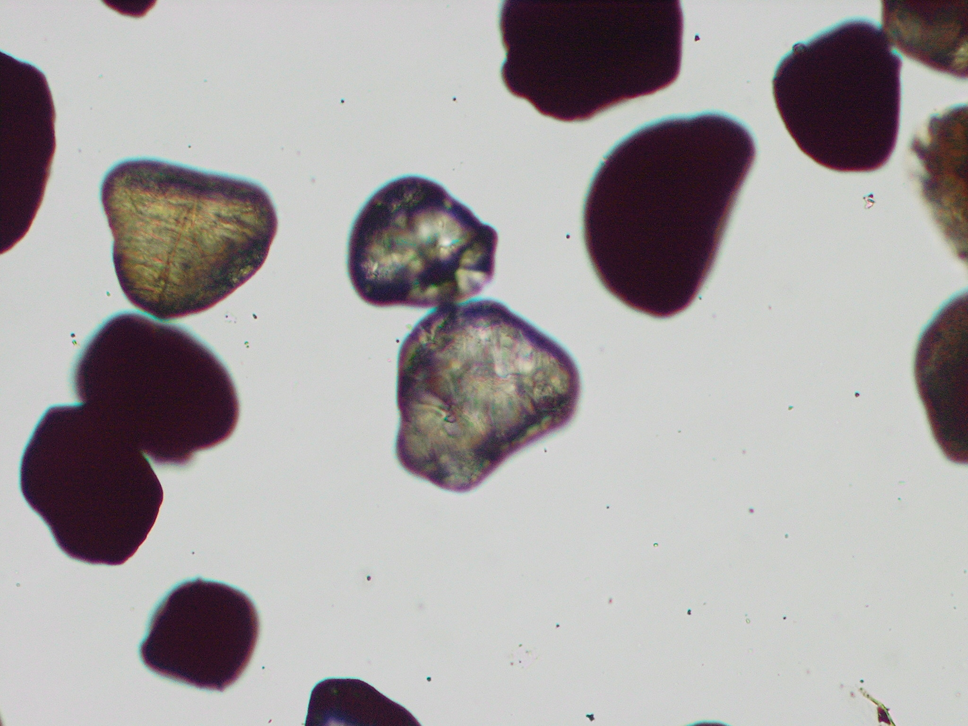
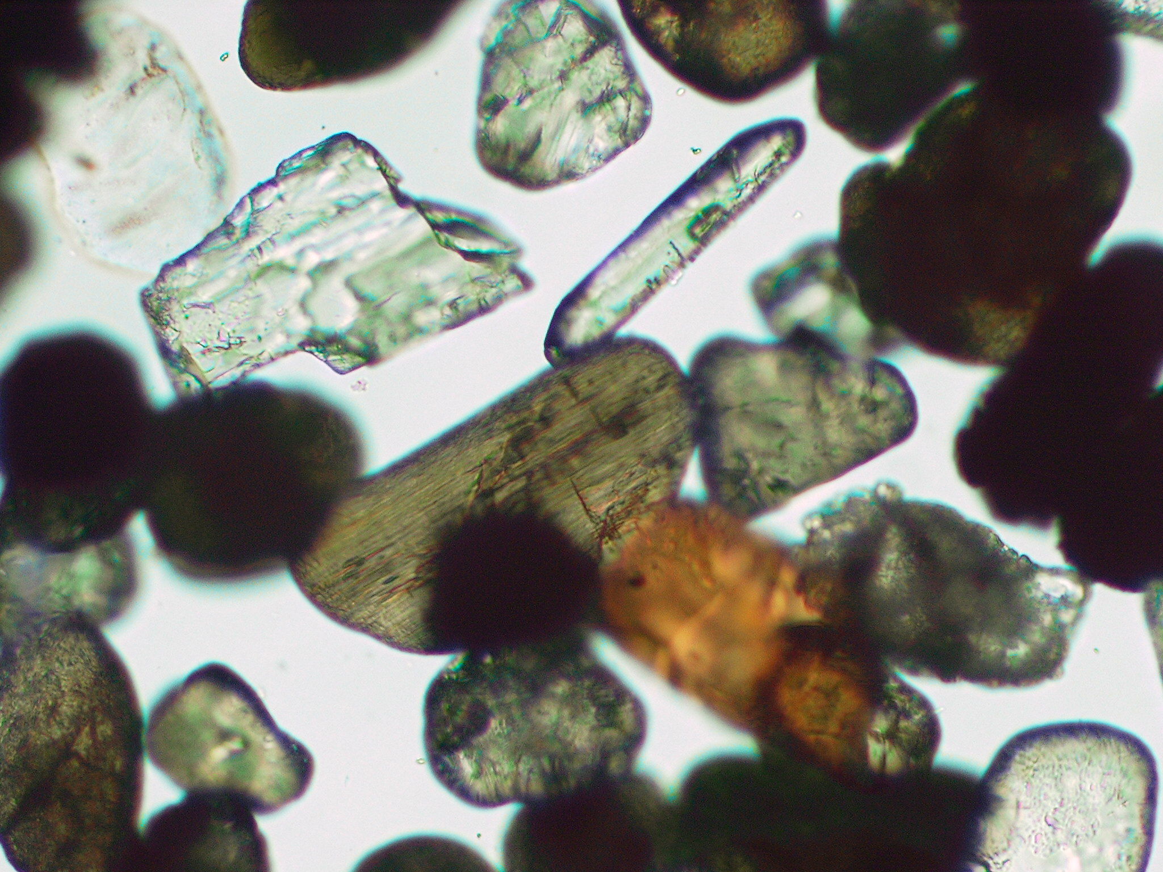

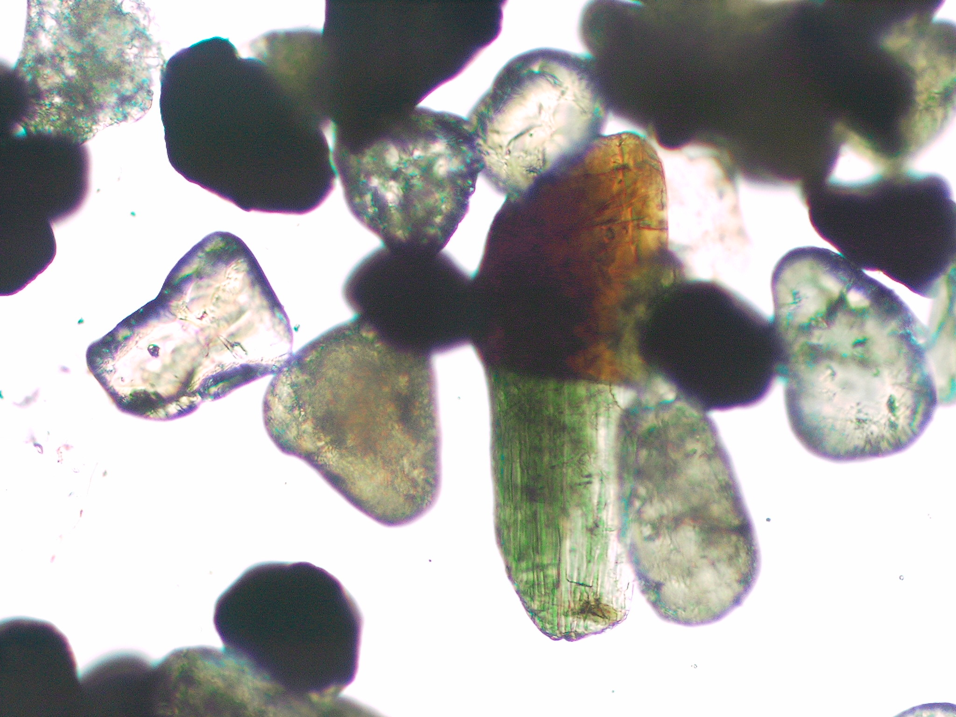
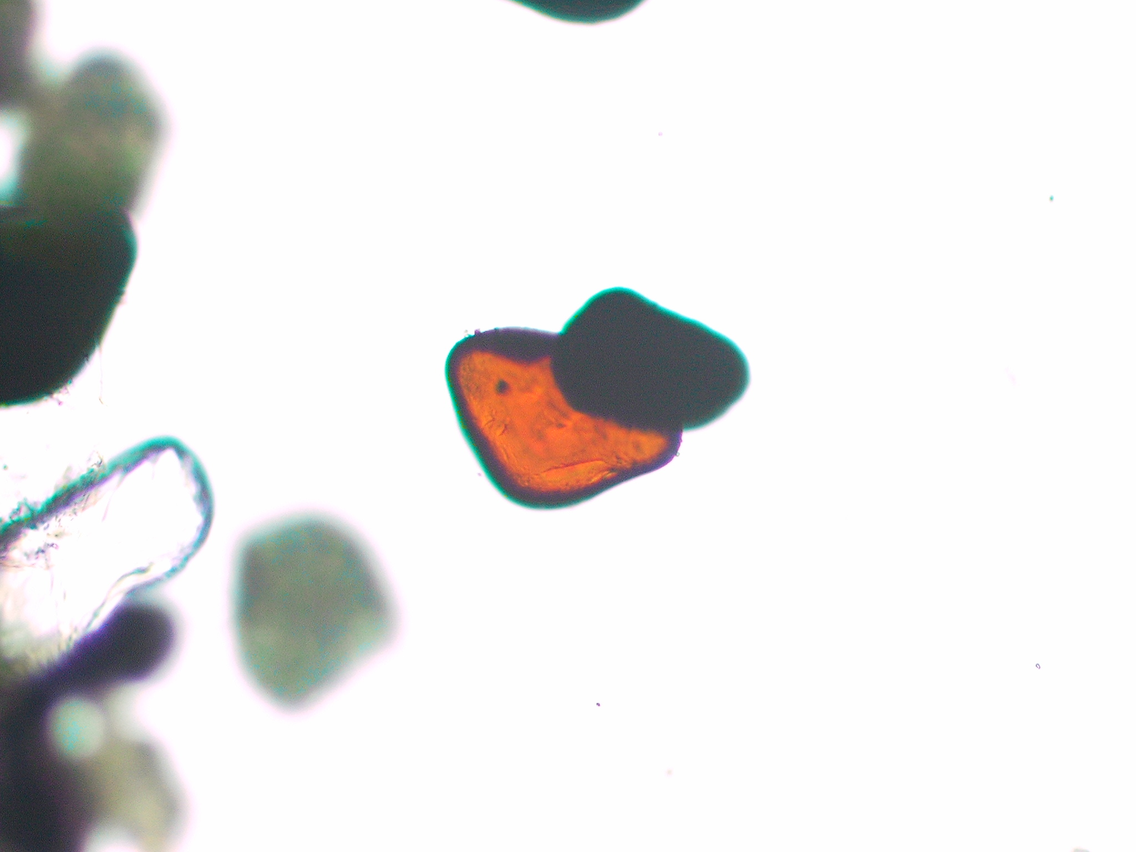
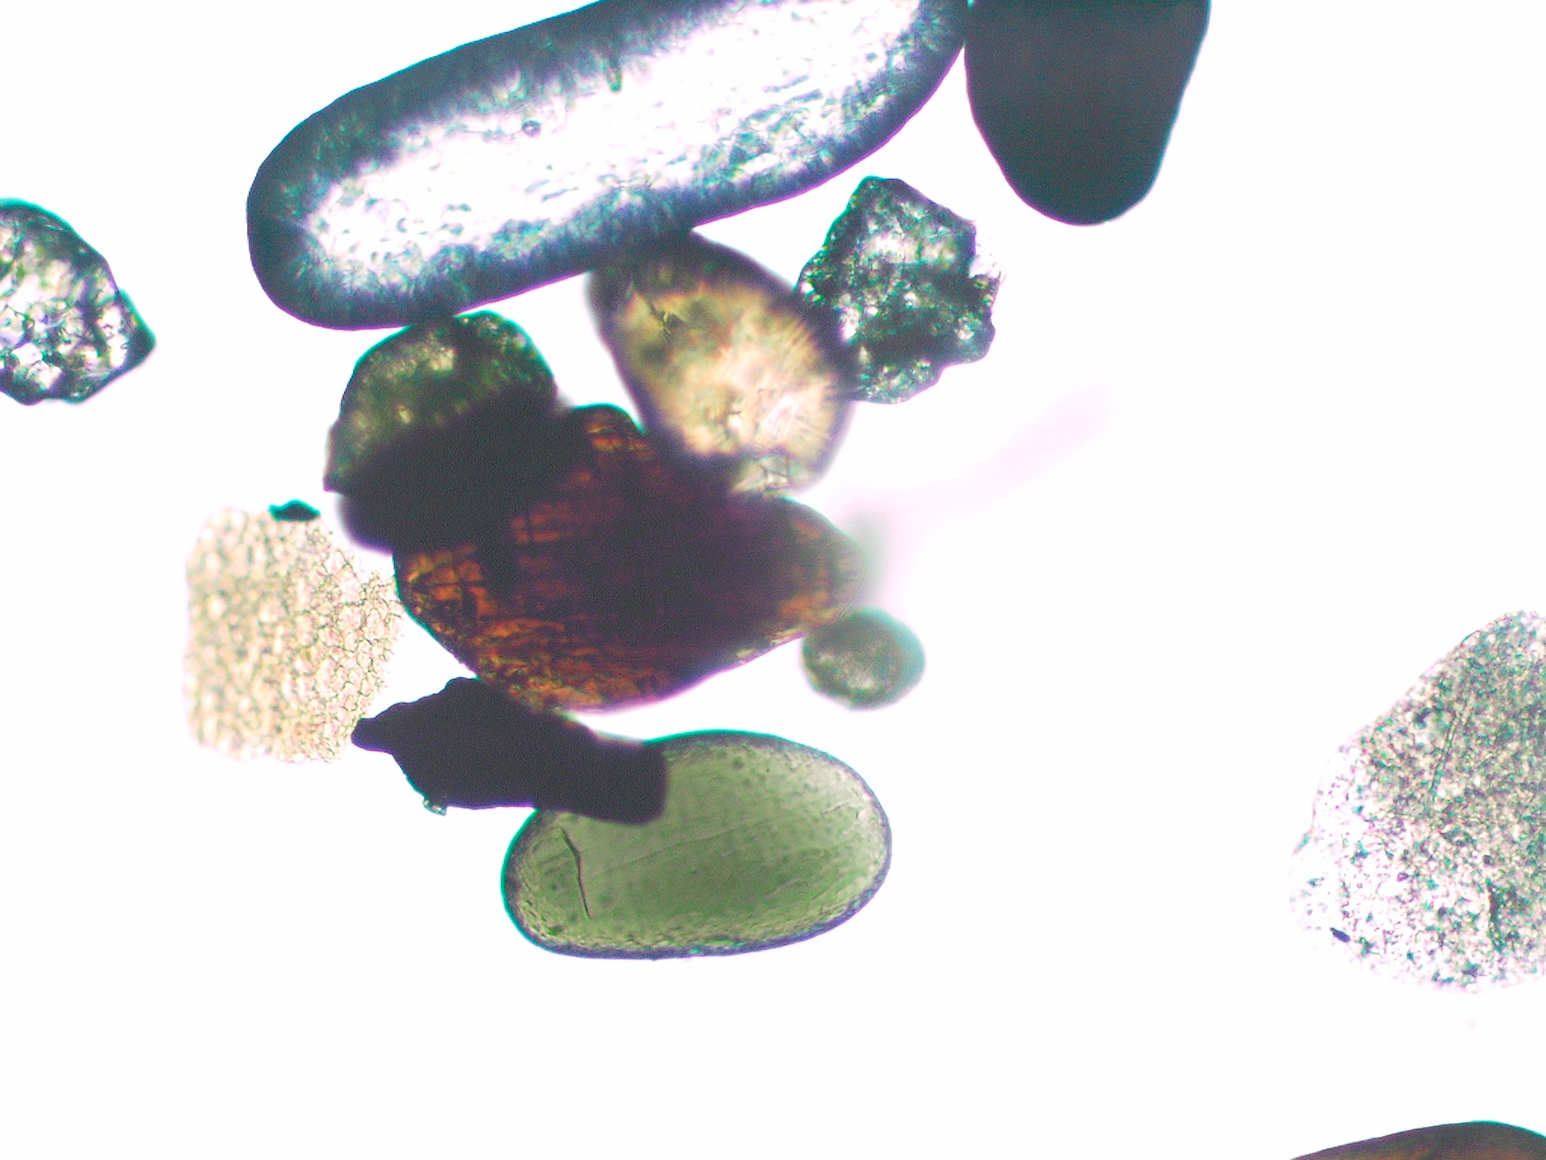
RUTILE
ZIRCON
HORNBLENDE
RUTILE
TOURMALINE
RUTILE
EPPITODE
RUTILE

