Censorship on the sly
Yes, even in death Stanley kubrick can't escape the censors. This time, rather than scenes being cut, shots have been digitally amended for the American video release.
Scene 1: Notice the two digitally amended characters.
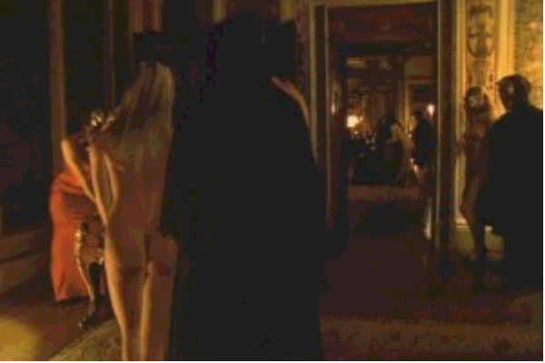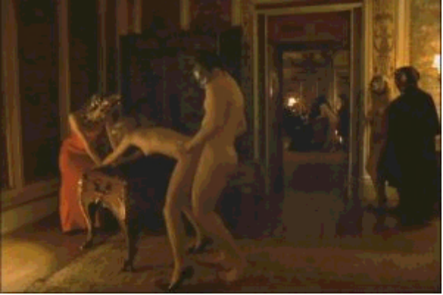
Scene 2: Two hooded characters were digitally added to block some activity..
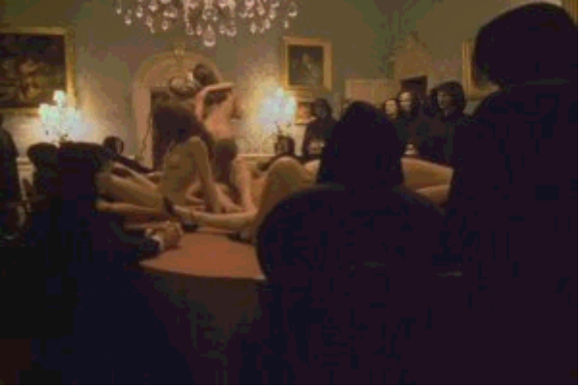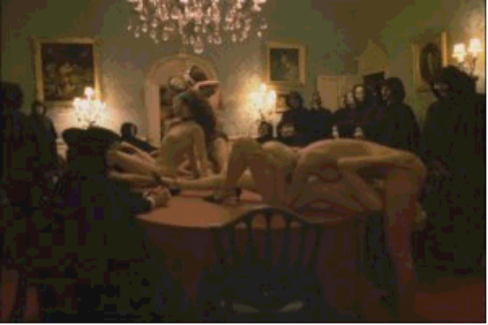
Scene 3: An entire second bench was digitally added with characters to hide some nastiness.
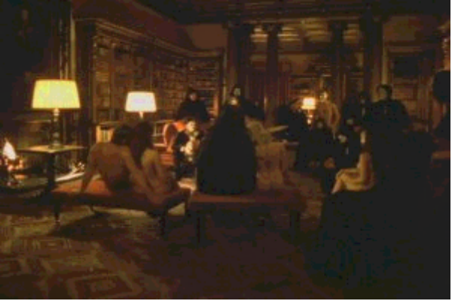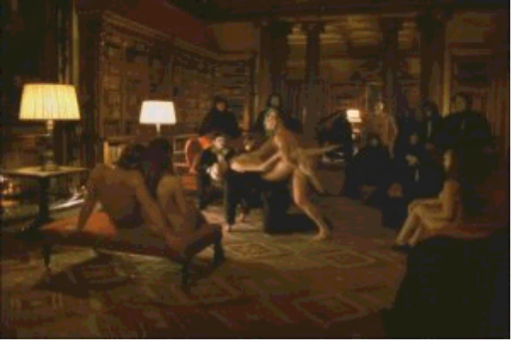
Scene 4: Two mannequin like figures block activity on a credenza.


