STEP ONE: EXTRACTING CHEEK CELLS

Materials needed:
- Pen for marking
- Dixie cup with a crimped spout
- Put all three of your initials (SMH) on the following:
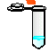
- 2- 1.5 μ tubes
- 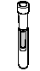15 mL centrifuge tube
W/. 9% saline
- 1 Paper cup 
    - Make a spout on your paper cup

Write your initials CLEARLY on the 15ml centrifuge tube containing sterile saline, on the paper cup, and on two 1.5μl micro centrifuge tubes (label tops).

STEP TWO: SLOSHING

Only 6 people can go TO THE CENTRIFUGE at a time. Only slosh if you are going to the centrifuge.

Pour all of the saline solution into your mouth, slosh it around VIGOROUSLY for 10 seconds, and expel it into the paper cup.
Why saline?
The salt keeps the cheek cells in proper osmotic balance so they don’t burst. This is an isotonic state. IV’s are .9 saline solutions also for proper osmotic balance.
STEP THREE: CENTRIFUGE

After expelling your saline and cheek cells into a paper cup, pour the solution back into the 15mL centrifuge tube, and immediately place it into the clinical centrifuge.

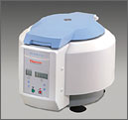

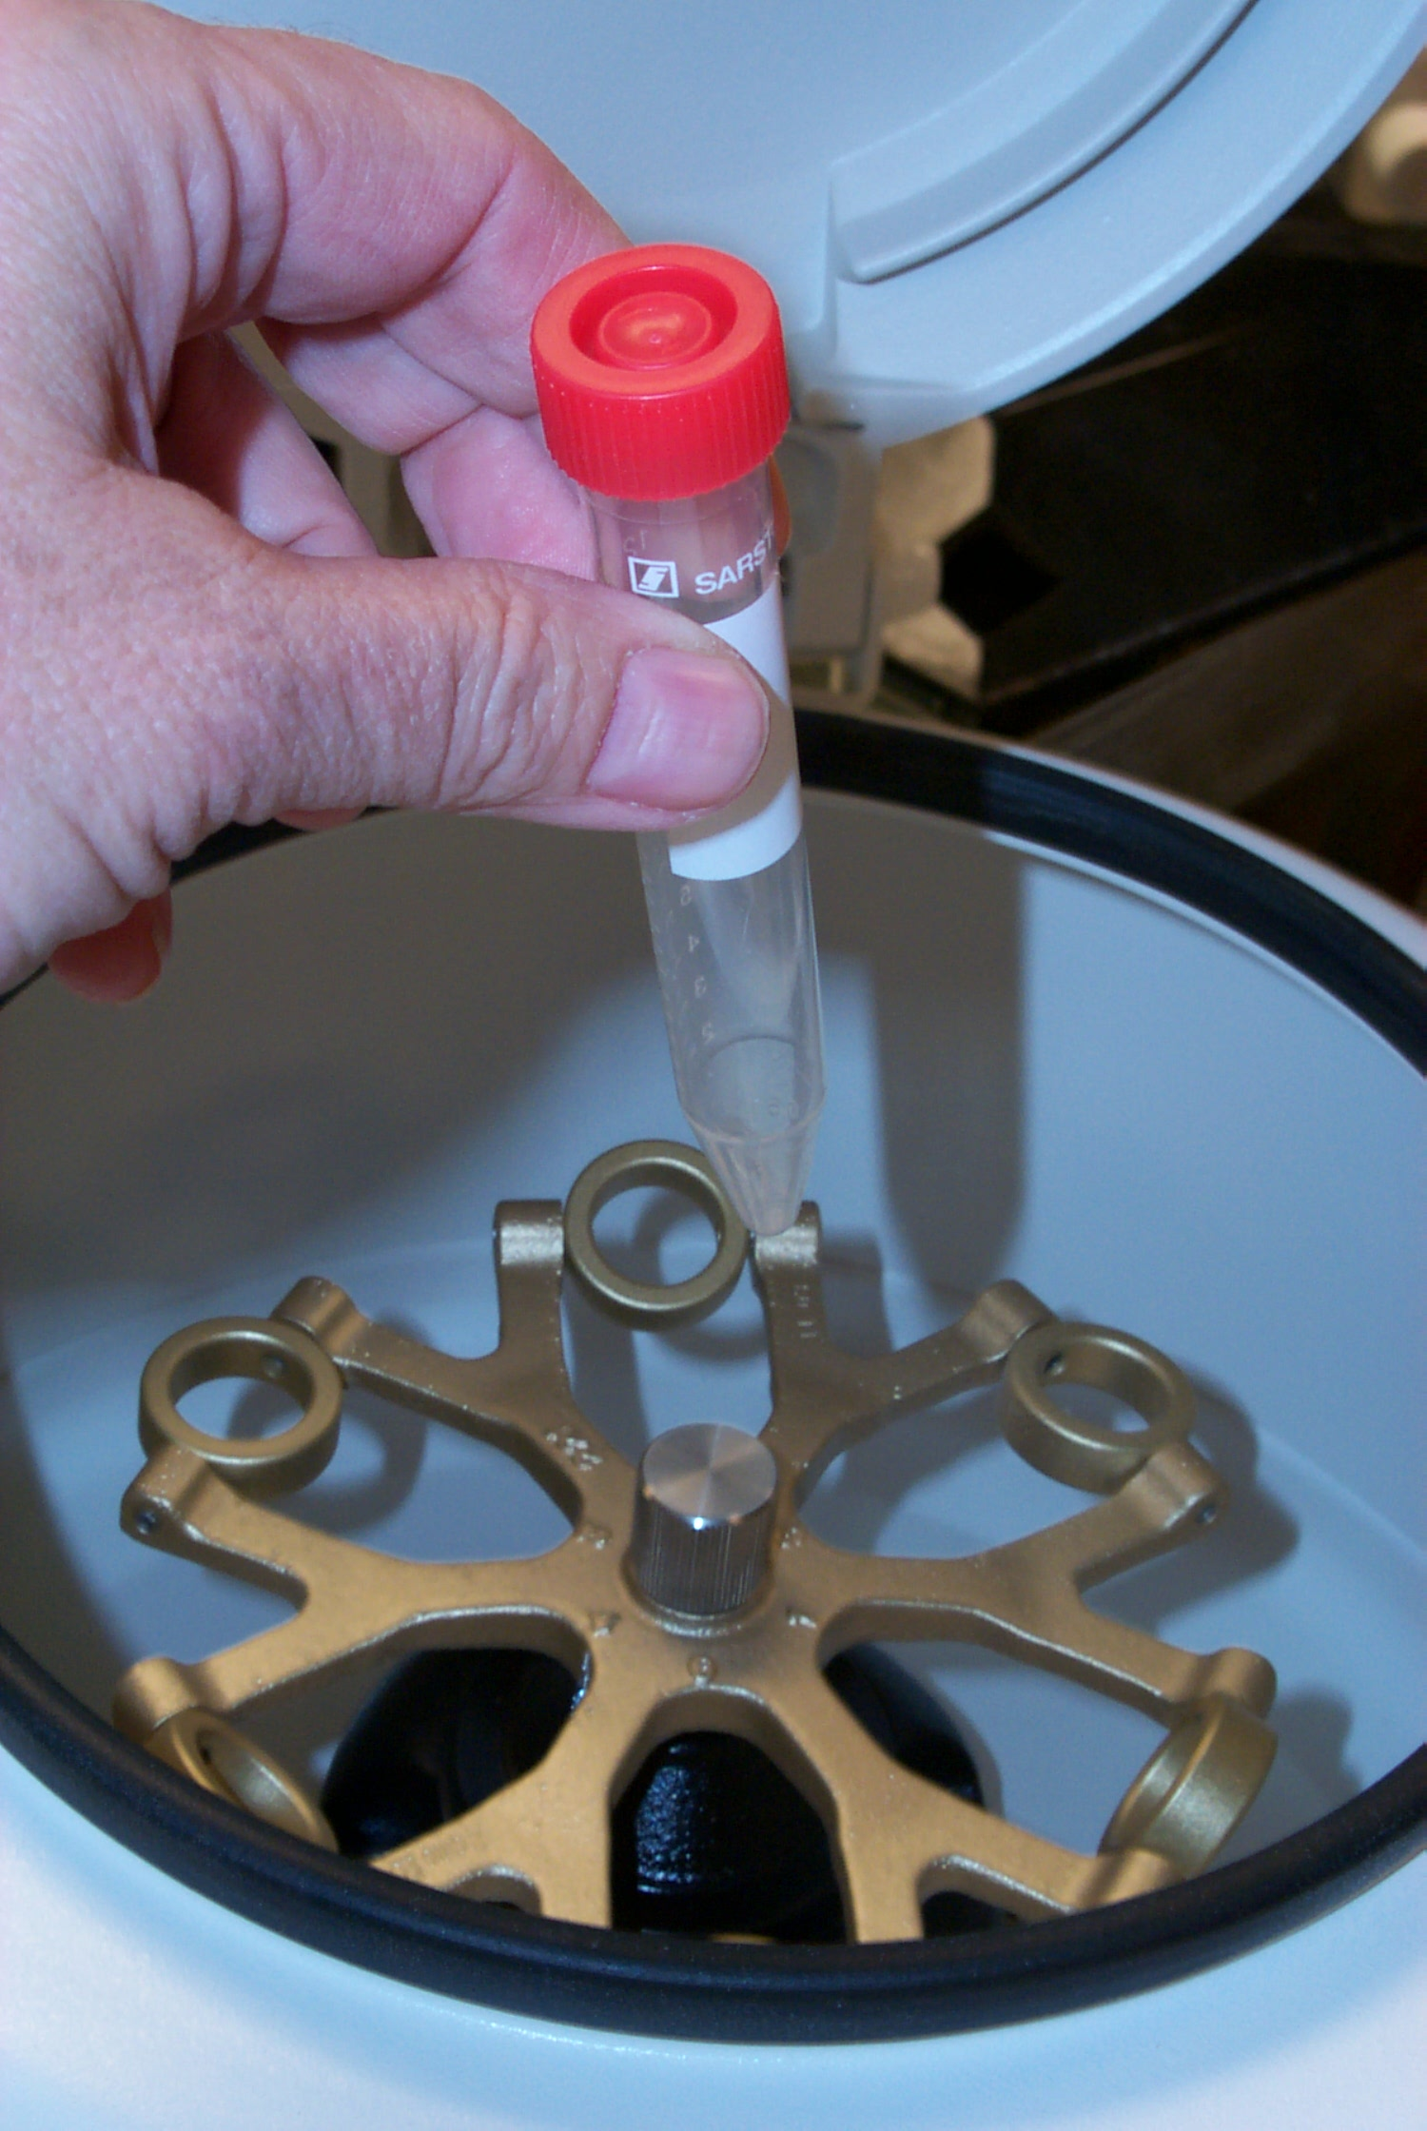

STEP 4: CENTRIFUGE
Spin (centrifuge) cells 10 minutes at maximum speed in the centrifuge. This is pre-set you do not have to set it for ten minutes.
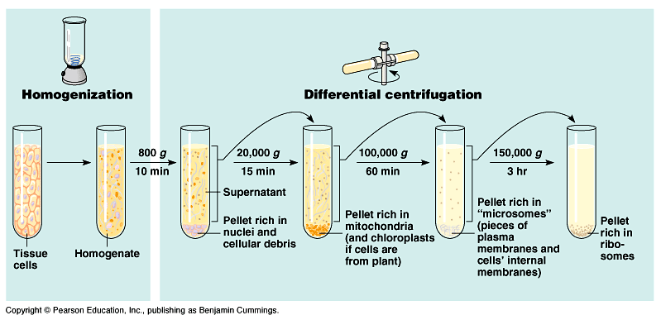
This is called cell fractionation. The reason for 10 minutes is to suspend the nuclei.

STEP 5: POURING SUPERNATANT

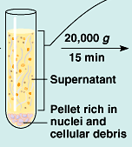
Supernatant is the liquid above the pellet shown in the picture above. Make sure you pour only the supernatant out and do not disturb the pellet that contains DNA.
Try not to tip the tube back and forth; this will re-suspend the pellet and lose cells.
Being careful not to disturb the pellet, pour the supernatant into the paper cup. Try not to tip the tube back and forth; this will re-suspend the pellet and lose cells. Remove as much supernatant as possible; when you notice the pellet starting to loosen stop pouring. (Additional supernatant can be removed with a 1000 μL pipette.)

STEP 6: ADDING CHELEX

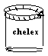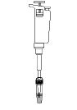

- Using a 1000μL pipette set at 500μL, pipette the Chelex suspension up and down to re-suspend the beads.
- Immediately pipette 500μL of Chelex suspension into your cheek cell pellet.
What does Chelex do?
The Chelex is made up of negatively charged microscopic beads that chelate or grab metal ions out of solution. It acts to trap metal ions, such as Mg+, which are required as catalysts or cofactors in enzymatic reactions. Your cheek cells will then be lysed or ruptured by heating to release all of their cellular components, including enzymes that were once contained in the cheek cell Lysosomes. Lysosomes are sacs within the cells cytoplasm that contain powerful enzymes, such as DNAses, which are used by cells to digest the DNA of invading viruses. When you rupture the cells, these DNAses can digest the released DNA of interest. However when the cells are lysed in the presence of the Chelex the cofactors are adsorbed and are not available to the enzymes. This blocks all enzyme degradation of the extracted DNA and results in a population of intact genomic DNA molecules that will be used as the template in your PCR reaction.



- Pipette up and down to mix resin and cells, and then transfer ALL OF YOUR cell pellet and resin to a 1.5 μL micro centrifuge tube.
- Check to make sure cap is on tight and is secure.

Make sure you disrupt the pellet by mixing the chelex and the pellet by pipetting up and down several times!

Tip: Do not invert the pipette tip! Make sure it is pointing down.
STEP 8: WATER BATH

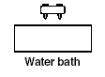
10 MINUTES

10 minutes.
WATCH OUT FOR POPPING LIDS BE READY TO RESCUE THEM WITH FORCEPS!! DO NOT LEAVE UNATTENDED!

- Place tube in “floater” rack and boil for 10 minutes.

Why water bath? This softens the plasma membranes and releases clumps of cells from each other. The increased temperature also acts to inactivate enzymes such as Dnase’s that will degrade the DNA template.
STEP 9: WATER BATH TO ICE!

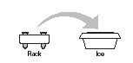

Remove tube from HOT WATER bath with forceps and place on ice for about 1 minute.
Why boil? The boiling ruptures the cells and releases the DNA from the cell nucleus. Your extracted genomic DNA will then be used as the target template for PCR amplification.

PLACE ON ICE!!!!! 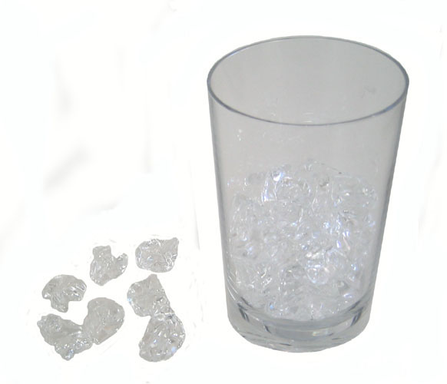
STEP 10: MICROCENTRIFUGE

Spin tubes in micro centrifuge (top speed) for 1 minute to pellet Chelex resin and impurities.

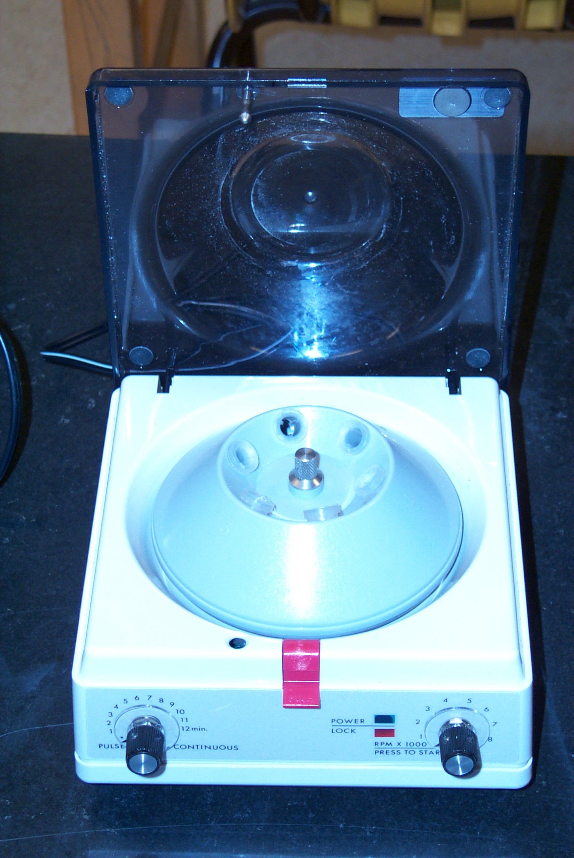

SPIN TIME: 1 minute

Tip:
Place the spine facing in TO THE CENTER OF the centrifuge.

This clear liquid above the pellet is the supernatant; this is where your DNA is! Do not put your tip into the pellet. Make sure you stay away from the pellet. It has impurities that could contaminate your DNA.

DNA
- Using 1000μL pipette, transfer 200μL of supernatant to clean, labeled 1.5μL micro centrifuge.
- Place on ice, or in freezer if not proceeding directly to PCR.
- This is your DNA sample.
- It will remain stable at -20°C for a few months.

NOW YOU ARE READY TO ADD YOUR DNA TO THE PCR MIX!!

THIS CONTAINS 27 μL OF PCR MIX

- Get a PCR tube from your teacher.
- Label your PCR tube with your initials.
- The PCR tube will contain 27μL of PCR mix that your teacher has prepared for you.
- These tubes are fragile, and should be handled only in the special racks provided.
- If you take one out and squeeze it slightly it will crack and leak!
- When you HAVE to remove it from a rack, handle it gently near the top.

The base is the most fragile part.

Tip: KEEP ON ICE AT ALL TIMES!!
What is in the PCR mix?

- DNA template (Your DNA)
- Individual deoxynucleotide
bases (A,T,C,G)
- TAQ Polymerase
- Magnesium ions a cofactor
(Catalyst) required by DNA
Polymerase to create the DNA
chain.
- Oligonucleotide primers pieces
of DNA complementary to the
template that tell DNA
Polymerase exactly where to
start making copies.
- Salt buffer, which provides the
optimum environment and pH
for PCR reaction.
Tip One:
Use all three initials on sides and top of micro centrifuge tube.
Tip two:
The heat from your hands on the bottom of your tube can ruin your DNA. That’s because you’re HOT!
Hold the tube near the top gently.
The PCR machine or thermocycler will run through 30 cycles.

Keep your DNA on ICE AT ALL TIMES when you are not adding reagents to it!
- You are now going to add 3 micro-liters of DNA to the PCR mix that is in your PCR tube.

- When adding the 3μL to your PCR mix place the DNA on the side of the PCR tube so you can see it is in the tube.
- Show your teacher!

That is your DNA! This is very small. Make sure you do not pipette it back into the pipette.

What is TAQ Polymerase?
This is DNA polymerase that has been isolated from a heat stable bacterium (Thermus aquaticus). Which in nature lives within the steam vents in the Yellowstone National Park. For this reason the enzymes within these bacteria have evolved to withstand high temperatures (95 degrees C) also used in each cycle of the PCR reaction.

- Mix gently by placing in micro centrifuge (use adaptors and balanced configuration-teacher will demonstrate).
- Pulse briefly at maximum speed.

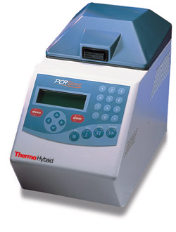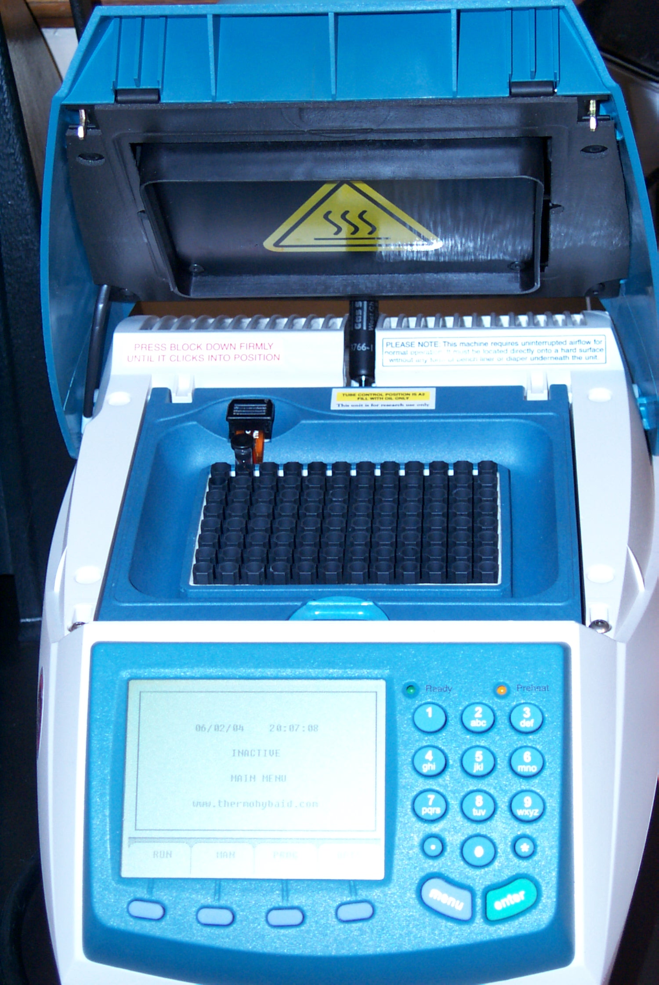
NOW IT IS TIME TO AMPLIFY YOUR DNA!
- USE THE SIGN UP SHEET PROVIDED TO SIGN UP FOR YOUR SLOT IN THE PCR MACHINE.
- PLACE ALL 3 INITIALS ON IN THE SLOT.
- Place tube in rack, secure cap with cap tool.
- Place in thermal cycler

- Denature Strands 95° C
- The temperature is so hot the hydrogen bonds between the bases break and the two strands separate.

- Hybridization 58° C
- The primers anneal (bond) to the parental strands. Remember these primers are specific for the locus that is being amplified.

- DNA Synthesis 72° C
- Taq Polymerase loves this temperature and starts elongating the strands by adding the complementary bases.

In our lab we repeated the cycle, 30 times.

