Student Guide to DNA Fingerprinting by PCR
Exercise 1: Isolation of Cheek Cell DNA

Introduction: In this exercise, each student will isolate DNA from his or her cheek cells (“mouthwash DNA”); this DNA will later be amplified by the polymerase chain reaction (PCR). Cheek cells will first be collected, by rinsing out your mouth with a saline solution (the salt keeps cells in proper osmotic balance so they don’t burst). They are concentrated by spinning in a centrifuge, and then boiled with a resin (Chelex). During the boiling, cells are disrupted and the DNA (now in single-stranded form) extracted in water. The Chelex removes impurities that would otherwise interfere with PCR.

Equipment:
Clinical centrifuge, micro centrifuge, 1000μl pipettes, thermal cycler, boiling water bath with distilled water, floater.

Supplies: 15ml conical centrifuge tubes, paper cup, 1.5μl micro centrifuge tubes (two for each reaction), blue pipette tips, ice bucket, gloves and forceps.

Reagents: 10ml of 0.9%(w/v) saline (NaCl) in distilled water; 10% Chelex suspension (ion-exchange resin).

A note on cheek cells: Once cells have been collected into saline, it is important to spin and concentrate them as soon as possible before they start to burst. We will work with only 6 samples at a time, which fit into the clinical centrifuge. Once these are concentrated, we can start collecting the next set of 6 samples.

STEP INSTRUCTIONS VISUAL
STEP ONE:  Tip:  Use all three initials on sides and top of micro centrifuge tube. | Write your initials CLEARLY on the 15ml centrifuge tube containing sterile saline, on the paper cup, and on two 1.5μl micro centrifuge tubes (label tops).  Tip: KEEP ON ICE AT ALL TIMES!! | 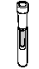Sterile Saline 15 ml centrifuge  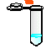  - 1.5 μl micro centrifuge tubes
STEP TWO:  Tip  Slosh your mouth side to  Side, very vigorously. Do not eat, drink OR chew gum, preferably 1 hour before lab. | Pour all of the saline solution into your mouth, slosh it around vigorously for 10 seconds, and expel it into the paper cup.  Only 6 people can go at a time. Do not start sloshing until the centrifuge reads 1 minute. Slosh until you are ready to place your centrifuge tube directly into the centrifuge.  Why saline?  The salt keeps the cheek cells in proper osmotic balance so they don’t burst. This is an isotonic state. IV’s are .9 saline solutions also for proper osmotic balance. |   Crimp one side to make a spout on the Dixie cup.
STEP THREE | Pour the solution back into the 15ml centrifuge tube, and immediately place it into the clinical centrifuge. | 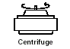
STEP FOUR:  Fact:  This is called cell fractionation. The reason for 10 minutes is to suspend the nuclei. | Spin cells 10 minutes at maximum speed in the centrifuge.
STEP FIVE  Tip:  Try not to tip the tube back and forth; this will re-suspend the pellet and lose cells. | Being careful not to disturb the pellet, pour the supernatant into the paper cup. Try not to tip the tube back and forth; this will re-suspend the pellet and lose cells. Remove as much supernatant as possible; when you notice the pellet starting to loosen stop pouring. (Additional supernatant can be removed with a 1000μl pipette.)
STEP SIX  Tip: Make sure they know to put a tip on the pipette!  When using a micro pipette be careful not to turn over or  under the maximum or minimum limits. Example: A 500 micro liter pipette should not be adjusted to 600. | Using a 1000μl pipette set at 500μl, pipette the Chelex suspension up and down to re-suspend the beads. Immediately pipette 500μl of Chelex suspension into your cheek cell pellet.  What does Chelex do?  The Chelex is made up of negatively charged microscopic beads that chelate or grab metal ions out of solution. It acts to trap metal ions, such as Mg+ which are required as catalysts or cofactors in enzymatic reactions. Your cheek cells will then be lysed or ruptured by heating to release all of their cellular components, including enzymes that were once contained in the cheek cell Lysosomes. Lysosomes are sacs within the cells cytoplasm that contain powerful enzymes, such as DNAses which are used by clls to digest the DNA of invading viruses. When you rupture the cells, these DNAses can digest the released DNA of interest. However when the cells are lysed in the presence of the Chelex the cofactors are adsorbed and are not available to the enzymes. This blocks all enzyme degradation of the extracted DNA and results in a population of intact genomic DNA molecules that will be used as the template in your PCR reaction.  . | 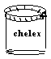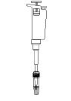
STEP SEVEN  Tip: Do not invert the pipette tip! Make sure it is pointing down. | Pipette up and down to mix resin and cells, and then transfer cell pellet and resin to 1.5μl micro centrifuge tube. Check to make sure cap is secure.  Make sure you disrupt the pellet by mixing the chelex and the pellet by pipetting up and down several times. | 
STEP EIGHT:  Tip:  Watch closely with the forceps in case the top opens due to pressure. | Place tube in “floater” rack and boil for 10 minutes.  Why water bath? This softens the plasma membranes and releases clumps of cells from each other. The increased temperature also acts to inactivate enzymes such as Dnases which will degrade the DNA template. | 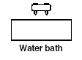  10 minutes.  WATCH OUT FOR POPPING LIDS BE READY TO RESCUE THEM WITH FORCEPS!! DO NOT LEAVE UNATTENDED!
STEP NINE  Tip:  It is critical to get the tube on ice immediately! | Remove tube from bath with forceps and place on ice for about 1 minute.  Why boil? The boiling ruptures the cells and releases the DNA from the cell nucleus. Your extracted genomic DNA will then be used as the target template for PCR amplification.  PLACE ON ICE!!!!! | 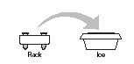  1 minute
STEP TEN  Tip:  Place the spine facing out in the centrifuge | Spin tubes in micro centrifuge (top speed) for 1 minute to pellet Chelex resin and impurities | 1 minute
STEP ELEVEN  Tip:  Remember the supernatant is the liquid on the top. That is your DNA! Do NOT get the pipette tip into the pellet you do not want any Chelex in your tip. | Using 1000μl pipette, transfer 200μl of supernatant to clean, labeled 1.5μl micro centrifuge. Place on ice, or in freezer if not proceeding directly to PCR. This is your DNA sample. It will remain stable at -20°C for a few months.  NOW YOU ARE READY TO ADD YOUR DNA TO THE PCR MIX!! | DNA

Experiment 2: PCR amplification with PV-92 (“Alu”) Primers

The true power of PCR is the ability to target and amplify a specific piece of DNA (or gene) out of a complete genome that consist of ~30,000 genes.

Introduction: This experiment examines PV92, a human-specific Alu insertion on chromosome 16. The PV92 genetic system has only two alleles indicating the presence (+) or absence (-) of the Alu transposable element on each of the paired chromosomes. This results in three PV92 genotypes (++, +-, or --). The + and - alleles can be separated by size using gel electrophoresis. The part of your DNA that actually codes for anything is only about 5% of your total chromosomal DNA or genome. The remaining 95% consists of stretches between genes, and interrupting sequences within genes (introns). Much of this non-coding DNA is thought to be “junk”, in that it doesn’t affect phenotype. For instance, our chromosomes have approximately 500,000 copies of a 300 base-pair sequence (called an “Alu” sequence). This junk “Alu” DNA actually makes up about 5% -10% of genomic DNA-as much as all out genes put together! (The presence of “Alu” sequences in our chromosomes is thanks to an ancient retrovirus in which once infected our ancestors. This virus, a distant relative of the AIDS virus, copied cellular RNA sequences into DNA and stuck then in at random chromosomal locations). Since it’s located within a non-coding portion of a gene, it doesn’t affect gene expression. This particular “Alu” insertion seems to have happened in the past million years, in a recent human ancestor. As a result, some human chromosomes have it and others don’t. It is stably inherited according to Mendel’s rules. At this particular genetic locus (PV-92), there are two alleles: Alu-present and Alu-absent. They can be detected by amplifying the locus with primers flanking the Alu insertion. After PCR amplification, the Alu-present allele gives rise to a 715 bp fragment; the Alu-absent allele yields a 415 bp fragment. These can be separated by gel electrophoresis in agarose. People can be homozygous for the Alu-present allele (one 715 bp fragment); heterozygous (one 715 bp and one 415 bp band) or homozygous for the Alu-absent allele (one 415 bp band).

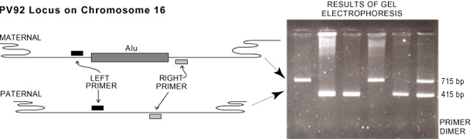

Equipment: Cycler, micro centrifuge, 100ul pipette.
Supplies: Yellow pipette tips, gloves, two cycler tubes.
Reagents: (in ice bucket)
Your cheek cell DNA
Alu PCR mix (already in cycler tube)

Note to teacher: Pre-warm thermal cycler by running program “mobovp-soak”
STEP ONE:  Tip:  Use all three initials on sides and top of micro centrifuge tube.  Tip two:  The heat from your hands on the bottom of your tube can ruin your DNA. That’s because your HOT!  Hold the tube near the top gently. | - Get a PCR tube from your teacher.  - Label your PCR tube with your initials.  - The PCR tube will contain 27 micro-liters of PCR mix that your teacher has prepared for you.  - These tubes are fragile, and should be handled only in the special racks provided.  - If you take one out and squeeze it slightly it will crack and leak!  - When you HAVE to remove it from a rack, handle it gently near the top.  The base is the most fragile part.  Tip: KEEP ON ICE AT ALL TIMES!!  What is in the PCR mix?  - DNA template (Your DNA)  - Individual deoxynucleotide bases (A,T,C,G)  - TAQ polymerase  - Magnesium ions a cofactor (catalyst) required by DNA polymerase to create the DNA chain.  - Oligonucleotide primers pieces of DNA complementary to the template that tell DNA polymerase exactly where to star making copies.  - Salt buffer, which provides the optimum environment and pH for PCR reaction. | The PCR machine or thermocycler will run through 30 cycles.  What is TAQ polymerase?  This is Dna polymerase that has been isolated from a heat stable bacterium (Thermus aquaticus)  Which in nature lives within the steam vents in the Yellowstone National Park. For this reason the enzymes within these bacteria have evolved to withstand high temperatures (95 degrees C) also used in each cycle of the PCR reaction.
STEP TWO:  Keep ice out of open tubes! | Set up a reactions as follows: (on ice- be careful to keep ice out of open tubes)  You are now going to add 3 micro-liters of DNA to the PCR mix that is in your PCR tube.  When adding the 3ul to your PCR mix place the DNA on the side of the PCR tube so you can see it is in the tube. Show your teacher! | 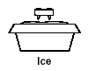
STEP THREE: | Mix gently by placing in micro centrifuge (use adaptors and balanced configuration-teacher will demonstrate).  Pulse briefly at maximum speed.
STEP FOUR:  Now you are ready to amplify your DNA!!  This is where you only need a little bit of DNA because the thermocycler amplifies it. | SIGN UP FOR YOUR PLACE IN THE PCR MACHINE. PLACE ALL 3 INITIALS ON IN THE SLOT.  Place tube in rack, secure cap with cap tool.  Place in thermal cycler | 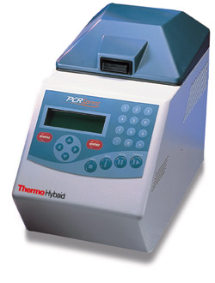
STEP FIVE: | Start program “mobobp-alu”.  Tip: Teacher will set this up.  Look below to see what is happening inside the thermocycler or PCR machine.  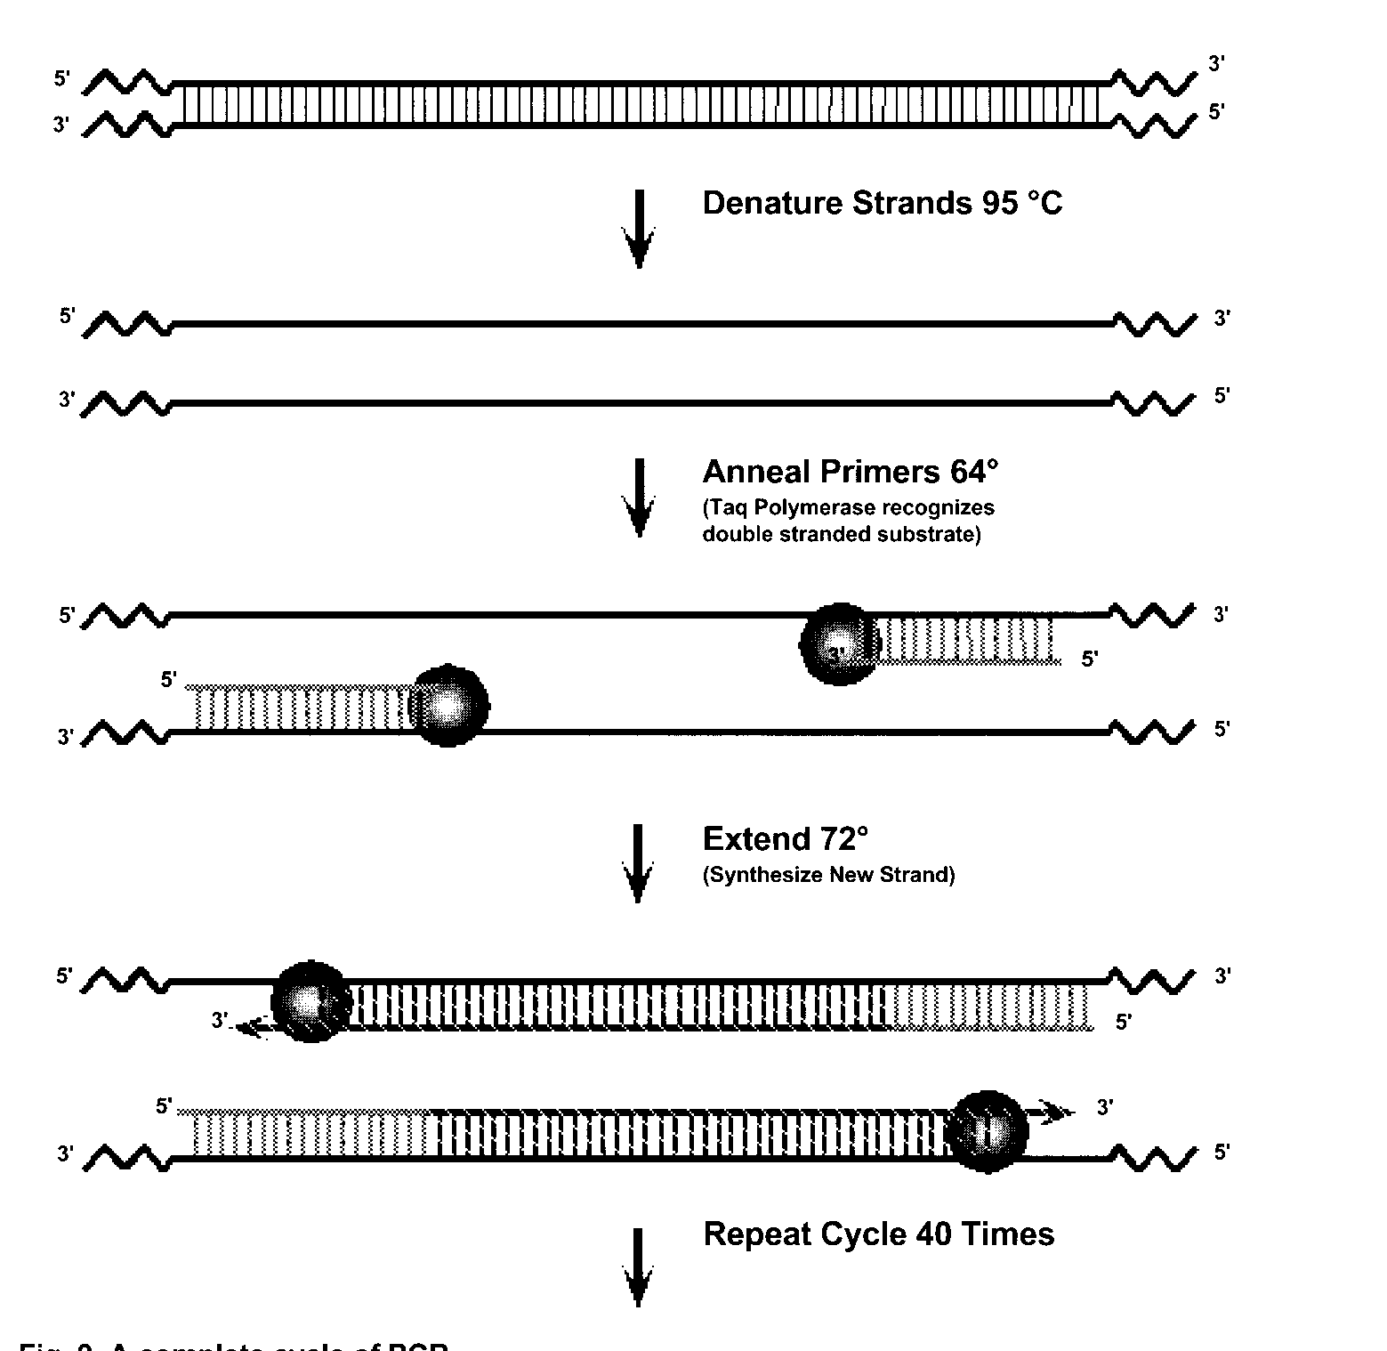 | PCR STEPS:  - Denature Strands 95° C  - The temperature is so hot the hydrogen bonds between the bases break and the two strands separate.  - Hybridization 58° C  - The primers anneal (bond) to the parental strands. Remember these primers are specific for the loci that is being amplified.  - DNA Synthesis 72° C  - Taq polymerase loves this temperature and starts elongating the strands by adding the complementary bases.  In our lab we repeated the cycle, 30 times.
STEP SIX: | At end of program, teacher will freeze your amplified DNA. | 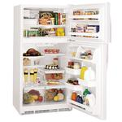

Where are introns located? Introns are found between exons. They are the non-coding segments. They are removed before translation, in RNA processing.
Remember RNA processing after transcription? RNA processing cuts out the introns so the exons or coding segment can be sent to the ribosome by messenger RNA. Remember spliceosomes remove the introns. Alu is found in the introns.
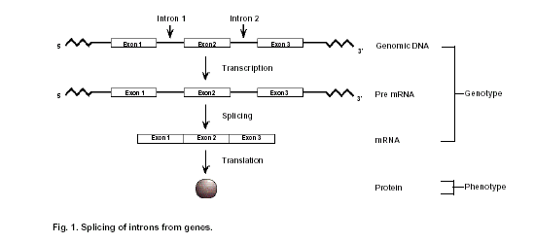

Below is a picture of what we are looking at. Alu or PV92 is an intron located between exons. It doesn’t code for a protein so it does not show anything important other than a link to an evolutionary past.

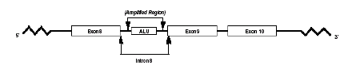

EXPERIMENT ONE: PRACTICE GELS USING CHROMATRACK DYES
STEP ONE | Prepare TAE buffer by adding 100 ml of 10x TAE buffer to 900 ml super water already in the supplied bottle. Use the 1x TAE buffer for pouring and running the gel. Chill remaining 1x TAE buffer.  (5 minutes prep time) | 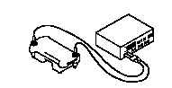
STEP TWO  Tip: This will be clear when ready. | For each gel you prepare ADD .36 GRAMS OF REGULAR AGAROSE TO 30 mL OF 1x TAE buffer. Set up gel apparatus Boil and swirl the gel solution until it is completely dissolved in solution. (Use settings 1 and 2 in alternation, and check frequently).
STEP THREE | Allow solution to cool to about 60°C before pouring. This will be hot to the touch but not painful.
STEP FOUR | Prepare gel tray by sealing ends with tape or other custom-made dam. You can use masking tape or the rubber dams provided.
STEP FIVE  Tip: The comb has to be spaced away from the edge so the wells are not up against the edge. Make sure you use a spacer. | Place comb in gel tray using spacer provided. Make sure you use spacer. Position the comb vertically such that the teeth are about 1-2 mm above the surface of the tray. | 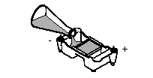
STEP SIX  Tip: If air bubbles appear use a disposable pipette to get the bubble out. | Pour 60°C gel solution into tray to a depth of about 5 mm. Allow gel to solidify about 20 minutes at room temperature.
STEP SEVEN  Tip: When removing the comb, make sure the buffer is covering the gel. This keeps the gel from tearing.  Be very careful removing the rubber bumpers when using metaphor agarose. These gels will tear very easily. | When gel is cooled (about 30 minutes, it should be grayish), pour 1X TAE buffer over it to fill the buffer chambers and cover the gel to about 3 mm. Place the apparatus in the refrigerator and chill about 30 minutes before removing the comb and bumpers. Gently remove the comb, place tray in electrophoresis chamber, and cover (just until wells are submerged) with electrophoresis buffer (the same buffer used to prepare the agarose) | 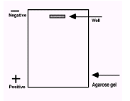
 | Loading the gel: You have three dye solutions to run on practice gels. One is a diluted solution of 5xTAE you normally use for PCR reactions. Another is a solution containing the same dye we normally use, as well as a second lighter blue dye, which runs more slowly. This solution is in the tube labeled BPB/XC. Finally you have chromatrack, which contains several dyes with multiple colors and separation characteristics.
Tip: Make sure the tip of the pipette is below the buffer yet above the floor of the well. Because of glycerol’s density the tip just has to break the surface and the sample will end up in the right place. If you push the pipette tip to deep it will puncture the gel. | Load 15 micro-liters, of each solution into lanes in whatever combination you like.  Run the gel at 70 Volts remembering to set the gel up so that DNA runs to the positive end or red electrode!!!  buffer  This will take ~ 1 hour. | 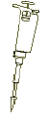  Pipette  DNA  Gel Well
WHAT SHOULD YOU SEE? | DNA TAE AGAROSE | This is dependent on the % agarose used. We use 1.0% so they migrate approximately equal to the chart shown to the left.  Why does orange move so far away from the wells?  Answer: the smaller fragments move the farthest away.
  DYE | 1.0% AGAROSE
  BLUE | 6,500 Bps
  YELLOW | 2,600 Bps
  RED | 1,500 Bps
  BLUE | 1,100 Bps
  FUCHSIA | 500 Bps
  ORANGE | 100 Bps

Experiment 3: Gel Electrophoresis

STEP ONE:  Tip:  A 123 base pair ladder will be added first to use as a reference.  Tip two:  Each student will write their number on the sheet of paper provided by the teacher so they know what lane their DNA is in. We will use numbers instead of initials. Record your number in your lab book so you don’t forget. | The teacher will give you your DNA that has been amplified through PCR. This is in the freezer.  Note: Lane 1 will be used for the 123 base pair ladder. We will use this to count the base pairs like 415 and 715. | 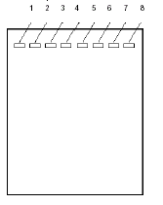
STEP TWO:  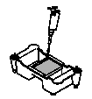  Tip:  When pipeting make sure you steady your hand using your finger and go to the first stop, hold down releasing the DNA and take out of buffer with the plunger still down. Do not let go of the plunger until you are out of the TAE buffer.  Remember that you don’t want to pierce the gel with the pipette. The DNA will go into the well due to gravity. | Stand in line and wait to load your gel.  Please be respectful of others and don’t hit the table or play around.  Make sure you use a new sterile tip on your pipette.  Each student will add 15 micro-liters of their DNA to the well in the gel provided by the teacher.  - Remember to write down your number. | 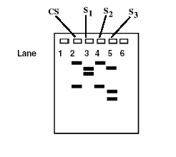
STEP THREE:  Does DNA run negative to positive or positive to negative?  Answer: Negative to positive because the dye and DNA is negatively charged. DNA has a phosphate backbone that gives it a negative charge. | When everyone is finished loading their well, the teacher will turn on the power supply to 70 volts!  - This will run for 1 1/2 to 2 hours. | 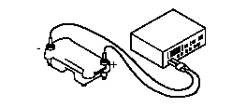
Step FOUR:  Safety:  Goggles and gloves are TO BE WORN! | Staining  The gel will be carefully placed into a well boat using a piece of film. | 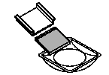
STEP FIVE:  Safety:  Goggles and gloves are TO BE WORN! | Syber green stain will then be poured over the gel and placed in the dark for 1 ½ to 2 hours. | 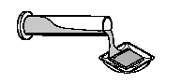
STEP SIX: | Gels are ready to be photographed using UV light and a digital camera.

Experiment 4: Run gel on amplification products

Equipment:
Toploading balance, microwave oven, 100 ml graduated cylinder, 500 ml Erlenmeyer flask, 50 ml Erlenmeyer flask, electrophoresis apparatus, power supply, Vortex mixer, glass dish, shortwave UV transilluminator, hooded camera with orange filter, 100 microliter micropipettes (yellow tips)

Supplies:
Metaphor agarose
TAE buffer
DH2O
Syber green stain
Camera
Micropipettes
Pasteur pipettes
Saran wrap
Purple sample buffer

STEP ONE:  TIP: When adding agarose to boat to weigh, make sure you tare the boat to zero then add the agarose so you are only weighing the agarose and not the agarose and boat. | Pour a 1.8% (w/v) Metaphor agarose gel: Weigh Metaphor agarose (1.3 g) and add to 500 ml flask. Using a graduated cylinder measure out 70 ml of freshly prepared 1x TAE buffer and pour into flask on top of agarose, swirl. Cover top of flask with Saran wrap, punch a hole in wrap. | 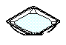  Metaphor Agarose 1.3 g  1X  TAE  70 ml
STEP TWO: | PLACE FLASK ON TOPLOADING BALANCE AND TARE WEIGHT TO “ZERO” | RECORD WEIGHT  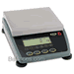
STEP THREE:  TIP: Make sure all flakes OR floaters are gone. This will turn real clear. | Place 500 ml flask and 50 ml flask containing super water into the microwave oven. Microwave on lowest setting for about 5 minutes, swirling from time to time. Repeat micro waving until the agarose solution is clear and no “floaters” remain. | 500  500
STEP FOUR: | Place flask on balance and use Pasteur pipette, hot super water to readjust weight to zero (this compensates for evaporation) | 500  
STEP FIVE:  Tip:  When placing comb’s in gel make sure the comb is away from the wall of the gel far enough. Use the spacers provided. If you do not place the comb in correctly the wells will be to close to the edge of the gel. | Place gel tray in chamber, rotated 90 degrees from running position to seal. Make sure it’s level. Place 20 well comb’s in tray. |   Make sure there is enough space here.
STEP SIX: | When agarose has cooled to ~70 degrees C (just hot to the touch) pour into tray. Use Pasteur pipette to pop any bubbles.
STEP SEVEN: | Leave gel undisturbed for at least half an hour – it will turn grayish. Pour TAE buffer to cover gel and place in refrigerator. Chill 1 liter bottle of TAE buffer in refrigerator at the same time. | 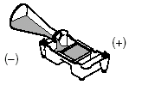
STEP EIGHT:  Tip:  If you do not cover gel with cold buffer the gel will tear when pulling the combs out. Tear the rubbers off the end where the wells are located first. Then slowly pull the rubber off the other side.  Be careful not to let the gel slide out of the tray! | Carefully and slowly pull comb out of gel, and check wells. (If any wells are damaged these should be avoided if possible). Rotate gel into running position (wells= origin at negative, or black end). Fasten leads into power supply (check orientation!)
STEP NINE: | Cover the gel with 1 liter of TAE buffer, starting at chamber nearest origin. This will fill the connecting tube between puffer chambers. There should be just enough buffer to cover entire gel about 1 mm (check from the side)
STEP 10 | If not ready to load samples replace gel apparatus in refrigerator and chill until ready to use ( this can be overnight, over weekend, etc.) If ready proceed to next step.
STEP 11  Tip:  Have students sign in for loading on a separate sheet of paper so you can keep track of pcr tubes. | At the end of the cycler run, press “stop” twice and turn off cycler. Wipe off any condensation that has formed in heating block. Carefully lift out tube rack. Check (and if necessary replace) labels on tubes. Transfer tubes to external racks.
STEP 12 | Add 7.5 microliters of purple sample buffer to each tube, using 100 microliter pipette. Mix briefly with vortex mixer, then pulse in microfuge to mix phases. The sample buffer contains glycerol, which makes the sample dense. | Purple sample buffer  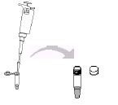
STEP 13 | Using 100 microliter pipette load samples in the following order, from left to right: lane 1 15 microliters of DNA ladder, remaining lanes, 15 microliters of PCR reaction. Record order of samples on gel student initials. Store remaining in freezer. | 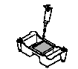
STEP 14 | Electrophorese for 2 hours at 70 volts. Using casting tray carefully slide gel into glass dish containing syber green. Stain for 20-30 minutes agitating gently from time to time. Careful the gel is fragile.
STEP 15 | Use an old piece of film to pick up gel and gently slide it onto the UV transilluminator. View gel using protective helmets. Instructor will take pictures.

Added Information:

Below is an example of how ALU jumps in and adds 300 base pairs.

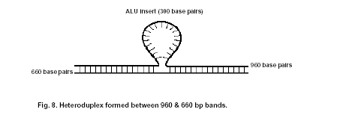
Note this is an example of Primer-Dimer Formation.
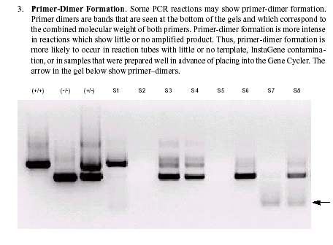

Focus Questions I : DNA extraction and template preparation

- Why is it necessary to trp the metal ions in the cheek cell solution before boiling/lysis step at 100 C? What would happen if you did not put in the Chelex?

- What is needed from the cheek cells in order to conduct the Polymerase Chain reaction?

- What structures must be broken in order to release the DNA from a cell?

- After boiling the samples why do you think the extracted cheek cell DNA is stored cold in the Chelex?

Focus Questions II : PCR amplification
- Why is it necessary to have a primer on each side of the DNA segment to be amplified?

- How did Taq polymerase acquire its name?

- Why are there nucleotide bases (ATG and C) in the PCR mix? What are the other components of the PCR and what are their functions?

- Describe the three main steps of each cycle of PCR amplification and what reactions occur at each temperature.

- Explain why the precise length target DNA sequence doesn’t get amplified until the third cycle. You may need to use additional paper and a drawing to explain your answer.

Focus Questions III: Analyzing your DNA Using Gel Electrophoresis

- What is DNA fingerprinting?

- Explain the difference between an intron and an exon.

- Why do the two possible PCR products differ in size by 300 base pairs?

- Explain how agarose electrophoresis separates DNA fragments of interest. Why does a smaller DNA fragment move faster than a larger one?

- What kind of controls, are run in this experiment? Why are they important? Could there be others used?

